**Exercise 1: Setting Up JUnit Scenario: You need to set up JUnit in your Java project to start writing unit tests.**

**Output:**

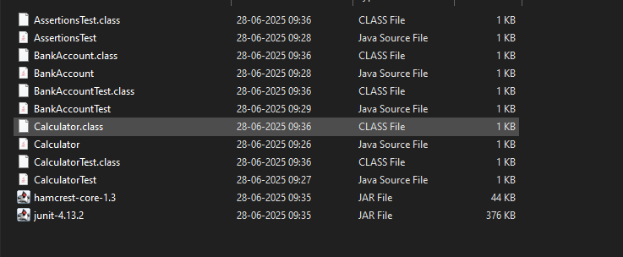

**Exercise 3: Assertions in JUnit**

**Scenario:**

**You need to use different assertions in JUnit to validate your test results**

**Assertion.java**

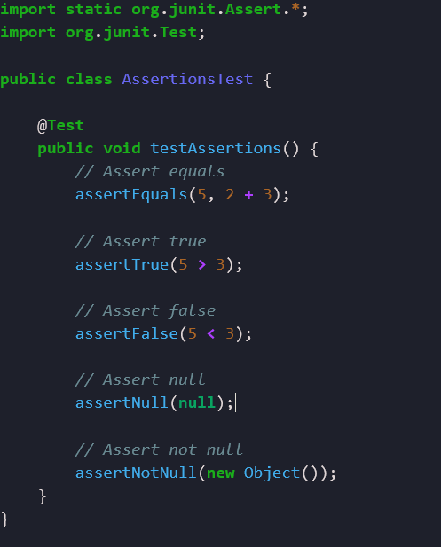

**Output:**

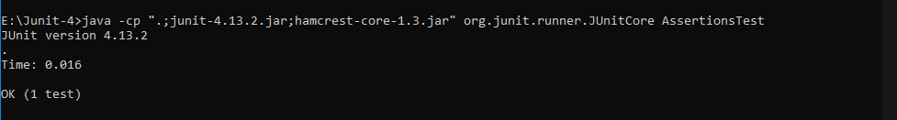

**Exercise 4: Arrange-Act-Assert (AAA) Pattern, Test Fixtures, Setup and Teardown Methods in JUnit**

**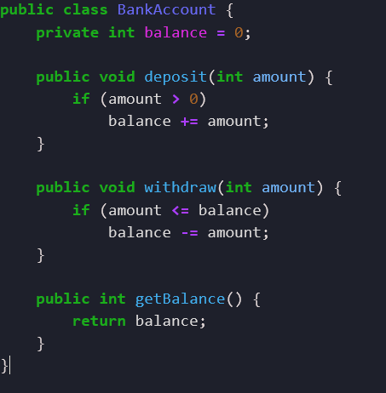  
output:**

