|  |  |
| --- | --- |
| **Auteur(s):** |  |
| Sander Jochems  Bram Swinkels |  |

|  |
| --- |
|  |
| Kwaliteitshandboek |
| *Online Stemmen* |

[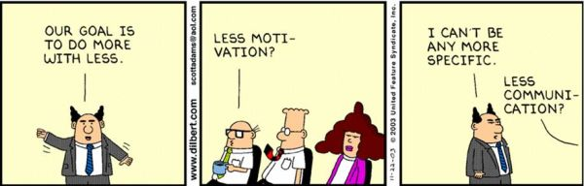](http://www.google.nl/url?sa=i&rct=j&q=&esrc=s&source=images&cd=&cad=rja&uact=8&ved=0ahUKEwiH-KDS2KLPAhVGWRQKHXQ8CS0QjRwIBw&url=http://www.raamstijn.nl/eenblogjeom/index.php/lean-six-sigma/2101-lean-volgens-dilbert&bvm=bv.133387755,d.ZGg&psig=AFQjCNGyJyGsn3fR1lV-nzNtQdRHKloDPw&ust=1474623965233793)

**Inhoud**

1. Kwaliteitshandboek 3

1.1 De planning van de realisatie en de test 3

1.2 De realisatie 3

1.3 De wijzigingen na de test 3

# Kwaliteitshandboek

## *De planning van de realisatie en de test*

|  |  |  |  |
| --- | --- | --- | --- |
| ***Planning van de realisatie en test*** | | | |
| *Onderdeel / Scherm / Venster* | *Programmeur* | *Van* | *Tot* |
| *Website: Backend* | *Sander* | *Week 3* | *Week 5* |
| *Website: Frontend* | *Bram* | *Week 3* | *Week 6* |
| *Applicatie* | *Sander* | *Week 6* | *Week 6* |
| *Database* | *Sander* | *Week 3* | *Week 3* |

## *De realisatie*

|  |  |  |
| --- | --- | --- |
| ***Realisatie*** | | |
| *Onderdeel / Scherm / Venster* | *Programmeur* | *Klaar op* |
| *Website: Backend* | *Sander & Bram* | *Week 6* |
| *Website: Frontend* | *Bram & Sander* | *Week 6* |
| *Applicatie* | *Sander* | *Week 7* |
| *Database* | *Sander* | *Week 3* |

## *De wijzigingen na de test*

|  |  |  |  |  |
| --- | --- | --- | --- | --- |
| ***Wijzigingen*** | | | | |
| *Naam bestand* | *Programmeur* | *Van* | *Tot* | *Wijziging* |
| *Core.php* | *Sander* | *Week 7* | *Week 7* | *Minify Code* |