|  |  |
| --- | --- |
| **Auteur(s):** |  |
| Sander Jochems  Bram Swinkels |  |

|  |
| --- |
|  |
| Testplan |
| *Online Stemmen* |

[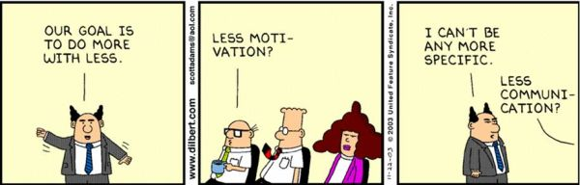](http://www.google.nl/url?sa=i&rct=j&q=&esrc=s&source=images&cd=&cad=rja&uact=8&ved=0ahUKEwiH-KDS2KLPAhVGWRQKHXQ8CS0QjRwIBw&url=http://www.raamstijn.nl/eenblogjeom/index.php/lean-six-sigma/2101-lean-volgens-dilbert&bvm=bv.133387755,d.ZGg&psig=AFQjCNGyJyGsn3fR1lV-nzNtQdRHKloDPw&ust=1474623965233793)

# Testplan

|  |  |  |
| --- | --- | --- |
| ***Testplan (Website)*** | | |
| *Pagina* | *Programmeur* | *Test In* |
| *Home* | *Sander* | *Week 8* |
| *Stemmen* | *Sander* | *Week 8* |
| *Resultaten* | *Sander* | *Week 8* |
| *Uitloggen* | *Sander* | *Week 8* |
| *Contact* | *Bram* | *Week 8* |
| *Sitemap* | *Bram* | *Week 8* |
| *Over* | *Bram* | *Week 8* |
| *Copyright* | *Bram* | *Week 8* |
| *Privacy* | *Bram* | *Week 8* |
| *Cookies* | *Bram* | *Week 8* |

|  |  |  |
| --- | --- | --- |
| ***Testplan (WPF)*** | | |
| *Scherm* | *Programmeur* | *Test In* |
| *Resultaten* | *Sander* | *Week 8* |
| *Statastieken* | *Sander* | *Week 8* |
| *Partijen* | *Sander* | *Week 8* |

|  |  |  |
| --- | --- | --- |
| ***Onderdeel*** | ***Formulier*** | ***Functie*** |
| *Navbar* |  | *Links* |
| *Stemmen* |  | *Een partij kiezen en stemmen* |
| *Resultaten* |  | *Gemeente selecteren en resultaten bekijken* |
| *Uitloggen* |  | *Uitloggen* |

# Testlog

|  |  |  |  |  |  |  |  |  |
| --- | --- | --- | --- | --- | --- | --- | --- | --- |
| Testlog | | | | | | | | |
| Onderdeel | Functie | Datum test | Tester | Opmerking | Prioriteit | Verbeteractie | Datum actie | Afhandelaar |
| Navbar | Links | 4 April | Sander | Geen Fouten |  |  |  |  |
| *Stemmen* | *Stemmen* | 4 April | Sander | Geen Fouten |  |  |  |  |
| *Resultaten* | *Resultaten Bekijken* | 4 April | Sander | Geen Fouten |  |  |  |  |
| *Uitloggen* | *Uitloggen* | 4 April | Sander | Geen Fouten |  |  |  |  |