|  |
| --- |
|  |
| Webwinkel  De Concurrent |
| |  |  |  | | --- | --- | --- | | Sander Jochems | 3/15/18 | Webwinkel | |

Contents

UI Diagram 2

Home 2

Fietsen 2

Reperatie 3

Contact 3

Web Diagram 4

Directory Structure 5

Database 6

Mockup overzicht 7

Home 7

Fietsen 7

Reperatie 8

Contact 8

# UI Diagram

## Home



## Fietsen



## Reperatie



## Contact



# Web Diagram



# Directory Structure

* assets
  + classes
    - database.php
    - core.php
  + images
    - Fietsen
      * *.png
  + styles
    - deconcurrent.css
  + head
    - nav.php
  + foot
    - content.php
    - scripts.php
  + header.php
  + footer.php
* home.php
* fietsen.php
* login.php
* logout.php
* bestellingen.php
* registreer.php
* contact.php
* overons.php
* reperatie.php

# Database

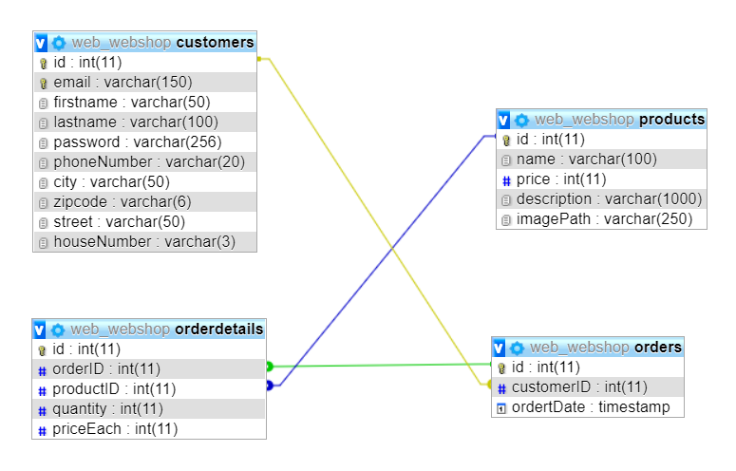

# Mockup overzicht

## Home



## Fietsen



## Reperatie



## Contact

