**CASE Status Report**

Name: Sander Peeters

CASE title: Sport events

Report no.: 2

Date: 25/09/2020

## Current Activities and Problems:

I am working on the functionality to view the locations on the map. As you can see in the first screenshot, the opencage api responds with all the info, still unstructured. The points on the map are still the ones from the template.

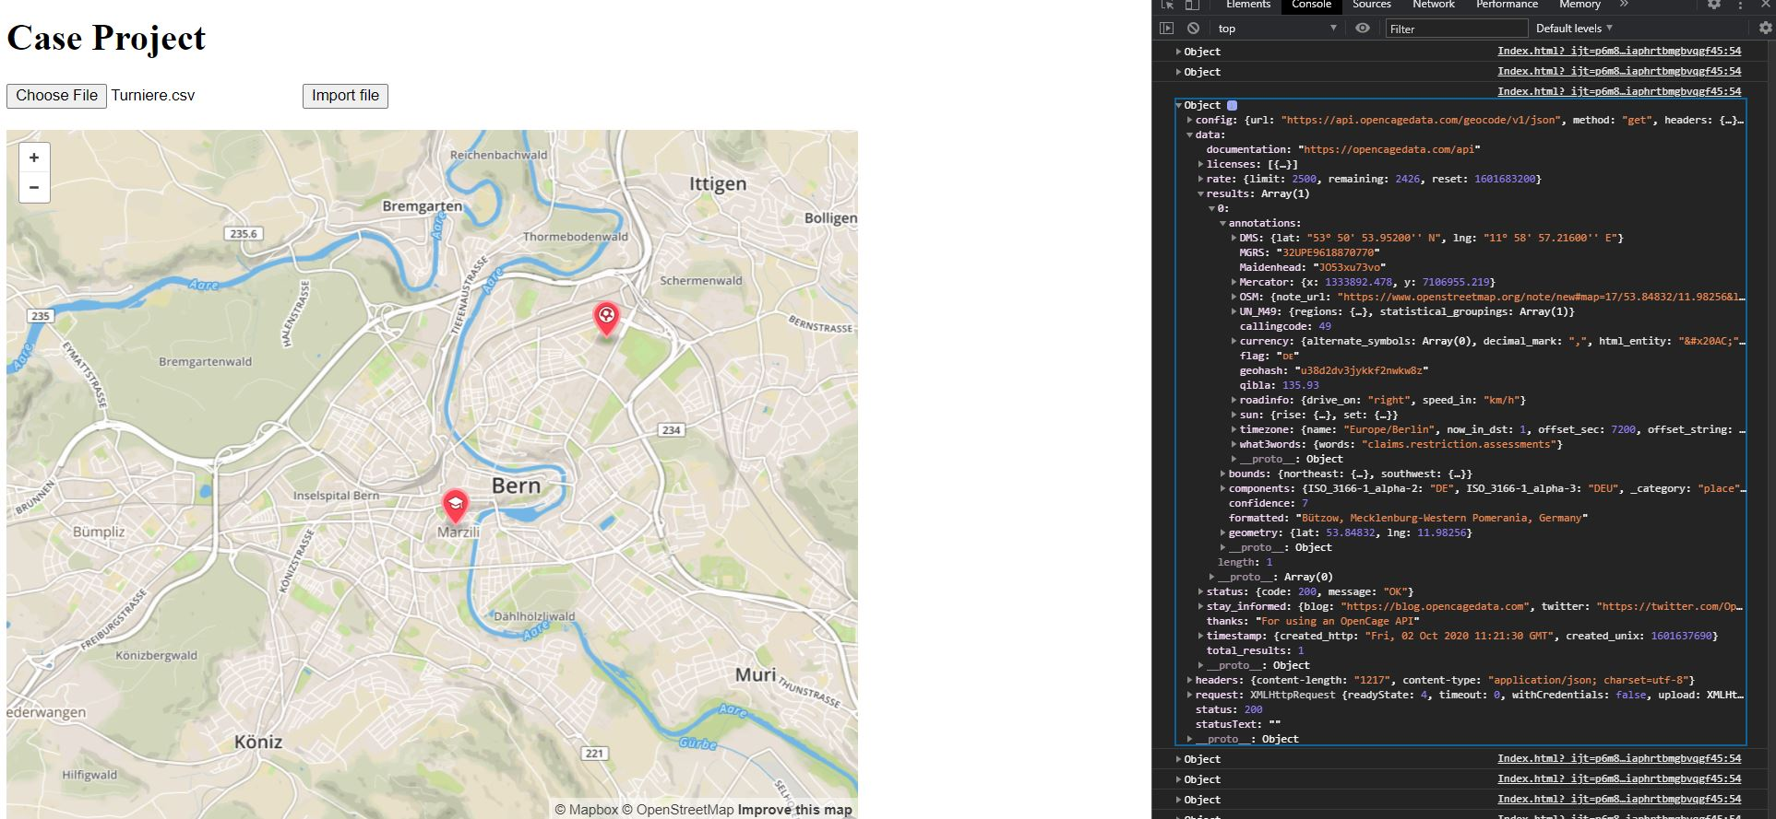

In the second screenshot you can see that I extracted the long and latitude from the response and I ‘pushed’ them into a list using the ‘objectarray.push(object)’ function. The objects contain at the moment only the long and latitude.

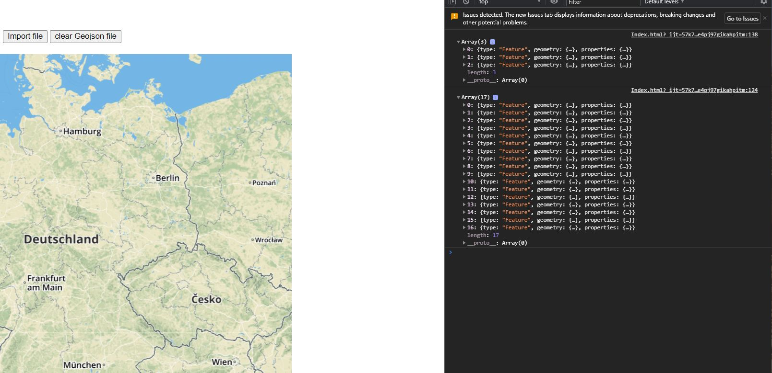

Even for the very unsorted data example : ‘Maintal +++ wegen Corona-Krise ABGESAGT +++’ (4th event in the list) it still can return a somewhat close location.

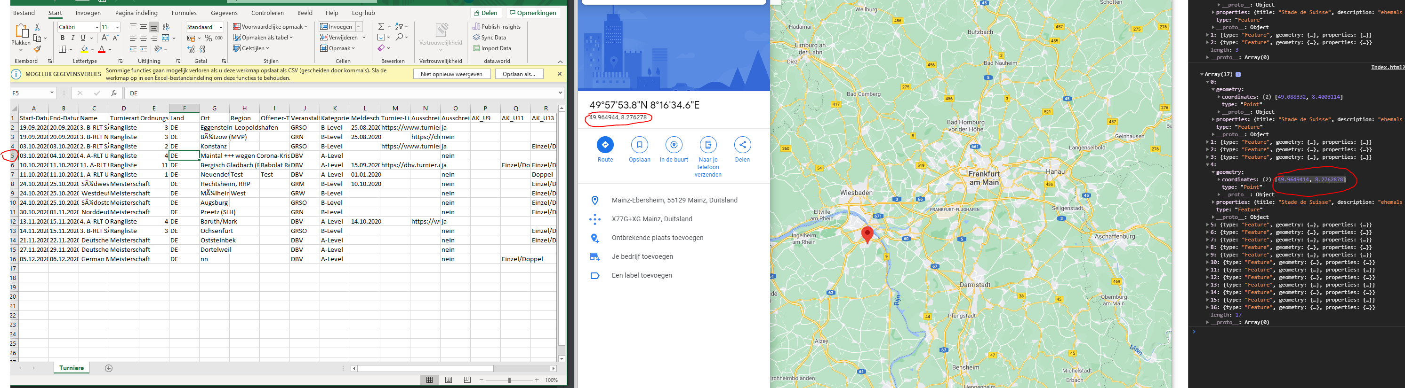

I still have not found out why the red arrows don’t show up on the map. As you can see in the second picture, the array with 3 items is from the example you gave me and the array with 17 items is from the csv file. The structure is exactly the same. I will keep looking for a solution.

## Reflection:

It was more difficult then I thought to get the red arrows from the csv file on the map. It will take more time to complete that step then I first thought. Also the geocoding is smarter then i thought. But I will still clean up the file like you said in your email from 1/10/2020.

## Next Steps:

Fix the red arrows on the map, also make them display more information on the cards like you said in the mail from 1/10/2020.