FloFISH Guide
Authors: Florence Berbain, Sander van Otterdijk

Introduction
In this tutorial, we will go through FloFISH, a software wrapper written by Florence berbain for the bigFISH spot detection library (https://github.com/fish-quant/big-fish).
Before we explore the code, we will complete all the necessary installations to run it. To run the code, we will clone her GitHub repository using git.

What Is Git?
Git is a version control system that tracks changes to files, helping you:
- Revert to earlier versions of the code
- Collaborate without overwriting work
- Sync updates across computers or team members
Git's main function is to record, manage, and synchronise code changes across contributors and versions.

Cloning FloFISH repo

1. Install Git
Follow the guide for your operating system:
🌐 https://github.com/git-guides/install-git.

2. Install Anaconda
Anaconda is a Python distribution used for data science and scientific computing.
🌐 https://www.anaconda.com/download

3. Open the Command Line Interface
- On Windows: Open the Anaconda Prompt
- On Mac/Linux: Open the Terminal

4. Check if Git Is Installed
Type this command and press Enter:
git --version
If installed, you’ll see something like:
git version 2.42.0

5. Navigate to Your Project Folder
Use the cd command to go to the folder where you want the project:
cd path/to/your/folder

6. Clone Florence’s GitHub Repository
Type the following command to clone the code:
git clone -b sander_testing https://github.com/SanderSMFISH/flofish.git
This will create a folder called flofish containing all the code files.

Making and Saving Code Changes to FloFISH with Git
Once the code is on your computer, you can edit it freely. Git helps you track and share these changes using four steps:
Change branch
A branch in Git is like a parallel version of your project — it allows you to work on changes without affecting the main code (usually the main or master branch) until you're ready.
To add (or create) a new branch in Git, use the following command:
git checkout -b your-branch-name

Stage Your Changes
Tell Git which files to save:
git add filename.py # Add one file
git add . # Add all modified files

Commit the Changes
Create a snapshot of your work:
git commit -m "Brief message about what you changed"

Push Your Changes to GitHub
Send your commit to the remote GitHub repository:
git push origin branch # ‘branch' is your branch name (might be 'master' or another)

Creating an anaconda environment and installing FloFISH

1. Open the Terminal or Anaconda Prompt
On Windows, use the **Anaconda Prompt**. On macOS/Linux, use your regular **Terminal**.

2. Create the `flofish` Environment
Run the following command to create the environment:
conda create --name flofish python=3.10

3. Activate the Environment
Activate the `flofish` environment by running:
conda activate flofish

4. Install Project Dependencies (Optional)
It is indicated you can install flofish libraries by typing: “pip install flofish”, however this is not true as the code has not been submitted to pypi.
Instead type:
“pip install -e . ”
To install all the flofish code and its dependencies 😊!

5. Install the napari-flofish plugin
Florence also made a napari plugin, a GUI embedded in the napari viewer, that can be used to explore FloFish code functionalities (https://github.com/LaToyaVanderB/napari-flofish/tree/main). Clone this repository and install its code by typing:
“pip install -e .”cd

Testing your installation
In the shell/command prompt, navigate to the folder /flofish/flofish using the CD path command (make sure you are in your activated conda flofish environment).
Next, type the command:
“pytest flofish/tests/test_image.py -v”
This script will execute all the code contained in the flofish library on some example data. The code should parse without any errors. Does this seem to be the case? If not, you have to troubleshoot and fix the raised errors.

Some background on the flofish code
The code makes use of two JSON files : config.json (Figure 1) and img.json (Figure 2), The config.json file is a description of the shared processing parameters used to analyze a list of images, see example below.
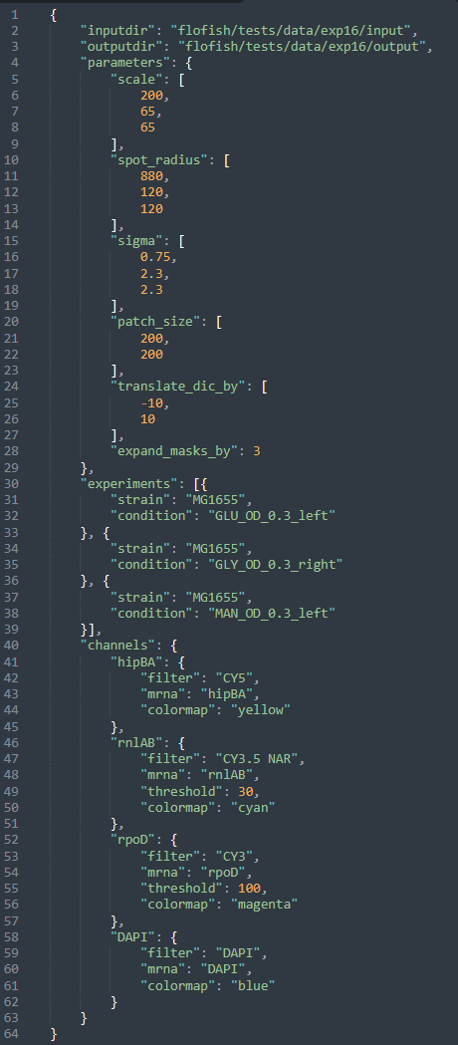
Figure 1. Example of config.json file.Note this file has to be updated for your specific experimental settings.

The img.json is a description of the parameters used in processing a single image. The img.json is produced during the analysis of your data. Whilst the config.json file is required beforehand.
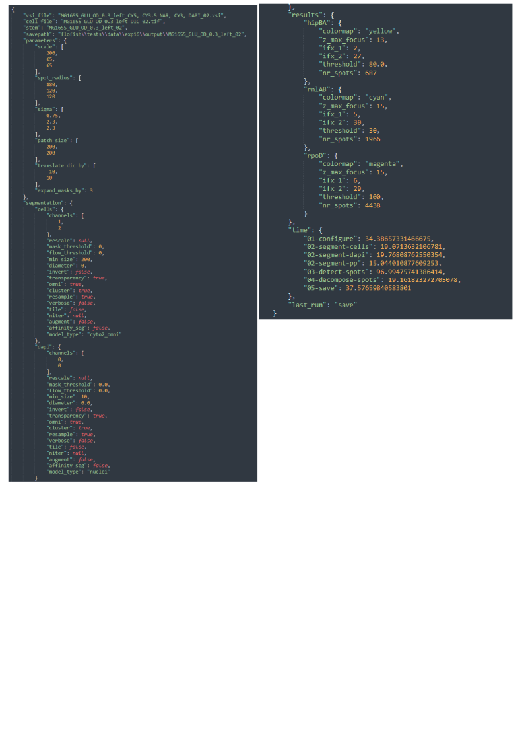
Figure 2. Example of img.json file. This file is produced during the analysis.

Exploring the napari-flofish plugin
The parameters necessary in bulk processing can be explored using the napari-floFISH plugin.
To open the plugin, in your command prompt/shell type:
“napari”
In the toolbar, click “Plugins” and hover the mouse over the Napari Flofish menu. A drop-down menu will appear with different options. Click the first option named “Read in VSI file”. A graphical user element will appear on the right hand of the screen (see Figure 3). This element can be used to load a single VSI image into your viewer. First, select the files in the config.json, VSI and DIC image you want to open. Next, press run to load the image into the viewer.
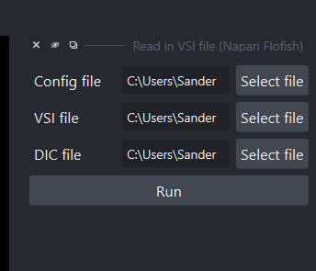
Figure 3. Read in VSI file GUI element.
Now open the new plugin in the dropdown menu named “Filter out background”.
Next, perform background filtering of one of the FISH channels by selecting the right image layer and pressing run (Figure 4, default parameters will probably work with most parameters).
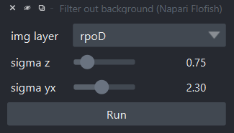
Figure 4. Filter out background GUI element.
Observe the new outputted layer (you might have to update the contrast settings). Is the contrast of spots to background enhanced? If not, update parameters and retry.
Next, we will perform spot detection on the produced background filtered image by running a Laplacian of Gaussian operation (Log), followed by local maxima detection (see Figure 5) on the image. First, open the next GUI element by pressing “Detect spot” in the dropdown menu. Run the spot detection with standard settings.
This will produce three new layers:
- rpoD spots detected thr=50
- rpoD local maxima
- rpoD LoG filtered
The fist layer is a napari point layer containing the detected spots. The second layer is a napari labels layer that contains the areas in the image that contain the unthresholded found local maxima. This layer is used to quickly threshold spots (see next steps and gui element in Figure 6) without reperforming the entire LOG operation on the image. The LoG filtered layer contains the LoG transformed image, on which local maxima detections is performed to find spots.
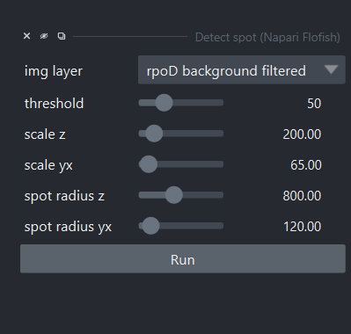
Figure 5. Detect spots GUI element.
Next, we will open the first to last GUI element from the dropdown menu named “Threshold spots”. In the GUI element that has appeared on the right, select the layer containing the detected rpoD spots (napari point layer), and update the threshold. Compare the newly produced spot point layer to the previous layer, how does changing the threshold affect the spot count?
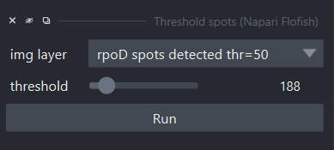
Figure 6. The threshold spots GUI element.
Now open the last GUI element named “Decompose spots” (Figure 7). This GUI element contains the code to identify spots with abnormal spot brightness and/ or shape, indicating that multiple RNAS are localised there (including Txs). 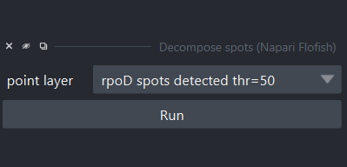
Figure 7. Decompose the spots GUI element.
The GUI element uses the bigFISH function decompose_dense with the standard parameters indicated in Figure 8 below.
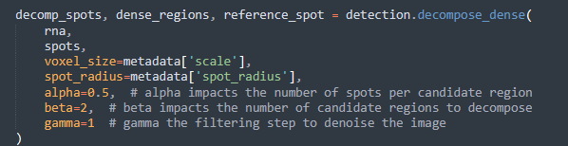
Figure 8. Default parameters used in spot detection.
Pressing the run button will produce two layers: dense regions and decomposed spots. Dense regions contain all the areas with abnormally bright or shaped spots, whilst the decomposed spots layer shows all spots + the newly detected spots and their number in the dense regions (see Figure 9).

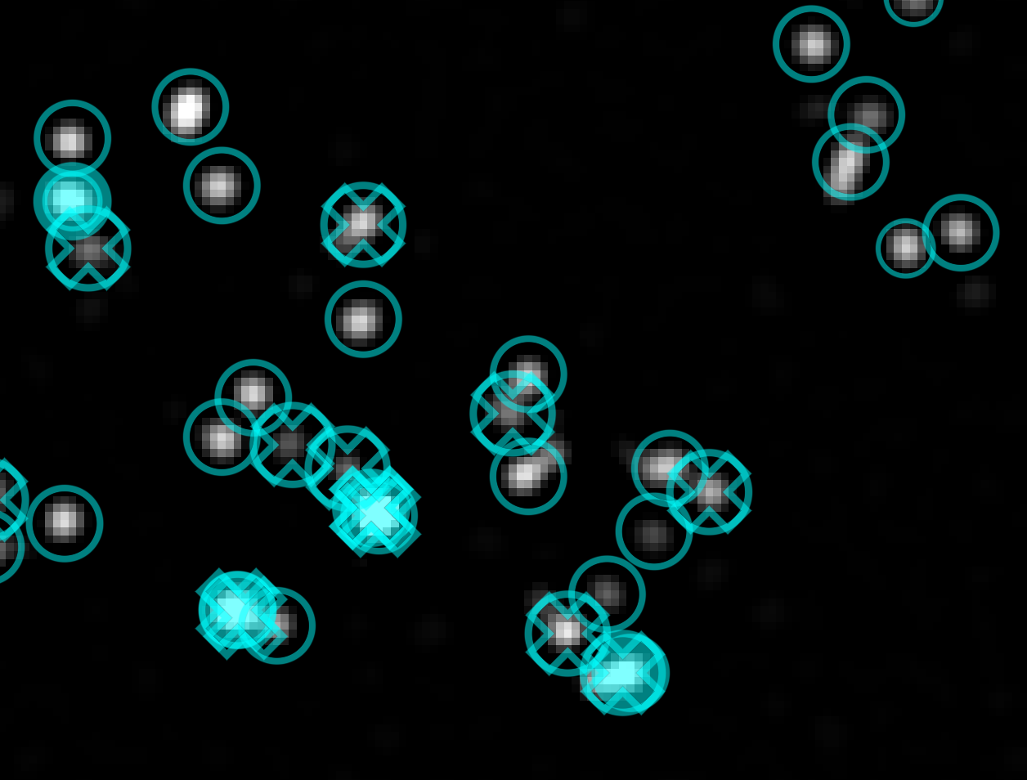
Figure 9. example of detected spots (circles), decomposed spots (crosses) and dense regions (filled blue circle).
We have now finished the napari-flofish tutorial. Make sure to record the used and improved spot detection parameters. Next, we will use these parameters to run “bulk processing” of a list of images.

Exploring bulk processing with floFISH
In this part of the guide, we will explore how we can use floFISH bulkprocessing.ipynb to process a lit of images that share the same processing parameters.
In the command prompt/shell type (make sure you are in the floFISH folder):
“jupyter notebook”
Next, navigate to the flofish/bulk_processing.ipynb. Execute cell by cell and observe how the output gets added to the bulk_processing folder. The code to run bulk processing is being imported from image.py notebook.
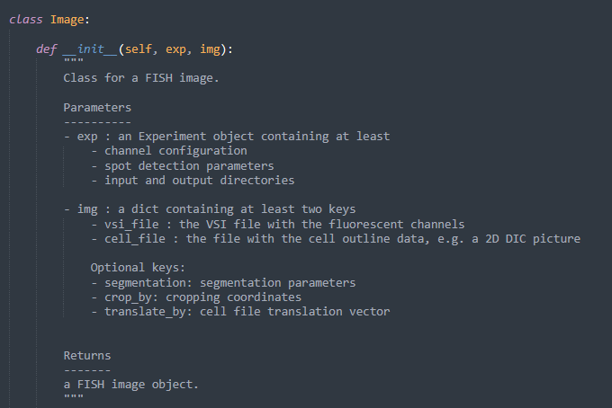

Notes:
- Had to change USE_GPU in experiment.py and image.py to USE_GPU=True. Also had to change two import line because of this
- Had to pip install natsort.
- Have to install pytest as well
- Set use_GPU=False

