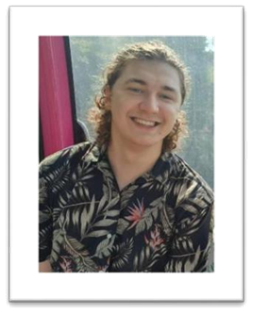

**CURRICULUM VITAE**

**Sander (Joris Augustijn) Verbeken**

|  |  |
| --- | --- |
| **Address** | Burgemeester van kelfstraat 5, 3078 Meerbeek |
| **Phone/GSM** | 0474428532 |
| **E-mail address** | sanderverbeken@gmail.com |
| **Place/Date of birth** | Leuven 14/05/2000 |
| **Marital Status** | Unmarried |

About myself:

|  |  |
| --- | --- |
| Man with solid fill | Qualities: dynamic, polyvalent, people-oriented & caring, support & coordination (a doer).  Social attitude.  A team player who also likes to work autonomously, good at keeping an overview, context, achieving goals step by step, willing to learn, careful, conscientious, dedicated, responsible, problem solver, able to adapt to (changing) environment, tasks, responsibilities and/or people. |
| Chat with solid fill | Dutch mother tongue, English fairly good, French moderate |
| Computer with solid fill | Programming languages: Java, base of python, base of C#  Website: Front & backend, Html5, CSS, JavaScript  Networking: Basic Cisco & Mikrotik, BGP, ...  System administration: Ubuntu, UbuntuServer, FreeBSD, ...  Data handling: PostgreSQL, MySQL  Microsoft office: Word, Excel, PowerPoint, ...  Video and photo editing |
| Information with solid fill | Personality: attentiveness, willingness to listen, commitment,  perseverance, insight, helpful, honesty, empathy, instinct, social, collegial, movement, action, humor |

|  |  |  |
| --- | --- | --- |
| **TRAINING** | Don Bosco Haacht | 2014 - 2018  Engineering Sciences  Thesis: Artificial photosynthesis |
| UCL Haasrode | 2018 - 2022  Graduated with Cum laude  Professional Bachelor of Applied Computer Science  Deepening your knowledge of System & Network Administration |
| **ADDITIONAL TRAINING** | Student job in Proxy Delhaize Meerbeek | Month of August 2017 |
| Student job in Park Abbey Leuven | 2 weeks in July 2020 |
| Trainee networking & systems at SIMAC ICT BELGIUM | March 2022 - June 2022 |
| **HOBBIES** | Was a leader for 3 years in the Chiro of Everberg after being a member for 12 years. Playing guitar. Work out. Running. Listening to music. Gaming. VR. Editing videos. Socializing. Working on technical projects. | |