

S3- Db02

Sander van Deurzen

**Leeruitkomsten**

18-02-2022

**Learning outcomes**

1. You design and build **user-friendly**, **full-stack** web applications**.**
2. You use software tooling and methodology that continuously monitors and improve the software quality during software development.
3. You choose and implement the most suitable agile software development method for your software project.
4. You design and implement a (semi)automated software release process that matches the needs of the project context.
5. You recognize and take into account cultural differences between project stakeholders and ethical aspects in software development.
6. You analyze (non-functional) requirements, elaborate (architectural) designs and validate them using multiple types of test techniques.
7. You analyze and describe simple business processes that are related to your project.
8. You act in a professional manner during software development and learning.
9. **You design and build user-friendly, full-stack web applications.**

***Clarification:***

***User friendly:****You apply basic User experience testing and development techniques.*

***Full-stack:****You design and build a full stack application using commonly accepted front end (Javascript-based framework) and back end techniques (e.g. Object Relational Mapping) choosing and implementing relevant communication protocols and addressing asynchronous communication issues.*

# Designs:

## C4 model Layer 1:

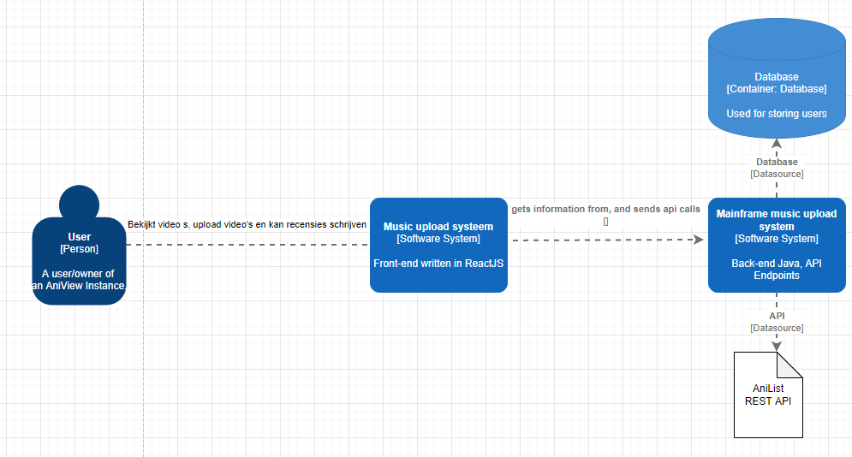

## C4 Model Layer 2:

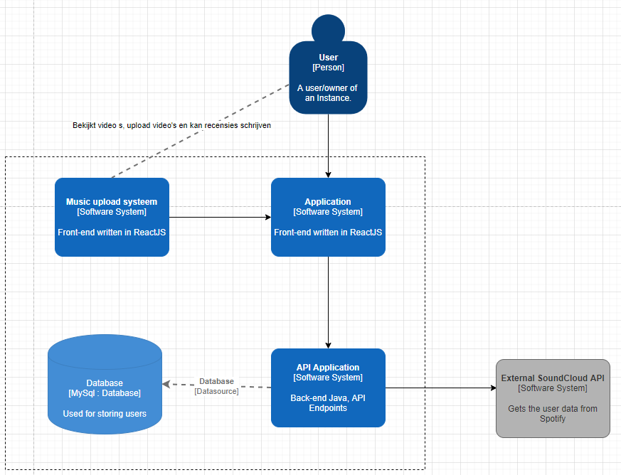

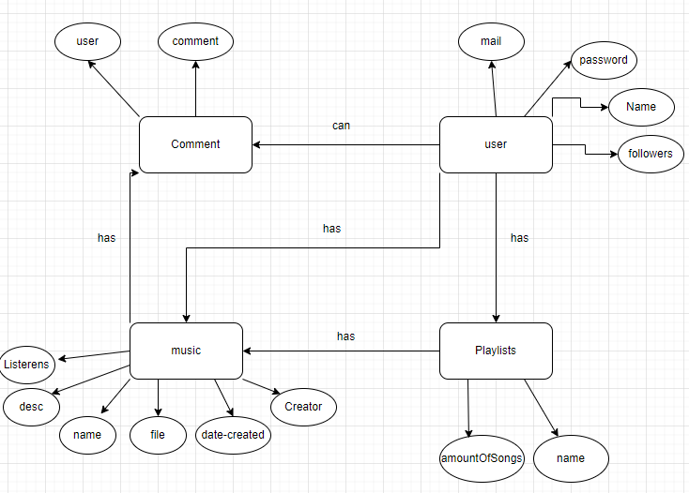

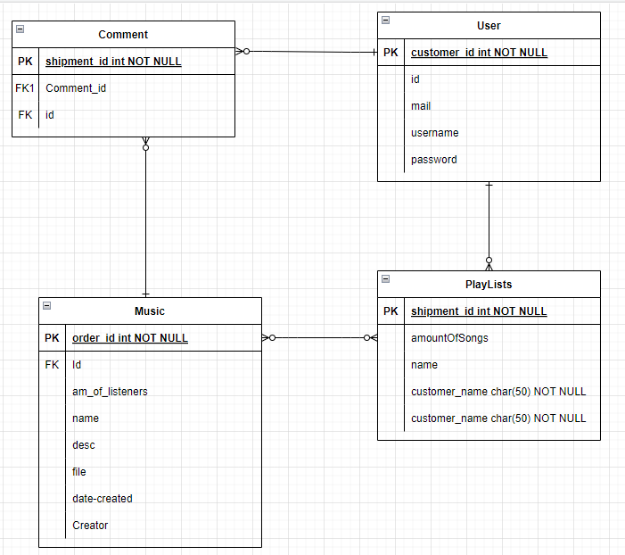

1. You use software **tooling and methodology** that continuously monitors and improve the software quality during software development.

***Clarification:***

***Tooling and methodology:****Carry out, monitor and report on unit integration, regression and system tests, with attention for security and performance aspects, as well as applying static code analysis and code reviews.*

Voor zowel het groepsproject en mijn individueel project maak ik gebruik van unit- en integratie tests. Elke functionaliteit die bij mijn user stories passen moet getest zijn.

**ProductControllerTests.java:**

**Mappen structuur test:**

**Test database:**

1. You **choose** and implement the most suitable agile software development method for your software project.

***Clarification:***

***Choose :****You are aware of the most popular agile methods and their underlying agile principles. Your choice of a method is motivated and based on well-defined selection criteria and context analyses.*

Wij maken gebruik van een sprint planner tool genaamd Trello. Hier in hebben we user stories opgezet waaruit technische- en functionele eisen zijn opgesteld. Elke user story heeft een verwachte tijdsduurAfbeelding met tekst, schermafbeelding, binnen

1. You **design and implement** a (semi)automated software release process that matches the needs of the project context.

***Clarification:***

***Design and implement:****You design a release process and implement a continuous integration and deployment solution (using e.g. Gitlab CI and Docker).*

In mijn project wil ik werken met Docker. Mijn plan is om mijn backend, front end en database te draaien op een productie omgeving. Dat wil ik doen aan de hand met docker. Hieronder wordt aangetoond hoe ik dat heb gedaan aan de hand van mijn docker files en omgeving.

### Docker comose.yaml

### Docker omgeving

### SonarCloud omgeving

In mijn project maak ik gebruik van SonarCloud. SonarCloud zorgt ervoor dat ik continue kan bekijken of ik enige issues heb in mijn code van mijn applicatie. Zo kan ik die fouten inzien en verbeteren indien nodig is.

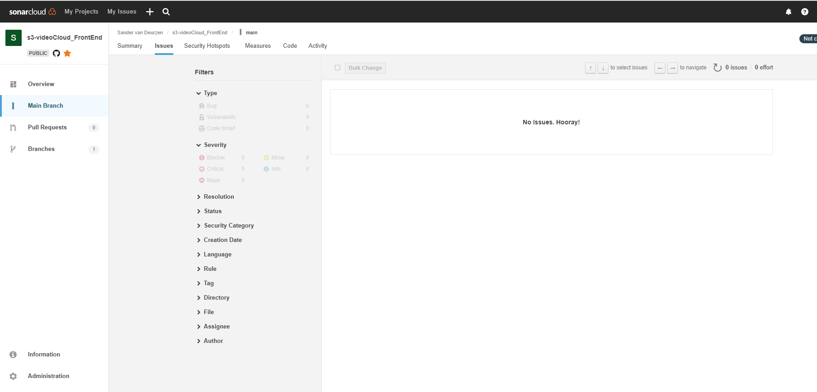

1. You **recognize** and **take into account** cultural differences between project stakeholders and ethical aspects in software development.

***Clarifications:***

***Recognize****:  Recognition is based on theoretically substantiated awareness of cultural differences and ethical aspects in software engineering.*

***Take into account:***

*Adapt your communication, working, and behavior styles to reflect project stakeholders from different cultures;*

*Address one of the standard Programming Ethical Guidelines (e.g., ACM Code of Ethics and Professional Conduct) in your work.*

1. You analyze (non-functional) requirements, elaborate (architectural) designs and validate them using **multiple types of test techniques**.

|  |
| --- |
| ***Clarification:***  ***Multiple types of test techniques:****You apply user acceptance testing and stakeholder feedback to validate the quality of the requirements. You evaluate the quality of the design (e.g., by testing or prototyping) taking into account the formulated quality properties like security and performance.* |

1. You analyze and describe **simple** business processes that are **related** to your project.

|  |
| --- |
| **Clarification**:  **Simple**: Involving stakeholders, predominantly sequential processes with one or two alternative paths.  **Related**:  Business processes during which the software that you are developing will be used (business processes that the software must support by fully or partially automating them).  or  Business processes needed for the success of your software development project (e.g., product release, market release, financial assurance). |

**BusinessProcess:**

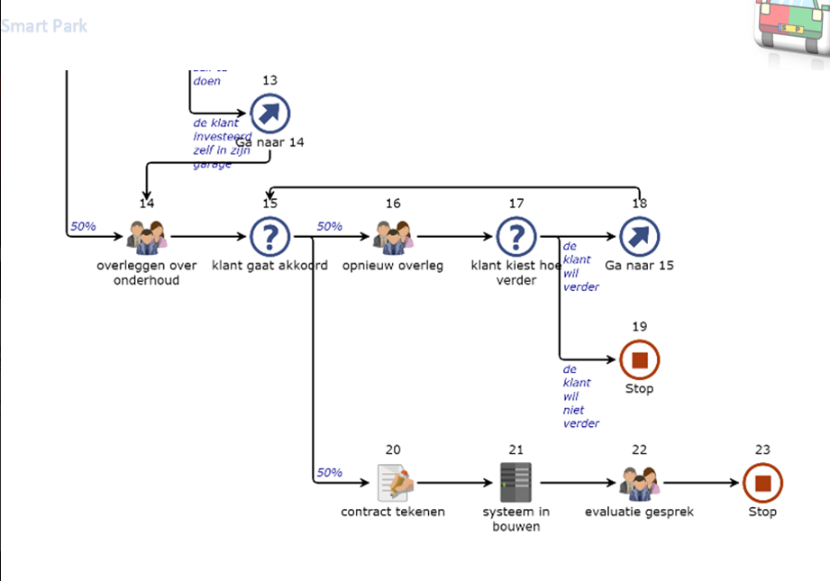

1. You act in a **professional manner** during software development and learning.

|  |
| --- |
| **Clarification:**  **Professional manner:**  You develop software as a team effort according to a prescribed software methodology and following team agreements. You are able to track your work progress and communicate your progress with the team.  You actively ask and apply feedback from stakeholders and advise them on the most optimal technical and design (architectural) solutions. You choose and substantiate solutions for a given problem. |

**Learning outcomes**

1. You design and build **user-friendly**, **full-stack** web applications**.**
2. You use software tooling and methodology that continuously monitors and improve the software quality during software development.
3. You choose and implement the most suitable agile software development method for your software project.
4. You design and implement a (semi)automated software release process that matches the needs of the project context.
5. You recognize and take into account cultural differences between project stakeholders and ethical aspects in software development.
6. You analyze (non-functional) requirements, elaborate (architectural) designs and validate them using multiple types of test techniques.
7. You analyze and describe simple business processes that are related to your project.
8. You act in a professional manner during software development and learning.
9. **You design and build user-friendly, full-stack web applications.**

***Clarification:***

***User friendly:****You apply basic User experience testing and development techniques.*

***Full-stack:****You design and build a full stack application using commonly accepted front end (Javascript-based framework) and back end techniques (e.g. Object Relational Mapping) choosing and implementing relevant communication protocols and addressing asynchronous communication issues.*

# Designs:

## C4 model Layer 1:



## C4 Model Layer 2:







1. You use software **tooling and methodology** that continuously monitors and improve the software quality during software development.

***Clarification:***

***Tooling and methodology:****Carry out, monitor and report on unit integration, regression and system tests, with attention for security and performance aspects, as well as applying static code analysis and code reviews.*

Voor zowel het groepsproject en mijn individueel project maak ik gebruik van unit- en integratie tests. Elke functionaliteit die bij mijn user stories passen moet getest zijn.

1. You **choose** and implement the most suitable agile software development method for your software project.

***Clarification:***

***Choose :****You are aware of the most popular agile methods and their underlying agile principles. Your choice of a method is motivated and based on well-defined selection criteria and context analyses.*

Wij maken gebruik van een sprint planner tool genaamd Trello. Hier in hebben we user stories opgezet waaruit technische- en functionele eisen zijn opgesteld. Elke user story heeft een verwachte tijdsduurAfbeelding met tekst, schermafbeelding, binnen

1. You **design and implement** a (semi)automated software release process that matches the needs of the project context.

***Clarification:***

***Design and implement:****You design a release process and implement a continuous integration and deployment solution (using e.g. Gitlab CI and Docker).*

In mijn project wil ik werken met Docker. Mijn plan is om voor elke service die ik in mijn backend heb een microservice te draaien. Dit doe ik om mijn applicatie veiliger te maken en makkelijker en veiliger te behouden.

1. You **recognize** and **take into account** cultural differences between project stakeholders and ethical aspects in software development.

***Clarifications:***

***Recognize****:  Recognition is based on theoretically substantiated awareness of cultural differences and ethical aspects in software engineering.*

***Take into account:***

*Adapt your communication, working, and behavior styles to reflect project stakeholders from different cultures;*

*Address one of the standard Programming Ethical Guidelines (e.g., ACM Code of Ethics and Professional Conduct) in your work.*

1. You analyze (non-functional) requirements, elaborate (architectural) designs and validate them using **multiple types of test techniques**.

|  |
| --- |
| ***Clarification:***  ***Multiple types of test techniques:****You apply user acceptance testing and stakeholder feedback to validate the quality of the requirements. You evaluate the quality of the design (e.g., by testing or prototyping) taking into account the formulated quality properties like security and performance.* |

1. You analyze and describe **simple** business processes that are **related** to your project.

|  |
| --- |
| **Clarification**:  **Simple**: Involving stakeholders, predominantly sequential processes with one or two alternative paths.  **Related**:  Business processes during which the software that you are developing will be used (business processes that the software must support by fully or partially automating them).  or  Business processes needed for the success of your software development project (e.g., product release, market release, financial assurance). |

1. You act in a **professional manner** during software development and learning.

|  |
| --- |
| **Clarification:**  **Professional manner:**  You develop software as a team effort according to a prescribed software methodology and following team agreements. You are able to track your work progress and communicate your progress with the team.  You actively ask and apply feedback from stakeholders and advise them on the most optimal technical and design (architectural) solutions. You choose and substantiate solutions for a given problem. |

**a**