Author : **A.S.M.Damunugalla**

Date: **10/12/2024**

Student ID: **w2121298**

**Outcomes**

**15/6/2024**

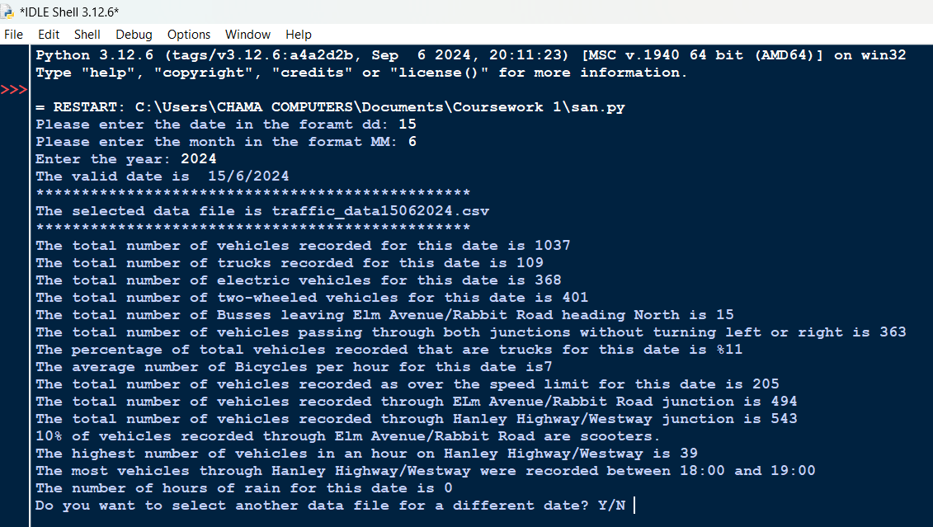

**16/6/2024**

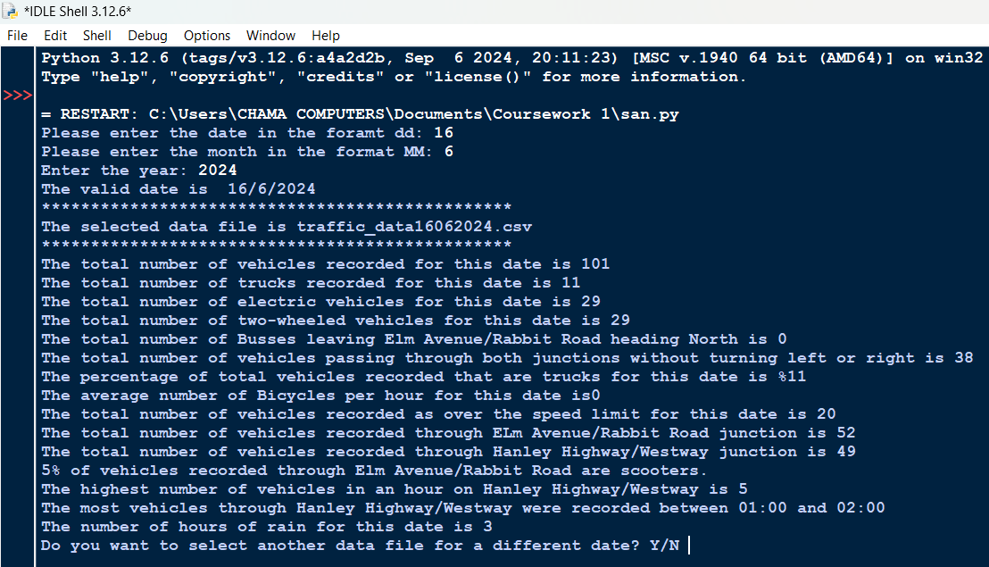

**21/6/2024**

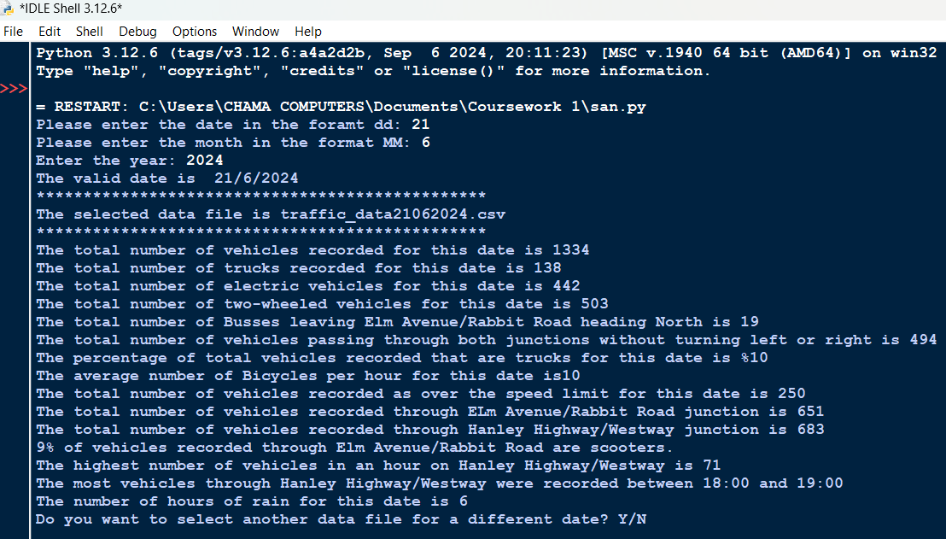

**Validation**

Date

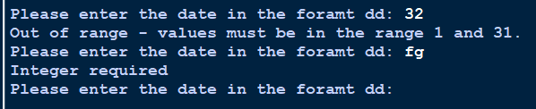

Month

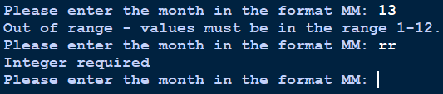

Year

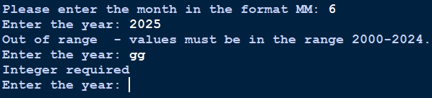

Separate date

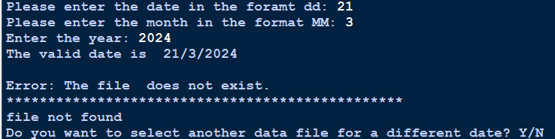

**Text file**

15/6/2024

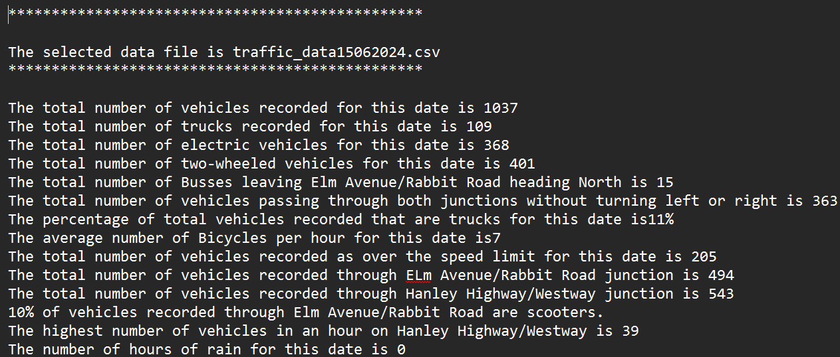

16/6/2024

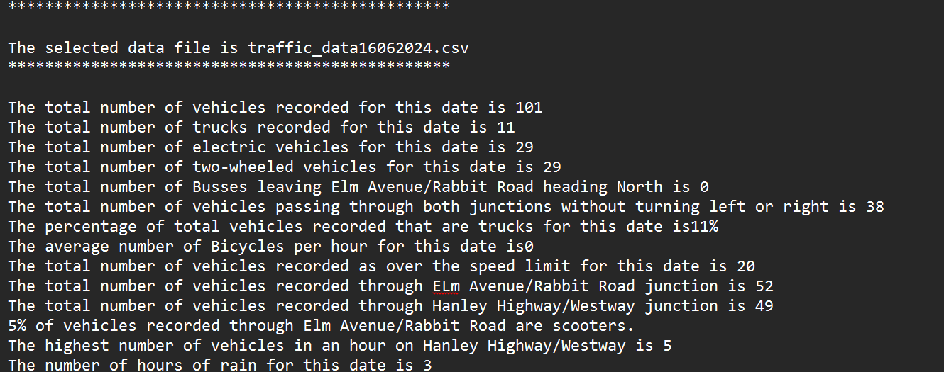

21/6/2024

