**NAME :**

**SANDESH GAJENDRA POL**

**COLLEGE NAME:**

**YASHWANTRAV CHAVAN POLYTECHNIC ICHALKARANJI**

**NAME OF SUBJECT :**

**ARTIFICIAL INTELLIGENCE**

**Artificial Intelligence**

• **What is Artificial Intelligence**

* AI is the ability of the machines or computer program To carry out tasks that requires human beings to use their intelligence

Artificial Intelligence is an approach to make a computer, a robot, or a product to think how smart human think. AI is a study of how human brain think, learn, decide and work, when it tries to solve problems. And finally this study outputs intelligent software systems.The aim of AI is to improve computer functions which are related to human knowledge, for example, reasoning, learning, and problem-solving.

The intelligence is intangible. It is composed of

* Reasoning
* Learning
* Problem Solving
* Perception
* Linguistic Intelligence

The objectives of AI research are reasoning, knowledge representation, planning, learning, natural language processing, realization, and ability to move and manipulate objects. There are long-term goals in the general intelligence sector.

Applications of AI

· Gaming − AI plays important role for machine to think of large number of possible positions based on deep knowledge in strategic games. for example, chess, river crossing, N-queens problems and etc.

· Natural Language Processing − Interact with the computer that understands natural language spoken by humans.

· Expert Systems − Machine or software provide explanation and advice to the users.

· Vision Systems − Systems understand, explain, and describe visual input on the computer.

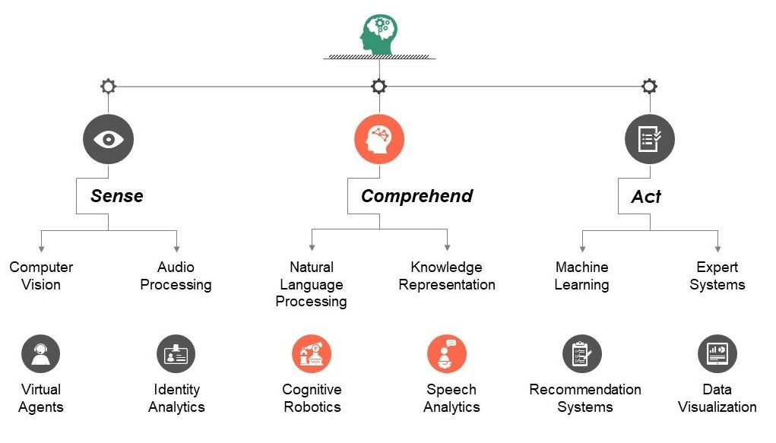

• **Rules and logic base approach**

The Google Glass operating system ([OS)](https://www.techtarget.com/whatis/definition/operating-system-OS) is based on a version of Android. The OS can run application virtualization tools called [Glassware](https://www.techtarget.com/searchvirtualdesktop/definition/Glassware-20) that are optimized for the device. Glassware allows the device to deliver an app to the user, instead of a full desktop. The

Glasses have built-in [Wi-](https://www.techtarget.com/searchmobilecomputing/definition/Wi-Fi)

[Fi](https://www.techtarget.com/searchmobilecomputing/definition/Wi-Fi) and [Bluetooth](https://www.techtarget.com/searchmobilecomputing/definition/Bluetooth) connectivity and a camera for taking photographs and videos.

The smart eyewear uses motion and [voice](https://www.techtarget.com/searchcustomerexperience/definition/voice-recognition-speaker-recognition)

[Recognition](https://www.techtarget.com/searchcustomerexperience/definition/voice-recognition-speaker-recognition) to process commands from the wearer. A touchpad is also available on the glasses' rim. To provide the requested information, the device relies on sending small packages of information straight to the wearer through a micro-projector, using a private

· Speech Recognition − There are some AI based speech recognition systems have ability to hear and express as sentences and understand their meanings while a person talks to it. For example Siri and Google assistant.

· Handwriting Recognition − The handwriting recognition software reads the text written on paper and recognize the shapes of the letters and convert it into editable text.

· Intelligent Robots − Robots are able to perform the instructions given by a human. 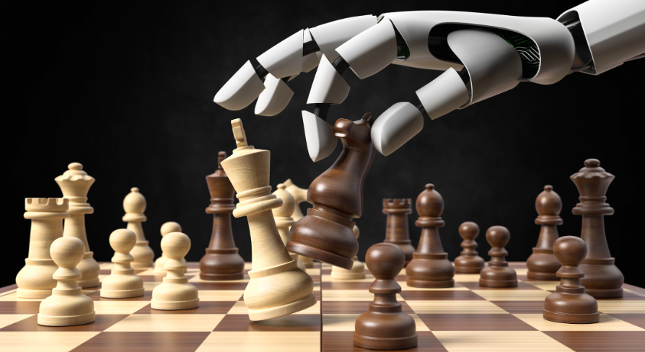

* **Applications**
* Stock market Prediction using machine learning
* Image classification
* Weather Forecasting
* AI Games

**Major Goals**

* Knowledge reasoning
* Planning
* Machine Learning
* Natural Language Processing
* Computer Vision
* Robotics
* **Scientist Prediction About AI**

A research paper warns that artificial intelligence is “likely” to kill the human race.  
Google and Oxford Scientists claim that AI will fight with humans for scarce resources on earth.  
Researchers say it’s almost inevitable that smart machines will win against humans.

* **Survey on Adoption of Emerging Technologies**

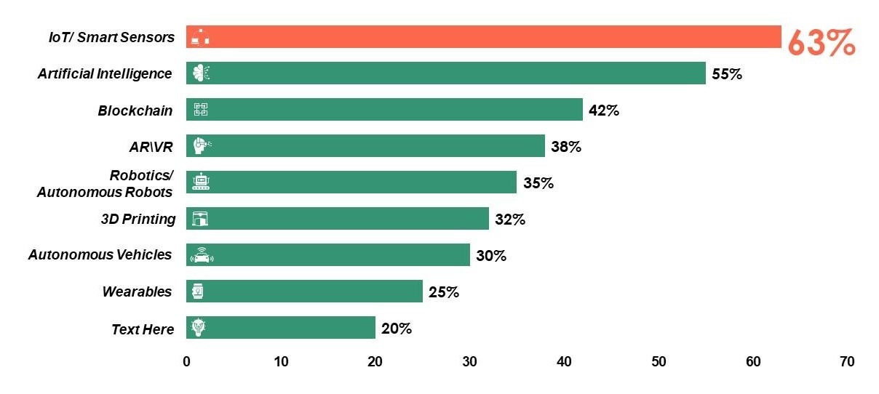

# Conclusion

* Artificial intelligence weapons
* AI is most dangerous Thing on earth
* There are many incidence that scientist reported that AI can destroy humanity
* In AI and field there is very good scope for career.

There are large scope in this field