Assignment submitted on 2023-08-02, 08:09 IST

***1 point***

What is the output of the following code?  
 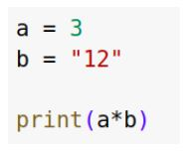

 36

 121212

 123

 Error: Invalid operation, unsupported operator ‘*’ used between ‘int’ and ‘str’

Yes, the answer is correct.  
Score: 1

Accepted Answers:

*121212*

***1 point***

What is the output of the following code?  
 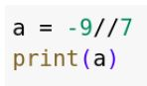

 -1

 -2

 -1.28

 1.28

Yes, the answer is correct.  
Score: 1

Accepted Answers:

*-2*

***1 point***

Consider a following code snippet. What is a data type of y�?  
 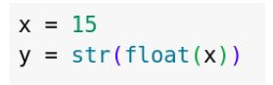

 int

 float

 str

 Code will throw an error.

Yes, the answer is correct.  
Score: 1

Accepted Answers:

*str*

***1 point***

Which of the following variable names are INVALID in Python?

 1_variable

 variable_1

 variable1

 variable#

Yes, the answer is correct.  
Score: 1

Accepted Answers:

*1_variable*

*variable#*

***1 point***

While naming the variable, use of any special character other than underscore(_) ill throw which type of error?

 Syntax error

 Key error

 Value error

 Index error

Yes, the answer is correct.  
Score: 1

Accepted Answers:

*Syntax error*

***1 point***

Let x = “Mayur”. Which of the following commands converts the ‘x’ to float datatype?

 str(float,x)

 x.float()

 float(x)

 Cannot convert a string to float data type

Yes, the answer is correct.  
Score: 1

Accepted Answers:

*Cannot convert a string to float data type*

***1 point***

Which Python library is commonly used for data wrangling and manipulation?

 Numpy

 Pandas

 scikit

 Math

Yes, the answer is correct.  
Score: 1

Accepted Answers:

*Pandas*

***1 point***

Predict the output of the following code.  
 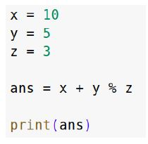

 12.0

 12

 11.667

 11

Yes, the answer is correct.  
Score: 1

Accepted Answers:

*12*

***1 point***

Given two variables, j = 6 and g = 3.3. If both normal division and floor division operators were used to divide j by g, what would be the data type of the value obtained from the operations?

 int, int

 float, float

 float, int

 int, float

Yes, the answer is correct.  
Score: 1

Accepted Answers:

*float, float*

***1 point***

Let a = 5 (101 in binary) and b = 3 (011 in binary). What is the result of the following operation?  
 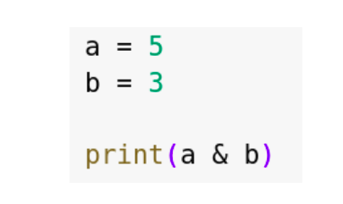

 3

 7

 5

 1

Yes, the answer is correct.  
Score: 1

Accepted Answers:

*1*