# Week 2: Assignment 2

**The due date for submitting this assignment has passed.**

**Due on 2023-08-09, 23:59 IST.**

### Assignment submitted on 2023-08-06, 23:13 IST

**1 point**

Which of the following object does not support indexing?

 tuple

 list

 dictionary

 set

### Yes, the answer is correct. Score: 1

### Accepted Answers:

*set*

**1 point**

Given a NumPy array, **arr = np.array([[[1, 2, 3], [4, 5, 6], [7, 8, 9]]])**, what is the output of the command, **print(arr[0][1])**?

 [[1 2 3]  
[4 5 6]  
[7 8 9]

 [1 2 3]

 [4 5 6]

 [7 8 9]

### Yes, the answer is correct. Score: 1

### Accepted Answers:

*[4 5 6]*

**1 point**

What is the output of the following code?  
  
 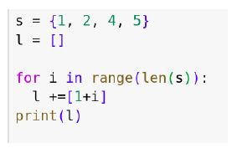

 [2, 3, 4, 5]

 [0 1 2 3]

 [1, 2, 3, 4]

 Will throw an error: Set objects are not iterable.

### Yes, the answer is correct. Score: 1

### Accepted Answers:

*[1, 2, 3, 4]*

**1 point**

What is the output of the following code?  
 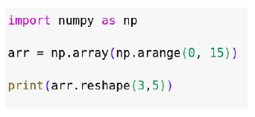

 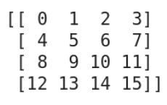

 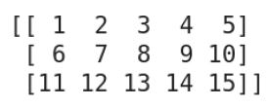

 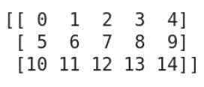

 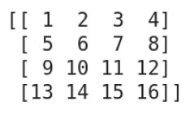

### Yes, the answer is correct. Score: 1

### Accepted Answers:

**

**1 point**

Which of the following code gives output **My friend’s house is in Chennai**?

 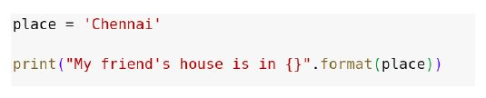

 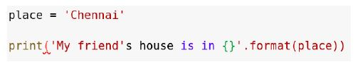

 https://storage.googleapis.com/swayam-node1-production.appspot.com/assets/img/noc23_cs99/a2q5c.JPG

 https://storage.googleapis.com/swayam-node1-production.appspot.com/assets/img/noc23_cs99/a2q5d.JPG

### Yes, the answer is correct. Score: 1

### Accepted Answers:

**

*https://storage.googleapis.com/swayam-node1-production.appspot.com/assets/img/noc23_cs99/a2q5d.JPG*

**1 point**

Let t1=(1,2,�1=(1,2, “tuple”,4)4) and t2=(5,6,7)�2=(5,6,7). Which of the following will not give any error after the execution?



t1.�1.append(5)(5)



x=t2[t1[1]]�=�2[�1[1]]



t3=t1+t2�3=�1+�2



t3=(t1,t2)�3=(�1,�2)



t3=(�3=(list(t1)(�1), list(t2))(�2))

### Yes, the answer is correct. Score: 1

### Accepted Answers:

x=t2[t1[1]]�=�2[�1[1]]

t3=t1+t2�3=�1+�2

t3=(t1,t2)�3=(�1,�2)

t3=(�3=(*list*(t1)(�1)*, list*(t2))(�2))

**1 point**

Let d={1:“Pyhton”,2:[1,2,3]}.�={1:“��ℎ���”,2:[1,2,3]}. Which among the following will not give the error after the execution?



d[2]�[2].append(4)(4)



x=d[0]�=�[0]



d[�[“one”]=1]=1



d.�.update({‘one’ : 22})

### Yes, the answer is correct. Score: 1

### Accepted Answers:

d[2]�[2]*.append*(4)(4)

d[�[*“one”*]=1]=1

d.�.*update({‘one’ :*22*})*

**1 point**

Which of the following data type is immutable?

 list

 set

 tuple

 dictionary

### Yes, the answer is correct. Score: 1

### Accepted Answers:

*tuple*

**1 point**

student = {‘name’: ‘Jane’, ‘age’: 25, ‘courses’: [‘Math’, ‘Statistics’]}  
Which among the following will return  
{‘name’: ‘Jane’, ‘age’: 26, ‘courses’: [‘Math’, ‘Statistics’], ‘phone’: ‘123-456’}?

 student.update({‘age’ : 26})

 student.update({‘age’ : 26, ‘phone’: ‘123-456’})

 student[‘phone’] = ‘123-456’  
student.update({‘age’ : 26})

 None of the above

### Yes, the answer is correct. Score: 1

### Accepted Answers:

*student.update({‘age’ : 26, ‘phone’: ‘123-456’})*

*student[‘phone’] = ‘123-456’  
student.update({‘age’ : 26})*

**1 point**

What is the output of the following code?  
 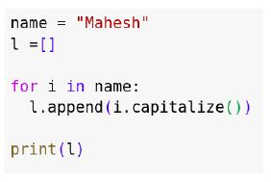

 **[‘M’, ‘A’, ‘H’, ‘E’, ‘S’, ‘H’]**

 **[‘m’, ‘a’, ‘h’, ‘e’, ‘s’, ‘h’]**

 **[‘M’, ‘a’, ‘h’, ‘e’, ‘s’, ‘h’]**

 **[‘m’, ‘A’, ‘H’, ‘E’, ‘S’, ‘H’]**

### Yes, the answer is correct. Score: 1

### Accepted Answers:

***[‘M’, ‘A’, ‘H’, ‘E’, ‘S’, ‘H’]***