# Week 3: Assignment 3

**Due date: 2023-08-16, 23:59 IST.**

**Your last recorded submission was on 2023-08-15, 19:15 IST**

**1 point**

Which of the following is the correct approach to fill missing values in case of categorical variable?

 Mean

 Median

 Mode

 None of the above

Assume a pandas dataframe df_cars which when printed is as shown below. Based on this information, answer questions 2 and 3.  
  
 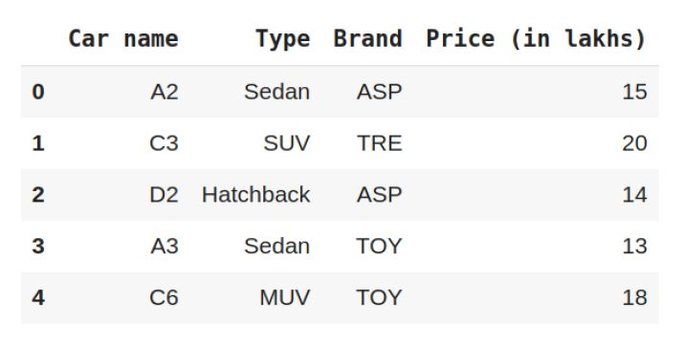

**1 point**

Of the following set of statements, which of them can be used to extract the column **Type**as a separate dataframe?

 df_cars[[‘Type’]]

 df_cars.iloc[[:, 1]

 df_cars.loc[:, [‘Type’]]

 None of the above

**1 point**

The method df_cars.describe() will give description of which of the following column?

 Car name

 Brand

 Price (in lakhs)

 All of the above

**1 point**

Which pandas function is used to stack the dataframes vertically?

 pd.merge()

 pd.concat()

 join()

 None of the above

**1 point**

Which of the following are libraries in Python?

 Pandas

 Matplotlib

 NumPy

 All of the above

Read the ‘[flavors_of_cocoa.csv](https://drive.google.com/file/d/1EB0OnTXy1R4JTz6HFXVLeX4Kzk8XBnNs/view?usp=sharing)’ file as a dataframe ‘df_cocoa’ and answer questions 6-9.  
The description of features/variables is given below:  
  
 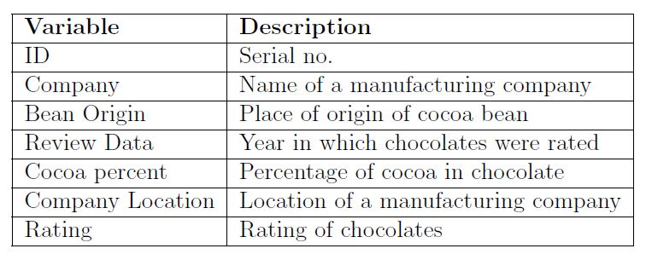

**1 point**

Which of the following variable have null values?

 ID

 Company

 Review Date

 Rating

**1 point**

Which of the following countries have maximum locations of cocoa manufacturing companies?

 U.K.

 U.S.A.

 Canada

 France

**1 point**

After checking the data summary, which feature requires a data conversion considering the data values held?

 Rating

 Review date

 Company

 Bean origin

**1 point**

What is the maximum rating of chocolates?

 1.00

 5.00

 3.18

 4.00

**1 point**

What will be the output of the following code?  
 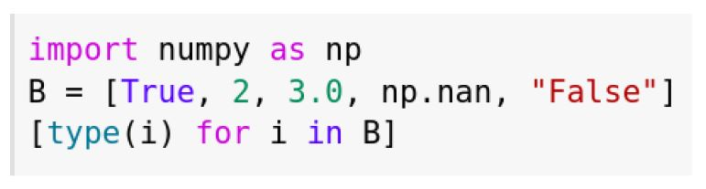

 [bool, int, float, float, str]

 [str, int, float, float, str]

 [bool, int, float, int, str]

 [bool, int, int, float, str]