|  |
| --- |
|  |
| SANDESH |
| Android app to help deaf and dumb |

|  |
| --- |
| Navya,Pavitra,Savita,Swati,Sindhu,Shalini  11/11/2014 |

About

An android application to which converts either of the two - voice input and/or keypad input into signs. Built to help the deaf and dumb communicate and the non-impaired to comprehend what the signs would mean; this app bases its interpretation on the American Sign Language (ASL).

There are situations where we would encounter deaf and dumb people in our daily life and will not be aware of how to communicate with them, this app not only converts voice to text and text to signs but also provides a brief overview on the commonly used signs.

Motivation

While choosing something which would help the society, after oscillating between many ideas, we zeroed in on ‘Sandesh’; an application which would enable the hearing and speech impaired to communicate with the rest of the world and vice versa.

How did this idea take birth?

Since there are very minimal applications available which would serve the purpose of helping the hearing and speech impaired communicate, our intention was to build an app which would both ways effortlessly.

DESIGN

Development Platform:

Android 4.3 – JellyBean

Eclipse IDE

Why Android?

We aimed to make a mobile application. Android is open source and there are several non expensive cell phones available which use Android OS.

Application Features:

1. Voice recognition: what the user speaks is converted to texts and the corresponding text can be viewed in the edit box and can be edited if need be.
2. Search: Users can search for the relevant signs in ASL for the sentences or words by clicking on search option
3. Display: Relevant images will be displayed in the screen for the user
4. Replay: Replay option is provided for the user to play the signd again incase if the user has missed
5. Additional info: ASL alphabets, numbers and frequently used words are listed out separately for the user to understand and interpret better.

Screenshots:Home page

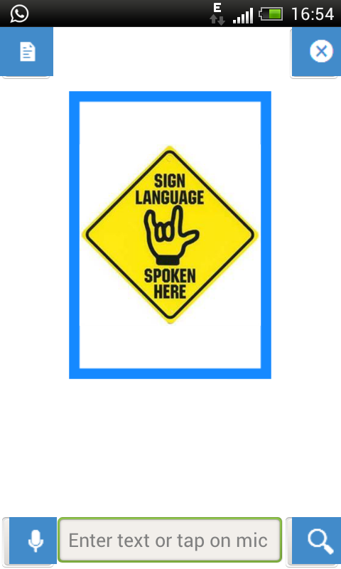

Voice Recognition:

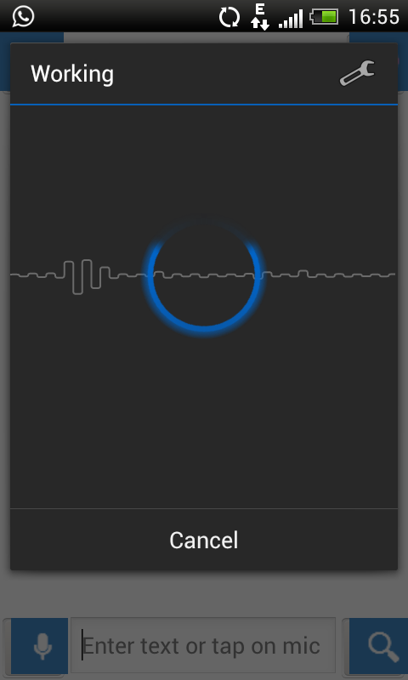

Display

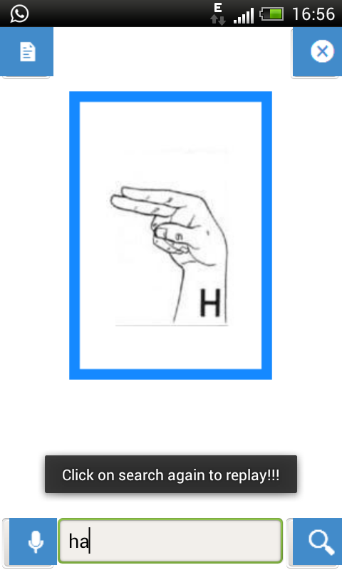

Replay

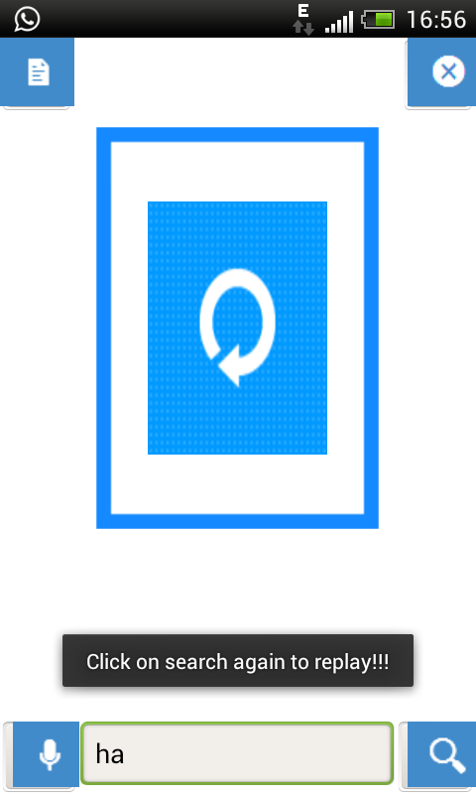

User options:

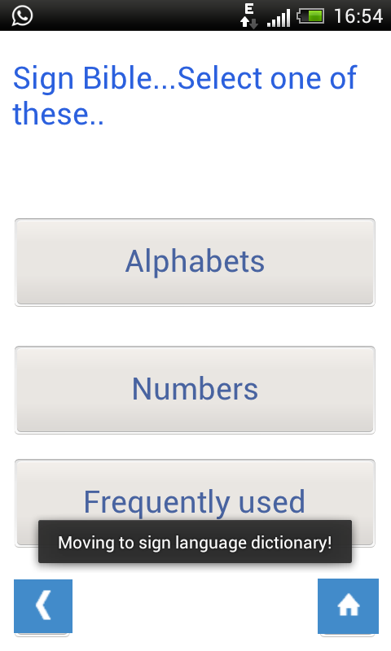

Alphabet list

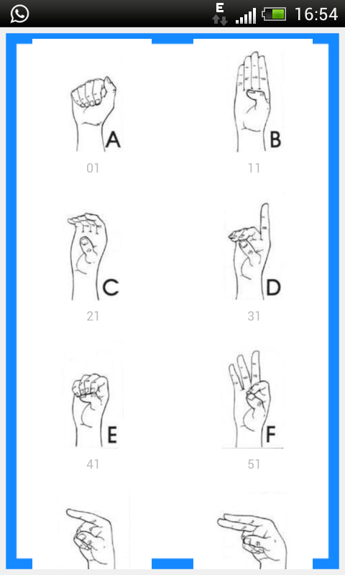

Numbers:

