React Native Assignment Submission Report

Candidate | Sandesh Pawar
Position | React Native Developer
Time Taken to Complete | ~6 hours
Date | ________________
Project | Restaurant Order Management App

1. Project Overview
The Restaurant Order Management App is a cross-platform mobile application built with
Expo SDK 54, React Native 0.81, React 19, and TypeScript. The application serves as an order management dashboard for restaurant staff to view, search, filter, and update the status of customer orders in real time. The app ships with 15 sample orders covering three status states — Pending, In Progress, and Completed — and persists all order data locally using AsyncStorage so that status updates survive app restarts.

2. Assignment Requirements Covered
- ☑ Login Screen
- ☑ Orders List (12+ Orders)
- ☑ Search
- ☑ Status Filter
- ☑ Order Details
- ☑ Update Order Status
- ☑ Local Persistence (AsyncStorage)
- ☑ TypeScript

3. Tech Stack
The following technologies and libraries were used to build the application:

Technology | Version | Purpose
React Native | 0.81.5 | Core framework for building native mobile UI
Expo | ~54.0.35 | Development platform and toolchain
TypeScript | ~5.9.2 | Static type checking and typed interfaces/enums
React Navigation | ^7.3.14 / ^7.18.6 | Native Stack navigation with typed routes
React Context API | Built-in | Feature-scoped state management for orders
AsyncStorage | 2.2.0 | Local data persistence layer
React Native Toast Message | ^2.4.0 | In-app success/error notifications
@expo/vector-icons | ^15.1.1 | Material Design icons throughout the UI
React Native Gesture Handler | ~2.28.0 | Touch handling and Pressable feedback
React Native Safe Area Context | ~5.6.0 | Safe-area aware layouts
EAS Build | >= 20.1.0 | Android APK release builds

4. Project Architecture
The project follows a feature-based modular architecture that separates concerns by domain. Each feature (auth, orders) is self-contained with its own screens, components, hooks, types, services, and data. Cross-cutting concerns such as navigation and shared UI (Toast) live at the top level of src/.

Folder structure:

src/
├── components/
│ └── Toast.tsx # Custom toast configuration
├── features/
│ ├── auth/
│ │ ├── constants/credentials.ts # Demo login credentials
│ │ └── screens/LoginScreen.tsx # Login UI with validation
│ └── orders/
│ ├── components/
│ │ ├── OrderCard.tsx # Reusable order list item
│ │ ├── SearchBar.tsx # Search input component
│ │ ├── StatusBadge.tsx # Status pill badge
│ │ └── StatusFilter.tsx # Filter chip group
│ ├── context/orderContext.tsx # React Context provider
│ ├── data/dummydata.json # 15 mock orders
│ ├── hooks/useOrder.ts # Custom hook wrapper
│ ├── screens/
│ │ ├── OrdersScreen.tsx # Orders list + search/filter
│ │ └── OrdersDetailsScreen.tsx # Order detail + status update
│ ├── services/orderService.ts # AsyncStorage CRUD layer
│ └── types/order.ts # TypeScript interfaces & enums
├── navigation/
│ ├── AppNavigator.tsx # Native Stack navigator
│ └── types/types.ts # Typed route params
└── App.tsx # Root component + providers

State Management Flow: The orders state is managed through a feature-scoped React Context. The OrdersProvider wraps the app root in App.tsx, and the custom useOrders() hook exposes the context to screens. Data flows:

OrdersScreen / OrdersDetailsScreen
↓ useOrders()
↓ OrdersContext (React Context API)
↓ orderService.ts (loadOrders / saveOrders)
↓ AsyncStorage (@restaurant_orders)

Navigation Flow: Login → (on success, replaces stack) → Orders → (tap card) → OrderDetails

5. Features Implemented

Login Screen
Located at src/features/auth/screens/LoginScreen.tsx. The login screen presents a branded card with a chef-hat logo, email and password inputs (with a show/hide password toggle), and a Sign In button. Credentials are validated against hardcoded demo values (owner@dummy.com / password123) defined in src/features/auth/constants/credentials.ts. On success, navigation.replace('Orders') replaces the login route so the user cannot navigate back to the login screen. Invalid credentials trigger an Alert. The layout uses KeyboardAvoidingView with platform-specific behavior to handle keyboard overlap.
Location: src/features/auth/screens/LoginScreen.tsx

Orders List (15 Orders)
Located at src/features/orders/screens/OrdersScreen.tsx. The Orders screen fetches all orders via the useOrders() hook and renders them in a FlatList. Each order is displayed as an OrderCard showing the order ID, customer name, total amount, item count, date, and a status badge. A loading state shows a branded spinner while data is being loaded from AsyncStorage. An empty state is shown when no orders match the current search or filter. Tapping a card navigates to the OrderDetails screen with the order ID as a route parameter.
Location: src/features/orders/screens/OrdersScreen.tsx

Search
Implemented as a reusable SearchBar component (src/features/orders/components/SearchBar.tsx) with a magnifying-glass icon and clear button. The search filters orders in real-time by customer name and order ID using a case-insensitive substring match. The filtering logic is memoized with useMemo in OrdersScreen to avoid unnecessary re-computation on every render.
Location: src/features/orders/components/SearchBar.tsx

Status Filter
Implemented as a reusable StatusFilter component (src/features/orders/components/StatusFilter.tsx) with four filter chips: All, Pending, In Progress, and Completed. The selected chip is highlighted with a purple background. Filtering is combined with search in a single memoized filter function, so both criteria are applied simultaneously.
Location: src/features/orders/components/StatusFilter.tsx

Order Details
Located at src/features/orders/screens/OrdersDetailsScreen.tsx. The details screen receives an orderId route parameter and looks up the order via getOrderById() from the context. It displays a summary card (order ID, status badge, customer name, date, item count, total), a FlatList of all order items with individual line totals, and a grand total at the bottom. A back button in the header returns to the Orders list. If the order is not found, a fallback message is shown.
Location: src/features/orders/screens/OrdersDetailsScreen.tsx

Update Order Status
Implemented in the OrderDetails screen. A 'Mark as ...' button is shown when the order status is not yet Completed. It follows a linear progression: Pending → In Progress → Completed. The updateOrderStatus function in orderContext.tsx maps the current status to the next status, updates the in-memory state, and persists the change to AsyncStorage. A success toast notification confirms the update. The button shows an inline ActivityIndicator while the update is in progress.
Location: src/features/orders/context/orderContext.tsx:52

Local Persistence (AsyncStorage)
Implemented in src/features/orders/services/orderService.ts. On first launch, the app loads orders from AsyncStorage; if no data exists, it seeds the store with dummydata.json and saves it. Every status update triggers saveOrders(), which serializes the updated orders array to JSON and writes it to AsyncStorage under the key @restaurant_orders. A resetOrders() utility is also provided for development.
Location: src/features/orders/services/orderService.ts

TypeScript
The entire codebase is written in TypeScript. Key typed artifacts include: the Order and OrderItem interfaces (src/features/orders/types/order.ts), the OrderStatus enum with Pending/InProgress/Completed values, the RootStackParamList type for typed navigation routes (src/navigation/types/types.ts), and typed props on every component and hook. The project uses TypeScript ~5.9.2.
Location: src/features/orders/types/order.ts

6. Data Flow
Navigation and State Flow

Navigation Flow: The app defines a single Native Stack navigator (src/navigation/AppNavigator.tsx) with three screens: Login (initial route), Orders, and OrderDetails. When the user successfully logs in, navigation.replace('Orders') replaces the Login route, preventing back navigation to the login screen. From the Orders list, tapping an OrderCard calls navigation.navigate('OrderDetails', { orderId: item.id }), passing the order ID as a typed route parameter. The OrderDetails screen reads this parameter from route.params. The navigator uses slide_from_right animation and hides the default header (headerShown: false), with custom headers implemented in each screen.

State Flow: Order data is managed through a feature-scoped React Context. The OrdersProvider (src/features/orders/context/orderContext.tsx) is mounted at the root of App.tsx, making the orders state available to all child screens. On mount, the provider calls initializeOrders(), which invokes loadOrders() from orderService.ts. This function first checks AsyncStorage for a persisted @restaurant_orders key; if found, it parses and returns the stored JSON. If not found, it seeds AsyncStorage with the 15 orders from dummydata.json and returns that data. The context exposes three values: orders (the array), loading (a boolean for the initial fetch), getOrderById (a memoized lookup function), and updateOrderStatus (an async function that advances an order's status and persists the change). The useOrders() custom hook (src/features/orders/hooks/useOrder.ts) is a thin wrapper around useContext that provides a clean API to consuming components.

Persistence Flow: All order state changes are persisted to AsyncStorage immediately. When updateOrderStatus is called, it maps over the orders array, advances the matching order's status (Pending → In Progress → Completed), calls setOrders to update React state, and then calls saveOrders() which serializes the array to JSON and writes it to AsyncStorage. On the next app launch, loadOrders() reads from AsyncStorage first, ensuring status changes survive restarts.

7. Challenges & Solutions
- AsyncStorage seeding on first launch
Problem: On first launch, AsyncStorage is empty, so the app needs to populate it with initial data. Solution: loadOrders() checks if stored data exists; if not, it seeds AsyncStorage with dummydata.json and returns the data. This ensures subsequent launches read from local storage.
Location: src/features/orders/services/orderService.ts:9
- Status progression logic
Problem: Orders should only advance forward through the status lifecycle (Pending → In Progress → Completed) and should not regress. Solution: The updateOrderStatus function in orderContext.tsx uses a switch statement to map each current status to its next state, and the OrderDetails screen only shows the update button when the status is not Completed.
Location: src/features/orders/context/orderContext.tsx:52
- Combining search and filter without performance issues
Problem: Filtering and searching must work together efficiently without re-computing on every keystroke. Solution: Both search text and selected status are combined into a single useMemo call in OrdersScreen, so the filtered list is only recomputed when orders, searchText, or selectedStatus changes.
Location: src/features/orders/screens/OrdersScreen.tsx:32
- Typed navigation with route parameters
Problem: Passing orderId from the Orders list to the OrderDetails screen requires type safety. Solution: The RootStackParamList in src/navigation/types/types.ts defines OrderDetails as { orderId: string }, and NativeStackScreenProps provides type-safe access to route.params in the screen component.
Location: src/navigation/types/types.ts
- Loading and empty states
Problem: The app needs to handle async data loading gracefully and show a meaningful message when no orders match the current filters. Solution: OrdersScreen shows a branded loading spinner while loading is true, and FlatList's ListEmptyComponent renders a 'No orders found' message with a suggestion to adjust search or filters.
Location: src/features/orders/screens/OrdersScreen.tsx:45
- Callback memoization in Context
Problem: Passing new function instances in the context value on every render would cause unnecessary re-renders of consumer components. Solution: getOrderById and updateOrderStatus are wrapped in useCallback with proper dependency arrays, and the context value is memoized with useMemo.
Location: src/features/orders/context/orderContext.tsx:45

8. AI Usage
The following AI tools were used during development:

- ChatGPT (OpenAI)
- Used for high-level architecture planning, navigation and state management strategy discussions, code generation and refinement for login screen, orders context, AsyncStorage service, screens, and reusable components, and technical guidance on React Context API, AsyncStorage integration, React Navigation setup, TypeScript typing, and component organization.
- GitHub Copilot
- Used as an inline coding assistant for generating boilerplate code, suggesting TypeScript type definitions, and providing real-time code completions during development.

Developer Responsibility: All AI-generated code was reviewed, integrated, tested, and modified as needed by the candidate before inclusion in the final submission. The candidate retains full responsibility for the correctness and quality of the final codebase.

9. Screenshots

Login Screen
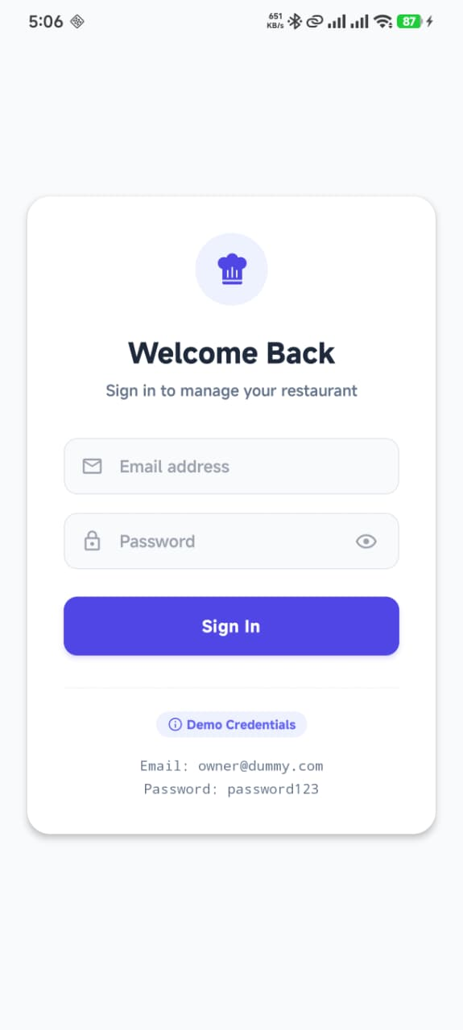

Orders List
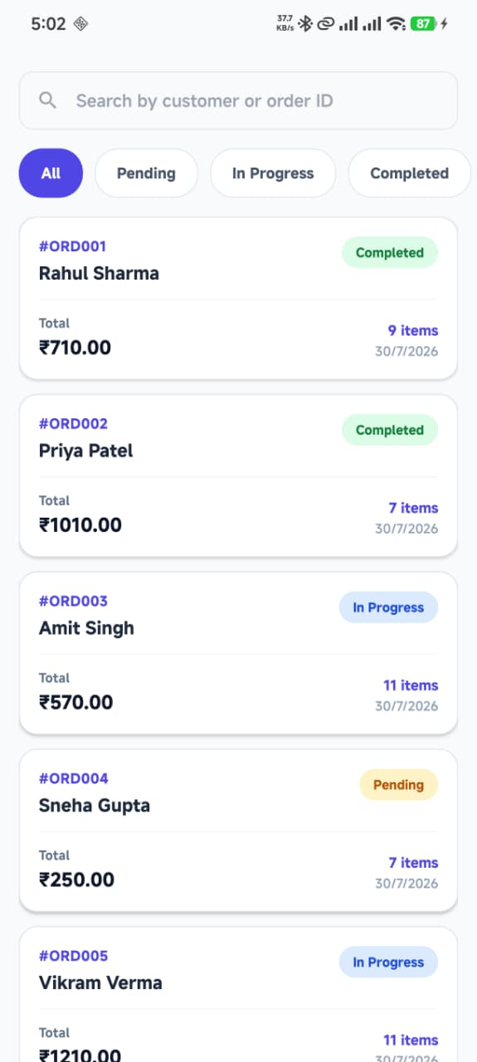

Order Details
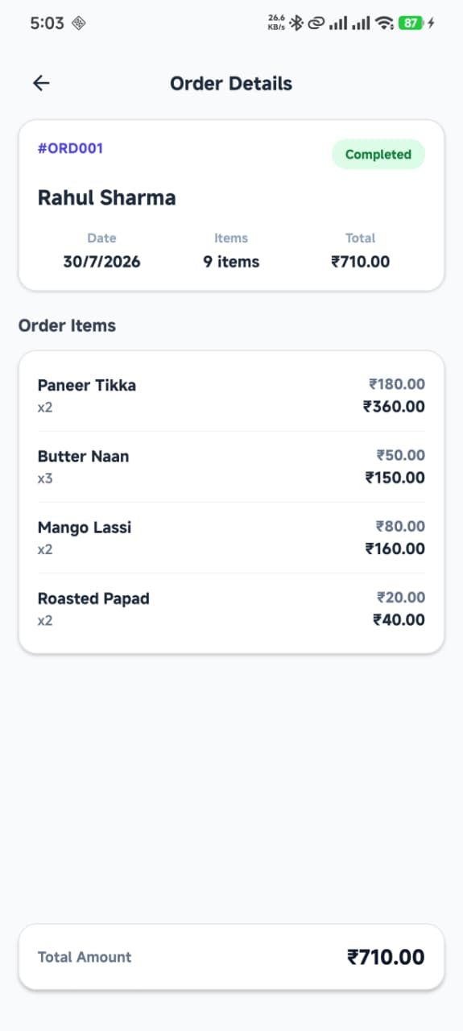

Order Details with Toast
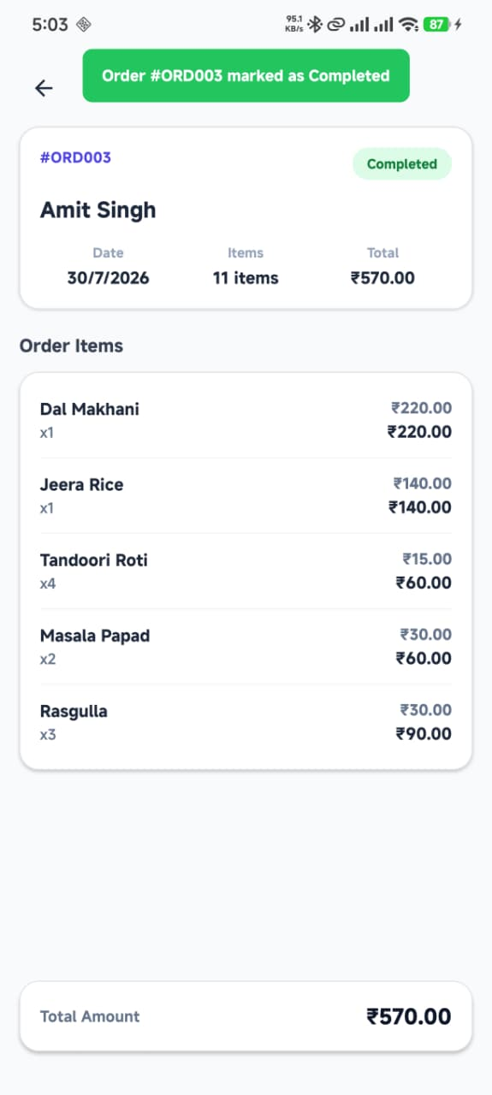

Pending Orders Filter
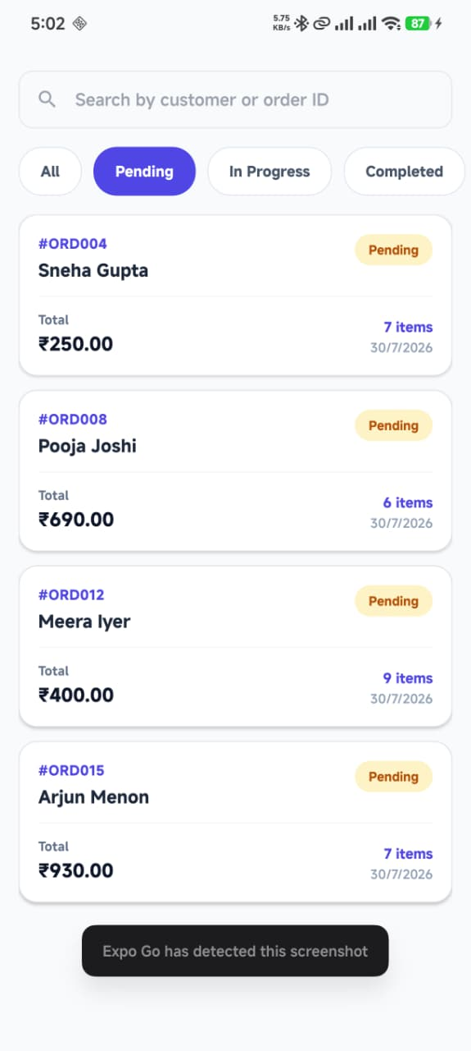

In Progress Filter
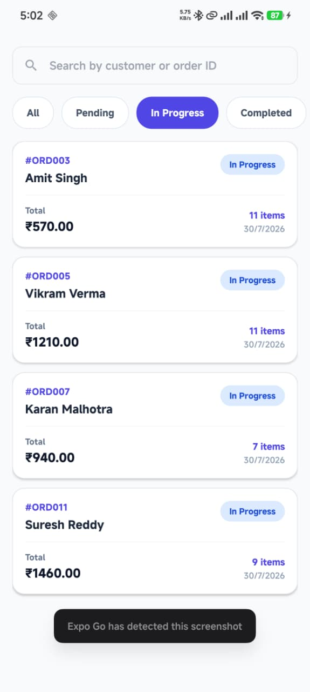

Completed Orders Filter
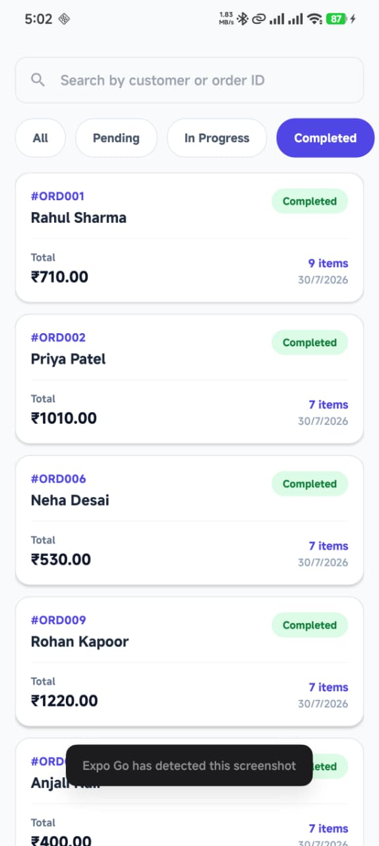

10. GitHub Repository & APK
Repository: https://github.com/Sandesh4141/Restaurant-solution

APK Release: https://github.com/Sandesh4141/Restaurant-solution/releases

Build Configuration: The project uses EAS Build (eas.json) with a dedicated 'release' profile configured for Android APK builds. The development and preview profiles support internal distribution, and the production profile uses autoIncrement for version management.

11. Conclusion
The Restaurant Order Management App successfully implements all assignment requirements: a secure login screen, a searchable and filterable orders list with 15 sample orders, detailed order views, and a status update workflow with local persistence. The project demonstrates a clean feature-based architecture, proper TypeScript typing throughout, and a well-structured state management approach using React Context and AsyncStorage. Key learnings include the importance of memoizing context values to prevent unnecessary re-renders, combining search and filter logic in a single useMemo for performance, and handling AsyncStorage seeding for first-launch scenarios. The app is production-ready with EAS Build configured for APK releases.

