Output:

15. Write SQL query to change default value of address to Kathmandu.

Query:

Output:

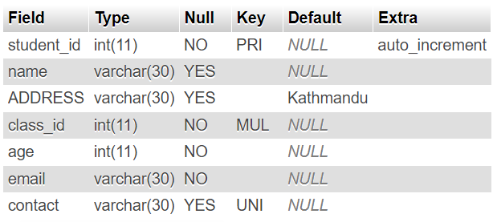

16. Insert five set of records in above table.

Query:

Output:

17. Write SQL query to update name and address of student whose student id is 5.

Query:

Output:

18. Write SQL query to delete all the records of student having age greater than 20.

Query:

Output:

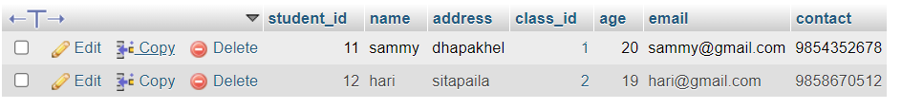

19. Write SQL query to update age of student having address ktm.

Query:

Output:

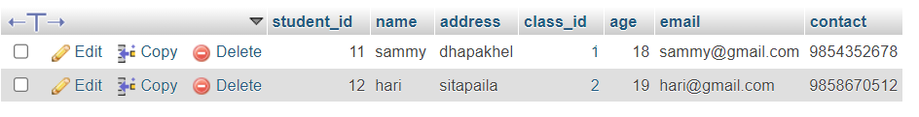

20. Write SQL query to delete all records of student having student id 1.

Query:

Output:

