1. Write SQL query to select all records of student.

**Query:**

**Output:**



1. Write SQL query to select all records of student having student id 3.

**Query:**

**Output:**



1. Write SQL query to select name and address of students whose age is greater than 21

**Query:**

**Output:**



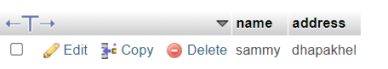

24. Write SQL query to select student id and name of students whose address in

Birtamode.

**Query:**

**Output:**

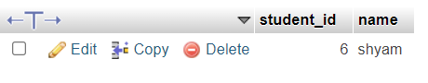

25. Write SQL query to select records of students whose class id is 5 and address is

Kathmandu.

**Query:**

**Output:**

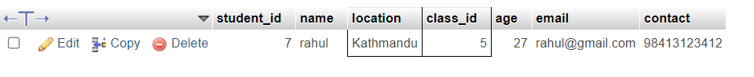

1. Write SQL query to select maximum age from above table.

**Query:**

**Output:**

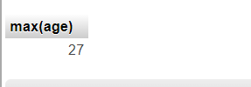

1. Write SQL query to select minimum age of students whose address is Birtamode.

**Query:**

**Output:**

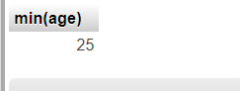

28. Write SQL query to find total number of students having class id 5 and age greater

than 19.

**Query:**

**Output:**

29. Write SQL query to find average age of students whose class id is 4 and section is B.

**Query:**

**Output:**

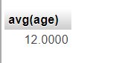

1. Write SQL query to select students whose address starts with letter ‘B’.

**Query:**

**Output:**

