**\*\* EXERCISE-1_MYSQL-PL \*\***

**Q1. Write a program that computes the perimeter and the area of a rectangle. Define your own values for the length and width. (Assuming that L and W are the length and width of the rectangle, Perimeter = 2*(L+W) and Area = L*W.**

**Ans -> create table rectangle(perimeter float,area float);**

**delimiter //**

**create procedure ab(L float,W float)**

**begin**

**declare perimeter float;**

**declare area float;**

**set perimeter = 2*(L+W);**

**set area = L*W;**

**insert into rectangle values(perimeter,area);**

**end //**

**delimiter ;**

**call ab(10,15);**

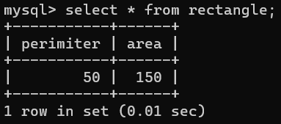

**Q2. Write a program that declares an integer variable called num, assigns a value to it, and computes and inserts into the tempp table the value of the variable itself, its square, and its cube.**

**Ans 🡪 create table math(square int,`cube` int);**

**delimiter //**

**create procedure abc(num int)**

**begin**

**declare square float;**

**declare `cube` float;**

**set square = num*num;**

**set `cube` = num*num*num;**

**insert into math values(square,`cube`);**

**end //**

**delimiter ;**

**call ab(10);**

**\*\*comment --- This is Grave Accent (`) we gave to cube because cube is reserved keyword that’s why to not show the error we use this sign.**

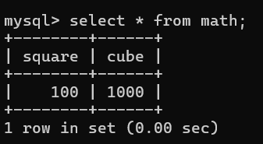

**Q3.** **Convert a temperature in Fahrenheit (F) to its equivalent in Celsius (C) and vice versa. The required formulae are:- C= (F-32)*5/9 F= 9/5*C + 32.**

**Ans 🡪 create table temp (Fahrenheit float,Celsius float);**

**delimiter //**

**create procedure bc(F float,C float)**

**begin**

**set F = 9/5*C+32;**

**set C = (F-32)*5/9;**

**insert into temp values(F,C);**

**end //**

**delimiter ;**

**call bc(95,35);**

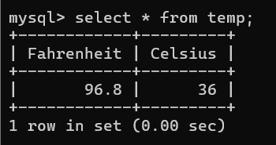

**Q.5 Write a program that enables a user to input an integer. The program should then state whether the integer is evenly divisible by 5.**

**Ans 🡪 create table divi ( value int, msg varchar(100));**

**delimiter //**

**create procedure acc(i int)**

**begin**

**declare msg varchar(50);**

**if**

**i % 5 = 0 then**

**set msg = concat(i,'is divisible by 5');**

**else**

**set msg = concat(i,'is not divisible by 5');**

**end if;**

**insert into divi values(i,msg);**

**end //**

**delimiter ;**

**call acc(35);**

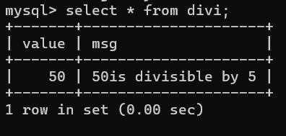

**Q.6 Your block should read in two real numbers and tell whether the product of the two numbers is equal to or greater than 100.**

**Ans 🡪 create table rn**

**(product int,msg varchar(50));**

**delimiter //**

**create procedure realnum(n1 int,n2 int)**

**begin**

**declare product int;**

**set product =n1*n2;**

**if product >= 100 then**

**insert into rn values(product,'is greater then or equal tp 100');**

**else**

**insert into rn values(product,'is not greater then or equal tp 100');**

**end if;**

**end //**

**delimiter ;**

**call realnum(32,34);**

