**SQL_Assignment_2**

**Q.1) Which field of the Customers table is the primary key?**

**---> CNUM is the Customers table primary key.**

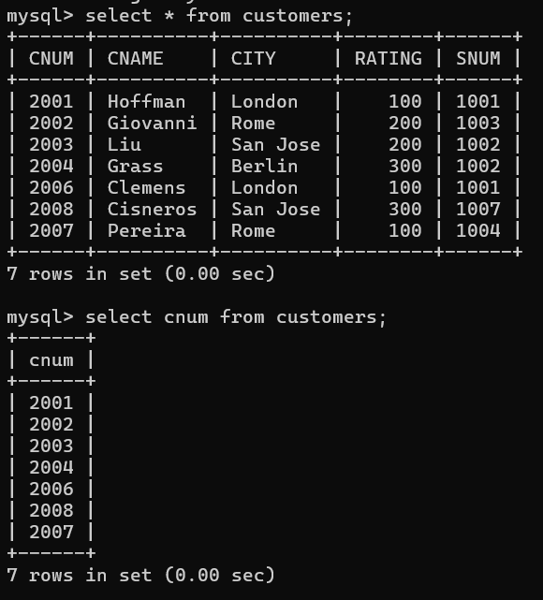

**Q. 2) What is the 4th column of the Customers table?**

**--->Rating is the 4th column of the Customers table.**

**Q.** **3) What is another word for row? For column?**

**--->Another word for row is Record and another word for column Field.**

**Q.** **4) Why isn’t it possible to see the first five rows of a table?**

**--->**