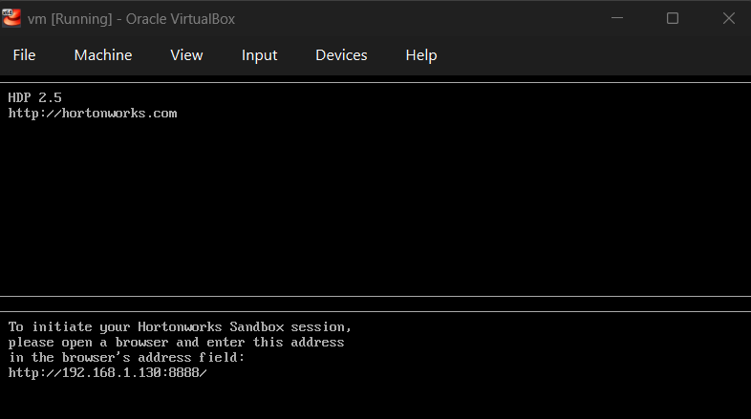
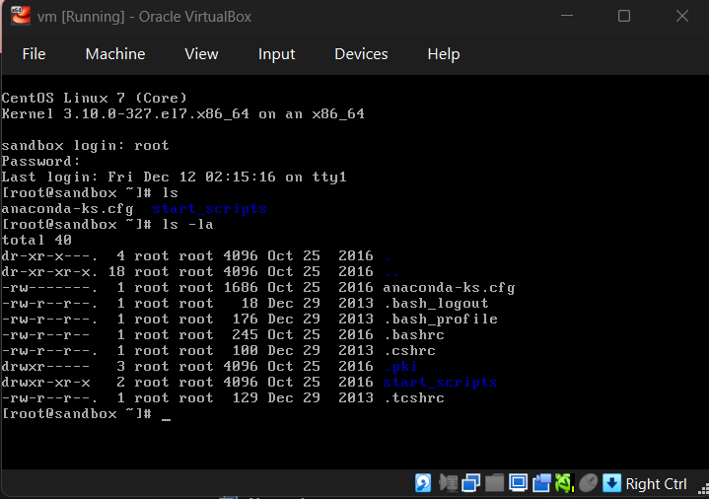

http://192.168.1.130:8080/#/login:
Username: maria_dev
Password: maria_dev
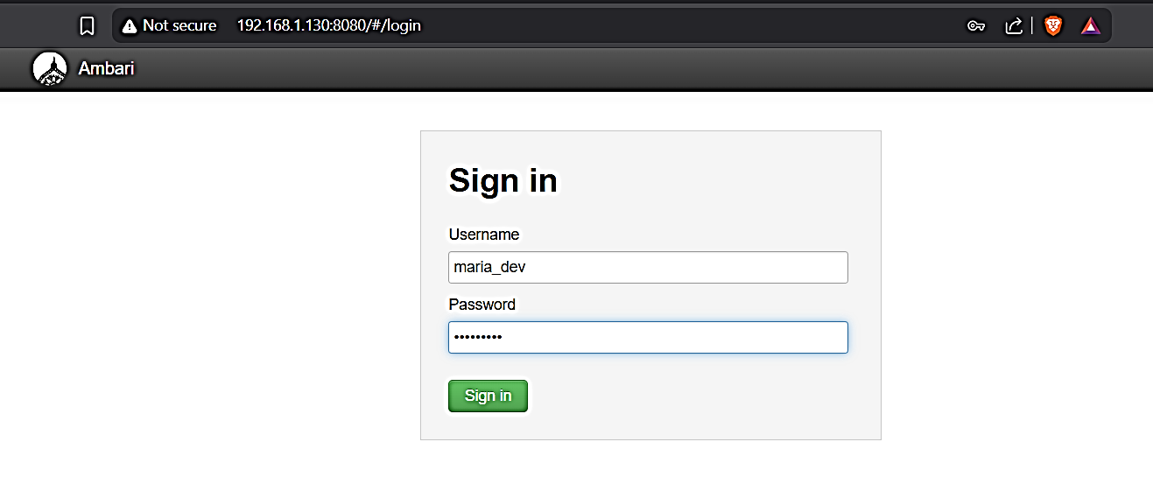

Ambari interface:
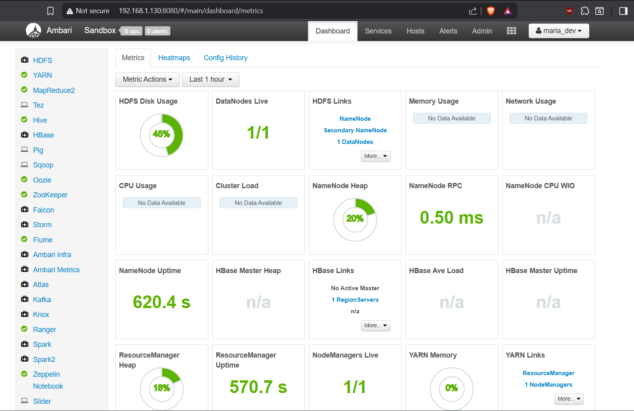

Under ambari:
- Load dataset
  - Dashboard: hdfs
  - Top: files view
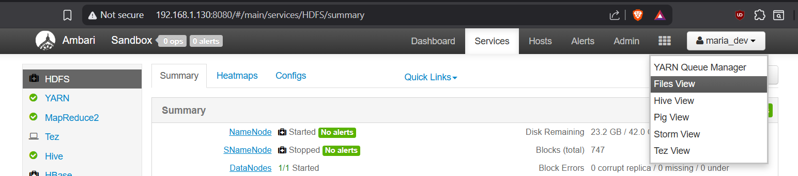
  - Go to user tab/folder > maria_Dev
  - There are files-view and hive, we need to upload data provided
  - Via: new folder option on top > name: ml_100k> u.data > download
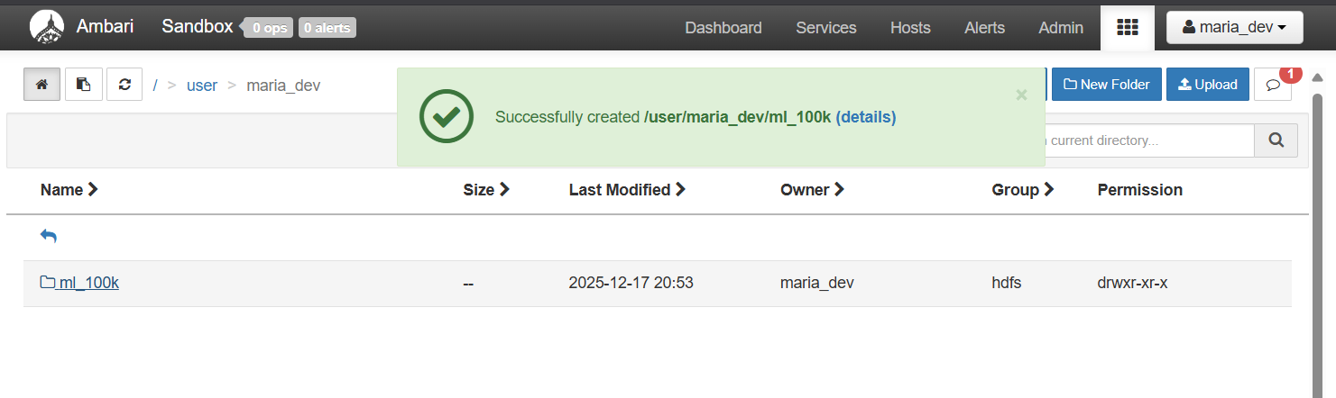
  - Another file > u.item
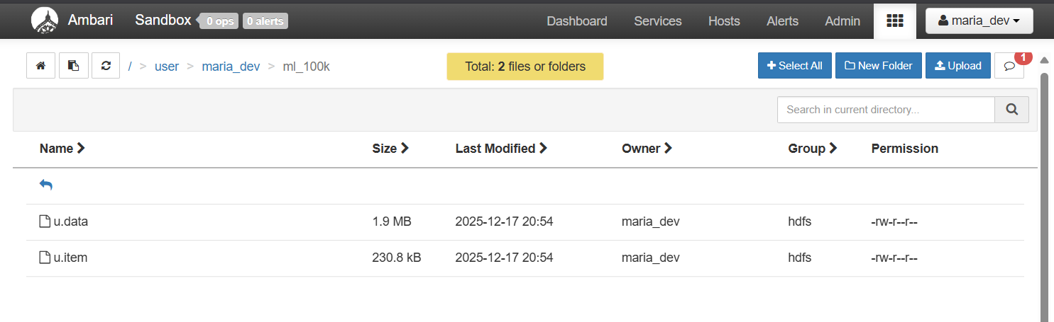
  - Ctrl select > concatenate to merge these
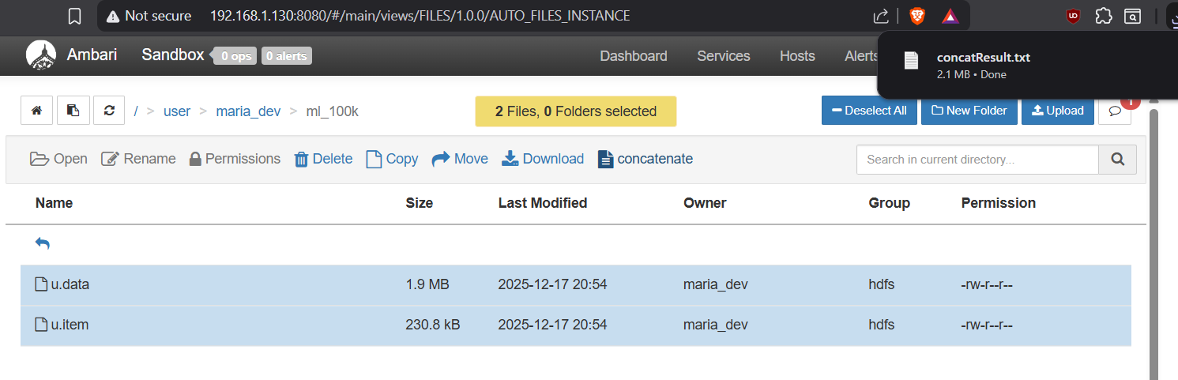
- Go to hive
  - Hive view
  - Upload a table
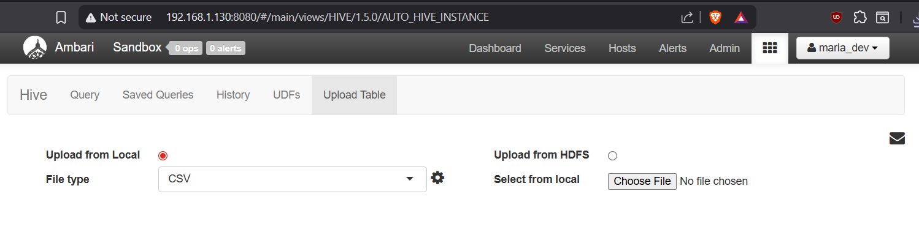
  - File type: csv side gear
  - Separate by tab
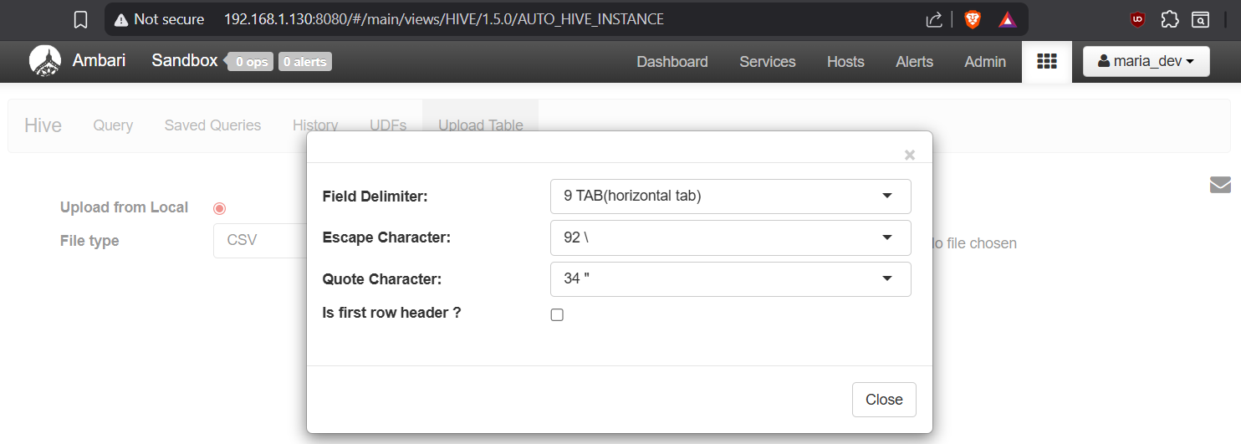

  - Create database:
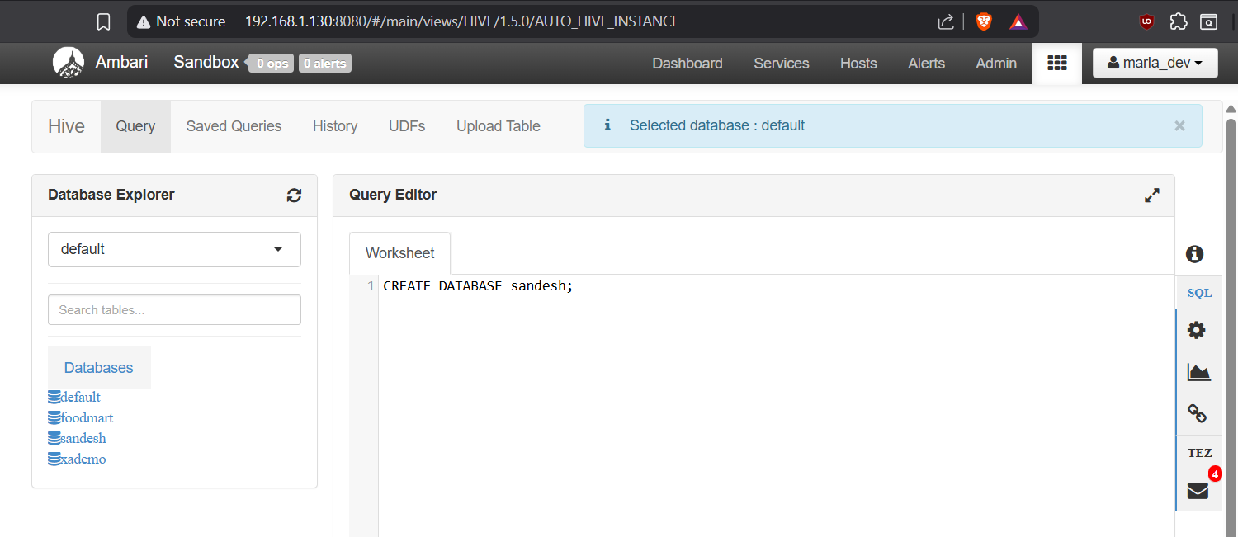
  - Select from locatl(u.data)
  - Table name: user_rating
  - Column, name it : user_id, movie_id, rating, data_time_stamp
  - Click upload table (if error change time stamp to string)
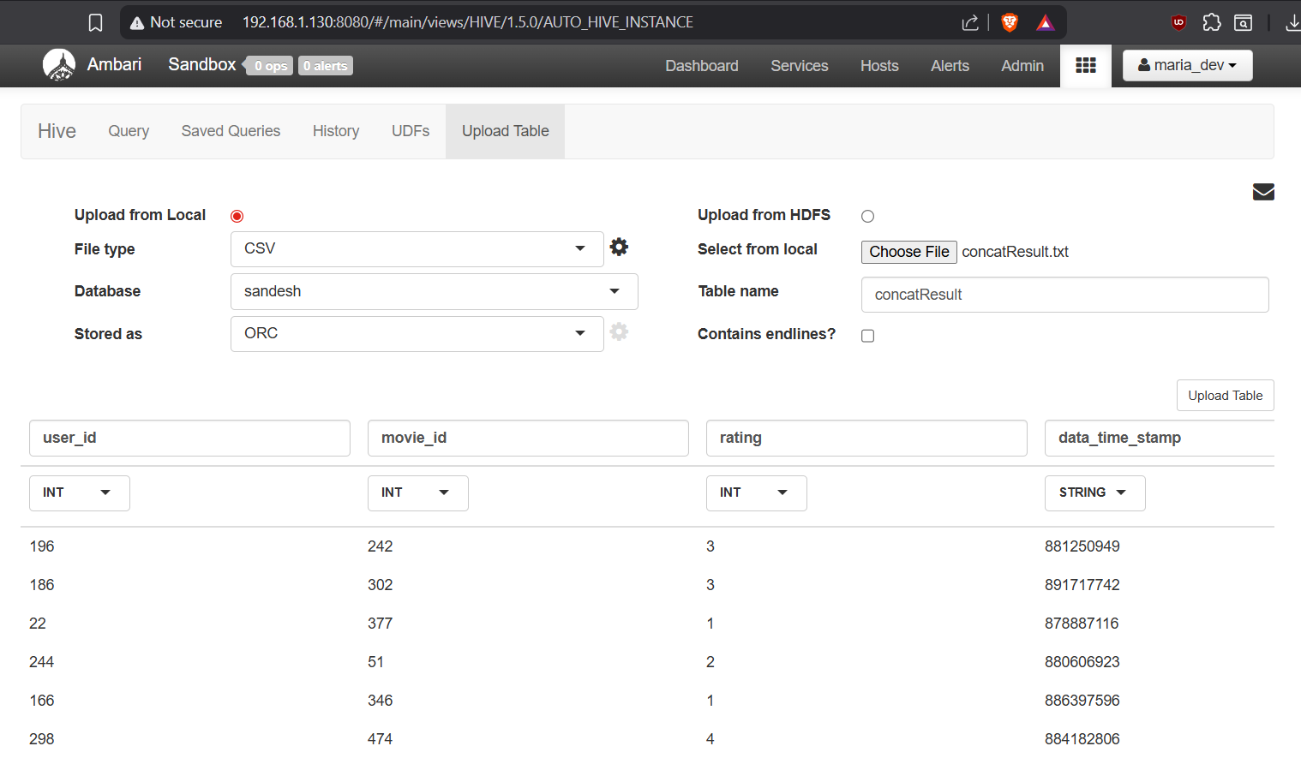

- Go to query
  - Select * from my_user_ratings2 where user_id = 279;
