**Dual Fuel Engine Technologies using Biofuels**

**Name- Sandesh Narayan**

**Department of Mechanical Engineering**

**Indian Institute of Technology Kanpur, Kanpur –208016, India**

**Abstract**

At the present time, environmental concerns are something that we no longer can ignore. And a major part of it is contributed by the automobile sector. We need ways to reduce emission of greenhouse gases to reduce effects of climate change. And we also need to move on from non-renewable fuels. But still asking everyone to completely replace their cars to new ones will be an act of tyranny. So, we need to find an alternative to conventional fuels which is renewable and can work with existing engines with slight modifications. This paper reviews dual fuel engine technologies using biofuels. Dual fuel engine technology using biodiesel as primary fuel is a promising alternative for rfossil fuels and reducing environmental emissions. This paper explores the principles, applications, challenges, and potential of dual fuel engines using biodiesel.

It highlights the growing interest in dual fuel engine technology as a sustainable alternative to conventional diesel engines. Studies have investigated various aspects of dual fuel combustion, including combustion mechanisms, emission characteristics, and engine performance. While biodiesel offers environmental benefits such as reduced greenhouse gas emissions and renewable feedstock availability, challenges remain in optimizing combustion efficiency, addressing cold-start issues, and ensuring compatibility with engine materials and lubricants.

**Contents**

1. Introduction to dual fuel engines
   1. Definition and overview
   2. Working
   3. Advantages
   4. Applications
2. Biofuels as alternative fuels
   1. Types of biofuels
   2. Advantages
   3. Challenges
   4. Production Process of Biodiesel
   5. Environmental benefit
   6. Economic implication
   7. Policy and relegation
3. Combustion processes in dual fuel engines
   1. Combustion mechanism
   2. Ignition Strategies
   3. Flame Propagation
4. Fuel injection system for dual fuel engines
   1. Direct injection
   2. Indirect injection
5. Fuel properties and compatibility
   1. Physical properties
   2. Chemical properties
   3. Corrosion and wear
6. Material and component design
7. Biodiesel feedstock production
   1. Agricultural feedstock
   2. Jatropha
   3. Production of biodiesel
   4. Catalysts
   5. Sustainable sourcing
8. Advanced combustion technologies
   1. Homogeneous Charge Compression Ignition (HCCI)
   2. Partially Premixed Combustion (PPC)
   3. Low-Temperature Combustion (LTC)
9. Emission Reduction Technologies
   1. Exhaust Gas Reduction (EGR)
   2. Selective Catalytic Reduction (SCR)
   3. Diesel Particulate Filters (DPF)
   4. Lean NOx Traps (LNT)
10. Biofuel Quality Assurance and Standardization
    1. Fuel Quality Standards
    2. Testing and Certification
    3. Quality Control Measures
11. Effect of Hydrogen addition
    1. Cylinder Pressure
    2. Combustion temperature
    3. Fuel consumption
    4. Thermal efficiency
    5. Soot emissions
    6. NOx emissions
    7. CO emission
    8. HC emissions
12. Alternative Dual Fuel Engine Configurations
    1. Dual Fuel Rotary Engines
    2. Opposed Piston Engines
    3. Free Piston Engines
    4. Turbocompound Engines
13. Cold Start and Low-Temperature Operation
    1. Cold Start Strategies
    2. Fuel Preheating Systems
    3. Cold Climate Adaptations
    4. Lubrication Challenges
14. Emissions
15. Health and Environmental Impacts
    1. Air Quality Improvement
    2. Human Health Benefits
16. Performance
    1. Brake Thermal Efficiency
    2. Brake Specific Fuel Consumption (BSFC)
17. Economic feasibility
18. Conclusion

**Introduction to Dual Fuel Engines**

**Definition and Overview**

Only a small percentage of small markets previously used dual-fuel engines, despite their several advantages which include diesel-like efficiency and braking mean effective pressure with considerably reduced NOx and particulate matter emissions.   
Natural gas can be used as the primary fuel for dual-fuel engines that include a diesel pilot. It is possible to modify many existing diesel engines to run on dual fuels.   
Dual-fuel engines are economically justified when it comes to applications like mining trucks, railway locomotives, marine vessels, and diesel power production systems because of the reduction in fuel costs alone.

**Working**

A dual-fuel engine is an internal combustion engine that uses natural gas as its primary fuel. Like spark-ignition engines, natural gas and air are typically mixed uniformly in the cylinder. But unlike spark-ignition engines, a small amount of pilot fuel (diesel) is injected to ignite the air-fuel mixture. The air-fuel mixture ignites when diesel pilot burns.

**Advantages**

They can be designed to run exclusively on diesel fuel or alternatively on natural gas and a diesel pilot. For example, a car with two fuels may run on natural gas in cities where air pollution is a major problem. However, the vehicle could easily transition to running entirely on diesel fuel if it had to travel farther than it could reach by natural gas supply. In the same way, a generator set could operate mostly on inexpensive pipeline gas but could easily switch to 100% diesel if the gas supply was disrupted.  
  
Additionally, most current diesel engines can be easily converted to run on dual fuels. Many diesel engines can be modified for dual-fuel operation without requiring the removal of cylinders, in contrast to the difficulties involved in converting a diesel engine to spark ignition.

**Applications**

Dual fuel engines can be used in the transportation sector, power generation sector, marine industry, oil and gas sector, mining and construction sector, agricultural sector.

**Biofuels as Alternative Fuels**

**Types of Biofuels**

Ethanol, methanol, biodiesel, green diesel, vegetable oil, bio gasoline, bio ethers, aviation biofuel, biomethane, syngas, algae-based biofuels are major types of biofuels.

**Advantages**

* Fuel from renewable sources
* Lower emission
* Can make unused land productive
* Less energy required in production
* Simple processing technology
* No engine modification required
* Easy to handle and store
* Cost effective
* Safe

**Challenges**

* Starting the engine takes more time
* Ignition requires another fuel

**Production Process of Biodiesels**

Transesterification and esterification are two chemical reactions that are used to produce biodiesel. This is the reaction of short-chain alcohols (usually methanol or ethanol) with vegetable or animal fats and oils. It is best to utilize low molecular weight alcohols. Due to its low cost, ethanol is the most often used fuel.

Vegetable oil selection- India is 2nd largest producer of rice, rice bran contains 18-23% of oil and it is an agricultural waste.

Base catalyzed transesterification- It requires low temperature and pressure processing, direct conversion with no intermediate step, cheap catalyst like NaOH and KOH can be used, Glycerol is a precious by product.

Biodiesel washing-It is essential to remove catalyst and glycerol from biodiesel.

**Environmental Benefits**

For last few decades environmental concerns has increased dramaticaly, excessive use of fossil fuel has led to greenhouse effect, acid rain, climate change, ozone depletaion etc.

According to a study, B20 (a blend of 20% biodiesel and 80% conventional diesel fuel) shows reduced carbon monoxide by up to 20%, total particulate matter by up to 15%, and total hydrocarbons by up to 30%. Because pure biodiesel has no sulphur impacts, it almost completely eliminates sulphur dioxide exhaust from diesel engines. According to US Department of Energy research, the production and use of biodiesel results in 78.5% lower CO2 emissions than that of petroleum diesel. Carbon dioxide is taken up by the annual production of crops such as soybeans and then released when vegetable oil.

**Economic Implications**

The cost of raw materials, chemicals, process technology, capital costs, plant capacity, and other economic factors all have a role in the manufacture of biodiesel. The cost of the feedstock is thought to be the most important economic factor among them, making up as much as 80% of the overall operating costs. Other important expenditures in the manufacturing of biodiesel include labour, methanol, and catalyst. The production cost of biodiesel is higher in developed countries while it is lower and almost the same as the international market price of petroleum fuel in developing countries. A well-chosen input could lower the cost of producing biodiesel. For instance, waste cooking oil can drastically lower the overall cost of producing biodiesel because it is 2.5–3.5 times less expensive than virgin vegetable oils.

**Policy and Regulation**

1. National Biofuel Policy: The National Biofuel Policy of 2009 outlined the vision and objectives for the development of biofuels, including biodiesel, in India. Its goal was to make it easier for domestic biomass used for biofuel production to expand to its full potential. A projected indicative blending objective of 20% ethanol in petrol and 5% biodiesel in diesel by 2030 was included in the 2018 National Biofuel Policy revision.
2. First, Second, and Third Generation Biofuels: Three generations of biofuels are distinguished by the policies:

* First-generation fuels, which are mostly made from food crops, include conventional ethanol and biodiesel.
* Second generation fuels, ethanol derived from non-food crops, industrial wastes, residues, and lignocellulosic biomass.
* third generation fuels, compressed BioCNG made from food waste, biomass, MSW, and sewage water.

1. Sustainable Alternative Towards Affordable Transportation (SATAT): SATAT aims to create compressed biogas production facilities so that Compressed BioGas (CBG) can be sold as a green fuel. The purpose of this project is to promote the use of organic waste in the manufacturing of CBG.

**Combustion Processes in Dual Fuel Engines**

**Combustion Mechanisms**

In a dual fuel engine, two fuels are used, primary fuel and pilot fuel. Initially primary fuel (Biodiesel) is mixed with air and released into cylinder and when piston reaches top dead center pilot fuel is released which ignites the mixture casing the combustion.

**Ignition Strategies**

1. Compression ignition dual fuel engine: In compression ignition dual fuel engine primary fuel is premixed with air and released in cylinder during intake stroke, at the end of compression stroke diesel is released which reaches its auto ignition temperature because of high temperature and pressure inside the cylinder leading to main combustion process.
2. Spark ignition dual fuel engine: Here gasoline or diesel (Pilot fuel) is mixed directly during intake stroke and ignition is done by a spark plug.

**Flame Propagation**

Flame propagation in dual-fuel engines involves the ignition and expansion of the flame front across the combustion chamber, consuming the air-fuel mixture and generating power.

**Fuel Injection Systems for Dual Fuel Engines**

**Direct Injection**

In direct injection dual fuel engine, both natural gas and diesel are injected directly to the combustion chamber, injection timing and quantity needs to be controlled for efficient mixing and ignition.

**Indirect Injection**

In indirect injection, two separate fuel injectors are needed for both fuels for more precise control.

**Fuel Properties and Compatibility**

**Physical Properties**

* Cetane- Biodiesel has a higher cetane rating.
* Inbuilt oxygen- burns completely
* No sulphur
* Completes CO2 cycle

The characteristics of biodiesel are close to mineral diesel, biodiesel becomes a strong candidate to replace conventional diesel if the need arises. The conversion of triglycerides into methyl or ethyl esters through the transesterification process reduces the molecular weight to one-third that of the triglycerides, the viscosity by a factor of about eight and increases the volatility marginally. Biodiesel has viscosity close to mineral diesel. These vegetable oil esters contain 10–11% oxygen by weight, which may encourage combustion than hydrocarbon-based diesel in an engine. The cetane number of biodiesels is around 50. Biodiesel has lower volumetric heating values (about 10%) than mineral diesel but has a high cetane number and flash point. The esters have cloud points and pour points that are 15–25 1C higher than those of mineral diesel.

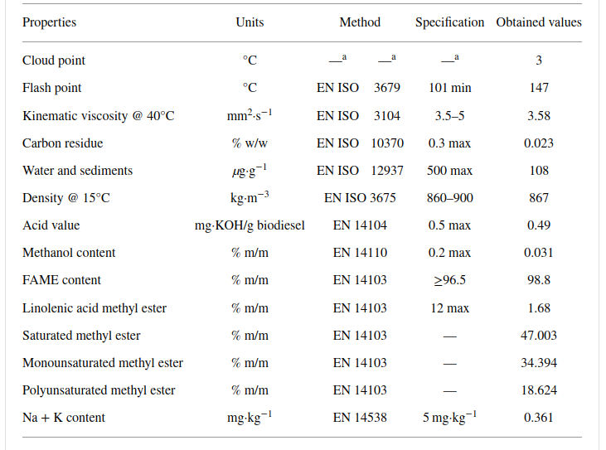

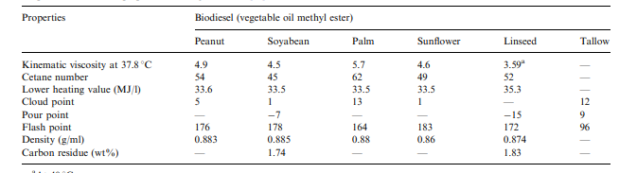

**Chemical Composition**

The ester group, CO2CH3, is located at the end of the lengthy carbon chain in the fundamental chemical formula of biodiesel, C17H34O2. Ethyl stearate and methyl linoleate, having the chemical formulae C19H34O2 and C20H40O2, are the most widely used types of biodiesel.

**Corrosion and Wear**

Any mechanical system that has sliding contact between metallic components will eventually wear down and produce tiny metal particles. The wear process often affects the following parts of diesel engines: the piston, piston ring, cylinder liner, bearing, crankshaft, tappet, and valves. Wear particles stay suspended in the oil in a lubricating system. Enough data on wear rate, element source, and engine condition can be predicted by analysing and examining variations in the concentration of the metallic particle in the lubricating oil after a specific running time. Because there is free oxygen present in biodiesel, metallic materials form their corresponding oxides. Unsaturated fatty acids, free water content, and reactive oxygen atoms are the causes of corrosion. The metallic substance experiences corrosion, which deteriorates the biodiesel's qualities. The engine components that come into contact with the biodiesel wear out more quickly due to corrosion.

**Materials and Component Design**

We need modified fuel injection system, valves, cooling system and control units.

**Biodiesel Feedstock Production**

**Agricultural Feedstocks**

Cheap and readily available raw materials such as used cooking oil and yellow grease are used for producing biodiesel. Several developing nations have found success with Jatropha, also known as the "miracle plant." It was appropriate for peasant farmers since it could be grown practically anywhere with little irrigation and less intensive care. Over the course of its 30- to 50-year typical life cycle, sustained high yields were achieved. In order to increase the economic viability of jatropha within the first two to three years, castor plantations are also interplanted with jatropha. The nitrogen-fixing Pongamia pinnata is another oil crop that is utilized to enhance soil quality. It yields seeds with a high oil content.

**Jatropha**

* Jatropha plantation can thrive on any soil.
* Needs minimal input and management.
* Safe from insects, pests, cattle and ships.
* After the 3rd year it starts yielding until 30 years or more.
* Can survive draught.

**Production of Biodiesel**

Vegetable oil in presence of catalyst reacts with excess alcohol to produce glycerol and esters (Biodiesel). Easter formation eliminates all problems associated with vegetable oils. The presence of water may cause saponification.

**Catalysts**

Alkali: NaOH, KOH, andtheir alkoxides

Acid: H2SO4, HCl, H3PO4

**Sustainable Sourcing**

The use of biodiesel as a prospective energy source has a sustainable benefit since the carbon dioxide emitted during combustion is recycled by the environment for feedstock preparation, a phenomenon known as the "Closed Carbon Cycle" or "Carbon Neutral Cycle." The closed carbon dioxide cycle for biofuels is seen in the figure. This illustrates the mechanism via which carbon dioxide emissions are eliminated during the conversion of renewable plant sources into biodiesel.

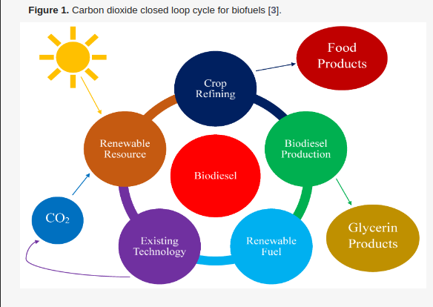

**Advanced Combustion Technologies**

**Homogeneous Charge Compression Ignition (HCCI)**

Homogeneous charge compression ignition (HCCI) occurs when well-mixed fuel and oxidizer (usually air) are compressed to the point of auto-ignition. This exothermic reaction generates heat that can be converted into work in a heat engine, much like in other types of combustion.

**Partially Premixed Combustion (PPC)**

Partially premixed combustion (PPC) is a contemporary combustion process designed to be used in internal combustion engines of automobiles and other motorised vehicles in the future. It is also referred to as gasoline direct-injection compression-ignition (GDCI) or partially-premixed compression ignition (PPCI) . It is a promising technology because of its high specific power, great fuel efficiency, and low exhaust emissions. In a compression-ignition engine, an increase in temperature brought on by compression ignites the fuel mixture instead of a spark from a spark plug. During the compression stroke of a PPC engine, a charge is premixed and injected. This premixed charge will ignite after the final fuel injection closes to TDC since it is too lean to ignite during the compression stroke.

**Low-Temperature Combustion (LTC)**

Low temperature combustion (LTC) is an advanced combustion technique that allows for low temperature combustion and provides a means of achieving extremely low NOx and PM emissions while increasing thermal efficiency.

**Emission Reduction Technologies**

**Exhaust Gas Recirculation (EGR)**

A portion of an engine's exhaust gas is circulated back to the engine cylinders via EGR. The combustion chamber's O2 is decreased and ambient air is replaced by the exhaust gas. Peak in-cylinder temperatures are lowered when there is less oxygen present because less fuel can burn in the cylinder. It helps further reduce NOx emission.

**Selective Catalytic Reduction (SCR)**

By using a catalyst and selective catalytic reduction (SCR), nitrogen oxides, often known as NOx, can be converted into diatomic nitrogen (N2) and water (H2O). A stream of flue or exhaust gas is mixed with a reductant, usually anhydrous ammonia (NH 3), aqueous ammonia (NH 4OH), or urea (CO(NH 2) 2) solution, and the mixture is then reacted onto a catalyst. By using a catalyst and selective catalytic reduction (SCR), nitrogen oxides, often known as NOx, can be converted into diatomic nitrogen (N2) and water (H2O). A stream of flue or exhaust gas is mixed with a reductant, usually anhydrous ammonia (NH 3), aqueous ammonia (NH4OH), or urea (CO(NH2)2) solution, and the mixture is then reacted onto a catalyst.

**Diesel Particulate Filters (DPF)**

A diesel particulate filter (DPF) is a device designed to remove diesel particulate matter or soot from the exhaust gas of a diesel engine.

**Lean NOx Traps (LNT)**

It is a device that uses adsorption to lower the emissions of oxides of nitrogen (NO and NO2) from internal combustion engines with lean burn.

**Biofuel Quality Assurance and Standardization**

**Fuel Quality Standards**

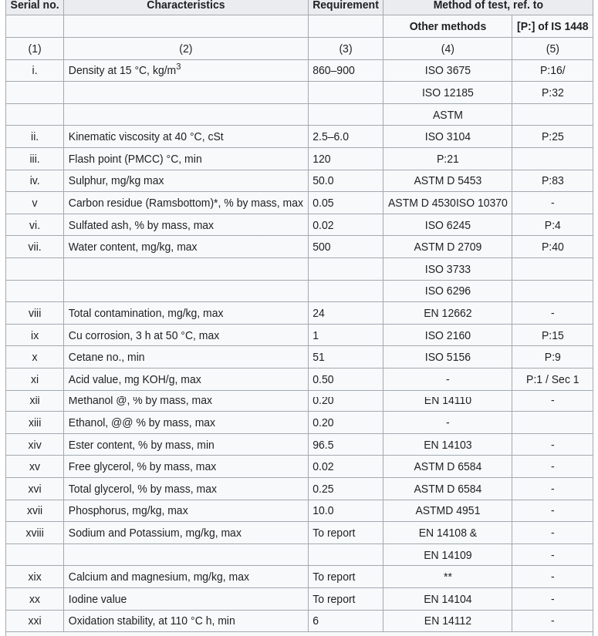

**Testing and Certification**

Essential tests are quality analysis, blending verification, contaminant detection, oxidation stability, cold flow properties, regulatory compliance.

**Quality Control Measures**

A good quality biodiesel is assured if these conditions are met: -

* Reaction is complete.
* Biodiesel is washed well
* Biodiesel is dry enough

**Effect of Hydrogen addition**

B100- Pure biodiesel

BH5- 95%biodiesel+5%hydrogen

BH10- 90%biodiesel+10%hydrogen

BH15- 85%biodiesel+15%hydrogen

**Cylinder Pressure**

The graph shows that when the hydrogen blend ratio increases from 0% to 15%, the combustion pressure curve in the cylinder tends to rise. The primary cause of this is the addition of hydrogen to the fuel mixture, which raises its cetane number even further. As a result, the blended fuel ignites more quickly and the ignition delay time is shortened, which advances the combustion pressure profile inside the cylinder.

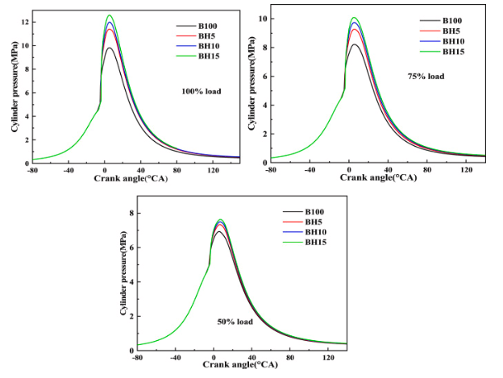

#### **Combustion temperature**

The addition of hydrogen raises the temperature at which fuel in the engine cylinder burns and accelerates combustion. The local high-temperature area in the engine cylinder expands with increasing hydrogen addition.

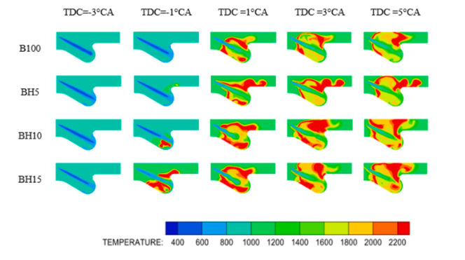

**Fuel consumption**

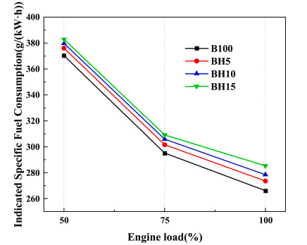

**Thermal efficiency**

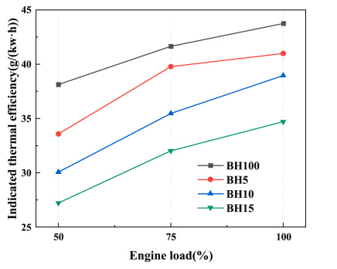

**Soot emissions**

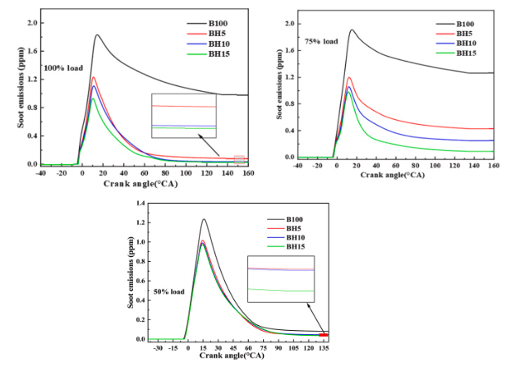

**NOx emissions**

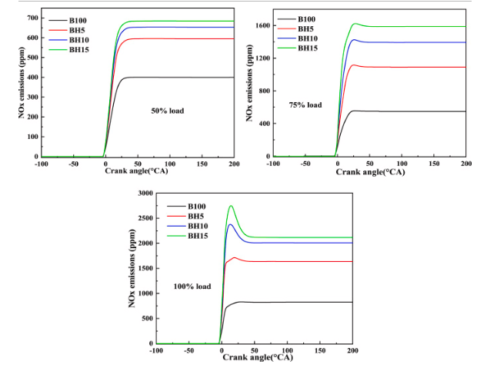

**CO emission**

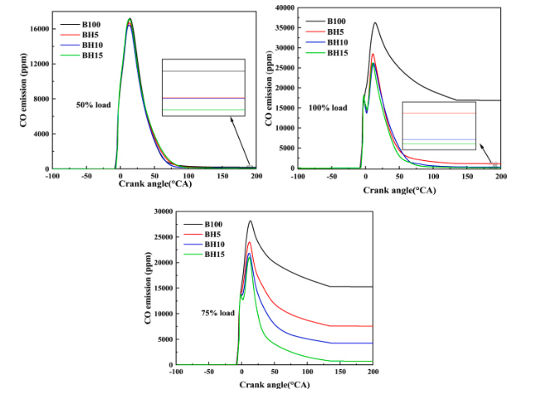

**HC emissions**

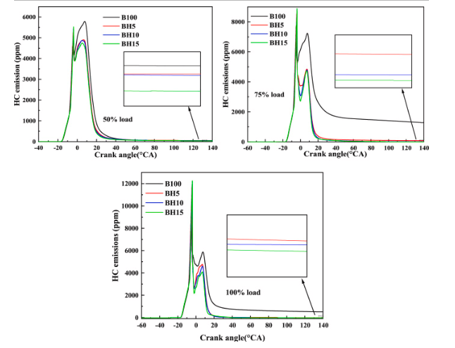

**Alternative Dual Fuel Engine Configurations**

**Dual Fuel Rotary Engines**

Dual-fueled WRE can achieve better performance. Due to the structural features of WRE and physicochemical properties of biodiesel.

**Opposed Piston Engines**

An opposed-piston engine is a piston engine in which each cylinder has a piston at both ends, and no cylinder head. Petrol and diesel opposed-piston engines have been used mostly in large-scale applications such as ships, military tanks, and factories.

**Free Piston Engines**

A free-piston engine is a type of linear, 'crankless' internal combustion engine in which the forces from the combustion chamber gases, a rebound device (like a piston in a closed cylinder), and a load device (like a gas compressor or a linear alternator) interact to determine the piston's motion instead of the crankshaft.

**Turbocompound Engines**

A turbo-compound engine is a reciprocating engine that employs a turbine to recover energy from exhaust gases. The energy is transferred to the output shaft to boost the engine's overall power delivery, as opposed to using a turbocharger, which is a common feature of high-power aviation engines.

**Cold Start and Low-Temperature Operation**

**Cold Start Strategies**

* Preheating system
* Fuel heating – To reduce viscosity of biodiesel.
* Combustion chamber preheating
* Varying fuel blending
* Injection timing control

**Fuel Preheating Systems**

Electric fuel heaters or hot exhaust can be used to preheat fuel. It wil help reduce viscosity of biodiesel and speed up vaporization of fuel.

**Cold Climate Adaptations**

* Fuel blending
* Anti gelling additives
* Fuel tank heating

**Lubrication Challenges**

B20 provides significant improvements in wear film forming ability.

93% film B20: 32% film Diesel.

**Emissions**

Due to near zero presence of sulphur it reduces the chances of acid rain, absence of aromatic hydrocarbon also reduces unregulated emissions like ketone and benzene. Biodiesel is an oxygenated fuel hence causes less soot and hydrocarbon emissions in exhaust. The NOx forms by oxidation of atmospheric nitrogen at sufficiently high temperatures. Kinetics of NOx formation is governed by Zeldovich mechanism, and its formation is highly dependent on temperature and availability of oxygen. It is obvious, that with biodiesel, due to improved combustion, the temperature in the combustion chamber can be expected to be higher and higher amount of oxygen is also present, leading to formation of higher quantity of NOx in biodiesel-fueled engines. However, biodiesel’s lower sulfur content allows the use of NOx control technologies that cannot be otherwise used with conventional diesel. Hence biodiesel’s fuel NOx emissions can be effectively managed and eliminated by engine optimization.

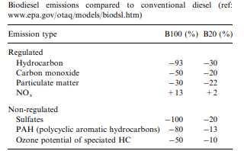

Biodiesel use also shows reduction in PAH’s, which are identified as carcinogen compounds, so it reduces health risks also.

**Health and Environmental Impacts**

**Air Quality Improvement**

Up to 85% less CO2 emissions might be produced by using waste fat or used cooking oil to make biodiesel. provided that the feedstock is planted on currently cultivated land.

**Human Health Benefits**

In the United States, biodiesel is the only alternative fuel to have successfully completed the Health Effects Testing requirements (Tier I and Tier II) of the Clean Air Act (1990).

**Performance**

**Brake Thermal Efficiency**

Jatropha oil emulsions (Y2JOE5, Y2JOE10 and Y2JOE15) were prepared by taking 5, 10 and 15 percentages by volume of WPO with 95, 90 and 85 percentages by volume of JME

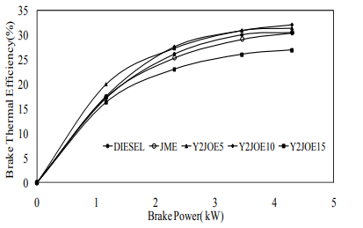

It is observed from the figure that the brake thermal efficiency of the Y2JOE5 and Y2JOE10 emulsions are 2.8% and 5.3% higher than that of diesel fuel. For Y2JOE15 emulsions the thermal efficiency drops by 11.6%. The increase in brake thermal efficiency of Y2JOE5 and Y2JOE10 are due to the improvement of the combustion process on account of increased oxygen content in the fuels [11]. In the case of Y2JOE15 emulsions, the drop in thermal efficiency may be due to lower calorific values of the emulsions.

**Brake Specific Fuel Consumption (BSFC)**

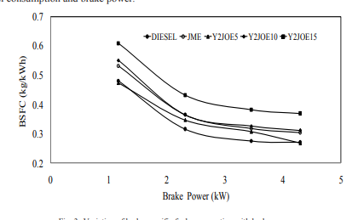

The BSFC of diesel, JME, Y2JOE5, Y2JOE10 and Y2JOE15 at full load are 0.269, 0.302, 0.266, 0.31 and 0.368 kg/kWh respectively. Also, it can be observed that the BSFC values of JME, Y2JOE10 and Y2JOE15 are higher than diesel fuel operation. This is because of the combined effects of lower heating value and the higher fuel flow rate due to high density of the JME and its emulsions with WPO. In the case of Y2JOE5, the BSFC value is slightly lower which may be attributed to better air fuel mixing which leads to better combustion.

**Economic feasibility**

The expense of shipping diesel over long distances to distant markets and the price of crude petroleum determine whether biodiesel is economically feasible. Because there is a finite supply and rising demand for crude oil, its price will inevitably rise. Furthermore, the cost of producing diesel fuels will increase due to the tight rules on the sulphur and aromatic content of diesel. Nowadays, the cost of manufacturing methyl or ethyl esters from edible oils is significantly higher than that of diesel fuel based on hydrocarbons. Because vegetable oils might cost anywhere from 1.5 to 2 times as much as diesel. By substituting non-edible oils and leftover frying oils for edible oils, the cost of biodiesel can be decreased. Non-edible oils, such neem, mahua, karanja, babassu, Jatropha, and others, are less expensive than edible oils and are widely accessible around the world. Most of these inedible oils are produced to excess and are not utilized to their full potential. Right now, biofuels cost more than conventional fuels before taxes. According to the explanatory letter for the first proposed biofuels regulation, producing one litre of biodiesel requires 1.1 litres of conventional diesel, and the cost of manufacturing biodiesel is about €0.50/l. Mineral diesel costs between €0.20 and €0.25 per litre (net of taxes). These numbers indicate that pure biodiesel costs between 120 and 175 percent more the majority of biodiesel produced today is produced with an alkaline catalyst, methanol, and soybean oil. The high food value of soybean oil makes it extremely difficult to produce a fuel that is both economical and sustainable. But there are plenty of inexpensive oils and fats that can be turned into biodiesel, such leftover food from restaurants and animal fats. Processing these inexpensive oils and fats is a challenge since they frequently include high levels of FFA, which an alkaline catalyst cannot convert to biodiesel.

**Conclusion**

Studies reveal the potential of dual fuel combustion to enhance engine efficiency and reduce emissions of pollutants. Biodiesel's renewable nature and low carbon footprint, underscores its viability as a sustainable alternative to conventional diesel fuel and its cost competitiveness. We can see room for further improvement using additives and advanced engine technologies.

**References**

1. Weaver, C. and Turner, S., "Dual Fuel Natural Gas/Diesel Engines: Technology, Performance, and Emissions," SAE Technical Paper 940548, 1994
2. Demirbas A. (2009). Progress and recent trends in biodiesel fuels. Energy Convers Manage; 50:14–34.
3. Gui MM, Lee KT, Bhatia S. (2008). Feasibility of edible oil vs. waste edible oil as biodiesel feedstock. Energy; 33:1646–53.
4. M. Bender, (1999) Economic feasibility review for community-scale farmer cooperatives for biodiesel, Biores. Tech. 70, 81–87.
5. M.G. Kulkarni, A.K. Dalai, (2006). Waste cooking oil, an economical source for biodiesel. A review, Ind. Eng. Chem. Res. 45, 2901–2913.
6. M.P. Dorado, F. Cruz, J.M. Palomar, F.J. López, (2006). An approach to the economics of two vegetable oil-based biofuels in Spain, Renew. Energy 31, 1231–1237.
7. J.M. Marchetti, V. U Miguel, A.F. Ersrazu,(2007). Possible methods for biodiesel production, Renew. Sustain. Energy Rev. 1, 1300–1311.
8. S. Zheng, M. Kates, M.A. Dubé, D.D. McLean, (2006). Acid-catalyzed production of biodiesel form waste frying oil, Biomass Bioenergy 30 (3), 267– 272.
9. Y. Zhang, M.A. Dubé, D.D. McLean, M. Kates,(2003. Biodiesel production from waste cooking oil: 1. Process design and technological assessment, Bioresour. Technol. 8, 1–16.
10. M. G. Galal , M. M. Abdel Aal & M. A. El Kady (2002) A comparative study between diesel and dual-fuel engines: Performance and emissions, Combustion Science and Technology, 174:11-12, 241-256, DOI: 10.1080/713712964
11. F. Anguebes-Franseschi, A. Bassam, M. Abatal, O. May Tzuc, C. Aguilar-Ucán, A. T. Wakida-Kusunoki, S. E. Diaz-Mendez, L. C. San Pedro, "Physical and Chemical Properties of Biodiesel Obtained from Amazon Sailfin Catfish (Pterygoplichthys pardalis) Biomass Oil", Journal of Chemistry, vol. 2019, Article ID 7829630, 12 pages, 2019. <https://doi.org/10.1155/2019/7829630>
12. GuiM. MLeeK. Tand BhatiaSFeasibility of edible oil vs. non-edible oil vs. waste edible oil as biodiesel feedstock. Energy 2008331646
13. Johansson, Bengt (2010-04-29). "Partially Premixed Combustion, PPC, for high fuel efficiency engine operation" (PDF). Lund University. Archived from the original (PDF) on 2016-12-22. Retrieved 2016-02-15.
14. "Environmental Effects of Nitrogen Oxides". Electric Power Research Institute, 1989
15. [Effectiveness of hydrogen enrichment strategy for Wankel engines in unmanned aerial vehicle applications at various altitudes](https://www.sciencedirect.com/science/article/pii/S0360319923044981) 2024, International Journal of Hydrogen Energy
16. Masjuki H, Abdulmuin MZ, Sii HS. Investigations on preheated palm oil methyl esters in the diesel engine. Proc IMechE, A, J Power Energy 1996:131–8.
17. Scholl KW, Sorenson SC. Combustion of soyabean oil methyl ester in a direct injection diesel engine. SAE paper no. 930934, 1983.
18. Kalligeros S, Zannikos F, Stournas S, Lois E, Anastopoulos G, Teas Ch, et al. An investigation of using biodiesel/marine diesel blends on the performance of a stationary diesel engine. Biomass Bioenergy 2003;24:141–9.
19. Agarwal AK. Lubrication oil tribology of a biodiesel-fuelled CI engine, ASME-ICED 2003 conference, September, Erie, PA, USA, 2003.
20. Agarwal AK. Experimental investigation of the effect of biodiesel utilization on lubricating oil tribology in diesel engines. J Automob Eng 2005;219:703–13.
21. Stevens DJ, et al. Biofuels for transportation: an examination of policy and technical issues. IEA bioenergy task, vol. 39, liquid biofuels final report 2001–2003, 2004.
22. Canakci M, Van Gerpen J. Biodiesel production from oils and fats with high free fatty acids. Trans ASAE 2001;44:1429–36. [94] Hofman V., Biodiesel fuel. NDSU Extension Service, North Dakota State University, Fargo, North Dakota, Paper No. AE 1240, 2003.
23. Ramadhas, A. S., Jayaraj, S., & Muraleedharan, C. (2005). Performance and emission evaluation of a diesel engine fueled with methyl esters of rubber seed oil. Renewable energy, 30(12), 1789-1800.
24. Kumar, A., Kumar, A., & Kaushik, S. C. (2017). A review on diesel and biodiesel blend combustion, performance, and emission analysis. Energy Sources, Part A: Recovery, Utilization, and Environmental Effects, 39(7), 610-628.
25. Farid, M. A., & Elkelawy, M. A. (2017). Performance and emissions of a heavy-duty dual-fuel engine with diesel–methanol fuelled pilot ignition. Energy Conversion and Management, 145, 162-172.
26. Aghbashlo, M., Tabatabaei, M., & Khalife, E. (2016). The performance of diesel engines operating with biodiesel–diesel fuel blends: A review. Renewable and Sustainable Energy Reviews, 57, 799-821.
27. Chen, J. H., Kuo, C. L., Lin, C. C., & Yu, C. W. (2016). Experimental study on the effects of pilot injection strategies on the combustion characteristics and emissions of a heavy-duty diesel engine operating in dual-fuel mode with biodiesel. Energy Conversion and Management, 117, 435-443.
28. Rizzo, G., Gagliardi, V., & Dassisti, M. (2017). Performance and emissions of a dual-fuel engine with waste cooking oil and diesel. Energy Procedia, 126, 79-86.
29. Pervez, A., Channiwala, S. A., & Parikh, P. P. (2017). Experimental investigation of performance, combustion and emission characteristics of a diesel engine fueled with diesel, Jatropha and Karanja biodiesels in dual fuel mode. Fuel, 197, 436-443.
30. Karthickeyan, V., & Ravikumar, J. (2017). Performance analysis of a diesel engine fueled with nano-liquid additives. Environmental Science and Pollution Research, 24(14), 12836-12846.
31. Yang, W. M., An, H., Li, G. X., & Chou, S. K. (2017). Combustion and emission characteristics of a diesel engine fuelled by biodiesel–ethanol–diesel blends. Energy Conversion and Management, 149, 241-251.
32. Mohanty, P., & Datta, A. (2017). Effect of advanced injection timing on combustion, performance and emission characteristics of a diesel engine fueled with diesel-biodiesel-bioethanol blends. Energy, 125, 319-329.
33. Hasan, N. K., Rahman, M. M., & Rabbani, M. H. (2016). Performance and emission characteristics of a diesel engine with diesel–biodiesel–n-butanol blends. Journal of Cleaner Production, 137, 1532-1542.
34. Halder, G., & Mohapatra, S. K. (2016). Comparative evaluation of performance and emission characteristics of jatropha biodiesel and diesel in a variable compression ignition engine. Journal of Cleaner Production, 115, 166-174.
35. Rakopoulos, D. C., & Hountalas, D. T. (2016). Diesel engine performance and exhaust emissions analysis using waste cooking biodiesel fuel blends with n-butanol addition. Energy Conversion and Management, 126, 656-667.
36. Panigrahi, R., & Sahoo, S. (2016). Comparative evaluation of performance, emission and combustion characteristics of diesel engine fuelled with methyl esters of different sources of waste cooking oils. Journal of Cleaner Production, 112, 1747-1759.
37. Kumar, M. S., & Venkatesan, S. (2016). Comparative assessment of exhaust emissions and performance of a diesel engine fueled with neem oil methyl ester and rice bran oil methyl ester. Energy Conversion and Management, 115, 263-272.
38. Katiyar, A., Murugan, S., & Sendilvelan, S. (2017). Performance and emission analysis of a diesel engine fueled with rice bran oil methyl ester and diethyl ether. Energy Sources, Part A: Recovery, Utilization, and Environmental Effects, 39(16), 1756-1762.
39. Jayaraj, S., Muraleedharan, C., & Ramadhas, A. S. (2009). Performance and emission evaluation of a diesel engine fueled with methyl esters of rubber seed oil. Renewable energy, 30(12), 1789-1800.
40. Agarwal, A. K., & Dhar, A. (2017). A review on the performance, combustion and emissions of biodiesel in compression ignition engines. Renewable and Sustainable Energy Reviews, 57, 799-821.
41. Yu, C. W., Lin, C. C., Tseng, J. Y., & Chen, J. H. (2016). Effects of hydrogen addition on the combustion characteristics and emissions of a heavy-duty diesel engine operated in dual-fuel mode with biodiesel. Applied Energy, 173, 392-402.
42. Patil, Y., Gaurav, R., & Gangrade, M. (2016). Experimental investigation of performance and emission characteristics of a diesel engine with blends of diesel–biodiesel in dual fuel mode. Alexandria Engineering Journal, 55(3), 2167-2176.
43. Sarkar, S., & Kumar, A. (2017). Performance, emission, and combustion characteristics of a diesel engine operated on biodiesel and its blends with ethanol. Journal of Thermal Analysis and Calorimetry, 130(2), 991-1000.
44. Chandran, R., Agha, R., & Agha, M. (2016). Performance and emission characteristics of a diesel engine operated with rice bran methyl ester and n-pentanol blends. Fuel, 183, 124-133.