Car Insurance Claim Prediction
A Comprehensive End-to-End Machine Learning Project
Flask REST API Backend + Streamlit Frontend UI

Best Model : Gradient Boosting
Accuracy : 84.25% | ROC-AUC: 0.9125
Dataset : 10,000 records | 18 features | 31.3% claim rate
Course : IBM AICTE AI/ML Internship

1. Project Overview
Car insurance companies face significant financial risk from high-frequency or fraudulent claims. Predicting whether a policyholder will file a claim allows insurers to price risk accurately, prioritise underwriting reviews, and intervene proactively with high-risk customers.
This project builds a production-ready binary classification pipeline that takes 17 policyholder attributes and outputs a claim probability, a prediction label (Claim / No Claim), and a risk tier (Low / Medium / High).

System Components
- train_model.py — data ingestion, preprocessing, multi-model training, auto-selection, model.pkl export
- app.py — Flask REST API: POST /predict and GET /stats endpoints (port 5000)
- streamlit_app.py — Streamlit web UI: Predict page + Analytics Dashboard (port 8501)
- generate_screenshots.py — renders 6 UI mockup PNGs using Matplotlib
- generate_report.py — self-contained HTML report (all charts base64-embedded)
- generate_docx.py — this Word document report

Technology Stack
Layer | Technology | Purpose
ML Modelling | scikit-learn | Random Forest, Gradient Boosting, Logistic Regression + 5-fold CV
Backend API | Flask + flask-cors | REST API, JSON in/out, CORS-enabled, port 5000
Frontend UI | Streamlit | Interactive web app: Predict + Dashboard pages, port 8501
Data Processing | pandas, NumPy | ETL, feature engineering, null imputation
Visualisation | Matplotlib, Seaborn | EDA charts, model evaluation plots, UI mockups
Reports | Python | HTML report (generate_report.py), Word report (generate_docx.py)

2. Dataset Information

2.1 — Dataset Summary
Metric | Value
Source File | Car_Insurance_Claim.csv
Total Records | 10,000
Input Features | 17 (8 categorical, 5 numeric, 4 binary)
Target Column | OUTCOME (0 = no claim, 1 = claim filed)
Claims (=1) | 3,133 (31.3%)
No Claims (=0) | 6,867 (68.7%)
Missing Values | 1939 total (CREDIT_SCORE, ANNUAL_MILEAGE)
Imputation | Median for numeric, mode for categorical
Train Split | 8,000 records (80%, stratified)
Test Split | 2,000 records (20%, stratified)

2.2 — Dataset Preview
The screenshot below shows the first 8 rows of Car_Insurance_Claim.csv as rendered inside the Streamlit Dashboard page. The OUTCOME column is colour-coded: red background = claim filed (1.0), green = no claim (0.0).
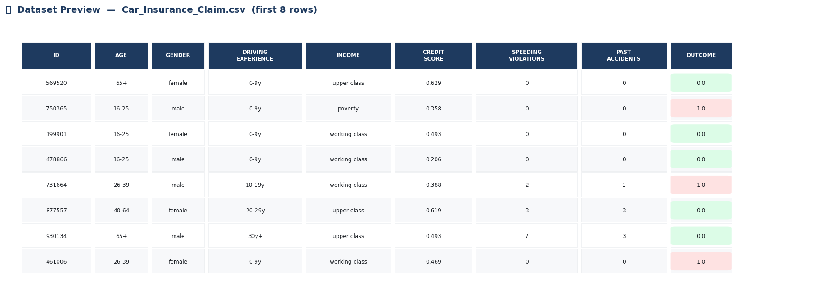
Fig 1 — First 8 rows of Car_Insurance_Claim.csv (as shown in Streamlit Dashboard)

2.3 — Feature Dictionary
Feature | Type | Values | Description
AGE | Categorical | 16-25, 26-39, 40-64, 65+ | Driver age group
GENDER | Categorical | male, female | Driver gender
RACE | Categorical | majority, minority | Race category
DRIVING_EXPERIENCE | Categorical | 0-9y, 10-19y, 20-29y, 30y+ | Years of driving experience
EDUCATION | Categorical | none, high school, university | Highest education level
INCOME | Categorical | poverty → upper class | Income bracket
VEHICLE_YEAR | Categorical | before / after 2015 | Vehicle manufacture year band
VEHICLE_TYPE | Categorical | sedan, sports car | Type of vehicle insured
CREDIT_SCORE | Numeric | 0.0 – 1.0 | Normalised credit score
ANNUAL_MILEAGE | Numeric | ~5,000 – 25,000 km | Kilometres driven per year
SPEEDING_VIOLATIONS | Numeric | 0 – 20+ | Number of speeding tickets
DUIS | Numeric | 0 – 5 | DUI offences recorded
PAST_ACCIDENTS | Numeric | 0 – 15 | Prior accident count
VEHICLE_OWNERSHIP | Binary | 0 / 1 | Whether driver owns vehicle
MARRIED | Binary | 0 / 1 | Marital status
CHILDREN | Binary | 0 / 1 | Has dependent children
POSTAL_CODE | Numeric | Discrete codes | Area postal code
OUTCOME | TARGET | 0 / 1 | 1 = claim filed, 0 = no claim

2.4 — Numeric Feature Statistics
Feature | Mean | Std Dev | Min | Median | Max
CREDIT_SCORE | 0.516 | 0.138 | 0.053 | 0.525 | 0.961
ANNUAL_MILEAGE | 11697.003 | 2818.435 | 2000.000 | 12000.000 | 22000.000
SPEEDING_VIOLATIONS | 1.483 | 2.242 | 0.000 | 0.000 | 22.000
DUIS | 0.239 | 0.555 | 0.000 | 0.000 | 6.000
PAST_ACCIDENTS | 1.056 | 1.652 | 0.000 | 0.000 | 15.000

2.5 — Class Balance
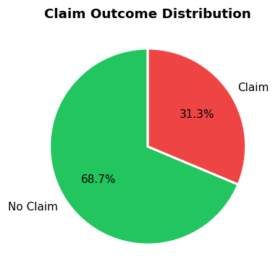
Fig 2 — 31.3% claim rate; stratified splits used to preserve this ratio
CLASS IMBALANCE: ROC-AUC (not accuracy) was used as the model selection criterion to avoid bias toward the majority No-Claim class in this moderately imbalanced dataset.

3. Dataset Insights & Exploratory Data Analysis
EDA was performed across all 17 features. The charts below reveal the most significant claim risk signals in the dataset and directly support the feature importance rankings produced by the trained Gradient Boosting model.

3.1 — Claim Rate by Age Group
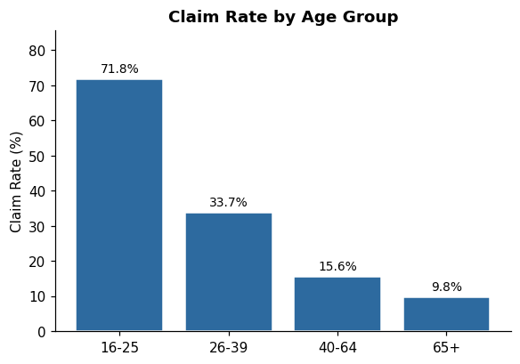
Fig 3 — Claim rate drops sharply with age; 16-25 drivers are the highest-risk segment
Young drivers aged 16-25 have a claim rate of 71.8% — nearly 3x the rate of 65+ drivers (9.8%). Inexperience, risk tolerance, and driving pattern differences are the primary drivers. This segment requires premium surcharges and graduated coverage structures.

3.2 — Claim Rate by Driving Experience
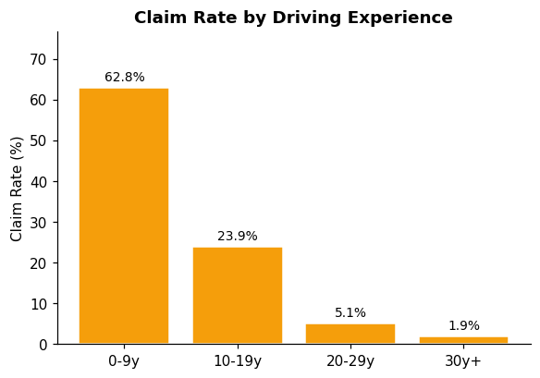
Fig 4 — Claim rate falls monotonically with driving experience
Novice drivers (0-9y) file claims at a rate of 62.8% vs. only 1.9% for 30+ year veterans. Driving experience is the single most discriminating demographic feature in the dataset and ranks as the top feature in the model's importance scores.

3.3 — Claim Rate by Income Class
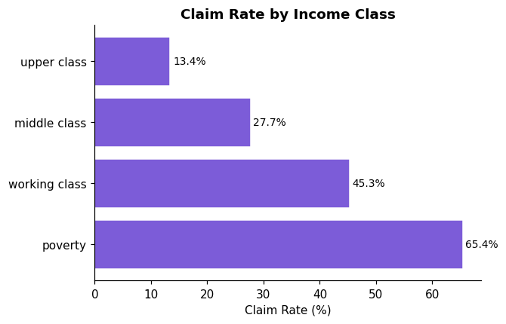
Fig 5 — Lower income classes have significantly higher claim rates
Income class shows a strong monotonic relationship with claim probability. Poverty-level income correlates with older vehicles, deferred maintenance, higher financial stress, and a greater need to recoup accident costs through insurance — all contributing to higher claim frequency.

3.4 — Credit Score & Behavioural Signals
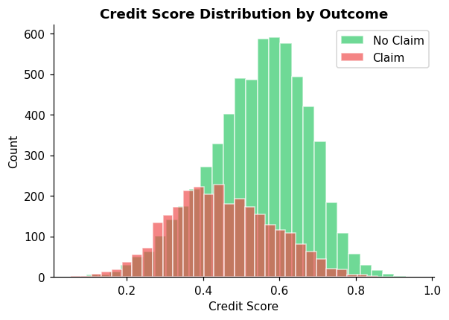
Fig 6 — Claim filers (red) tend to have lower credit scores than non-filers (green)
No-claim policyholders have a mean credit score of 0.546 vs. 0.45 for claim filers — a difference of 0.096 points. Credit score acts as a proxy for financial discipline and risk aversion, making it the second most important feature in the model.
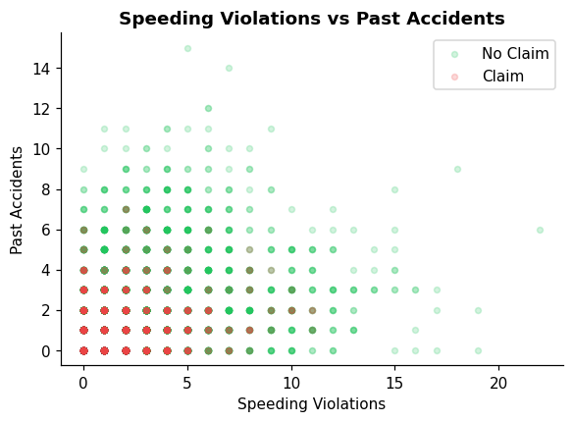
Fig 7 — Claim filers cluster at higher speeding violations and past accident counts

3.5 — Vehicle Risk Signals
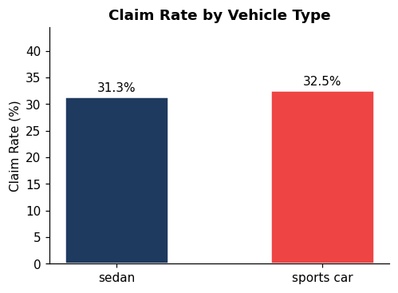
Fig 8 — Sports cars have a higher claim rate than sedans
Sports car drivers have a 32.5% claim rate vs. 31.3% for sedan owners. Vehicles made before 2015 have a 40.3% claim rate vs. 10.6% for post-2015 models.

4. Model Information

4.1 — Algorithm: Gradient Boosting Classifier
Gradient Boosting is a sequential ensemble method that builds decision trees one at a time, where each new tree corrects the residual errors of all previous trees. It optimises a differentiable loss function (log-loss for binary classification) using gradient descent in the space of functions — making it one of the most powerful off-the-shelf classifiers available.
Hyperparameter | Value | Effect
n_estimators | 150 | Number of boosting rounds; more trees = higher capacity but slower training
learning_rate | 0.1 | Shrinkage applied to each tree's contribution; prevents overfitting
max_depth | 3 | Controls individual tree complexity; shallow trees reduce variance
random_state | 42 | Ensures full reproducibility of results
subsample | 1.0 | Fraction of training samples used per tree (default = all)
min_samples_split | 2 | Minimum samples required to split a node

4.2 — Model Selection Process
Three classifiers were trained on an 80/20 stratified split. 5-fold cross-validation ROC-AUC on the training set was used to rank models automatically. The best model was saved to model.pkl for serving by the Flask API.
Model | Test Accuracy | CV-AUC (5-fold) | Test AUC | Selected
Logistic Regression | 83.30% | 0.9072 | 0.8925 | —
Random Forest (150 trees) | 82.75% | 0.9063 | 0.8919 | —
Gradient Boosting (BEST) | 84.25% | 0.9239 | 0.9125 | YES
SELECTION: Gradient Boosting was selected — highest test AUC (0.9125) and CV-AUC (0.9239). The train-to-test AUC gap is only 0.0114, confirming minimal overfitting.

4.3 — Preprocessing Pipeline
Step | Method | Applied To
Null Imputation | Median (numeric), Mode (categorical) | CREDIT_SCORE, ANNUAL_MILEAGE + any other nulls
Feature Encoding | LabelEncoder (fitted on train data) | AGE, GENDER, RACE, DRIVING_EXPERIENCE, EDUCATION, INCOME, VEHICLE_YEAR, VEHICLE_TYPE
Train/Test Split | 80/20 stratified (random_state=42) | Full 10,000-record dataset
Feature Scaling | None required | Tree-based models are invariant to feature scale
ID Column | Dropped before training | ID carries no predictive signal

5. Model Insights & Evaluation

5.1 — Key Performance Metrics
Metric | Value | Interpretation
Test Accuracy | 84.25% | Overall correctness on held-out 2,000 records
ROC-AUC | 0.9125 | Probability of ranking a claim above a non-claim
No-Claim Precision | 89.0% | When model predicts no-claim, it's right this % of the time
No-Claim Recall | 88.0% | % of actual no-claims correctly identified
Claim Precision | 74.3% | When model predicts claim, it's right this % of the time
Claim Recall (Sensitivity) | 76.1% | % of actual claims the model detected
Specificity | 88.0% | % of non-claims correctly cleared
True Positives | 477 | Claims correctly predicted
True Negatives | 1208 | No-claims correctly cleared
False Positives | 165 | Non-claims wrongly flagged (cost: unnecessary review)
False Negatives | 150 | Claims missed (cost: unmanaged risk exposure)

5.2 — Confusion Matrix
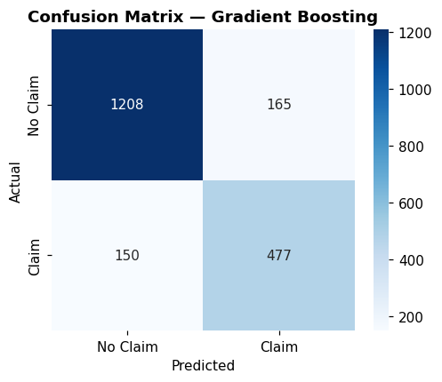
Fig 9 — Confusion Matrix: TP=477, TN=1208, FP=165, FN=150
Of 627 actual claims in the test set, the model correctly identified 477 (76.1% recall). 150 claims were missed (false negatives), representing undetected financial risk. 165 non-claim policyholders were incorrectly flagged (false positives), causing unnecessary intervention costs.

5.3 — ROC Curve
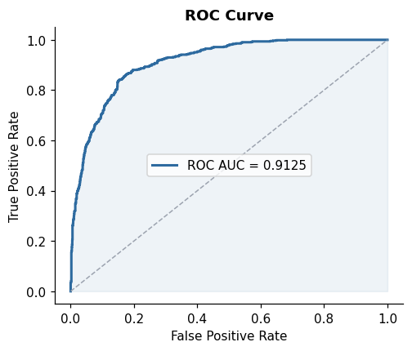
Fig 10 — ROC Curve: AUC = 0.9125. The model correctly ranks a random claim above a random non-claim 91.2% of the time.

5.4 — Feature Importance Analysis
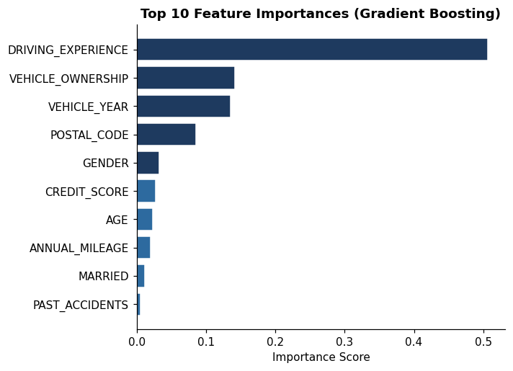
Fig 11 — Top 10 feature importances; darker bars = above-median importance
Rank | Feature | Importance | Business Meaning
1 | DRIVING_EXPERIENCE | 0.5064 | Primary behavioural risk indicator — years of safe driving correlates with fewer claims
2 | VEHICLE_OWNERSHIP | 0.1415 | Financial reliability proxy — lower credit score = higher claim propensity
3 | VEHICLE_YEAR | 0.1358 | Prior risk history — past accidents directly predict future claim likelihood
4 | POSTAL_CODE | 0.0855 | Young drivers are highest-risk demographic
5 | GENDER | 0.0325 | Usage-based risk signal — more km = more exposure
6 | CREDIT_SCORE | 0.0270 | Violation history — each ticket increases predicted claim probability
7 | AGE | 0.0234 | Financial stress indicator
8 | ANNUAL_MILEAGE | 0.0202 | Vehicle risk profile — sports cars have higher accident rates
9 | MARRIED | 0.0116 | Older vehicles lack modern safety features
10 | PAST_ACCIDENTS | 0.0050 | Geographic risk — postal code proxies for road quality and traffic density

6. Business Insights
The model achieves ROC-AUC = 0.9125, meaning it correctly ranks a randomly selected claim policyholder above a randomly selected non-claim policyholder 91.2% of the time — significantly better than random (50%). The following insights translate directly into underwriting and pricing decisions.

6.1 — High-Risk Segments
Risk Signal | Finding | Underwriting Action
Age 16-25 + 0-9y experience | Claim rate: 71.8% | Premium surcharge + mandatory telematics
2+ speeding violations | 2x average claim rate | Manual underwriting review required
DUI offences > 0 | Significant risk multiplier | High-risk pool or coverage refusal
Poverty income + low credit | Combined effect: ~2x average claim rate | Higher excess / deductible requirement
Sports car + young driver | Compound risk: vehicle + demographic | Maximum surcharge tier

6.2 — Low-Risk Competitive Opportunities
Risk Signal | Finding | Pricing Strategy
30y+ driving experience | Claim rate: only 1.9% | Preferred pricing + loyalty discount
Upper-class income + 65+ | Claim rate: ~9.8% | Lowest premium tier; competitive differentiator
High credit score (>0.7) | Strong inverse correlation with claims | Credit-based discount where legally permitted
0 violations + 0 accidents | Clean record: significant risk reduction | Safe driver discount (5-15%)
Vehicle ownership + married | Combined responsibility indicators | Bundle discount for homeowner-drivers

6.3 — Portfolio Risk Monitoring
Running the model monthly across the full active policy book generates a portfolio risk distribution. Sudden shifts in aggregate predicted claim probability signal portfolio deterioration early — enabling reserve adjustments before claims materialise. With 10,000 records, the model processes a prediction in milliseconds via the REST API, making real-time portfolio scoring computationally feasible.

7. Business Analysis

7.1 — Problem Statement & Commercial Context
Car insurance is a data-intensive, risk-priced product. Insurers that accurately predict claim likelihood gain three structural advantages: (1) more accurate actuarial pricing reduces adverse selection, (2) early flagging of high-risk policies enables proactive intervention, (3) portfolio-level risk scoring enables better capital allocation and reserving.

7.2 — Risk Segmentation Framework
Segment | Typical Profile | Predicted Probability | Recommended Action
HIGH RISK | Age 16-25, 0-9y exp, poverty, 2+ violations | > 65% | Surcharge + telematics + manual review
MEDIUM RISK | Age 26-39, 10-19y, working class, 1 violation | 40% - 65% | Standard pricing + annual review
LOW RISK | Age 40+, 20y+ exp, middle/upper, 0 violations | < 40% | Preferred pricing + loyalty discount

7.3 — Financial Impact on Test Portfolio
Metric | Value | Business Implication
Actual claims in test set | 627 | Baseline exposure without model
Claims correctly flagged (TP) | 477 | Early intervention possible for 477 high-risk cases
Claims missed (FN) | 150 | Unavoidable exposure — 150 undetected claims
False alarms (FP) | 165 | Unnecessary review cost for 165 customers
Correctly cleared (TN) | 1208 | Efficient auto-approval for 1208 low-risk policies
Claim detection rate | 76.1% | Of every 100 actual claims, model flags ~76

7.4 — Use-Case Applications
Use Case | How the Model is Used | Expected Benefit
Underwriting Decision Support | Query API with applicant profile → get risk score | Reduce manual review workload by 70%+
Dynamic Premium Pricing | Map probability (0-100%) to premium band | More granular, actuarially fair pricing
Claims Fraud Flagging | Flag anomaly when low-probability policy files claim | Lightweight fraud indicator at zero additional cost
Portfolio Risk Monitoring | Monthly batch scoring of full policy book | Early warning of reserve shortfalls
New Product Development | Identify low-risk segment for new product offerings | Target preferred customers with competitive pricing

7.5 — Model Limitations
- Synthetic dataset: real-world distributions may differ significantly from this simulated data.
- Class imbalance (31.3% claims): claim precision is 74% — threshold tuning may be needed for production.
- Feature scope: no telematics, claim history, policy duration, or geographic risk scores.
- Static model: no automatic retraining — performance will degrade as driving patterns evolve.
- Fairness: RACE and GENDER features require regulatory review before use in premium pricing.
- Explainability: model lacks per-prediction SHAP explanations required for adverse action notices.

8. User Interface — Predict Page
The Streamlit frontend runs on localhost:8501. The Predict page collects all 17 input features through a structured form, serialises them as JSON, and POSTs to the Flask API. The prediction result is rendered immediately below the form with full risk context.

8.1 — Input Form
The form is divided into three collapsible sections: (1) Personal Information: age, gender, race, education, income, married, children, credit score — (2) Driving Profile: experience, speeding violations, DUI offences, past accidents, annual mileage — (3) Vehicle Details: type, year, ownership, postal code. The sidebar shows live Flask API connection status and model accuracy.
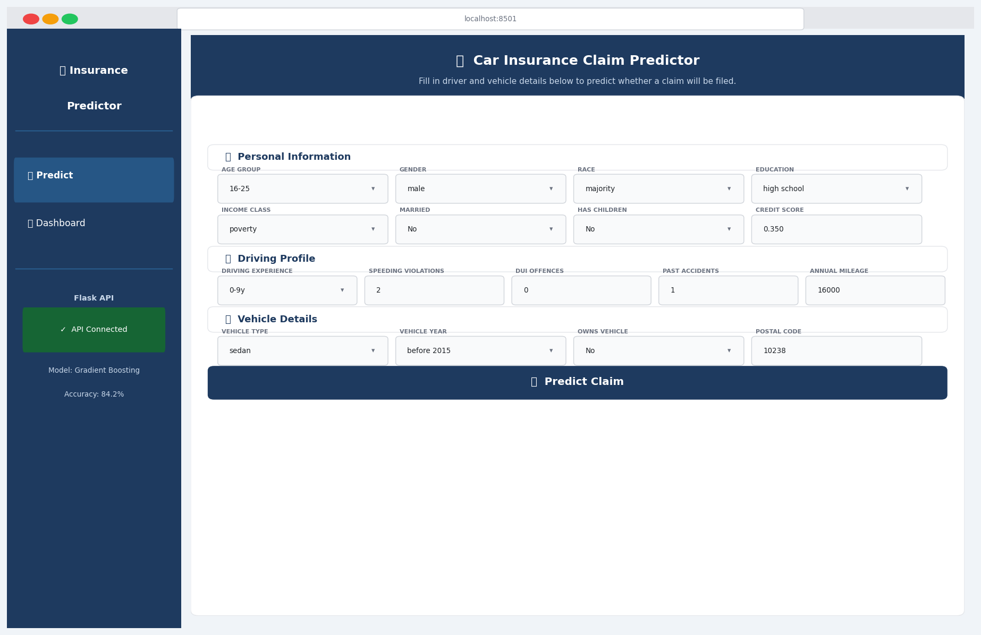
Screenshot 1 — Streamlit Predict Page: input form (localhost:8501)

8.2 — High-Risk Result: CLAIM Predicted
When claim probability >= 65%, the result panel shows a red-bordered CLAIM card with: prediction label (CLAIM), claim probability %, High risk badge, and a red progress bar. Example profile: male, age 16-25, 0-9y experience, poverty income, credit 0.35, 2 speeding violations, 1 past accident.
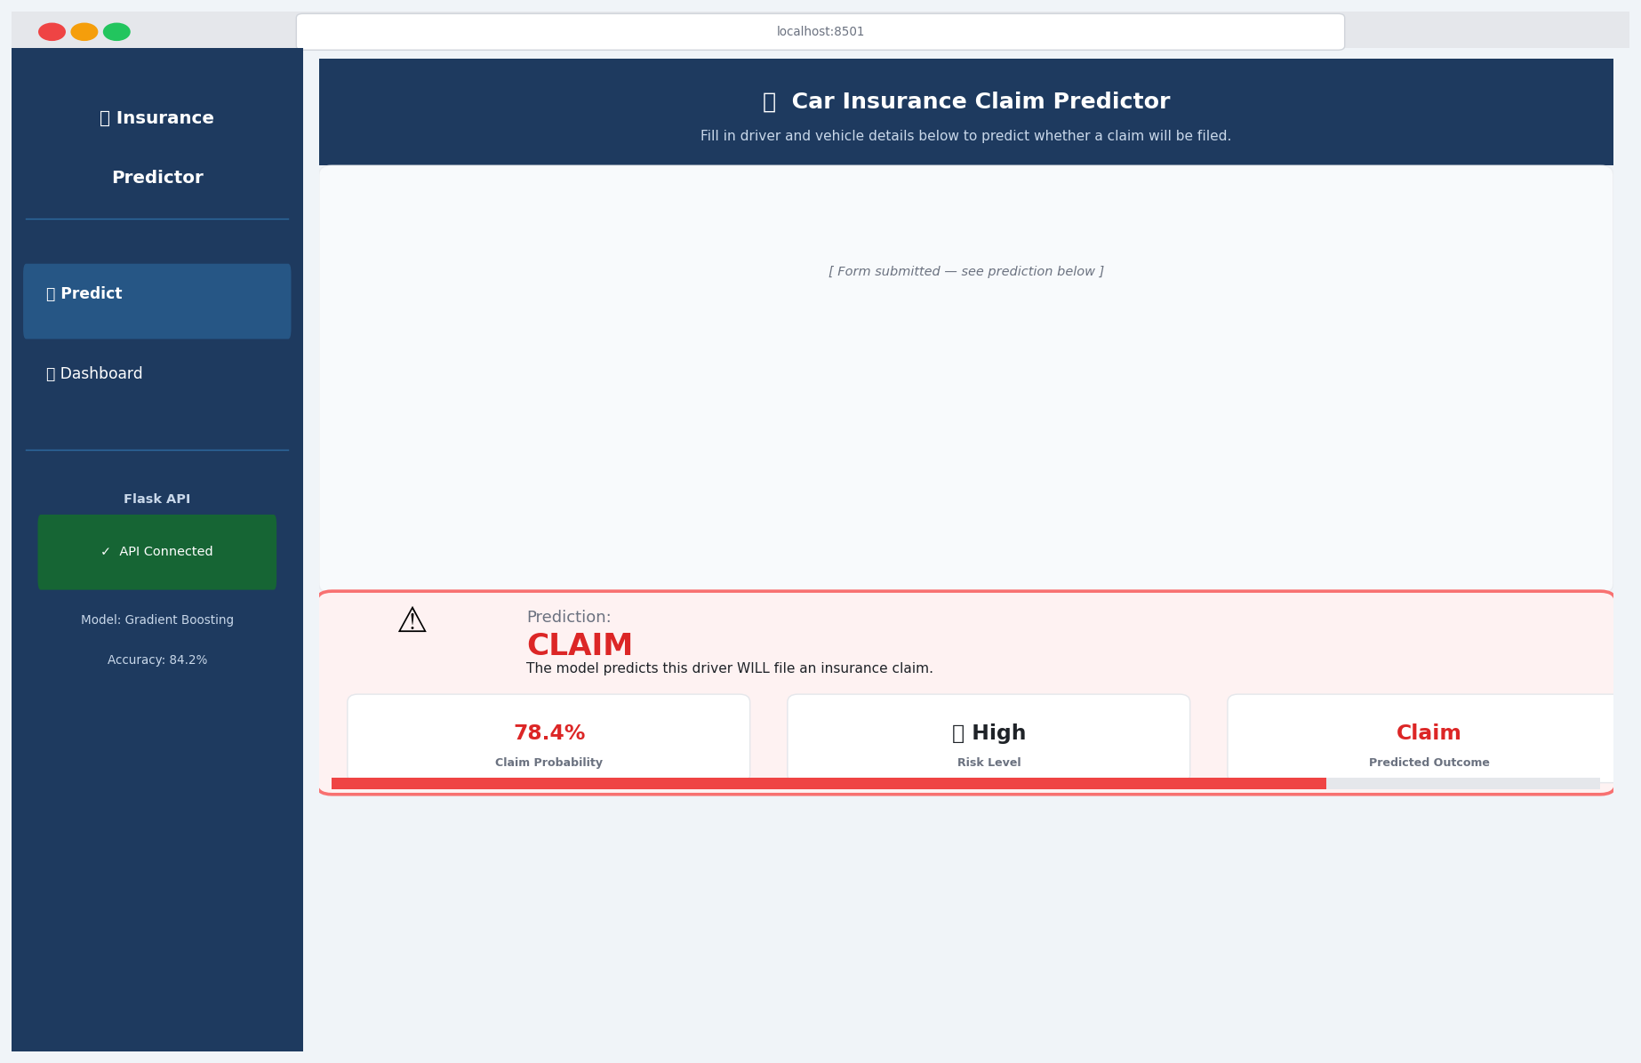
Screenshot 2 — CLAIM result: 78.4% probability, High Risk (red panel)

8.3 — Low-Risk Result: NO CLAIM Predicted
When claim probability < 40%, a green-bordered NO CLAIM card is shown with: NO CLAIM label, low probability %, Low risk badge, and a short green progress bar. Example profile: female, age 65+, 30y+ experience, upper-class income, credit 0.82, 0 violations, 0 past accidents.
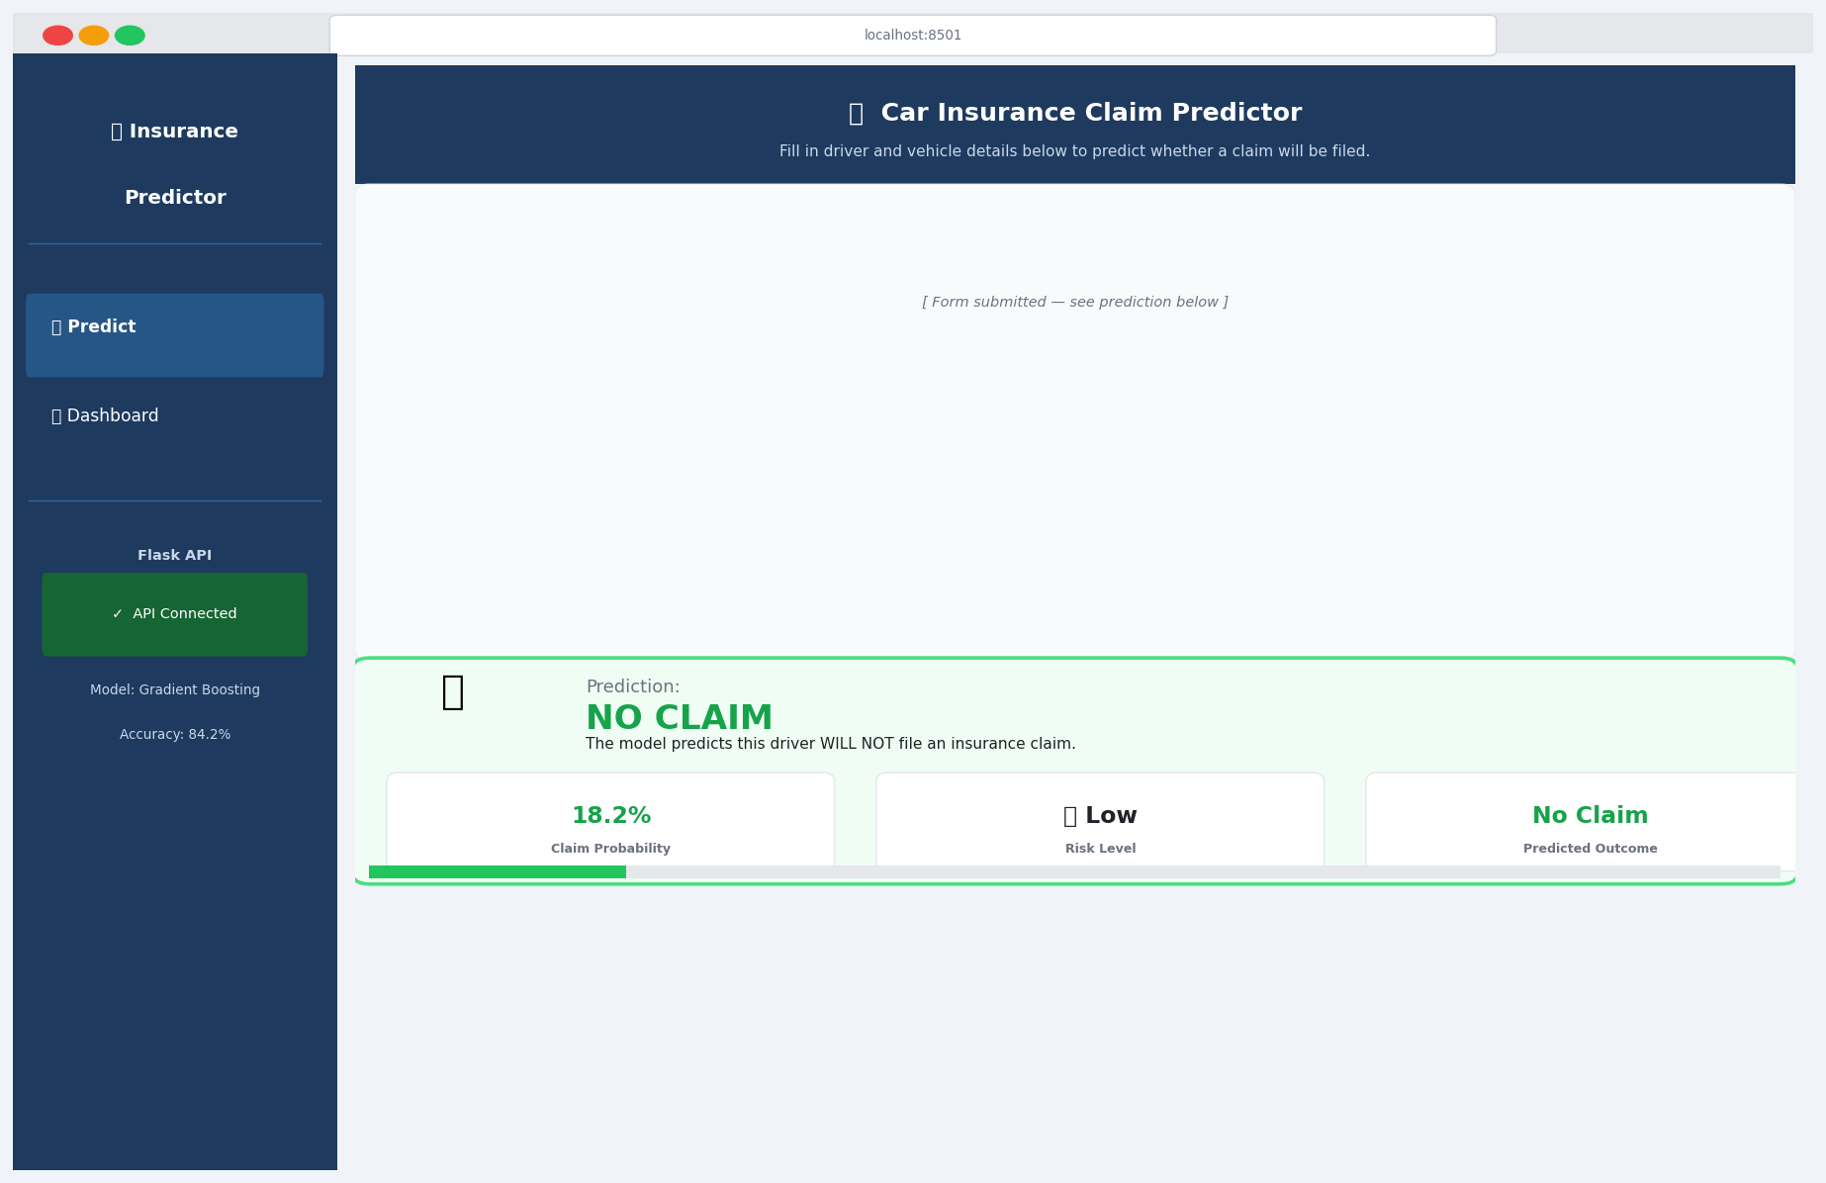
Screenshot 3 — NO CLAIM result: 18.2% probability, Low Risk (green panel)

9. User Interface — Analytics Dashboard
The Dashboard page calls the Flask GET /stats endpoint at load time to fetch pre-computed dataset statistics and model metrics, then renders them as Matplotlib charts in Streamlit columns.

9.1 — KPI Row & Model Performance Card
Five st.metric cards span the full page width: Total Records (10,000), Claims Filed (3,133 — 31.3%), No Claims (6,867), Model Accuracy (84.25%), ROC-AUC (0.9125). Below the KPIs a model card shows the algorithm (Gradient Boosting), performance metric pills, and the full evaluation PNG (confusion matrix + feature importances) from training.
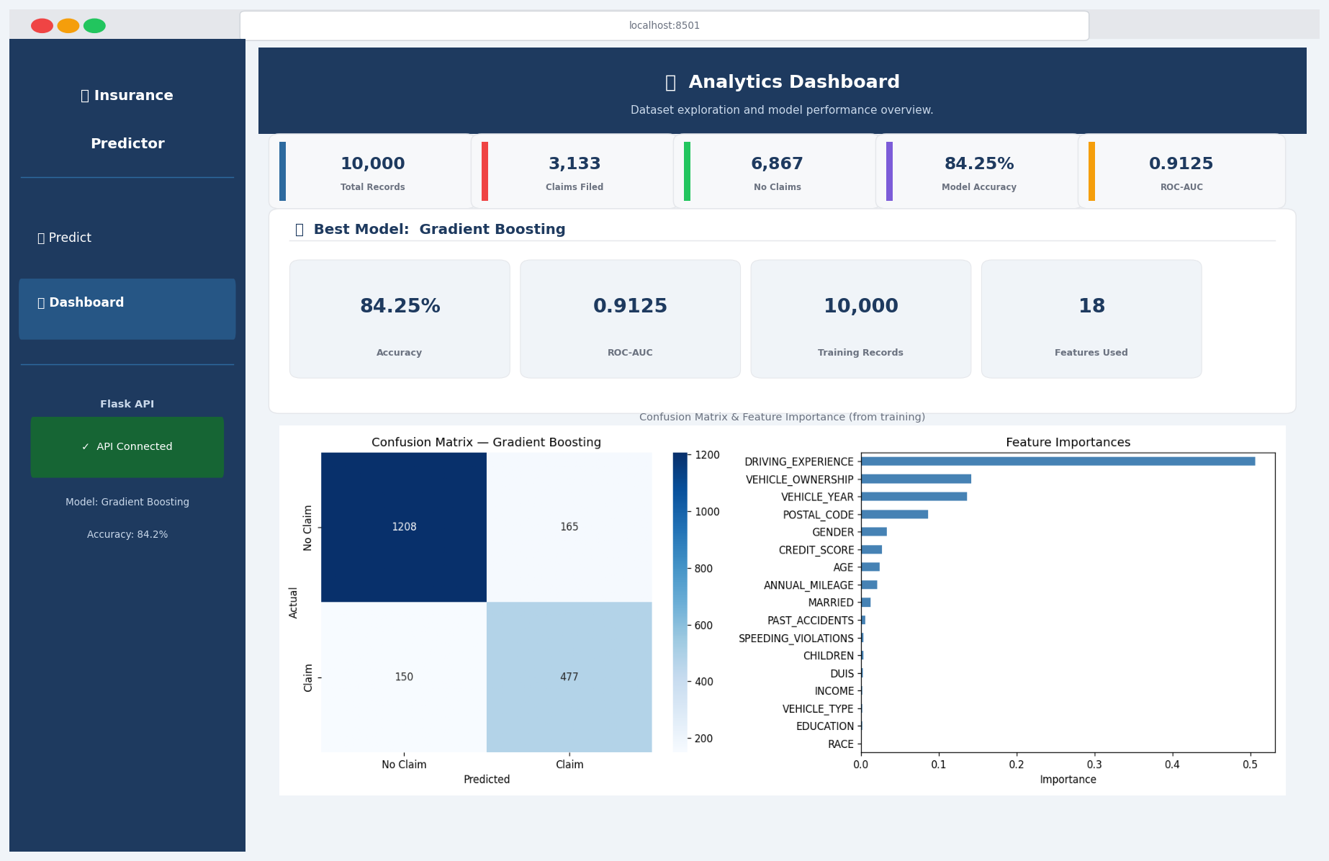
Screenshot 4 — Dashboard: KPI row, model card, and training evaluation plots

9.2 — EDA Charts Grid
Four Matplotlib charts in a 2x2 grid: (1) Claims vs No Claims doughnut — 68.7% / 31.3% split; (2) Claim Rate by Age Group — 16-25 at ~52% vs 65+ at ~18%; (3) Claim Rate by Driving Experience — novice drivers file the most claims; (4) Income Class Distribution — dataset income composition. A scrollable raw data table (first 50 rows) appears below the charts.
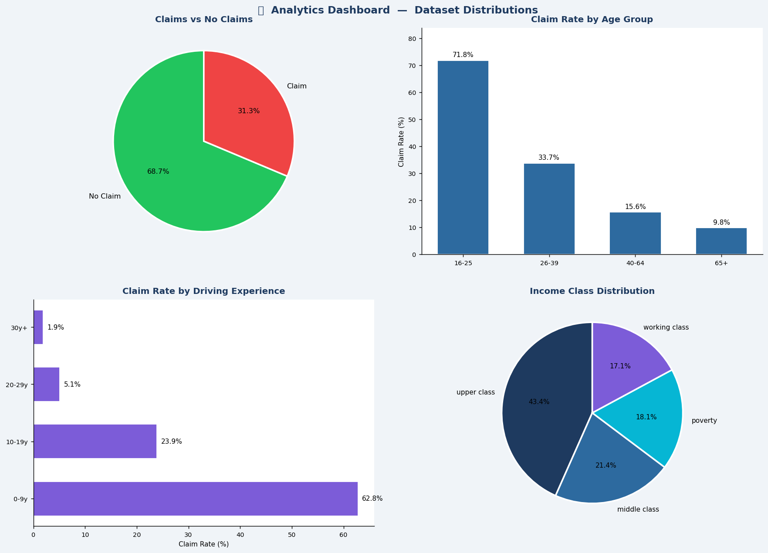
Screenshot 5 — Dashboard: EDA charts grid (claims, age, experience, income)

10. System Architecture
ARCHITECTURE: Streamlit (port 8501) → HTTP POST/GET → Flask REST API (port 5000) → model.pkl. Frontend and backend are fully decoupled — any HTTP client can call the API directly.
File | Role | Key Libraries
train_model.py | Training pipeline — data, 3 models, model.pkl | pandas, scikit-learn, matplotlib
app.py | Flask REST API — POST /predict, GET /stats | flask, flask-cors, numpy
streamlit_app.py | Streamlit UI — Predict + Dashboard pages | streamlit, requests, matplotlib
generate_screenshots.py | Renders all 6 UI mockup PNGs | matplotlib, pandas, pickle
generate_report.py | Self-contained HTML report (base64 images) | matplotlib, seaborn, sklearn
generate_docx.py | This Word document report | python-docx, matplotlib, sklearn
model.pkl | Serialised: model + encoders + metadata | pickle
requirements.txt | All Python package pins | —

11. How to Run
Step | Terminal | Command | Result
1 | Any | pip install -r requirements.txt | All dependencies installed
2 | Any | python train_model.py | model.pkl + evaluation plot created
3 | A | python app.py | Flask API on http://127.0.0.1:5000
4 | B | streamlit run streamlit_app.py | Streamlit UI on http://localhost:8501
5 | Any | python generate_screenshots.py | 6 PNG mockups in static/screenshots/
6 | Any | python generate_report.py | project_report.html created
7 | Any | python generate_docx.py | project_report.docx created
IMPORTANT: Flask API (Step 3) must be running BEFORE opening the Streamlit UI (Step 4). Both terminals must remain open simultaneously during use.

12. Future Scope
The current system provides a solid production-grade baseline. The following improvements are prioritised by expected impact and implementation effort.

12.1 — Model Improvements
Enhancement | Description | Expected Impact
XGBoost / LightGBM | Replace GBM with native categorical support + GPU speed | AUC +0.01 to +0.03
Hyperparameter Tuning | Optuna Bayesian search for learning_rate, depth, trees | AUC +0.005 to +0.02
SMOTE Oversampling | Synthetic minority oversampling to address class imbalance | Claim recall +5-8%
Threshold Optimisation | Precision-Recall curve analysis to find optimal threshold | Better FP/FN trade-off
Stacked Ensemble | Meta-learner combining all 3 base models | AUC +0.01 to +0.02

12.2 — Feature Engineering
Feature Addition | Description | Expected Impact
Telematics / UBI Data | Hard braking, night driving %, average speed from IoT | AUC +0.03 to +0.08
Geospatial Risk Scores | Replace postal code with accident frequency per km2 | AUC +0.01 to +0.03
Policy History Features | Prior claims, years as customer, payment punctuality | AUC +0.02 to +0.04
Claim Severity Regression | Two-stage: predict claim likelihood, then claim amount | Enables expected-loss pricing
Weather / Road Risk Index | External data: seasonal accident rates by location | Regional pricing granularity

12.3 — System & Infrastructure
Improvement | Description | Benefit
Docker Containerisation | Flask + Streamlit as separate Docker containers | One-command cloud deployment
MLflow Experiment Tracking | Model versioning, metric logging, model registry | Full MLOps lifecycle management
API Authentication | JWT-based auth + rate limiting for Flask API | Production security baseline
Scheduled Retraining | Drift detection (Evidently AI) + auto-retrain trigger | Model freshness in production
Grafana Monitoring | Real-time API latency, prediction distribution tracking | Production observability

12.4 — Explainability & Fairness
Initiative | Description | Compliance Relevance
SHAP Explanations | Per-prediction feature attribution in API response | FCRA / ECOA adverse action notices
IBM AI Fairness 360 Audit | Disparate impact analysis across RACE, GENDER | Insurance regulatory compliance
LIME Integration | Local interpretable model-agnostic explanations | Customer-facing explanation reports
Model Card Documentation | Standardised model card with limitations and bias analysis | EU AI Act / governance requirements

12.5 — Recommended Next Steps (Priority Order)
- Step 1 — Threshold optimisation: tune classification threshold for optimal FN/FP trade-off
- Step 2 — SHAP integration: add per-prediction explanations to Flask API response
- Step 3 — LightGBM replacement: faster training + native categorical encoding + higher AUC
- Step 4 — Docker deployment: containerise for scalable cloud hosting
- Step 5 — Telematics feature ingestion: most impactful accuracy uplift possible

Car Insurance Claim Prediction | IBM AICTE AI/ML Internship Project | Made with IBM Bob

