

# SAMRIDDHI COLLEGE

(Affiliated to Tribhuvan University) Lokanthali-16, Bhaktapur

# Bachelor in Computer Science and Information Technology

Project Report on

Online HealthCare Management System

# “Online Doctor”

**Submitted by: Submitted to:**

Sandesh Pokharel Sarbin Sayami sir

Sanam Thapa

Jeevan Karki

Simanta Poudel

# Introduction

## Concept

The purpose of the project titled “UAlbany HealthCare Management System” is to exclusively

provide a web application which is user friendly, reliable, free of cost to University students,

Faculties and staff. In addition, this will provide patient’s with the ease of visiting a doctor for

their health related concerns/problems. Mainly, the system has two modules: Patient and

Administration. The administrator module will manage the doctor’s account. This involves the

addition and updating of doctors account’s. Data over the system will be well protected and data

processing will be very fast.

The purpose of the project titled “UAlbany HealthCare Management System” is to exclusively

provide a web application which is user friendly, reliable, free of cost to University students,

Faculties and staff. In addition, this will provide patient’s with the ease of visiting a doctor for

their health related concerns/problems. Mainly, the system has two modules: Patient and

Administration. The administrator module will manage the doctor’s account. This involves the

addition and updating of doctors account’s. Data over the system will be well protected and data

processing will be very fast.

The purpose of the project titled “UAlbany HealthCare Management System” is to exclusively

provide a web application which is user friendly, reliable, free of cost to University students,

Faculties and staff. In addition, this will provide patient’s with the ease of visiting a doctor for

their health related concerns/problems. Mainly, the system has two modules: Patient and

Administration. The administrator module will manage the doctor’s account. This involves the

addition and updating of doctors account’s. Data over the system will be well protected and data

processing will be very fast.

The purpose of the project titled “Online Doctor” is to exclusively provide a web app

which is user friendly, reliable, free of cost to University students, Faculties and staff.

In addition, this will provide patient’s with the ease of visiting a doctor for their

health related concerns/problems. Mainly, the system has two modules: Patient and

Administration. The administrator module will manage the doctor’s account. This involves

the addition and updating of doctors account’s. Data over the system will be well

protected and data processing will be very fast.

The Health Care project is going to be solely implemented for patients and web admin. In detail, the main function of the system is to register and store patients detailed medical record. Patient will be able to access their medical history at the click of a button. They can book an appointment specific to their problem through the web app. Patient can also contact doctor’s office seeking any information, refill prescription, request diagnosis report and suggestion on their current medical condition through email. Whenever notification is required to remind important dates/time to patient only email will be used and where money comes into the picture, the system checks the patient’s insurance first to help them save money. Administrator must have to register and sign up through special permission to access all modules available on the web. Administrator can verify the authentication of doctor and pharmacist before serving on the system.

## Functional Requirements

* + - Patients should be able to register into the system
    - Patient should be able to login to the system using their user id and password
    - Patient should be able to make appointments by choosing date, time and doctor
    - Patient should be able to view previous appointments
    - Patient should be able to cancel the upcoming appointments
    - Patient should get In-app notifications
    - Doctors should be able login into their system and view appointments
    - Admin should be able to add doctor
    - Admin should be able to manage users both doctors and patients

## Non-Functional Requirements

* + - Availability: The system must provide customers 24*7 hours online booking service except for a few hours for maintenance if required.
    - Usability: The system should support almost all the browsers (Chrome, Firefox, Edge, Safari, etc).
    - Understandability: The interface of the system should be user friendly and easy to understand.
    - Throughput: The system should be able to handle multiple users concurrently.
    - Response Time: Response Time must be fast
    - Accuracy: The appointments scheduling system should display the appointment time with appropriate time zones and user should not be able to choose any past date
    - Security: The system should be able to secure the user private information from unauthorized accesses

# Task Division and Schedule

## Task Division

The task was divided among 4 team members equally in different fields. Some were responsible for research, project planning, and documentation while others were responsible for development work.

## Schedule

The Schedule finalized is represented in the form of the Gantt Chart below. Project Management Tool (Specifically “Project Libre”) was used to realize the Gantt chart through the finalized schedule.

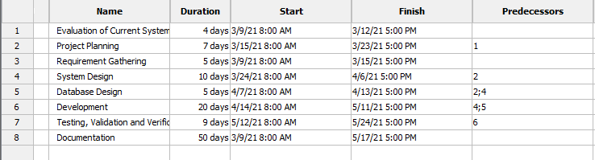

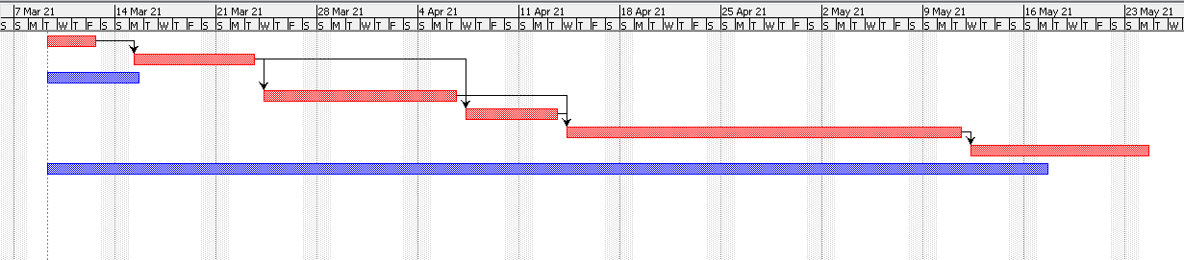

Figure 2.1.1 Gantt Chart

# System Model

## General Block diagram

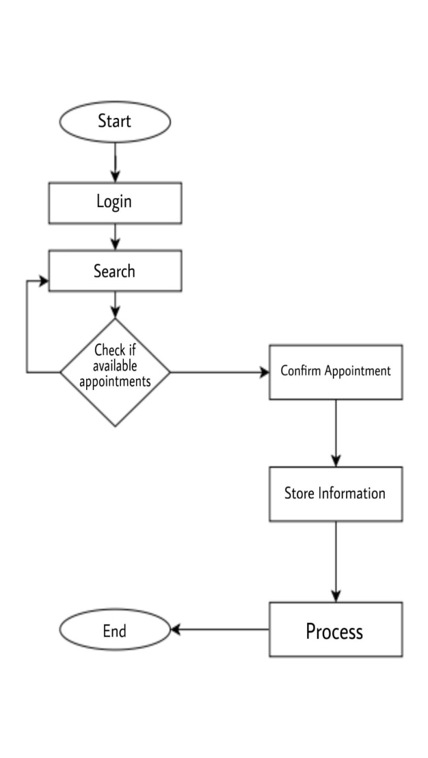

Figure 3.1.1. General Block Diagram

## Client-Server Model of the system

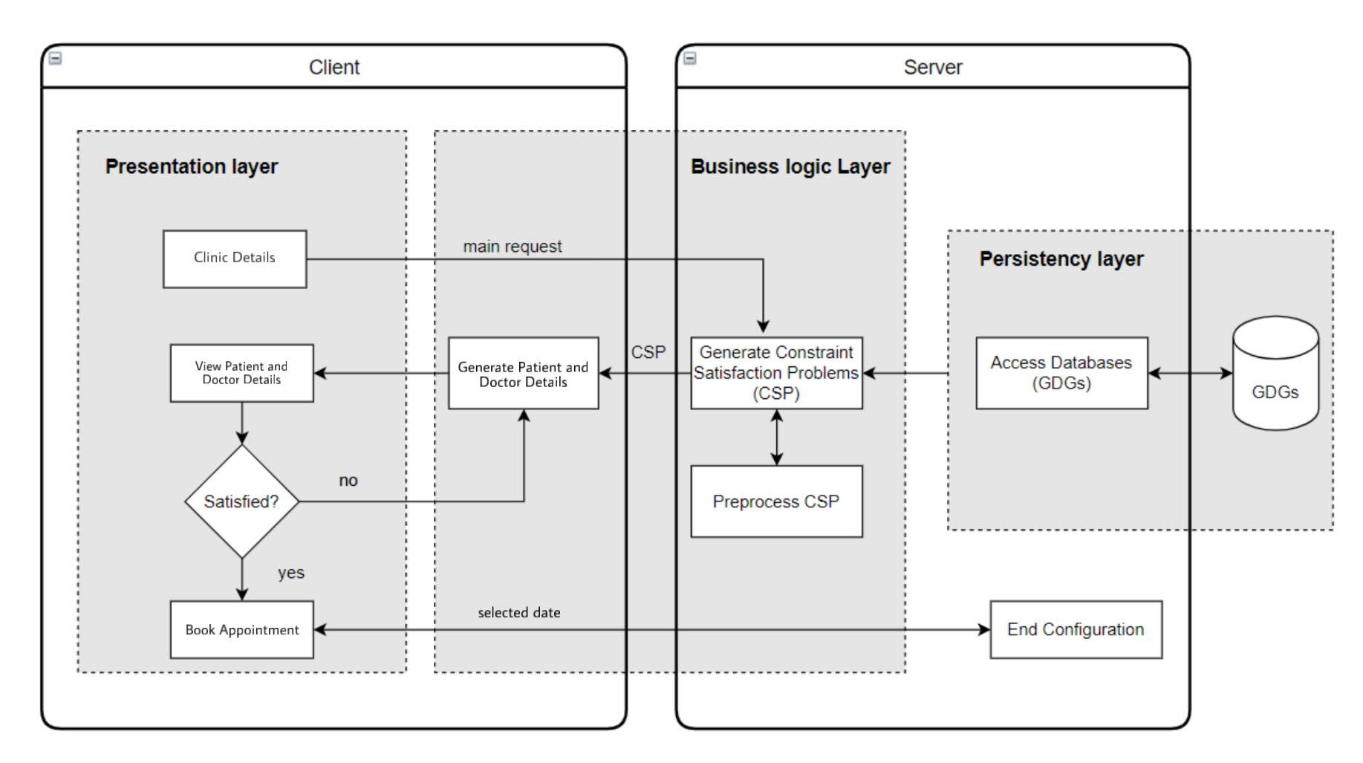

Figure 3.2.1. Client server model

# UML diagrams

UML design is the shortest form of “Unified Modelling Language”. The purpose of this modeling language is to visualize the design of the system. Some of the UML diagrams are:

* Use case Diagram
* Class Diagram
* Sequence Diagram
* Activity Diagram

## Use case diagram

It shows how the business system interacts with its environment and shows what the system

does rather than how. It illustrates the activities performed by users interacting with the system.

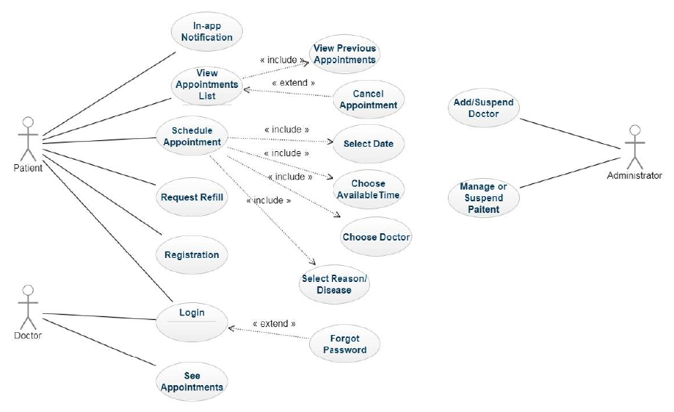

Figure 4.1.1: Use Case Diagram

## Class diagram

This is the most used UML diagram in the field of software engineering design. Usually, it illustrates the classes in a system, attributes and operations of each class, and shows the

relationship between each class.

Below is the “Class Diagram” of our new proposed system.

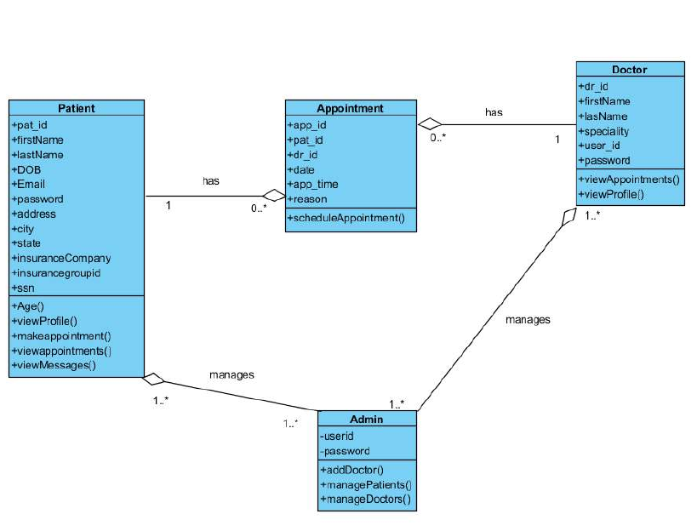

Figure 4.2.1 Class Diagram

## Sequence diagram

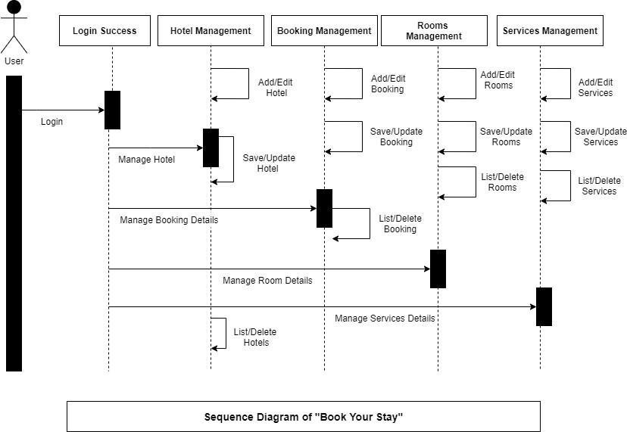

Figure 4.3.1 Sequence Diagram

## Activity diagram

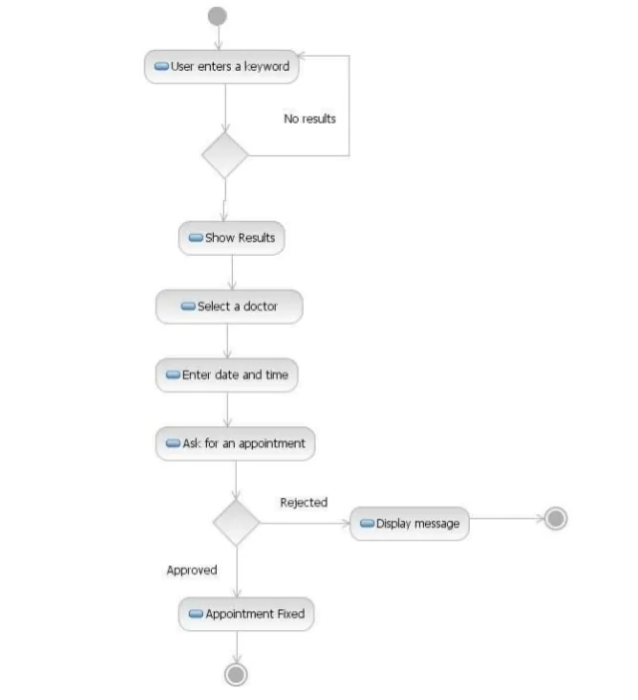

Figure 4.4.1 Activity Diagram

# Testing

## Test case design

Table 5.2.1 Test Cases for Sign in

|  |  |  |  |
| --- | --- | --- | --- |
| **Test Object** | **Test Condition** | **Expected Result** | **Actual** |
| 1. | Click the “Sign in” button  without email and/or password | Display Email Id and/or Password is required | As Expected |
| 2. | Click the “Sign in” button with wrong email and/or password | Display Email Id and/or Password is incorrect. Try Again |  |
| 3. | Click “Sign in” button with right email and password | Go to the account page of the user |  |

Table 5.2.2 Test cases for Sign up a new user

|  |  |  |  |
| --- | --- | --- | --- |
| **Test Object** | **Test Condition** | **Expected Result** | **Actual Result** |
| 1. | Signup with previously existing email | Display message to user “Email already exists. Sign in Instead” |  |
| 2. | Signup without email | Display Error “Email is required” |  |

Table 5.2.3 Test cases for Booking an Appointment

|  |  |  |  |
| --- | --- | --- | --- |
| **Test Object** | **Test Condition** | **Expected Result** | **Actual Result** |
| 1. | Book Now button | Book Now button in page redirects to page with a booking form |  |
| 2. | Click Submit/ Confirm Booking without filling in information | Prompts related errors/ messages. |  |
| 3. | Click Submit with all details | Prompts booking success message and emails site admin about the booking details |  |

# UI design

## Home Page

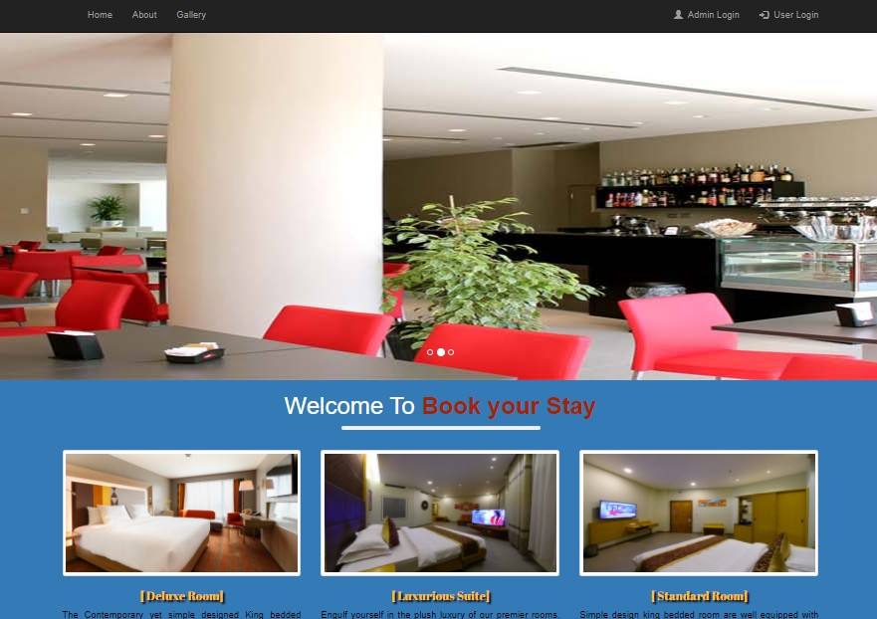

* 1. User Login Page

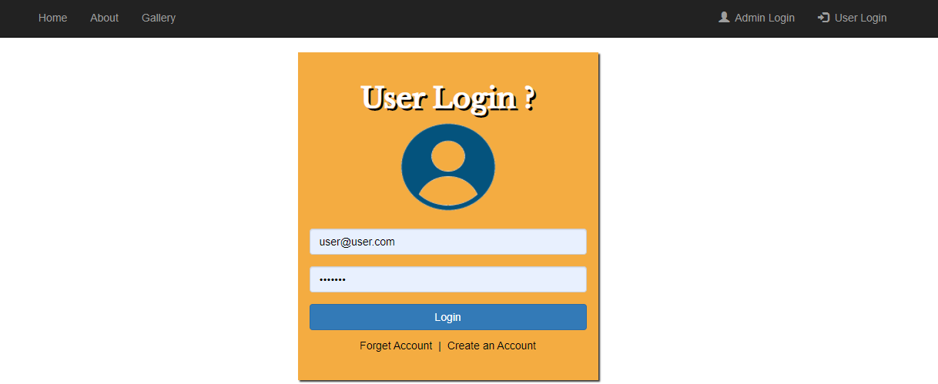

* 1. Admin Login Page

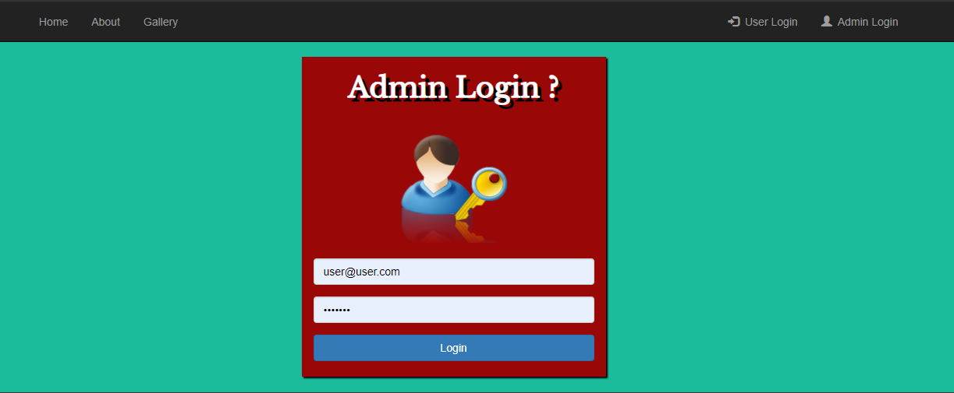

* 1. Room Detail Page

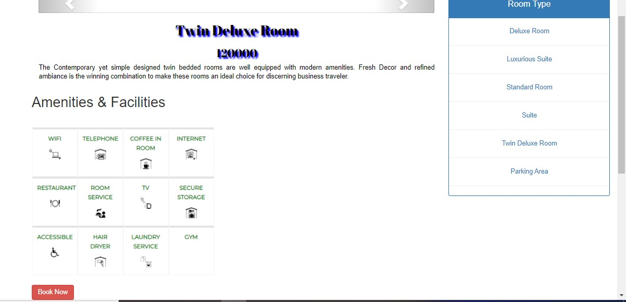

* 1. Booking Form

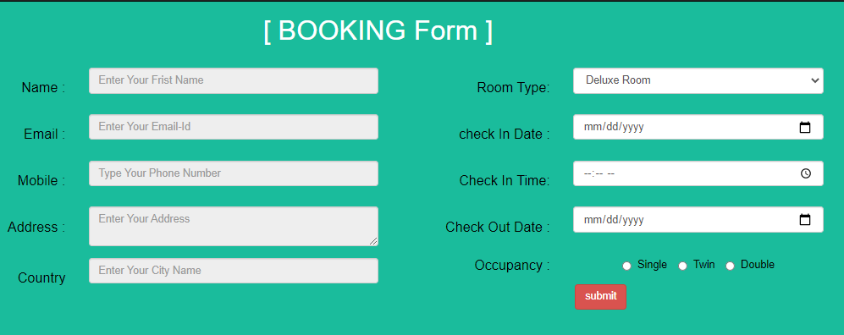

1. **Conclusion**

The system is beneficial for both management and patients. The application is built for laptop or desktop view however will be available in mobile view in a future enhancement. Patients can book appointment online after registering into the system and doctors can their appointment schedule online. Again, patients don’t need to worry about payment in advance. Hence, the overall system will give the patients, departments and doctors a better user-friendly environment to view all available information and use that to perform necessary functionalities online.