


Srishyla Educational Trust®

GM UNIVERSITY
(Established under the Karnataka State Act No.19 of 2023) Post Box No.4, Davanagere - 577006

Project Based Learning Semester: III
(UE24CS2306)
PBL Report

“AI-Driven Spatio-Temporal Traffic Intelligence System for Traffic Forecasting and Congestion Optimization”

Section- [your section]

Submitted By,
[Member 1 name] [USN 1]
[Member 2 name] [USN 2]
[Member 3 name] [USN 3]
[Member 4 name] [USN 4]

PBL Coordinator Guide

[Coordinator name] [Guide name]

CONTENTS

1. ABSTRACT

2. INTRODUCTION

3. PROBLEM STATEMENT

4. OBJECTIVES

5. METHODOLOGY

6. SOFTWARE AND HARDWARE REQUIREMENTS

7. CONCLUSION

1. ABSTRACT

Traffic congestion is one of the most visible problems of large cities. A spatio-temporal traffic intelligence system treats the road network as a graph of connected roads and the traffic on every road as a time series, so that the traffic of the next few minutes can be predicted from the traffic of the past hour. Data comes from sensors or from GPS probe vehicles, is cleaned and arranged on a regular time grid, and is passed to forecasting models that range from simple statistical baselines (historical average, ARIMA) to deep graph neural networks such as DCRNN, Graph WaveNet and STID. The predicted speeds can then be converted into predicted travel times, which allows congestion to be flagged early and less-congested routes to be recommended. The main challenges are missing and noisy data, sudden events such as rain and accidents, the lack of open data for Indian cities, and the licence terms of commercial data providers.

This report describes the design of such a system for the Outer Ring Road (ORR) of Bengaluru, from Silk Board to KR Puram, and the roads around it. The system forecasts the traffic speed on every road stretch for the next 15, 30 and 60 minutes and uses the forecasts for two kinds of congestion optimization: early congestion alerts and route recommendation, where the cost of a road is its length divided by its predicted speed and Dijkstra’s algorithm selects the fastest route. Models are first learned and validated on the public METR-LA and PEMS-BAY benchmarks, and then applied to our own dataset of 21 connected road stretches, collected around the clock since 27 September 2026 together with weather and incident data. Evaluation uses MAE, RMSE and MAPE on a chronological split. At the end of Phase-1 the problem has been scoped, the literature has been reviewed and the data pipeline is running.

2. INTRODUCTION

Road traffic has become a daily challenge in fast-growing cities such as Bengaluru. Corridors like the Outer Ring Road, which connects the main technology and residential areas, carry very heavy traffic in the morning and evening, and a single slow stretch can delay thousands of vehicles. Intelligent Transportation Systems (ITS) use sensing, data analysis and communication to manage such traffic, and forecasting is one of their most useful building blocks.
Traffic is not random. It follows daily and weekly rhythms (rush hours, weekends) and it is disturbed by shocks such as rain, accidents, road works and events. It is also a network phenomenon: a jam on one road slows the roads that feed it. A forecast is therefore most accurate when it uses both the recent history of a road (time) and the state of the connected roads (space). This is what the term spatio-temporal means.
Most commonly used tools show the present state of traffic. Navigation applications display live speeds and estimate arrival times, but their models are proprietary and cannot be inspected or tuned for a study region. Classical statistical models such as the historical average and ARIMA forecast every road independently and lose accuracy quickly as the horizon grows. Since 2018, graph neural networks such as DCRNN, STGCN and Graph WaveNet have shown that modelling the road network reduces the 60-minute forecast error to about half of that of ARIMA on the METR-LA benchmark.
Building such a system for an Indian city does not require installing sensors on every road. Commercial providers derive road speeds from the GPS traces of vehicles and phones, and public benchmarks such as METR-LA and PEMS-BAY allow models to be developed and compared fairly. In this project, speeds for 21 road stretches on the Outer Ring Road and its feeder roads are collected automatically every 15 minutes in the two rush-hour windows and less often at other times, together with weather and traffic incidents, and the road stretches are connected into a graph using OpenStreetMap.
The proposed system forecasts the speed on every road stretch for the next 15, 30 and 60 minutes, converts the forecasts into congestion alerts, and recommends the route with the lowest predicted travel time. It is built as a complete pipeline: data collection, road graph, forecasting models, optimization (alerts and routes) and a map dashboard, rather than only a trained model.

3. PROBLEM STATEMENT

The project title is “AI-Driven Spatio-Temporal Traffic Intelligence System for Traffic Forecasting and Congestion Optimization”. In practice, congestion on arterial roads such as the Bengaluru Outer Ring Road is noticed only after it has formed. Drivers see the current speeds on a navigation map, but they cannot see where the traffic will be in 30 or 60 minutes, and traffic authorities have no open, region-specific forecast to plan with. Statistical forecasts that treat each road alone ignore how a jam spreads along connected roads, and the best deep learning models are normally evaluated only on freeway sensors in the United States.

The core problem is: given the past T time steps of speed at N connected road stretches of a region, predict the next T’ steps at all N stretches (by default T = T’ = 12 steps of 5 minutes, reported at 15, 30 and 60 minutes), and use the predicted speeds to warn about congestion and to recommend the route with the lowest predicted travel time. The system should therefore:

- Collect and store speed, weather and incident data for a connected corridor automatically, without field sensors.

- Represent the corridor as a directed road graph that links each stretch to the stretches it leads into.

- Forecast the speed of every stretch 15, 30 and 60 minutes ahead more accurately than simple baselines.

- Turn the forecasts into congestion alerts and into the fastest route between two points, shown on a dashboard.

5. Be reproducible, low-cost (free data tiers) and respect the licence terms of its data sources.

4. OBJECTIVES

The primary objectives of this traffic forecasting and congestion optimization system are:

- Dataset: To build a spatio-temporal dataset from the public METR-LA and PEMS-BAY benchmarks and from our own Bengaluru Outer Ring Road corridor of 21 stretches, with weather and incident data.
- Road Network Model: To model the corridor as a directed graph, with stretches as nodes, drivable links as edges and OpenStreetMap features such as signals, lanes and speed limits.
- Speed Forecasting: To predict speed 15, 30 and 60 minutes ahead and to compare Historical Average, XGBoost, LSTM, Graph WaveNet and STID.
- Fair Evaluation: To use a chronological train, validation and test split and masked MAE, RMSE and MAPE at every horizon, so that every claim can be checked.
- Congestion Optimization: To give early congestion warnings and to recommend routes by Dijkstra’s algorithm on predicted travel time, delivered through an API and a map dashboard.
- To collect at least four to six weeks of continuous data from the Outer Ring Road corridor.
- To report forecast errors at 15, 30 and 60 minutes and show whether graph models beat the baselines.
- To flag a stretch as congested when its predicted speed falls well below its free-flow speed.
- To show that the recommended route has a lower predicted travel time than the route chosen from current speeds.
- To keep the system low-cost and reproducible by using free data tiers and open-source tools.

5. METHODOLOGY

The system follows a five-stage pipeline: Data Collection, Road Network Construction, Preprocessing and Forecasting, Congestion Optimization, and Application (API and dashboard).

5.1. Data Collection
Every collection run asks the TomTom Traffic Flow service for the current speed, free-flow speed and travel time of each of 21 road stretches (17 on the Outer Ring Road in both directions and 4 on Hosur Road, Old Airport Road and Varthur Road), the Open-Meteo service for weather, and the TomTom incident service for accidents, closures and road works. The Outer Ring Road stretches are read every 15 minutes in the windows 08:07 to 10:07 and 17:37 to 20:07 IST, every 30 minutes around them and every 2 hours at night, which keeps the project inside the free request limits. A scheduled GitHub Actions workflow runs the collector around the clock, and the readings are stored in a private repository because the provider’s terms do not allow publishing them. The public METR-LA and PEMS-BAY datasets are used for learning and validation.

5.2. Road Network Construction
TomTom returns each stretch as a piece of road of very different length (0.65 km to 14.6 km). The network builder walks along the road: it asks for the stretch under a seed point, steps a few metres past its end and asks again, which chains the stretches without gaps. A directed link is created when a vehicle can drive from the end of one stretch into the start of the next, and a crossing record is created where two roads cross. OpenStreetMap adds road class, lanes, speed limit, traffic signals, intersections and nearby schools, offices, bus stops and metro stations to every stretch.

5.3. Preprocessing and Forecasting
Readings are resampled to a regular 15-minute grid, a fixed reference (free-flow) speed is used for each road instead of the noisy value reported at each reading, and data are split chronologically (70% training, 10% validation, 20% testing) with normalization statistics taken from the training part only. Historical Average, XGBoost and LSTM are the baselines; Graph WaveNet and STID are the main models. Metrics are MAE, RMSE and MAPE with missing values masked, reported at 15, 30 and 60 minutes.

5.4. Congestion Optimization
A stretch is flagged as congested when its predicted speed falls well below its reference speed. For route recommendation the predicted travel time of a stretch is its length divided by its predicted speed at the time the vehicle reaches it, and Dijkstra’s shortest-path algorithm on the road graph selects the route with the lowest total predicted travel time.

5.5. Application and Dashboard
The forecasts, alerts and recommended routes are served through an API and shown on a map dashboard in which every road stretch is coloured by its predicted speed at +15, +30 and +60 minutes.

FLOWCHART

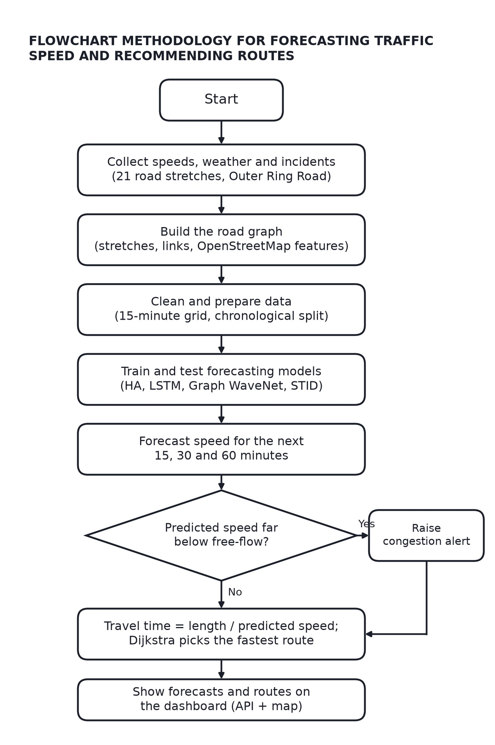

6. SOFTWARE AND HARDWARE REQUIREMENTS

6.1. Hardware Specifications
Component | Function | Example Components
Computer / Laptop | Runs data preparation, baseline models and the dashboard; development and testing. | Laptop with at least 8 GB RAM, Python 3 installed.
GPU (cloud) | Trains the deep spatio-temporal models (Graph WaveNet, STID) faster than a CPU. | Google Colab or Kaggle free GPU (NVIDIA T4 class).
Cloud runner | Runs the data collector around the clock without a machine of our own. | GitHub Actions hosted runner (Ubuntu).
Data storage | Keeps the collected speed, weather and incident readings. | Private GitHub repository (CSV files).
Internet connection | Needed for the data services and for the cloud tools. | Broadband or mobile data.

6.2. Software Specifications

Component | Function | Example Technologies
Language and libraries | Data collection, preprocessing, baselines and evaluation. | Python 3 with NumPy, pandas, scikit-learn and XGBoost.
Deep learning framework | Builds and trains the forecasting models. | PyTorch, with the BasicTS or LibCity benchmark toolkits.
Data sources | Traffic speed, weather, incidents, road map and benchmark datasets. | TomTom Traffic API, Open-Meteo, OpenStreetMap (Overpass), METR-LA and PEMS-BAY.
Routing and API | Computes fastest routes and serves forecasts. | NetworkX (Dijkstra) and FastAPI.
Dashboard and automation | Shows predicted speeds and routes on a map; schedules the collector. | Web map (Leaflet) and GitHub Actions workflows.

Conclusion

In conclusion, a spatio-temporal traffic intelligence system that forecasts speed on connected road stretches and turns the forecasts into congestion alerts and route recommendations addresses a clear gap: existing tools show current traffic, but do not offer open, network-aware, region-specific forecasts that can be tested and tuned. By using GPS-derived speed data from a commercial provider instead of field sensors, the project can study a real Bengaluru corridor at low cost.
So far, the problem has been scoped, the literature on graph-based traffic forecasting has been reviewed, a 24-hour automatic data collector is running on 21 stretches of the Outer Ring Road corridor, and the road stretches have been connected into a directed graph with OpenStreetMap features. No forecasting results are claimed at this stage.

The next phase is to reproduce the baselines on METR-LA, train the models on four to six weeks of Bengaluru data, and build the congestion alerts, route recommendation and dashboard. With further data and models, the system can be extended to more corridors and to the whole city.

