**VISVESVARAYA TECHNOLOGICAL UNIVERSITY**

**Jnana Sangama, Belagavi, Karnataka-590018**



Technical Seminar Report

on

**“Toward** **5G Edge Computing for Enabling Autonomous Aerial Vehicles”**

Submitted in partial fulfillment of the requirements for the award of the degree of

#### Bachelor of Engineering

in

#### Electronics and Communication Engineering

Submitted by

### SANDESH G NAIK 1BI20EC127

Under the guidance of

#### Mr. GAHAN A V

**Assistant Professor Department of ECE**



**Department of Electronics and Communication Engineering**

### BANGALORE INSTITUTE OF TECHNOLOGY

**KR Road, VV Puram, Bangalore – 560004**

**2023-2024**

# BANGALORE INSTITUTE OF TECHNOLOGY

K.R Road, V.V Puram, Bangalore 560004 Phone:26613237/26615865, Fax:22426796

[www.bit-bangalore.edu.in](http://www.bit-bangalore.edu.in/)



#### Department of Electronics and Communication Engineering

**CERTIFICATE**

This is to certify that the seminar report entitled **“ Toward 5G Edge Computing for Enabling Autonomous Aerial Vehicles ”** has been submitted by **SANDESH G NAIK, USN: 1BI20EC127,** a bonafide student of **Bangalore Institute Of Technology** in partial fulfillment for the award of **Bachelor of Engineering** in **Electronics and Communication Engineering** of the **Visvesvaraya Technological University**, Belgaum during the year 2023-2024.

##### Mr. GAHAN A V Dr. HEMANTH KUMAR A R

Assistant Professor Professor & HOD

BIT, Bangalore BIT, Bangalore

# ACKNOWLEDGEMENT

I would like to thank my guide, **Mr. GAHAN A V**, Assistant Professor, ECE Department, BIT, Bangalore for guiding me untiringly all through my tenure.

I would like to thank the Technical Seminar Coordinator **Dr . C P NARENDRA**, Associate Professor, and **Dr**. **NAVANEETH NATARAJ**, Assistant Professor, ECE Department, BIT, Bangalore for their guidance.

I would like to thank **Dr . HEMANTH KUMAR A.R,** Head of the Department, ECE, BIT, Bangalore for this opportunity to present this seminar on an IEEE paper of my choice and interest and for his encouragement to complete the same with utmost fidelity.

I extend my gratitude to **Dr . ASWATH M U**, Principal, BIT, Bangalore, for his encouragement and support.

I am fortunate to be part of BIT, the institution that stood by my side and assisted me in successfully completing the Technical Seminar. I also take this opportunity to thank the **Department of Electronics and Communication, BIT** for their tremendous help and guidance.

##### SANDESH G NAIK

##### 1BI20EC127

**VISION AND MISSION OF COLLEGE**

### BANGALORE INSTITUTE OF TECHNOLOGY

#### Vision

* To establish and develop the Institute as a Centre of higher learning, ever abreast with expanding horizon of knowledge in the field of engineering and technology, with entrepreneurial thinking, leadership excellence for life-long success, and solve societal problems.

#### Mission

* Provide high-quality education in the engineering disciplines from the undergraduate to doctoral levels with creative academic and professional programs.
* Develop the Institute as a leader in Science, Engineering, Technology and management, Research, and apply knowledge for the benefit of society.
* Establish mutual beneficial partnerships with industry, alumni, local, state and central governments by public service assistance and collaborative research.
* Inculcate personality development through sports, cultural and extracurricular activities and engage in the social, economic and professional challenges.

### VISION AND MISSION OF DEPARTMENT

**DEPARTMENT OF ELECTRONICS AND COMMUNICATION ENGINEERING BANGALORE INSTITUTE OF TECHNOLOGY**

#### Vision

* + Imparting Quality Education to achieve Academic Excellence in Electronics and Communication Engineering for Global Competent Engineers.

#### Mission

* + Create state of art infrastructure for quality education.
  + Nurture innovative concepts and problem solving skills.
  + Delivering Professional Engineers to meet the societal needs

# ABSTRACT

Offloading processes responsible for a robot’s control operation to external computational resources has been in the spotlight for many years. The vision of having access to a full cloud cluster for any autonomous robot has fueled many scientific fields. Such implementations rely strongly on a robust communication link between the robot and the cloud and have been tested over numerous network architectures. However, various limitations have been highlighted upon the realization of such platforms. For small-scale local deployments, technologies such as Wi-Fi, Zigbee, and blacktooth are inexpensive and easy to use but suffer from low transmit power and outdoor coverage limitations. In this study, the offloading time-critical control operations for an unmanned aerial vehicle (UAV) using cellular network technologies were evaluated and demonstrated experimentally, focusing on the 5G technology. The control process was hosted on an edge server that served as a ground control station (GCS). The server performs all the computations required for the autonomous operation of the UAV and sends the action commands back to the UAV over the 5G interface. This research focuses on analyzing the low-latency needs of a closed-loop control system that is put to the test on a real 5G network. Furthermore, practical limitations, integration challenges, the intended cellular architecture, and the corresponding Key Performance Indicators (KPIs) that correlate to the real-life behavior of the UAV are rigorously studied.

**Keywords:_**5G,_edgecomputing,_robotics,_UAV. V

**TABLE OF CONTENTS**

|  |  |  |  |
| --- | --- | --- | --- |
| **CHAPTER** | **TITLE** | **PAGE NO** |  |
| **1** | **INTRODUCTION** |  |  |
|  | 1.1 Background of UAVs | 2 |  |
|  | 1.1.1 IOT | 4 |  |
|  | 1.1.2 Cloud | 5 |  |
|  | 1.2 Need and Feasibly | **6** |  |
|  | 1.3 Application | 8 |  |
|  | 1.4 System design & Architecture |  |  |
| **2** | **RELATED STUDY** |  |  |
|  | 2.1 Motivation | 13 |  |
|  | 2.1.1 Related Works | 13 |  |
|  | 2.2 Contribution | 15 |  |
| **3** | **METHODOLOGY** |  |  |
|  | 3.1 System Model | 19 |  |
|  | 3.2 Devices & Hardware | 20 |  |
|  | 3.3 Closed Loop Control Architecture | 20 |  |
|  | 3.4 Robot - Edge Server Communication | 22 |  |
|  | 3.5 Impact of Latencies in the Close Loop System | 23 |  |
|  | 3.6 Collision Avoidance Use-Case | 25 |  |
|  | 3.7 System Latency Evaluation | 27 |  |

**LIST OF FIGURES**

|  |  |  |
| --- | --- | --- |
| **SL. NO** | **TITLE** | **PAGE NO.** |
| 1.1 | Baseline network architecture of cellular UAV communication. Payload (data link) vs. non-payload (CNPC) communication | 3 |
| 1.2 | Three different network topologies for the used experimental setup | 4 |
| 1.3 | System architecture for the UAV communication over 5G to the edge | 10 |
| 2.1 | Application-based categorization of UAV Navigation | 16 |
| 3.1 | Edge server oriented proposed closed loop control architecture | 21 |
| 3.2 | ROS multiple machine node topology over wide area networks | 23 |
| 3.3 | Latency behavior expected at the UAV trajectory | 24 |
| 3.4 | Complete data flow regarding the collision avoidance use-case | 27 |

# CHAPTER 1

**INTRODUCTION**

The idea of moving the processes responsible for controlling the robot to external computing resources has been around for many years. It's a vision that has fueled many scientific fields, including robotics, artificial intelligence and cloud computing. The ability to access a full cloud cluster for any autonomous robot has the potential to revolutionize robotics and make robots smarter, more efficient and more autonomous.

However, the introduction of such a system is not without problems. One of the biggest challenges is the need for a robust communication link between the robot and the cloud. This requires a reliable and broadband network architecture that can support the transfer of large amounts of data in real time.

In this study, researchers evaluated the feasibility of using cellular network technologies, specifically 5G, to offload time-critical control operations for an unmanned aerial vehicle (UAV). The control process was hosted on an edge server that served as the ground control station (GCS). The server performed all the calculations required for the autonomous operation of the UAV and sent action commands back to the UAV via the 5G interface.

The researchers focused on analyzing the low-latency needs of a closed-loop control system that is being tested on a real 5G network. They studied the practical constraints, integration challenges, intended cellular architecture, and corresponding key performance indicators (KPIs) that correlate with real-world UAV behavior.

The use of cellular network technologies to offload control operations has several advantages. Cellular networks are ubiquitous and can provide large area coverage, making them suitable for outdoor applications. They also provide wide band, low-latency communications that are critical for real-time control operations.

Researchers have found that 5G technology is particularly well-suited to lighten control operations for UAVs. It provides broadband communication with low latency and can support multiple simultaneous connections, making it suitable for controlling multiple UAVs at the same time.

However, there are also several challenges associated with using 5G for landing management operations. One of the biggest challenges is the limited coverage area of 5G networks, which can be a problem for UAVs that need to operate in remote or hard-to-reach areas. In addition, the reliability of 5G networks may be affected by environmental factors such as weather conditions or interference from other wireless devices.

Overall, the study demonstrates the feasibility of using 5G for UAV relief control operations. However, further research is needed to address the challenges associated with using cellular networks to control UAVs. This includes improving network coverage and reliability, developing robust communication protocols, and addressing cyber security issues.

* 1. **Background of Unmanned Aerial Vehicles (UAVs):**

Unmanned aerial vehicles (UAVs) are gaining increasing interest in both the research and industrial communities. UAVs offer a wide range of capabilities, including ease of deployment, high maneuverability and range, as well as the ability to carry different types of payloads for different needs. In many cases, a reliable real-time control channel is required for remote control of UAVs or large computing resources onboard the UAV. Researchers and organizations are exploring the manifestations of these capabilities, either by improving communication technologies or by focusing on optimizing algorithms that take into account available onboard resources.

In recent years, there has been a consideration of solving both problems in a common architecture. A possible solution would be the combination of a large external computing resource in synergy with a reliable communication system enabling the transfer of data from sensors in real time. A number of organizations have considered the possibility of using application servers near the sensing platform or agent to offload computationally intensive tasks. Such servers are usually called Edge servers, and this term usually expresses the characteristic of these servers to be as close as possible to the corresponding agent. This practice primarily serves the latency requirements of the corresponding applications. An edge server performing computationally intensive tasks allows modest platforms to perform more complex tasks and offers the opportunity to explore other cloud technologies such as distributed processing, containers, container orchestrators, etc.

However, external computing resources for serving real-time applications require a reliable communication system. In this study, offloading the time-critical control operation for UAVs using cellular network technologies was evaluated and experimentally demonstrated. The use of the mobile network, and especially the 5G network, for communication with UAVs brings a number of new possibilities and functions to this area. Higher data rates, lower latency, increased coverage and the potential use of 5G Quality of Service (QoS) features are some of the most notable. In addition, 5G networks enable the use of remote technology in time-critical applications such as remote medicine applications, the Industry 4.0 paradigm, 5G-connected vehicles and 5G-connected Internet of Things, as well as 5G-connected UAVs and unmanned aerial systems (UAS).

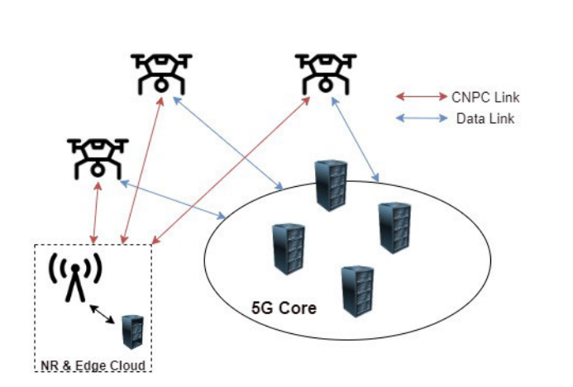

**Fig. 1.1 :** Baseline network architecture of cellular UAV communication. Payload (data link) vs. non-payload (CNPC) communication.

Undoubtedly, one of the significant advantages of considering operating UAVs over cellular networks would be the utilization of installed infrastructure and the coverage advantages that area-wide cellular technologies offer compared to local wireless solutions. Applications such as UAV-assisted power line inspection, port inspection, and other demanding long-distance applications are expected to benefit from the use of cellular networks. In conventional cellular networks, application servers are usually located in the cloud; communication with the UAV therefore suffers from latency effects. With the edge server option, mobile network providers have the ability to connect an edge server to a base station (BS), avoiding wide area routing and significantly reducing system latency.

UAV communications are generally divided into two groups: control and non-payload communications (CNPC) and payload communications. The baseline architecture is shown in Fig.1. CNPC links are responsible for the control and operation of the UAV. It must meet a strict set of requirements to maintain safe and reliable flight operations. Many studies have indicated rough requirements regarding CNPC and payload communication links. In addition to the CNPC link, many studies consider UAVs as a sensing platform and propose their application around the payload communication link. During this definition, other important indicators revolve around throughput and Age of Information (AoI) metrics and address various complex issues. These indicators are often used together; a sample of exciting and promising communication scheme optimization problems would include path planning scenarios where AoI, throughput, round-trip packet latency, and energy consumption are dominant factors in solving these problems. The autonomous operation of a 5G enabled UAV is presented and operated by utilizing an edge server solution. The focus is on comparing the performance with that of similar architectures. The architecture of each scenario is illustrated in Fig. 2. We name the three architectures as 1) Local 5G & Edge Cloud, 2) 5G with remote core & Cloud and 3) Public LTE & Cloud.

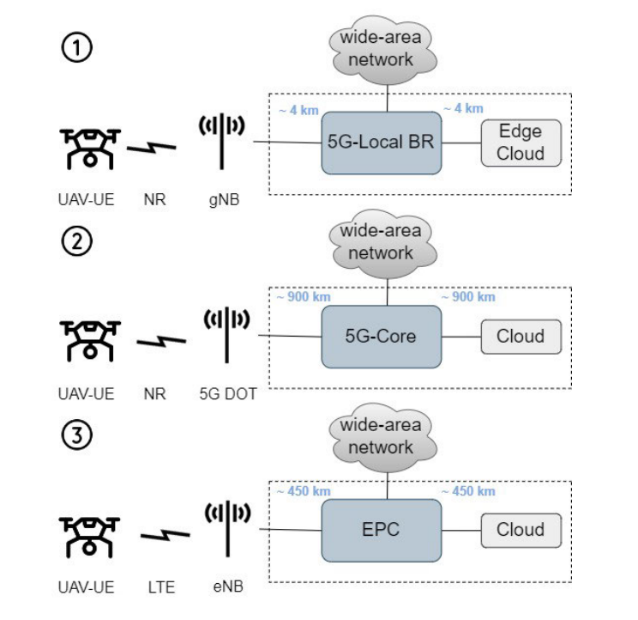

**Fig. 1.2 :** Three different network topologies for the used experimental setup.

**1.1.1 IOT:**

The Internet of Things (IoT) is the term used to refer to the communication between people to things and things to things. In today’s society, technology is improving at an exponential rate. Broadband Internet is more widely available and more cost-efficient than ever before. Technology costs are going down and as of 2018, 36% of the world’s population use smart phones. The number of smart phone users worldwide is forecast to grow from 2.1 billion in 2016 to around 2.5 billion in 2019. IoT is the focus of research, and industries are investing heavily due to the potential benefits of IoT in various fields. All of these things are creating a ripe environment for IoT.

The health-care industry is benefiting from the technological advances that IoT has to offer with improved access to care, increased quality, efficiency, and reduced costs. As the technology for collecting, analyzing and transmitting data in the IoT continues to grow, more IoT-driven health-care applications, services, and systems emerge. Currently, many vehicles are equipped with an automatic crash response system that can communicate with a server in the Cloud alerting a paid provider of an emergency. Once the provider has been alerted, an operator communicates back with the driver to get further instruction and sends emergency personnel if necessary. This paper proposes a system that can eliminate the need for an operator. When the vehicle is in an accident it communicates directly with emergency services and family members giving the severity of the accident, GPS location, and the car ID. Ambulances are currently capable of sending patient information to the hospital. The uniqueness of this project is that sensors detect an accident and information is sent immediately to the ambulance, thus eliminating the need for an intermediary step.

**1.1.2 Cloud:**

Cloud computing refers to the delivery of computing services over the internet, including servers, storage, databases, networking, software, and analytics. Instead of having physical hardware and infrastructure on-premises, cloud computing enables users to access these resources remotely via the internet.

There are several types of cloud computing services available, including:

1. Infrastructure as a Service (IaaS): provides users with virtualized computing resources such as servers, storage, and networking.
2. Platform as a Service (PaaS): provides users with a complete platform to develop, run, and manage applications without having to worry about the underlying infrastructure.
3. Software as a Service (SaaS): provides users with access to software applications over the internet, eliminating the need to install and maintain software locally.

The use of cloud in the project "Toward 5G Edge Computing for Enabling Autonomous Aerial Vehicles" is to enable the real-time transmission of sensor data by combining a large external computational resource in synergy with a reliable communication system. The project focuses on evaluating and demonstrating experimentally the offloading of a time-critical control operation for an unmanned aerial vehicle (UAV) using cellular network technologies, specifically 5G networks.

Cloud computing provides the external computational resources necessary for UAVs to perform more complex tasks, such as distributed processing and container orchestration. The cloud also enables the use of other cloud technologies, such as edge servers, for offloading computational demanding tasks. Edge servers are typically located close to the corresponding agent, which primarily serves the latency requirements of the corresponding applications.

In this project, the use of cloud in combination with 5G cellular networks allows for higher data rates, lower latency, increased coverage, and the potential use of the 5G Quality of Service (QoS) features. The use of cloud also enables the utilization of the installed infrastructure and the coverage benefits that wide area cellular technologies offer compared with local area wireless network solutions. Additionally, the edge server option allows cellular network providers to collocate the edge server with a base station (BS), thereby avoiding wide area network routing and significantly reducing the latency of the system.

* 1. **NEED AND FEASIBLY**

Certainly! Unmanned Aerial Vehicles (UAVs) have a wide range of potential benefits, including cost-effectiveness, versatility, safety, efficiency, and precision. Let's explore these benefits in more detail:

1. Cost-effectiveness: One of the primary benefits of UAVs is their cost-effectiveness. Compared to traditional manned aircraft, UAVs are significantly less expensive to operate and maintain. This is because UAVs do not require a pilot or crew, and can be operated remotely. This reduces the cost of salaries, training, and equipment associated with manned aircraft. Additionally, UAVs can often be operated for longer periods of time than manned aircraft, allowing for greater efficiency in data collection or surveillance operations.
2. Versatility: UAVs can be used in a wide range of applications. Some common applications include surveying and mapping, search and rescue operations, inspection of critical infrastructure, environmental monitoring, and more. This versatility is due to the ability to equip UAVs with various payloads, such as high-resolution cameras, sensors, or even advanced AI algorithms for autonomous flight and decision-making.
3. Safety: UAVs can be used in hazardous environments, such as natural disasters or military operations, where it may be dangerous for humans to operate. This reduces the risk to human life and can also provide a quicker and more efficient response in emergency situations.
4. Efficiency: UAVs can cover large areas quickly and efficiently, reducing the time and cost required to complete a task. For example, a UAV equipped with a high-resolution camera can survey and map large areas of land in a fraction of the time it would take a human crew to do the same task. This efficiency can also reduce the carbon footprint associated with traditional manned aircraft.
5. Precision: UAVs can be equipped with high-resolution cameras and sensors, allowing for precise data collection and analysis. This is particularly useful in applications such as agriculture, where UAVs can collect data on crop health, soil moisture, and other variables to optimize crop yields.

However, the feasibility of using UAVs largely depends on the specific application and the regulatory environment in which they will be used. Factors such as regulations, technology, cost, and weather can all impact the feasibility of using UAVs. For example, regulations may restrict where and how UAVs can be flown, and inclement weather conditions may make it difficult or unsafe to operate UAVs. Additionally, the initial investment in purchasing and maintaining UAV equipment may be prohibitive for some organizations.

The feasibility of using UAVs largely depends on the specific application and the regulatory environment in which they will be used. Some factors to consider include:

Regulations: UAVs are subject to regulations and restrictions regarding where and how they can be flown, which may limit their feasibility in certain locations.

Technology: UAVs require a certain level of technological sophistication to operate, which may make them impractical or infeasible in some applications.

Cost: While UAVs can be more cost-effective than traditional

**1.3 APPLICATION**

**1. Autonomous Navigation:**

AI algorithms can be used to develop autonomous navigation systems for drones. With AI, drones can be programmed to fly themselves to specific destinations, avoid obstacles, and even react to changing weather conditions.

**2. Precision Agriculture:**

Drones equipped with AI can be used to collect and analyze data on crop health, soil moisture, and other environmental factors. This information can be used by farmers to optimize their irrigation and fertilization practices, leading to increased yields and reduced waste.

**3. Surveillance and Security:**

AI can be used to analyze the video footage captured by drones to detect and identify suspicious activities or objects, such as potential intruders, stolen vehicles, or lost items. Additionally, AI-powered drones can be used for crowd monitoring and management during large events or protests.

**4. Disaster Response:**

During natural disasters, drones can be deployed to gather real-time data on the affected areas, such as the extent of flooding or damage to buildings. With AI, this data can be quickly analyzed to identify areas that require immediate assistance, such as rescue operations or supplies delivery.

**5. Delivery Services:**

Companies like Amazon and Google are already exploring the use of drones for package delivery. AI can be used to optimize the delivery routes, manage the fleet of drones, and even predict demand in different areas.

**6. Environmental Monitoring:**

Drones equipped with sensors and AI can be used to collect data on air and water quality, as well as wildlife populations and habitat conditions. This information can be used to inform conservation efforts and improve environmental policies.

**7. UAVs for Inspection of Overhead Power Lines:**

Detection and prevention of faults from power lines is crucial for the availability and reliability of electricity supply. The drawbacks of traditional techniques include high cost, cumbersome deployment and hazardous risks. Therefore, UAV-aided power line distribution and transmission lines inspection have gained significant interest by researchers. Inspection of power lines also refers to the safety of a power transmission grid. UAV equipped with digital camera to take images of power lines corridors is a convenient approach to support these inspection tasks. UAVs can be used to trace power pylons for damaged bolts, corrosion or rust and lightning strikes. Short-circuiting of these power lines usually occurs due to harsh weather conditions, bush fires and tree falls. In a recent study, scholars discussed the installation of UAVs in the overhead power lines to identify faults. Both UAVs and climbing robots can be used to locate faults. UAVs can perform these inspection operations at lower cost than helicopters and low risk associated to conventional foot patrol.

**8. Real-Time Monitoring of Road Traffic:**

Road traffic monitoring (RTM) system constitutes a domain where the integration of UAVs has captured great interest. In RTM, the complete automation of transportation sector can be achieved through UAVs. It will include the automation of rescue teams, road surveyors, traffic police and field support teams. Reliable and smart UAVs can assist in the automation of these elements. UAVs have emerged as new promising tools to gather data about traffic conditions on highways. In contrast to conventional monitoring devices such as microwave sensors, surveillance videos cameras and loop detectors, cost-efficient drones can monitor huge road segments. Drones can be operated by local police to get a sharp vision of road accidents or massive security [crackdown](https://encyclopedia.pub/entry/30446) on highway criminal activities such as car theft. Other applications include vehicle identification, raids on suspect vehicles, chasing armed robbers and hijackers or anyone who violates traffic rules. It can also detect vehicle over-speeding, accidents and can assist in avoiding traffic jams and mass congestions.

**1.4 SYSTEM DESIGN & ARCHITECTURE:**

The development of fifth-generation (5G) wireless networks has the potential to revolutionize the use of Unmanned Aerial Vehicles (UAVs) in various applications. To make the most of this potential, there is a need to design architectures that can support autonomous operations of UAVs in 5G networks. In this report, we will discuss a proposed architecture for enabling UAV autonomy in 5G networks. We will begin by discussing the process of designing the proposed architecture, which involved the evaluation of multiple topologies. We will then describe the baseline system that was used as a reference for the different architectures studied. Finally, we will describe the proposed architecture and its components, including the UAV, the control computer, the 5G Ericsson Radio DOT, the local breakout node, and the edge cloud application server.

To design the proposed architecture, multiple topologies were studied, considered, and evaluated for the execution of the considered application. The objective was to find the best architecture that could support the autonomous operations of UAVs in 5G networks. To make a comparison possible between similar architectures, a baseline system was designed. This baseline system was later modified to constitute the manifestation of different architectures.

The baseline system used in this study involved a UAV with limited computational resources taking off from a set point, executing an autonomous mission, and performing a safe landing operation. The autonomous mission consisted of the UAV executing a circular trajectory at a constant height. The entire autonomy of the UAV took place at a remote server where a Model Predictive Control (MPC) controller was implemented and was fully responsible for the operation of the UAV.

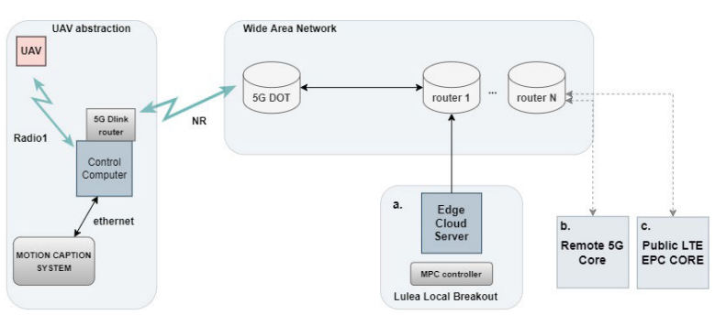

**Fig.1.3:** System architecture for the UAV communication over 5G to the edge server

For the a. scenario, the Local 5G & Edge Cloud is used and the MPC controller is hosted on the edge cloud server. For the b. scenario, the 5G with remote core & Cloud, all the control loop data has to pass through the remote 5G core. For the c. scenario, the Public LTE & Cloud, all the control loop data has to pass through the public LTE core.

In Fig. 3, the baseline architecture of the proposed system is illustrated. Consider the block that is abbreviated as UAV abstraction to be one UAV. The UAV in use is a Crazyflie 2.0, which possesses limited computational resources and lacks the ability to carry payloads exceeding 15 g. The UAV communicates with a radio connection, Radio 1, using a control computer that simulates the actual onboard computer of a UAV. This control computer hosts the 5G router, where communication with the 5G Ericsson Radio DOT is established. The latter radio communication is illustrated with the 5G New Radio (NR) interface. From this DOT base station, data traffic is sent to the local breakout node of this 5G stand-alone (SA) network.

The local breakout imitates a local version of a 5G core, and is responsible for routing packets of data to their destination and implementing other essential functionalities. The use of a local breakout is essential in latency-sensitive applications, as it mitigates extended data routing. The data destination is a Linux virtual machine (VM) hosted at the edge cloud application server of this 5G innovation network in the premises of the Luleå University of Technology. This Linux VM hosts the entire MPC operation in all three scenarios considered in this study.

The proposed architecture in this study involved the design and evaluation of multiple topologies for executing a UAV application with limited computing resources. The basic architecture of the system consisted of the Crazyflie 2.0 UAV, which had limited computing resources and lacked the ability to carry a payload exceeding 15 g. The UAV would take off from a set point, perform an autonomous mission consisting of a circular trajectory at a constant altitude, and perform a safe landing operation. All the autonomy of the UAV takes place on a remote server, where the Model Predictive Control (MPC) controller is implemented, which is fully responsible for the operation of the UAV.

The proposed solution aims to demonstrate the ability to use the 5G network and external edge server computing resources to fully support UAVs that cannot carry large-scale onboard computing resources. This practice allows small UAVs to exploit the full potential of the edge cloud. In addition, the exclusion of large computing resources from UAVs creates the opportunity to equip them with additional sensors that can enable fully autonomous operations, even in environments where GNSS is prohibited.

In the proposed architecture, the UAV communicates with the radio link, Radio 1, using a control computer that simulates the actual on-board computer of the UAV. This control computer (CC) hosts the 5G router where communication with the 5G Ericsson Radio DOT takes place. The second radio communication is shown with the 5G New Radio (NR) interface. From this DOT base station, the data traffic is sent to the local separation node of this 5G stand-alone network (SA). The local breakout is responsible for routing data packets to their destination and implementing other basic functions.

The data point is a Linux virtual machine (VM) hosted on the boundary cloud application server of this 5G innovation network on the premises of Luleå University of Technology. This Linux VM hosts the entire MPC operation in all three scenarios considered in this study. Subsequently, after each MPC controller cycle, the calculated control commands follow the opposite path to the UAV abstraction node responsible for the UAV dynamics operation.

The entire application was implemented in ROS, which supports communication based on either Transmission Control Protocol (TCP) or User Datagram Protocol (UDP). After initial pilot experiments, the authors thoroughly tested the framework and the results between TCP and UDP were almost identical. Therefore, TCP was chosen as the transport protocol because it showed identical performance to UDP. TCP also allows authors to monitor network congestion behavior.

The proposed architecture was evaluated by examining the challenges and important key performance indicators (KPIs) that enable autonomous operations, are reliable and robust for 5G-enabled UAVs. Alternative architectures were also considered for comparison purposes. As described above, three main components have been modified to explore different scenarios: NR radio interface, edge server, and local leakage. The second architecture paradigm replaces the local breakout with a remote 5G core and the edge server with a cloud server. The third option is similar to this solution, where the NR radio interface has been replaced with LTE, the edge server with a cloud server, and a local breakout with a remote 5G core.

# CHAPTER 2

**RELATED STUDY**

**2.1 MOTIVATION:**

The primary motive behind crash detection and SOS services is to enhance safety and provide emergency assistance to people involved in vehicular accidents. Crash detection systems use various sensors and algorithms to detect collisions or accidents and trigger an automatic emergency response. This can include sending alerts to emergency services, providing the vehicle's location, and notifying the driver's emergency contacts. These systems can help reduce response time and save lives by quickly alerting first responders to the accident. SOS services, on the other hand, provide a quick and easy way for drivers and passengers to request emergency assistance in case of an accident or other emergency. These services typically involve a button or voice command that immediately connects the vehicle occupants to an emergency response center. The response center can then dispatch emergency services or provide guidance on how to handle the situation until help arrives. Overall, the motive behind crash detection and SOS services is to improve safety on the roads and provide quick, efficient emergency assistance in case of an accident or other emergency.

# RELATED WORKS:

The significant advancements in AI and the contribution of AI to autonomous UAV navigation are the primary motivations behind this study. Several surveys on UAVs in different aspects have been published in the last decade. In, Souissi et al. discussed several state-of-the-art methods for UAV path planning, such as Dijkstra’s algorithm, A∗ algorithms, particle swarm optimization (PSO), ant colony optimization (ACO), probabilistic road-mapping, rapidly-exploring random trees (RRT), and multi-agent path planning , and outlined their advantages and disadvantages. Moreover, the authors categorized UAV path planning in terms of environmental modelling. UAVs with environmental knowledge have a higher probability of achieving an optimal or near-optimal solution compared with the UAVs having no environmental knowledge, however, they cannot deal with sudden changes in the environment.

Sujit et al. analyzed five traditional path-following algorithms: carrot-chasing, nonlinear guidance law (NLGL), pure pursuit with line-of-sight (PLOS), linear quadratic regulator (LQR), and vector field (VF) algorithms for fixed-wing UAVs. Moreover, the authors simulated these algorithms using Monte Carlo simulations and provided performance comparisons.

Pandey et al. discussed different single solution-based and population-based meta-heuristic approaches in, including simulated annealing (SA), tabu search, evolutionary computation, and swarm intelligence. They also analyzed various algorithms and highlighted research gaps. Ghambari et al. performed an experimental analysis and compared different meta-heuristic algorithms such as PSO , differential evolution (DE), artificial bee colony (ABC) invasive weed optimization (IWO) , teaching learning-based optimization (TLBO), grey wolf optimization (GWO), and lightning search algorithm (LSA) .

Meanwhile, Zhao et al. discussed computational intelligence (CI)-based approaches for UAV path planning. The authors highlighted the genetic algorithm (GA), PSO, ACO, artificial neural network (ANN), fuzzy logic (FL), and Q -learning based papers considering online/offline planning and 2D/3D environments. However, research works based on AI/ML were not included in the paper. Radmanesh et al. carried out a comparative study of UAV path planning algorithms for heuristic and non-heuristic methods in. The authors tested algorithms, such as the potential field, Floyd-Warshall, GA, greedy algorithm, multi-step look-ahead policy, Dijkstra’s, A∗ , Bellman-Ford, Q -learning algorithms, and mixed-integer linear programming (MILP), under three different obstacle scenarios in terms of computational time and optimality.

In contrast, Lu et al. surveyed vision-based methods of UAV navigation while focusing on visual localization and mapping, obstacle avoidance, and path planning. Subsequently, many authors analyzed all types of approaches, including AI-based approaches for handling challenges, such as security, communication, interference, and localization, related to cellular-connected UAVs in wireless networks. In addition, Liu et al. highlighted the AI-based approaches for resource allocation, big data handling, dynamic deployment, and trajectory design for UAV-aided wireless networks (UAWN).

The majority of the surveys focus on AI for UAV-connected wireless communication or CI-based solutions for autonomous UAV navigation, explaining their future applications. However, none of them focuses solely on AI approaches for autonomous UAV navigation and future AI potential approaches Unassociated with these works, this paper discusses the present and future AI approaches for autonomous UAV navigation. This paper provides a comprehensive survey of this crucial paradigm of AI approaches covering all UAV navigation scenarios, identifying the prevailing gap in the literature that inspired the current research. This survey aims to help the researchers to work in the direction of AI-based methods in autonomous UAV navigation.

**2.2 CONTRIBUTION**

This study focuses on different AI approaches, such as deep learning, mathematical optimization methods, reinforcement learning, and transfer learning, for different types of UAV navigation. After analyzing different AI techniques, future research directions for UAV navigation are highlighted. The main contributions of this study are as follows:

Many authors have simulated and incorporated different types of UAVs and their characteristics. Knowledge of different UAV parameters is mandatory for implementing different AI algorithms. These parameters help researchers to develop appropriate system models and simulation scenarios. Moreover, setting an reasonable goal is very important for implementing AI algorithms. Thus, the key characteristics and types of UAVs are highlighted to familiarize the reader with UAV architecture. A brief overview of the UAV navigation system and application-based categorization are provided, which will help new researchers to easily understand the various methods of AI implementation.

AI is a vast area that includes different types of learning and optimization algorithms. Thus, the AI approaches for autonomous UAV navigation are divided into two parts: optimization-based and learning-based approaches. Different types of memory-free computational heuristic approaches are discussed in the optimization-based part. In these types of approaches, the AI agent has to perform all the necessary calculations from the beginning every time to obtain the optimal solution. Thus, optimization-based solutions have high time complexity and require high computational power. The memory-based computational learning approaches are discussed. Here, the AI agent learns the surrounding, obtains an optimal policy, and saves it for future use. The agent can use and update the saved policy later if needed. Therefore, the fundamentals and working principles of several AI techniques implemented by different researchers for autonomous UAV navigation in terms of optimization-based and learning-based approaches are presented in this paper.

A comparative study of different optimization-based and learning-based AI approaches for autonomous UAV navigation is conducted in this paper. Here, the features of the approaches are identified and compared them in terms of their complexity, hyper-parameters, and objectives. Extended categorizations of the optimization-based and learning-based AI approaches are included in the comparative analysis.

Finally, the open research challenges and future directions are highlighted to accelerate the current research on autonomous UAV navigation in terms of the different crucial parameters and features of the UAV. New possible AI approaches for autonomous UAV navigation are highlighted in Fig. 2.1.

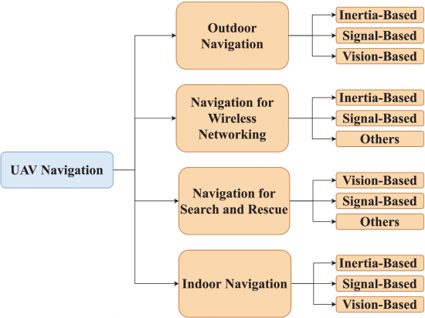

**Fig. 2.1:** Application-based categorization of UAV Navigation.

# CHAPTER 3

**METHODOLOGY**

This Study proposes a framework for enabling autonomous aerial vehicles (AAVs) using edge computing and 5G networks. The framework consists of three main components: the AAVs, the edge computing infrastructure, and the 5G network.The AAVs are equipped with a variety of sensors, such as cameras, lidar, and radar, that collect data about the environment. The data is processed on-board the AAVs using artificial intelligence (AI) algorithms to make real-time decisions about flight control, obstacle avoidance, and other tasks.

The edge computing infrastructure is located close to the AAVs, typically within a few kilometers, and consists of a network of small data centers or edge nodes. The edge nodes provide computational resources and storage capacity for processing the data generated by the AAVs. The edge nodes can be located on the ground, on buildings, or even on other AAVs.The 5G network provides high-bandwidth, low-latency connectivity between the AAVs and the edge nodes. This enables real-time communication between the AAVs and the edge nodes, allowing the AAVs to make decisions quickly and efficiently.The paper discusses several use cases for AAVs enabled by the proposed framework, including surveillance, disaster response, and transportation. In each use case, the AAVs would be able to operate autonomously, making real-time decisions based on the data collected by their sensors and processed by the edge computing infrastructure.

The realization of unmanned aerial systems have been a significant challenge for engineers and scientists since the invention of airplanes. There are many different types of UAVs available today for military and civilian applications. UAVs are often classified based on characteristics related to shape, range, price, maximum take-off weight, and pricing as shown in Table 2. One of the most crucial features of a UAV is its payload. The maximum weight that a UAV can carry, or payload, is a measurement of its lifting capabilities. UAV payloads can range from a few grams to hundreds of kilograms. The larger the payload, the more equipment, and accessories can be carried at the price of the UAV’s size, battery capacity, and flight time. Conventional payloads include cameras, sensors, mobile phones, and base stations for cellular assistance.

The methodology of a project "Toward 5G Edge Computing for Enabling Autonomous Aerial Vehicles" would typically involve the following steps:

1. Research and Literature Review: Conduct a comprehensive review of existing literature related to 5G edge computing and autonomous aerial vehicles. This will help in identifying the current state-of-the-art, challenges, and opportunities in this area.
2. Problem Formulation: Based on the literature review, identify the specific research problem that the project aims to address. This may involve defining the scope of the project, identifying the research questions, and outlining the objectives.
3. Design of Experiment: Once the problem is formulated, the next step is to design a suitable experiment to address the research question. The design should include the selection of hardware and software platforms for the experiment, the setup of the experiment, and the selection of performance metrics.
4. Data Collection: Conduct experiments to collect data on the performance of 5G edge computing in enabling autonomous aerial vehicles. This may involve simulating the environment or conducting experiments in real-world scenarios.
5. Data Analysis: Analyze the data collected in step 4 to draw conclusions regarding the performance of 5G edge computing in enabling autonomous aerial vehicles. This may involve statistical analysis, machine learning algorithms, or other relevant techniques.
6. Validation: Validate the results of the analysis through simulation or real-world experiments.
7. Conclusion and Recommendations: Based on the results of the analysis and validation, draw conclusions and provide recommendations for future research in this area. This may include identifying areas for improvement in the current approach, proposing new algorithms or techniques, or suggesting modifications to the hardware or software platforms used.
8. Publication and Presentation: Finally, prepare a manuscript describing the results of the research and submit it to a relevant journal or conference. Also, prepare a presentation summarizing the findings and present it at relevant conferences or seminars.

**3.1 System Model**

In general, UAVs can be categorized into four categories based on their flight mechanisms: fixed-wing, helicopters, loons, and multi-copters. Fixed-wing UAVs can glide through the air, making them more energy-efficient and capable of carrying heavier payloads. In addition, fixed-wing UAVs can benefit from gliding to go quicker. However, they require more space to take off and land, and they cannot hover over a fixed position. Helicopters are a combination of multi-copters and fixed-wings. They can glide through the air with tail wings and take off and land vertically. In contrast, loons depend entirely on air pressure and have no motors for directed movement. Lastly, Multi-copters can take off and land vertically and hover over a certain place. Thus, they are excellent for any application because of their exceptional maneuverability. However, multi-copters have limited flight time and use a considerable amount of energy because they always fly against gravity.

As flying is the main characteristic of UAVs, UAV navigation can be categorized into four categories based on application: outdoor navigation, indoor navigation, navigation for SaR, and navigation for wireless networking. Here, outdoor navigation includes applications, such as surveillance, good delivery, target tracking, and crowd monitoring, and indoor navigation includes applications, such as indoor mapping, factory automation, and indoor surveillance. In addition, the UAV navigation can be categorized based on navigation parameters: inertia-based, signal-based, and vision-based navigation. For inertia-based navigation, UAVs mainly use gyroscopes, accelerometers, and altimeters to guide the onboard flight controller. UAVs use GPS modules and a remote radio head (RRH) in the case of cellular connectivity for signal-based navigation and cameras for vision-based navigation.

Initially, the altitude and horizontal controllers receive feedback from these sensors and guide the pitch and yaw controllers depending on the desired path planning. Then, the pitch and yaw controllers guide the elevators and ailerons to maneuver the UAV depending on the feedback of these sensors, as shown in UAVs obtain the desired path planning in case of autonomous navigation, as shown in utilizing various AI techniques. Thus, this paper focuses on different AI approaches implemented by different researchers for UAV navigation.

**3.2 Devices & Hardware**

As briefly described above, the UAV is a Crazyflie 2.0. This UAV has limited computational resources and communicates with the CC utilizing a Crazyradio PA antenna, which operates under low latency and at 2.4GHz Industrial, Scientific, and Medical (ISM) band radio. The 5G router that was used for communicating over the 5G innovation network is a D-Link DWR-2101 5G. The entire 5G network runs over 3.7GHz , and supports a 5G stand alone version, which is used in this study. This 5G innovation network offers two options for connecting to the 5G core. The selection between the two is established through different Access Point Names (APN), either to the local breakout server at Luleå center (∼4km away from the experiment site), or to the primary remote 5G core in Kista, Stockholm (∼900km away). Considering the travel distance to Kista, as well as traditional network delays in internet protocol (IP) based networks, the data packet delay for traveling to Kista and back is significant for time-critical applications. The aforementioned observation will be further discussed in sections II-D and II-E.

**3.3 Closed Loop Control Architecture**

For the closed loop control of the UAV a Model Predictive Control approach was adopted MPC is a popular choice for researchers working on UAVs. Many articles in the literature use MPC controllers for a UAV platform. Therefore, the selected MPC is briefly described. Here the UAV is presented as a robot with six degrees of freedom and a fixed body frame.

The body frame and the global frame are denoted as W and B respectively, whereas the kinematics of the UAV.

θ˙(t)= &1/τθ (Kθ θref (t)−θ(t))

The position of the UAV is denoted as p=[px,py,pz]T and the linear velocity is denoted as v=[vx,vy,vz]T . A rotation matrix that describes the attitude of the UAV in Euler form is denoted by R(θ(t),ϕ(t))∈SO(3) , where SO(3) is the 3D rotation group. Additionally, the roll and pitch angles are respectively defined as ϕ∈[−π,π] and θ∈[−π,π] . ϕref∈R represents the reference input value in roll, θref∈R represents the reference input value in pitch and T≥0 represents the reference input value for the total thrust. The only parameters that affect the acceleration are the magnitude and the angle of the thrust vector produced by the motors, the linear damping terms Ax,Ay,Az∈R and the gravity of earth g . This can be derived from [(1)](https://ieeexplore.ieee.org/document/#deqn1). A first order system is used to model the relationship between the attitude (roll/pitch), and the referenced terms ϕref and θref∈R , with gains Kϕ and Kθ∈R and time constants τϕ and τθ∈R . Additionally, a lower-level attitude controller takes as input the thrust, roll and pitch commands and generates the motor commands for the UAV. Note here that the position and the linear velocity in the described setup are obtained through the VICON motion capture system.

The MPC controller that was used for the operation of the UAV during this study, experiences two latency effects. Initially all the data Xk(t) acquired by the sensing system is delayed by a time interval of tup , while every thrust, roll and pitch command sent by the MPC to the lower-level attitude controller is delayed by a time interval of tdown . Where tup is the time required for the sensing data to reach the edge server (where the MPC controller is hosted), and tdown is the required time for the transmission of the commands from the edge server to the 5G enabled UAV. An overview of the expected behavior of the UAV is presented in Section II-E, and the expected outcome is observed and discussed in Section III. Although there are many articles addressing delayed closed loop control systems in the literature, during this study in order to evaluate the system’s reliability we chose to operate within the limits of the network and thus, we~purposely selected a closed loop control method that does not take into account latency effects.

[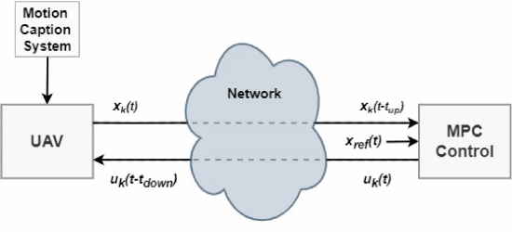](https://ieeexplore.ieee.org/mediastore_new/IEEE/content/media/6287639/10005208/10011219/damig5-3235067-large.gif)

**Fig. 3.1:** Edge server oriented proposed closed loop control architecture.

In Fig. 3.1, the focus is on the evaluation of the behavior of the MPC over a multiple machine architecture by examining the behavior of the system in correlation with the network latency. To succeed that, multiple experiments were designed in order to identify when the system was most affected by the latency effect, as well as when the system was more reliable to network latency.

**3.4 Robot - Edge Server Communication**

Compared to what is considered state-of-the-art today, 5G provides various improvements over 4G LTE and also over other local area wireless networks. Although maybe not yet implemented in public networks, some of the most notable features would be availability of higher data rates, and URLLC (ultra reliable low-latency communication) to provide improved reliability and latency of the CNPC link. This indicates that 5G is a promising technology for the evolution of UAV communications. Another striking feature is the Quality of Service (QoS) capabilities that a specific user equipment (UE) can request from the network. In addition, multi-user transmission with centralized scheduling enables the cellular network to make more efficient use of the spectrum. For further information about communication comparisons.

One vital aspect of the proposed framework is the integration of the ROS software with the 5G network. The problem here relies on the fact that ROS is not designed to function over public IP based and wide area networks. One of the most pronounced causes of that would be the Network Address Translation (NAT) method of translating local private IP addresses to public IPs. Since ROS requires a direct IP visibility in-between nodes a workaround is essential. Here, Virtual Private Network (VPN) was chosen in order to integrate the 5G innovation network with ROS and also utilize the encryption layer that will likely be necessary when operating autonomous missions over non-private networks. The choice of using a VPN on one hand naturally adds computational and transmission overheads but on the other hand reduces the risk of spoofing and can be considered one of the most robust solutions for running robotics applications over non-private networks. Note that our suggestion is to consider only peer-to-peer VPN solutions in order to avoid directing the packet traffic over a third node VPN server, which inevitably increases the latency of the system.

The ROS topology in the Fig. 3.2 is used in this study is briefly described. A two machine-node system is visualized. The first node, called UAV abstraction runs on the UAV abstraction component and is responsible for the UAV dynamics and the operation of the VICON system. The second node runs on the edge server and hosts both the ROS master, and the MPC controller. The VPN interface is created and evaluated over different connectivity scenarios, i.e. two scenarios for 5G (Local 5G & Edge Cloud and 5G with remote core & Cloud) and one scenario for public 4G LTE & Cloud, thereby allowing us to directly compare the performance.

[[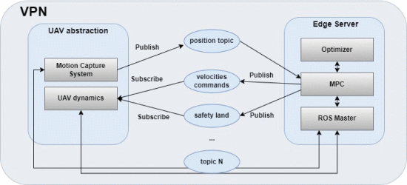](https://ieeexplore.ieee.org/mediastore_new/IEEE/content/media/6287639/10005208/10011219/damig6-3235067-large.gif)](https://ieeexplore.ieee.org/mediastore_new/IEEE/content/media/6287639/10005208/10011219/damig6-3235067-large.gif)

**Fig.3.2:** ROS multiple machine node topology over wide area networks.

**3.5 Impact of Latencies in the Close Loop System**

The fact that the network latency affects time-critical applications has been well studied Of interest in this study is the effect of the latency on the autonomous mission of the UAV. The circular trajectory chosen for this experiment serves exactly that purpose. Considering the design of this system, the drone executes each control command continuously until it receives a new command. From this fact, it can be expected that the trajectory of the drone might vary from its desired circular trajectory, drifting out from the circle and then rapidly trying to correct this with the future commands. An illustrative figure of this behavior, where an example of the trajectory variation is shown in Fig. 3.3, as the delay in the next command occurs and, the behavior of the control commands delivered at varying time intervals is shown.

[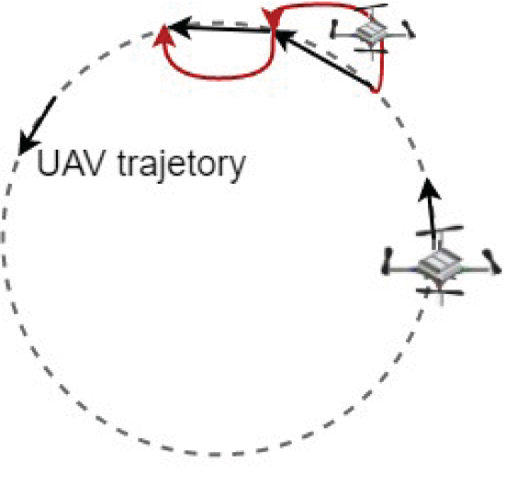](https://ieeexplore.ieee.org/mediastore_new/IEEE/content/media/6287639/10005208/10011219/damig7-3235067-large.gif)

**Fig. 3.3:** Latency behavior expected at the UAV trajectory.

**3.6 Collision Avoidance Use-Case**

This subsection examines a more demanding scenario in order to evaluate the reliability of a UAV’s time-critical autonomous mission when being served over a 5G interface. Here a collision avoidance scenario is considered and implemented over the proposed architecture. Consider the non-linear model predictive controller (NMPC) and the UAV dynamics that are modeled by [(1)](https://ieeexplore.ieee.org/document/#deqn1). The UAV performs a circular trajectory at a certain height, similar to the one that section II-C described. The primary distinction is that the proposed architecture is application agnostic and the MPC controller described in section II-C is swapped for an NMPC controller that considers collisions. The NMPC controller takes the collision avoidance constraint into account and performs reactive navigation (i.e., diverging from the desired circular trajectory) to avoid the obstacle.. The essence of this design is that an obstacle is represented by a sphere centered on its position. A projectile motion model determines the velocity of the obstacle. The collision avoidance condition is satisfied if the UAV lies outside the sphere. The problem, as with the use-case presented in section II-C, is solved by optimization. For more information, the reader is referred to the complete study. For this use-case, the emphasis is to capture the reliability in a real-time-critical operation, such as the collision avoidance scenario, and demonstrate that the 5G enabled UAV can reliably offload computational intensive optimization methods, such as the NMPC, to the edge cloud. That said, the purpose of this study is not to evaluate the corresponding controller, i.e., the MPC described in section II-C or the NMPC described here, but to assess whether the proposed architecture is robust enough to support any controller.

To further elaborate on the considered use-case, the following is presented. Foremost, the UAV continues to execute its circular trajectory, where the circular trajectory is a baseline trajectory that simulates many real-life scenarios. Simultaneously at each control cycle, the offloaded NMPC solves the optimation problem considering the potential collision with a dynamic obstacle. The obstacle in this scenario is a ball whose actual position in the 3D space is captured again by the Vicon motion capture system. The NMPC hosted on the edge server operates at the frequency of 40Hz . Thus, to perform a successful maneuver and achieve the collision avoidance action, the action must be computed in the remote edge server, and the control command that describes the action must be sent back to the UAV. Fig. 3.4 illustrates a complete data cycle, and the separate steps are explained below: The state of the robot and the position of the ball (i.e., the obstacle) are captured.

The data are sent from the UAV abstraction and over the 5G NR to the BS. The destination is the edge server.The BS forwards the data to the Local 5G core.The data arrives at the local 5G core breakout, where that instance of the 5G core takes care of routing the packets. The destination remains to be the edge server. Note that in most cellular networks data has to route through the core of the network.

Data are sent from the local 5G core breakout to the edge server.Data reaches the edge server where the NMPC is operating. An action is decided, either to continue the circular trajectory or to perform a collision avoidance maneuver. The control command is sent back to the UAV.

The control command data are sent from the edge server to the UAV. First they have to route over the local 5G core breakout.The control command data arrive at the local 5G core breakout, where that instance of the 5G core takes care of routing the packets. The destination remains to be the UAV abstraction.

The control commands are routed from the local 5G core breakout to the serving BS.The serving BS sent the control command data to the UAV abstraction.The control commands arrive at the UAV abstraction and are fed to the onboard attitude controller. The action occurs.

[[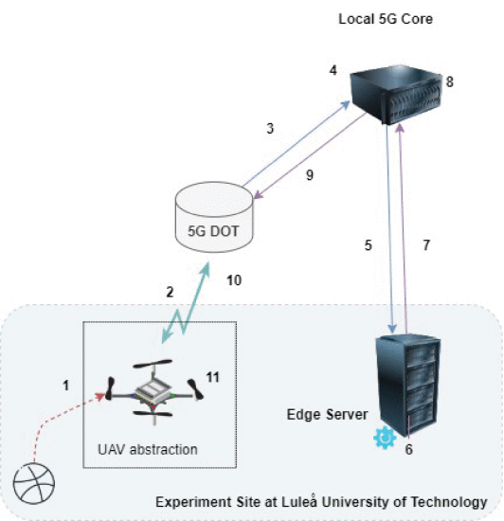](https://ieeexplore.ieee.org/mediastore_new/IEEE/content/media/6287639/10005208/10011219/damig9-3235067-large.gif)](https://ieeexplore.ieee.org/mediastore_new/IEEE/content/media/6287639/10005208/10011219/damig9-3235067-large.gif)

**Fig. 3.4:** Complete data flow regarding the collision avoidance use-case.

The UAV used in the study is a Crazyflie 2.0 with limited computational resources, which communicates with the CC using a Crazyradio PA antenna operating at 2.4 GHz ISM band radio. The 5G router used is a D-Link DWR-2101 5G, running over 3.7 GHz, and supporting a 5G stand alone version. The 5G network offers two options for connecting to the 5G core, either to the local breakout server at Luleå center or to the primary remote 5G core in Kista, Stockholm. The data packet delay for traveling to Kista and back is significant for time-critical applications.

**3.7 SYSTEM LATENCY EVALUATION:**

The 5G technology offers various improvements over 4G LTE and other local area wireless networks, making it a promising option for UAV communications. The Quality of Service (QoS) capabilities of a specific user equipment (UE) and multi-user transmission with centralized scheduling enables the cellular network to make more efficient use of the spectrum. However, the integration of ROS software with the 5G network is challenging due to the NAT method of translating local private IP addresses to public IPs. To overcome this challenge, a VPN was chosen to integrate the 5G innovation network with ROS, which adds computational and transmission overheads but reduces the risk of spoofing. The ROS topology used in the study involves a two-machine node system where the first node is responsible for UAV dynamics and the operation of the VICON system, while the second node hosts both the ROS master and the MPC controller. The VPN interface is created and evaluated over different connectivity scenarios, allowing for a direct comparison of performance.

The impact of network latency on the autonomous mission of UAVs. The circular trajectory of the drone is used to study the effect of latency, as the drone may drift out from the circle and then rapidly try to correct its trajectory when it receives new commands. To ensure reliable execution of the mission, the time intervals between the commands should be as constant as possible, with a latency threshold used to denote the maximum tolerance between two subsequent control commands. The closed-loop control round trip time is used to evaluate the system, and delays in the data transmission occur mainly due to the stochastic and unpredictable behavior of wide area networks. Various methods, such as queuing theory and Poisson distributions, can be used to better describe the delays of the system.

The obstacle in this scenario is a ball whose actual position in the 3D space is captured again by the Vicon motion capture system. The NMPC hosted on the edge server operates at the frequency of 40 Hz. Thus, to perform a successful maneuver and achieve the collision avoidance action, the action must be computed in the remote edge server, and the control command that describes the action must be sent back to the UAV. Fig. 3.4 illustrates a complete data cycle, and the separate steps are explained below:

1. The state of the robot and the position of the ball (i.e., the obstacle) are captured.
2. The data are sent from the UAV abstraction and over the 5G NR to the BS. The destination is the edge server.
3. The BS forwards the data to the Local 5G core.The data arrives at the local 5G core breakout, where that instance of the 5G core takes care of routing the packets. The destination remains to be the edge server. Note that in most cellular networks data has to route through the core of the network.
4. Data are sent from the local 5G core breakout to the edge server.
5. Data reaches the edge server where the NMPC is operating. An action is decided, either to continue the circular trajectory or to perform a collision avoidance maneuver. The control command is sent back to the UAV.
6. The control command data are sent from the edge server to the UAV. First they have to route over the local 5G core breakout.
7. The control command data arrive at the local 5G core breakout, where that instance of the 5G core takes care of routing the packets. The destination remains to be the UAV abstraction.
8. The control commands are routed from the local 5G core breakout to the serving BS.
9. The serving BS sent the control command data to the UAV abstraction.
10. The control commands arrive at the UAV abstraction and are fed to the onboard attitude controller. The action occurs.

# CHAPTER 4

**CONCLUSION**

Autonomous UAV navigation has introduced great flexibility and increased performance in complex dynamic surroundings. This survey highlights UAVs’ essential characteristics and types to familiarize the reader with the UAV architecture. Furthermore, the UAV navigation system and application-based classification were summarized to make it easier for researchers to grasp the concepts introduced in this survey. In terms of optimization-based and learning-based methods, the fundamentals, operating principles, and critical features of numerous AI algorithms applied by different researchers for autonomous UAV navigation were described. Different optimization-based approaches such as the PSO, ACO, GA, SA, PIO, CS, A*, DE, and GWO algorithms were analyzed and highlighted. Many researchers have modified these methods according to their requirements to achieve optimal objectives.

In addition, this survey categorized and analyzed learning-based algorithms such as RL, DRL, A3C, and DL. The researchers utilized different neural networks, learning parameters, and decision-making processes to fulfill their objectives. After analyzing all AI approaches, comparative studies were presented comparing all the methods from the same ground. In summary, various resources and data related to autonomous UAV navigation and AI are available to further research and development. Furthermore, there is a scope of improvement and novel ideas in different scenarios, such as big data processing, computing power, energy efficiency, and fault handling. Thus, this survey highlights future research directions to speed up the present research on AI-based autonomous UAV navigation. Finally, AI can be computationally expensive, but it increases the overall performance of UAVs in terms of significant parameters, such as energy consumption, flight time, and communication delay, in a complex dynamic environment for any critical mission.

# REFERENCES:

|  |  |
| --- | --- |
| [1] | Y. Lu, X. Zhucun, G.-S. Xia, and L. Zhang, ‘‘A survey on vision-based UAV navigation,’’ Geo-spatial Inf. Sci., vol. 21, no. 1, pp. 1–12, Jan. 2018. |
| [2] | M. Sheraz, M. Ahmed, X. Hou, Y. Li, D. Jin, Z. Han, and T. Jiang, ‘‘Artificial intelligence for wireless caching: Schemes, performance, and challenges,’’ IEEE Commun. Surveys Tuts., vol. 23, no. 1, pp. 631–661, 1st Quart., 2021. |
| [3] | M. Y. Arafat and S. Moh, ‘‘Bio-inspired approaches for energy-efficient localization and clustering in UAV networks for monitoring wildfires in remote areas,’’ IEEE Access, vol. 9, pp. 18649–18669, 2021. |
| [4] | O. Esrafilian, R. Gangula, and D. Gesbert, ‘‘Three-dimensional-map- based trajectory design in UAV-aided wireless localization systems,’’ IEEE Internet Things J., vol. 8, no. 12, pp. 9894–9904, Jun. 2021. |
| [5] | M.Mozaffari,W.Saad,M.Bennis,andM.Debbah,‘‘Wirelesscommunica- tion using unmanned aerial vehicles (UAVs): Optimal transport theory for hover time optimization,’’ IEEE Trans. Wireless Commun., vol. 16, no. 12, pp. 8052–8066, Dec. 2017. |
| [6] | M.Kothari,I.Postlethwaite,andD.-W.Gu,‘‘Asuboptimalpathplanning algorithm using rapidly-exploring random trees,’’ Int. J. Aerosp. Innov., vol. 2, nos. 1–2, pp. 93–104, Apr. 2010. |
| [7] | C. T. Cicek, H. Gultekin, B. Tavli, and H. Yanikomeroglu, ‘‘UAV base station location optimization for next generation wireless networks: Overview and future research directions,’’ in Proc. 1st Int. Conf. Unmanned Veh. Syst.-Oman (UVS), Feb. 2019, pp. 1–6. |
| [8] | C. Wang, J. Wang, J. Wang, and X. Zhang, ‘‘Deep-reinforcement-learning- based autonomous UAV navigation with sparse rewards,’’ IEEE Internet Things J., vol. 7, no. 7, pp. 6180–6190, Jul. 2020. |
| [9] | K. Sundar, S. Misra, S. Rathinam, and R. Sharma, ‘‘Routing unmanned vehicles in GPS-denied environments,’’ in Proc. Int. Conf. Unmanned Aircr. Syst. (ICUAS), Jun. 2017, pp.62–71, doi: 10.1109/ICUAS.2017.7991488. |
| [10] | R. K. Dewangan, A. Shukla, and W. W. Godfrey, ‘‘Three dimensional path planning using grey wolf optimizer for UAVs,’’ Int. J. Speech Technol., vol. 49, no. 6, pp. 2201–2217, Jun. 2019, doi: 10.1007/s10489- 018-1384-y. |