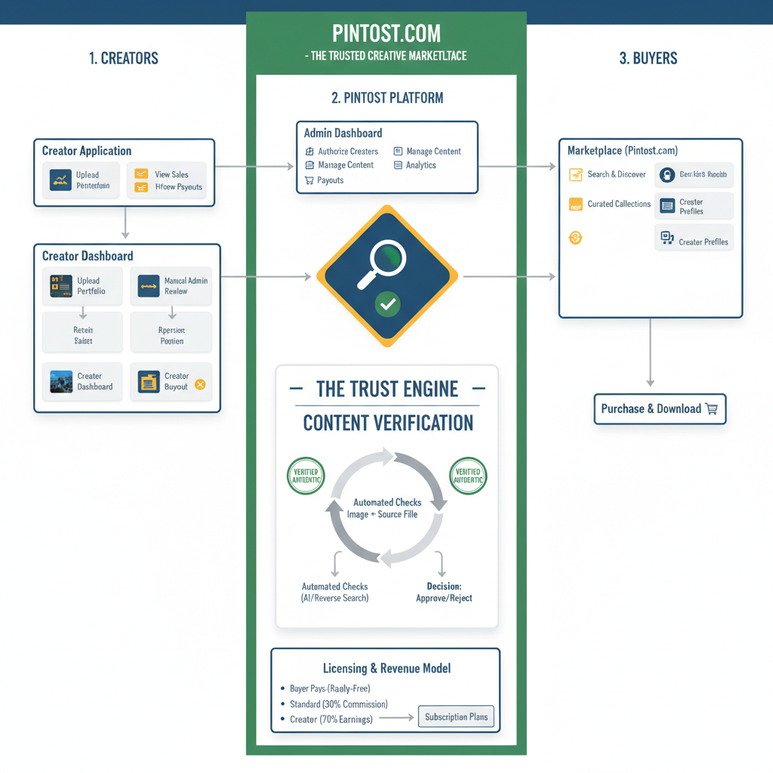
Diagram Explaination:

Overview
This diagram illustrates the complete ecosystem of Pintost.com. It is divided into three main pillars:

The Creators (Supply Side): The journey of an artist from application to selling their work.

The Pintost Platform (The Core Engine): The central hub where you, the admin, manage the platform and where the unique verification process happens.

The Buyers (Demand Side): The journey of a customer from discovering an image to purchasing it.

1. The Creator Journey (Left Column)
This section details the two-stage process for your artists.

Creator Application (Top-Left): This is the first step for any new artist. They cannot simply sign up and start selling. They must apply by submitting their portfolio for review. This is your first and most important gatekeeper step to ensure quality.

Creator Dashboard (Bottom-Left): Once you (the Admin) approve their application, the creator gains access to their personal dashboard. This is their command center where they can:

Upload Portfolio: Submit their digital art, photos, or illustrations.

Set Prices: Define the price for a Standard License (Royalty-Free) and an optional, much higher price for an Exclusive Buyout.

View Sales: Track their earnings and see which of their images are popular.

Manage Payouts: Configure how they receive their money.

The arrow from the Creator Dashboard pointing to the center shows that every image they upload enters your platform's core verification system.

2. The Pintost Platform (Center Column)
This is the engine of your business, where you manage everything and where your brand's promise of trust is fulfilled.

Admin Dashboard (Top-Center): This is your private "mission control" panel. From here, you perform all critical business functions:

Authorize Creators: Review applications and approve or reject new sellers.

Manage Content: Oversee the verification queue for all submitted images.

Payouts: Manage and execute payments to your creators.

Analytics: View site-wide sales data and platform health.

The Trust Engine - Content Verification (Middle-Center): This is your unique selling proposition. Every piece of content submitted by a creator goes through this mandatory workflow:

Submission: The creator uploads their final image and the required proof-of-originality (source file).

Automated Checks: Your system automatically runs a reverse image search across the web to check for plagiarism or existing copies.

Manual Review & Decision: You, the admin, review the image, the source file, and the results of the automated check. You then make the final decision to Approve or Reject the submission.

Verified Status: Once approved, the image is marked as "Verified Authentic" and is published to the marketplace.

Licensing & Revenue Model (Bottom-Center): This section explains how the business makes money.

The primary model is a commission split on Royalty-Free sales (e.g., 70% to the creator, 30% to Pintost).

The platform also supports Buyer Subscription Plans as a future revenue stream.

3. The Buyer Journey (Right Column)
This section shows how customers interact with the platform.

Marketplace (pintost.com) (Top-Right): This is your public website where buyers discover and purchase images. The content here is populated only with images that have successfully passed through the Trust Engine. Key features for buyers are:

Search & Discover: A powerful search engine to find the right image.

Curated Collections: Collections hand-picked by you (the admin) to showcase the best content, which adds a premium feel.

Creator Profiles: Buyers can click on an artist's name to see their entire portfolio, encouraging more sales and discovery.

Purchase & Download (Bottom-Right): This is the final step. A buyer selects an image, purchases the appropriate license, and downloads the high-resolution, verified file for their use.

In summary, the diagram shows a complete, self-reinforcing loop. High-quality Creators are vetted and their content is verified by the Pintost Platform's Trust Engine, which builds a premium library on the Marketplace that attracts discerning Buyers, whose purchases then reward the creators and generate revenue for the platform.

