Pintost.com: Business & Platform Documentation
Version: 1.0
Date: October 3, 2025

Table of Contents
- Executive Summary

- Mission & Vision Statement

- The Pintost Ecosystem: Platform Architecture

Diagram 1: Pintost Platform Architecture

Core Business Model & Revenue Streams

Diagram 2: Pintost Revenue Flow

The Key Differentiator: The "Trust Engine" Verification Process

Diagram 3: Content Verification Workflow

Content Licensing Models

Go-To-Market Strategy

Phased Development Roadmap

Copyright & Legal Management

Conclusion

1. Executive Summary
Pintost.com is a curated marketplace for high-quality, legally-safe digital art, photos, and illustrations. It addresses a key problem in the stock content industry: a lack of trust and the difficulty of finding unique, authentic imagery. Pintost differentiates itself from large competitors like iStockphoto by focusing on a specific market niche, implementing a rigorous, multi-layered verification process for both creators and content, and fostering a creator-first community. The primary revenue model is a commission on sales, supplemented by subscriptions and premium services.

2. Mission & Vision Statement
Mission: To be the most trusted source for authentic, niche-focused digital content, empowering creators to thrive from their original work.

Vision: To build a global community where creators are celebrated, and buyers can confidently source unique visuals that elevate their brands.

3. The Pintost Ecosystem: Platform Architecture
The platform is built on a "three-panel" system, catering to the specific needs of each user type: Buyers, Creators, and the Admin.

Marketplace (pintost.com): The public-facing platform for discovery and sales. Buyers can search, browse curated collections, view creator profiles, and purchase content licenses.

Creator Dashboard (creators.pintost.com): The private portal for authorized creators to upload and manage their portfolio, track sales analytics, and manage their earnings and payouts.

Admin Dashboard (admin.pintost.com): The central command center for the platform operator. This is where creator authorization, content verification, financial oversight, and site-wide management occur.

Diagram 1: Pintost Platform Architecture:

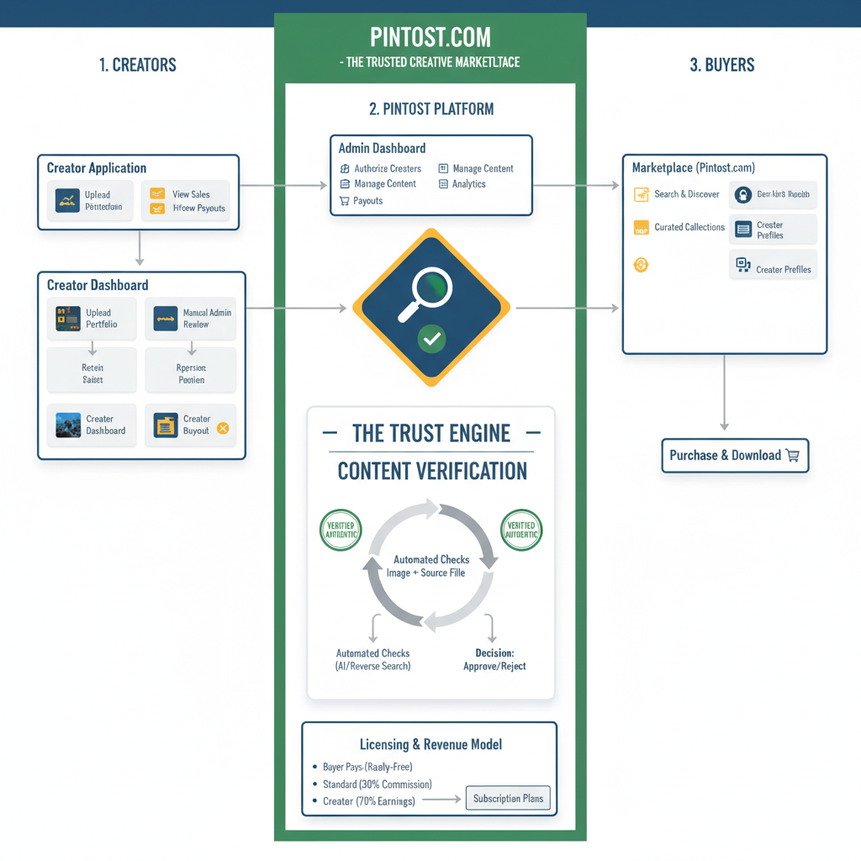

4. Core Business Model & Revenue Streams
Pintost will generate revenue through a diversified model, ensuring long-term financial health.

Primary Stream: Sales Commission: A commission (e.g., 30%) is taken from every sale made on the platform.

Secondary Streams:

Buyer Subscriptions: Monthly plans allowing a set number of downloads (e.g., 10 images/month).

Pro Creator Accounts: A subscription for creators offering lower commission rates and advanced analytics.

Extended Licenses: An upsell on standard licenses for use on merchandise for resale.

Promoted Listings: Creators can pay to have their work featured in prominent positions.

Diagram 2: Pintost Revenue Flow (Example Sale)
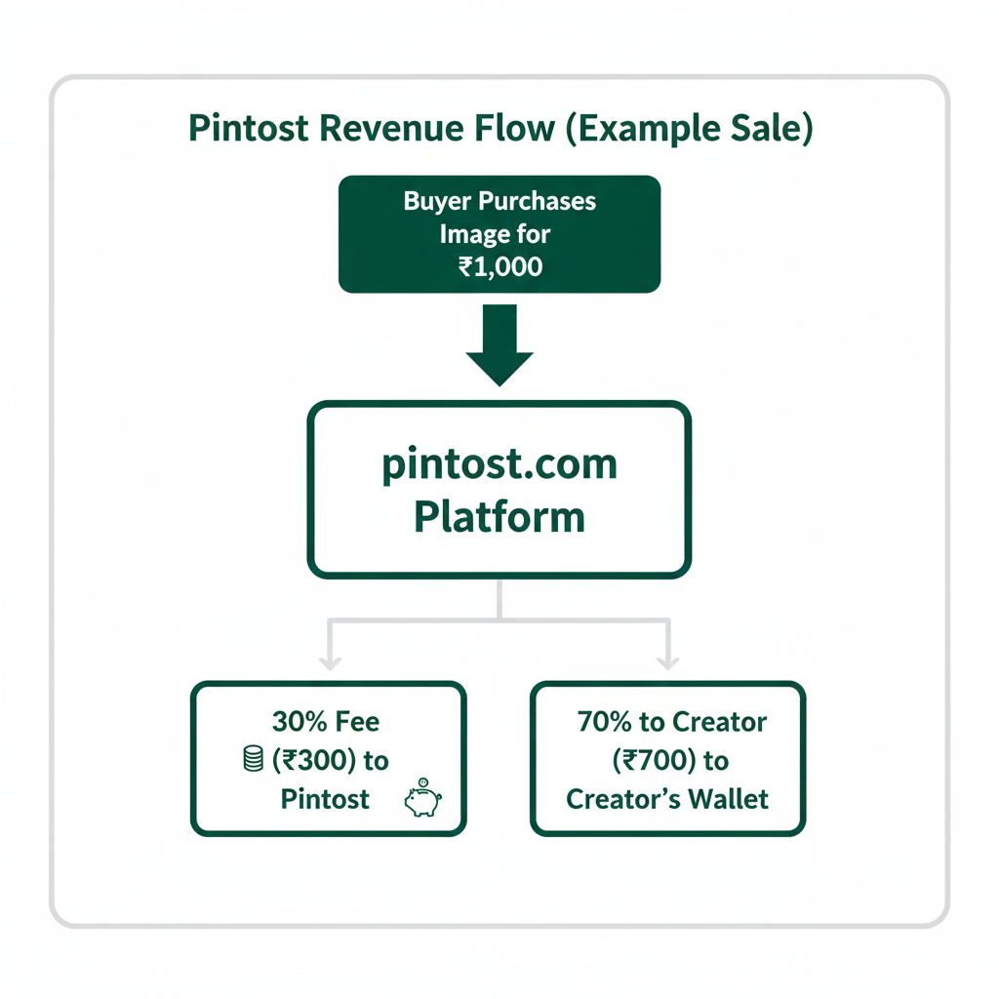
5. The Key Differentiator: The "Trust Engine" Verification Process
This two-stage process is the core of the Pintost brand promise.

Creator Authorization: The Admin manually vets every applicant by reviewing their public portfolio and history before granting them the ability to sell.

Content Verification: Every submitted image goes through a verification queue in the Admin Dashboard, involving both automated and manual checks.

Diagram 3: Content Verification Workflow
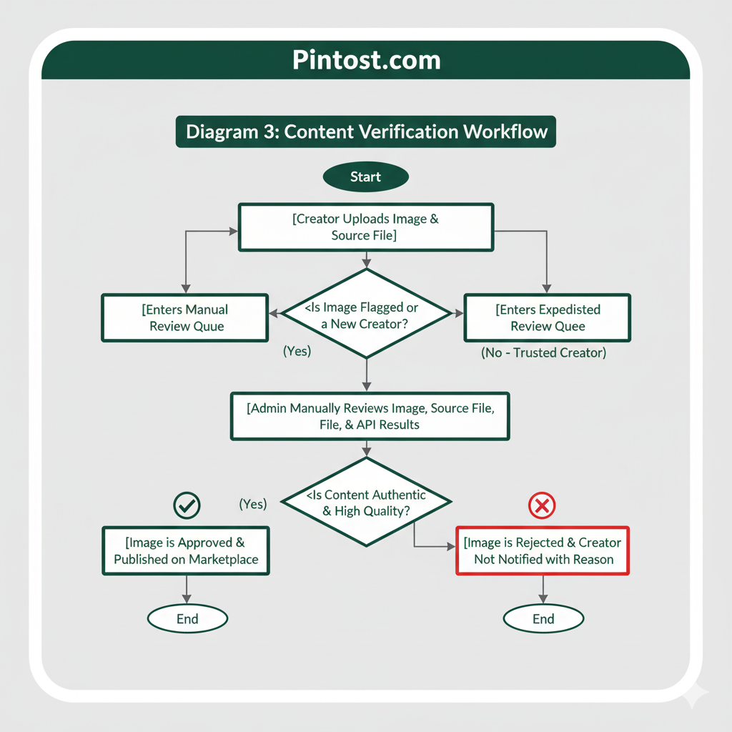

6. Content Licensing Models
Pintost will offer two clear licensing options to serve different buyer needs.

Standard License (Royalty-Free): Allows a buyer to use the image multiple times for various projects (websites, ads) without paying a royalty for each use. The creator can sell this license to an unlimited number of buyers.

Exclusive Buyout License: A high-cost option for a buyer to purchase exclusive rights to an image. Once sold, the image is removed from the marketplace permanently.

7. Go-To-Market Strategy
A niche-focused, two-phase approach to solve the marketplace "chicken and egg" problem.

Phase 1: Attract Creators First: You cannot sell what you do not have.

Action: Manually recruit 50-100 "Founding Creators" from a specific niche (e.g., "Illustrations for Tech Startups") by offering them a lifetime low commission rate.

Phase 2: Attract Buyers: With a solid content library, target the buyers in that niche.

Action: Use content marketing (blogging, social media) and SEO to attract organic traffic. Offer "Free Image of the Week" promotions to build an email list.

8. Phased Development Roadmap
A practical roadmap for a solo developer.

Phase 1 (MVP - First 6 Months):

Build the three core panels with essential features.

Implement the manual Creator Authorization and Content Verification workflows.

Launch with a simple, commission-based, per-image sales model.

Focus on recruiting Founding Creators.

Phase 2 (Growth - Months 6-18):

Introduce Buyer Subscriptions.

Integrate automated reverse image search APIs into the verification workflow.

Develop creator profile features like "Follow" and "Collections".

Begin content marketing efforts.

Phase 3 (Scale - Months 18+):

Launch Pro Creator Accounts and Extended Licenses.

Implement Creator Tiers ("Trusted," "Auto-Approve") to reduce admin workload.

Explore expansion into adjacent niches.

9. Copyright & Legal Management
This will be managed through a three-part strategy:

Prevention: The strict "Trust Engine" verification process.

Process: A legally compliant DMCA Takedown workflow for handling infringement claims.

Protection: An iron-clad Terms of Service (drafted by a lawyer) that includes an indemnification clause for creators and a termination policy for infringers.

Disclaimer: You must consult with a lawyer specializing in Intellectual Property (IP) law to draft your legal documents and ensure compliance.

10. Conclusion
Pintost.com has a clear path to success by differentiating itself from market giants through a focus on a specific niche and building a brand synonymous with trust and quality. The phased roadmap allows for sustainable development, and the diversified revenue model ensures long-term viability. The core of the business is the "Trust Engine," which protects buyers, rewards legitimate creators, and builds a powerful, defensible brand.

