ZOMATO RESTAURANT ANALYSIS

**Objective Questions**:

1. What is the total no. of tables present in the data?

**Ans :-** The data provided by the Newton school has mainly two sheets which are raw data and country description sheets based on these two sheets I have created the 7 pivot tables.

1. What is the total no. of attributes present in the data?

**Ans :-** The data provided by the Newton school has 20 attributes(cols) and I have created 3 more which are country names, year and the customized price.

1. How many categorical columns are there in the data? [Search about categorical and continuous data, and try to answer this question]

**Ans :-** There are 17 categorical columns in the data:

RestaurantID,RestaurantName,CountryCode,CountryName,City,Address,Locality,LocalityVerbose,Has_Table_booking,Has_Online_delivery,Is_delivering_now,Switch_to_order_menu,Price_range,Votes,Average_Cost_for_two,Rating,Datekey_Opening.

1. The data consists of some inconsistent and missing values so ensure that the data used for further analysis is cleaned.

**Ans :-** The data provided by the Newton school has only the country code in the raw data so we have to using lookup function to extract the country names from the country description sheet, then I have extracted the year from the datekey_opening column because it required for analysis,as well as we have created a customized price column that contain the currency of each country.

1. Using the LookUp functions, fill up the countries in the original data using the country code.

**Ans:-** As we have the country code in the country description sheet provided to us so using the vlookup function I have extracted the country names in the raw data sheet.

**=VLOOKUP(C2,'country description'!$A$1:$B$16,2,0)**

1. Create a table to represent the number of restaurants opened in each country.

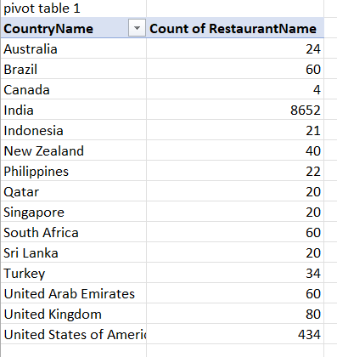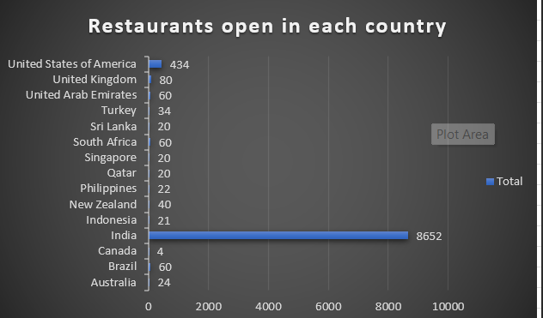

1. Also, the management wants to look at the number of restaurants opened each year, so provide them with something here.

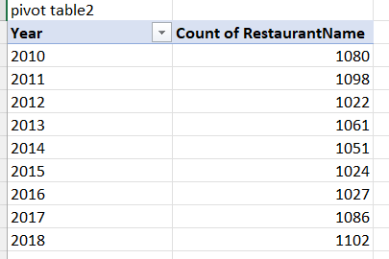

1. What is the total number of restaurants in India in the price range of 4?

**Ans :-** The number of restaurants in India that have price range 4 is 388. This count I have calculated by using COUNTIFS()

**=COUNTIFS('Raw Data'!D:D,"India",'Raw Data'!Q:Q,"4")**

1. What is the average number of voters for the restaurants in each country according to the data?

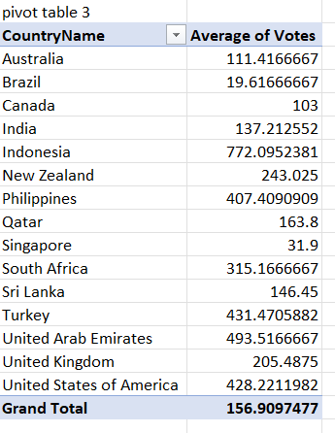

1. Calculate the average rating for all the restaurants that have price_range < 4 and provide online delivery. Use only the “IF” function, Logical Operators, and Aggregation functions to solve this problem. **[Note: Don’t use Conditional aggregation in this question.]**

**Ans:-** The average rating for all the restaurants that have price_range < 4 and provide online delivery is 3.27381151. This number is calculated by using IF() and AND() function.

**=AVERAGE(IF(('Raw Data'!Q:Q < 4) * ('Raw Data'!N:N = "Yes"), 'Raw Data'!T:T))**

1. Using Conditional formatting highlight the rows of restaurants that are located in the countries or cities that you’ve suggested to the management for opening new restaurants.

**Ans:-** I have use conditional formatting for the cell in the country name that is suggested to management to open new restaurants are colored as green.

1. Create a new customized price column that consists of the abbreviation/symbol of the currency along with the Average_cost_for_two value. [Use string operations to do this task]

**Ans:-** I have created a new price column that have the price with the country currency name and symbol. This I have done using the CONCATENATE() as we have the Average_cost_of_two column and the currency column.

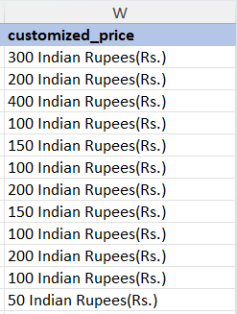

1. How can you create an array formula in Excel or Google Sheets to count the number of restaurants listed that do not offer online delivery, are in the lowest price range, and have an average cost for two people less than or equal to 250 Indian Rupees?

**Ans:-** Count of number of restaurants listed that do not offer online delivery, are in the lowest price range, and have an average cost for two people less than or equal to 250 Indian Rupees 1805. This count or total is calculated by using array COUNTIFS() formula.

**=COUNTIFS('Raw Data'!N:N,"No",'Raw Data'!Q:Q,"1",'Raw Data'!W:W,"<=250 Indian Rupees(Rs.)")**

**Subjective Question:**

1. Suggest a few countries where the team can open newer restaurants with lesser competition. Which visualization/technique will you use here to justify the suggestions?

**Ans:-** Few countries where the team can open newer restaurants with lesser competition are Australia, Brazil, India, Sri Lanka ,United Kingdom, United States of America, New Zealand, United Arab Emirates . These are the suggested countries based on various parameters like rating, count, has online delivery available, has online booking available.

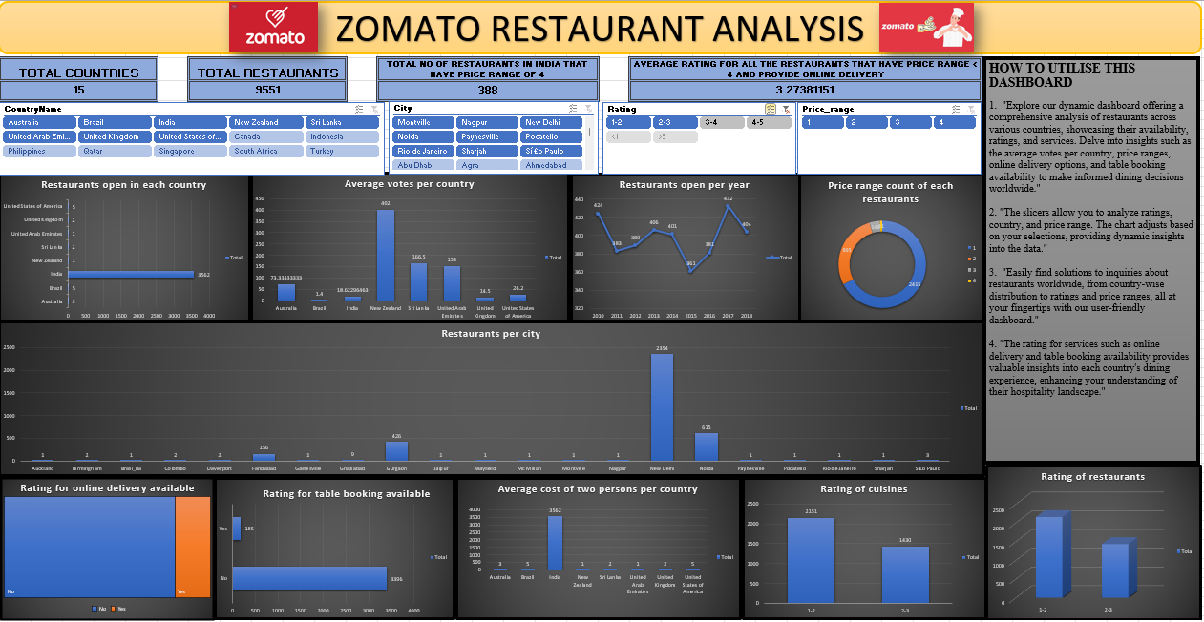

1. Come up with the names of States and cities in the suggested countries suitable for opening restaurants.

**Ans :-** The names of States and cities in the suggested countries suitable for opening restaurants are: Auckland, Birmingham, barsí_lia, Colombo, Davenport, Faridabad, Gainesville, Ghaziabad, Gurgaon, Jaipur, Mayfield, Mc Millan, Montyille, Nagpur, New Delhi, Noida, Paynesyille, Pocatello, Rio de Janeiro, Sharjah, Sí£o Paulo. In these cities some of the cities like New Delhi, Noida, Gurgaon, Faridabad are more number of restaurants but the rating is less, count for the do not provide online delivery available and has online booking available is also more.

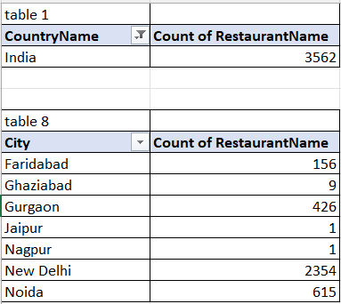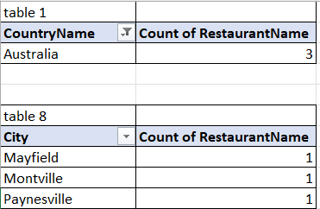

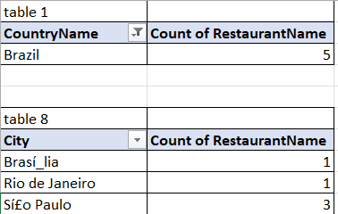 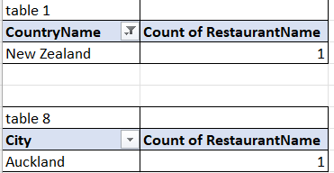

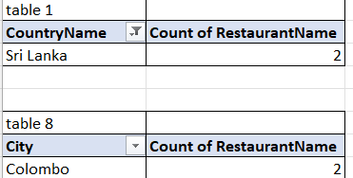 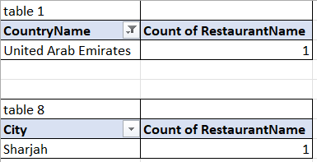

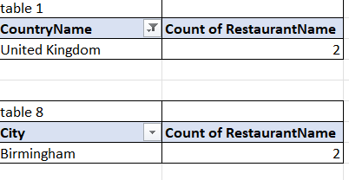

1. According to the countries you suggested, what is the current quality regarding ratings for restaurants that are open there?

**Ans :-** The current quality regarding ratings for restaurants that are open there are between 1-3. Using the dashboard we can easily notice that the suggested restaurants are in between 1-3 rating.

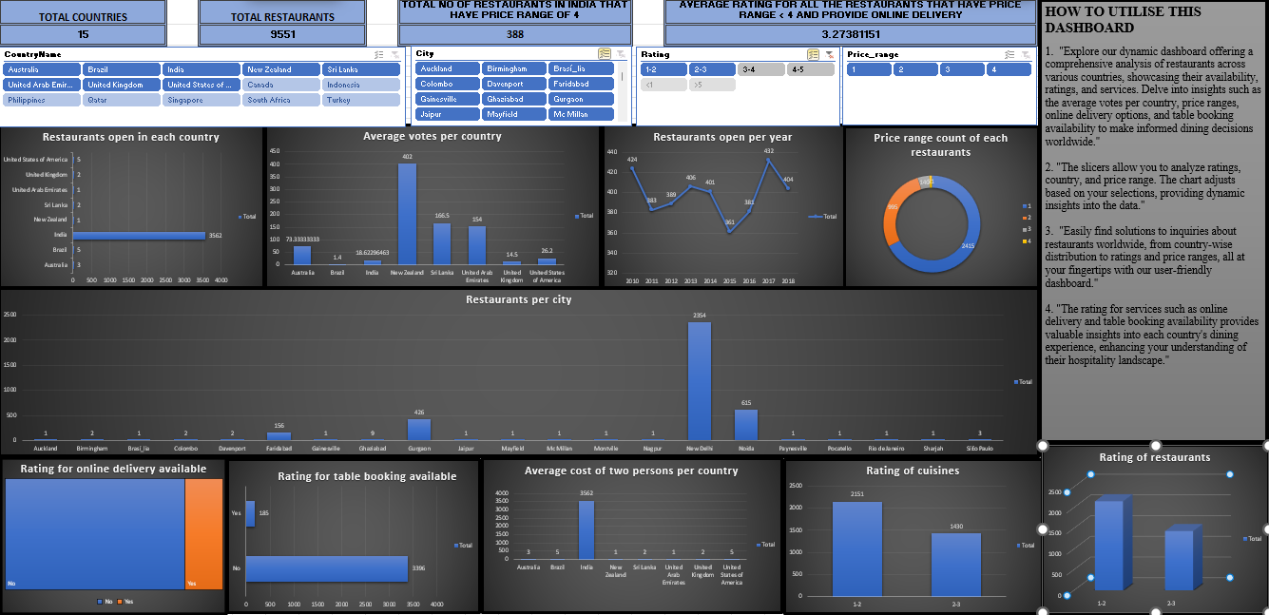

As we can easily notice that at the last chart named as “Rating of restaurants” the range of rating is between 1-2 and 2-3 so rating rating lies between 1-3.

1. Also, what is the current expenditure on food in the suggested countries, so we can keep our financial expenditure in control?

**Ans :-** The current expenditure on food in the suggested countries are 2645.431967.

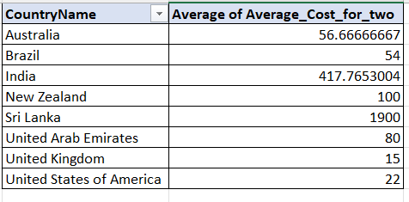

1. Come up with the names of restaurants from the recommended states that are our biggest competitors and also those that are rated in the lower brackets, i.e. 1-2 or 2-3.

**Ans**:-

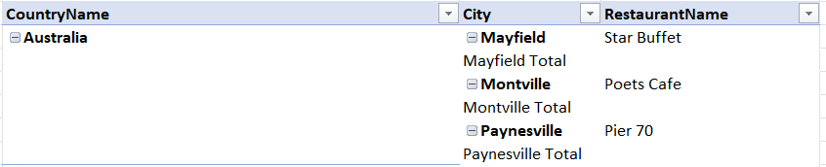

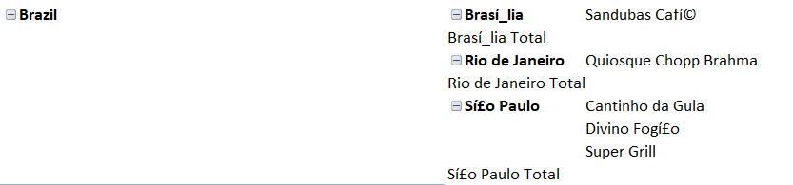

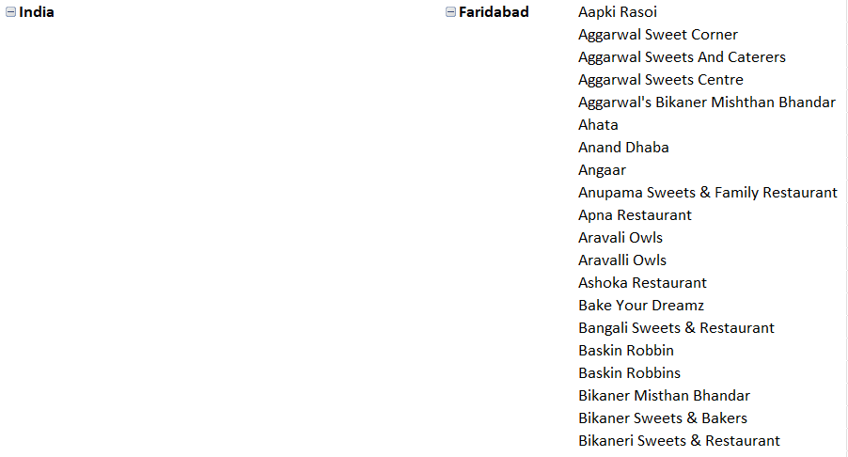

India – India has more number of restaurants these are some of them.

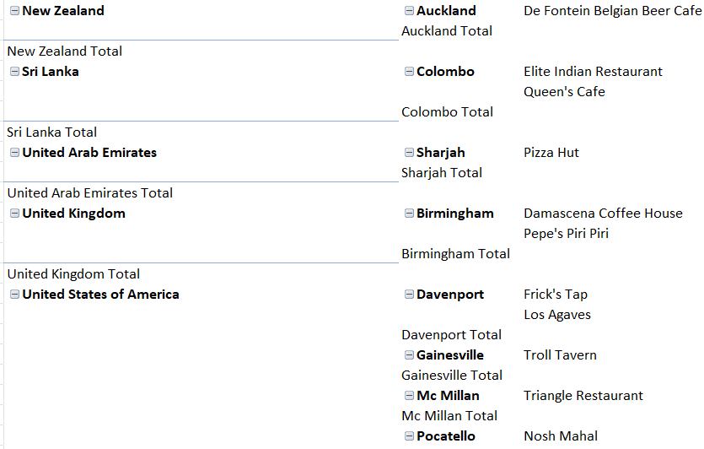

1. Which cuisines should we focus on in the newer restaurants to get better feedback? Does the choice of cuisines affect the restaurant ratings?

**Ans:-** Yes, the choice of cuisines affects the rating of the restaurants.

these are the list of cuisines that are in the range of 1-2 and 2-3 rating so we need to focus more on these cuisines.

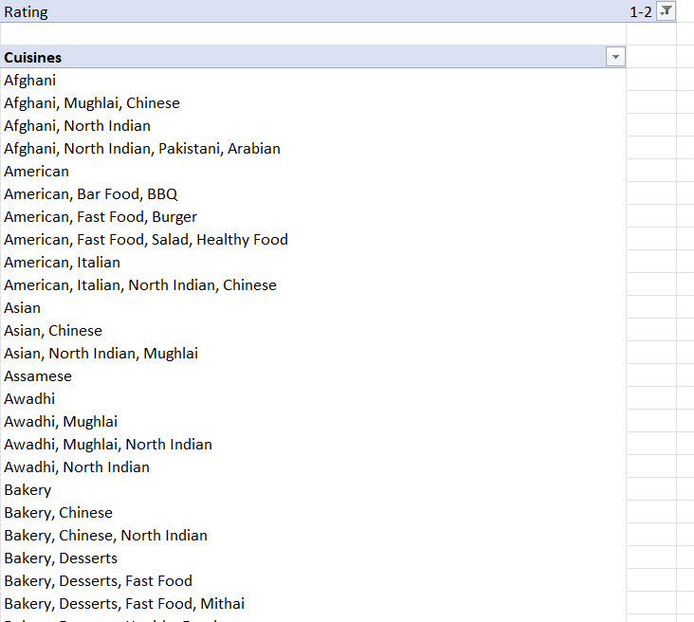 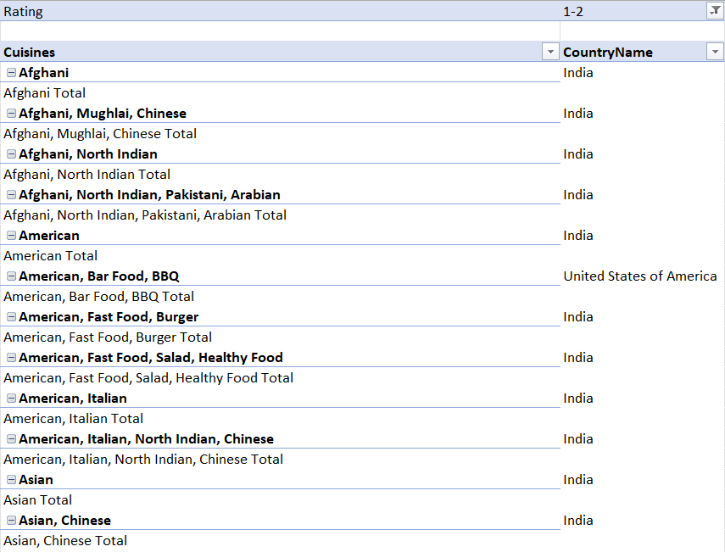

1. According to our current data, should we go for online delivery and table booking? Does that affect the customer’s ratings?

**Ans :-** Based on the current data we should go for online delivery and table booking because many restaurants do not offers online delivery and table booking so we can attract more customers easily.

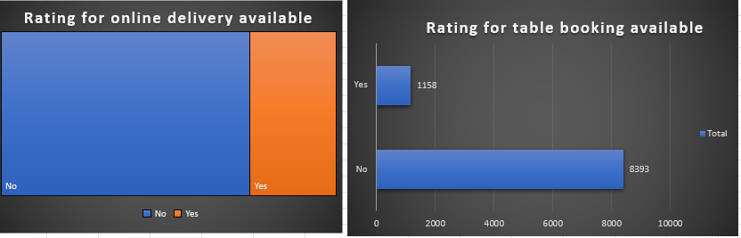

1. Should the team keep the rate of cuisines higher? Will that affect the feedback? According to our data are the rates of cuisines and ratings, correlated?

**Ans :-** Yes, the team keep the rate of cuisines higher there will be no affect on the rating because cuisines are liked by many people and if people like the cuisines they will pay for it.

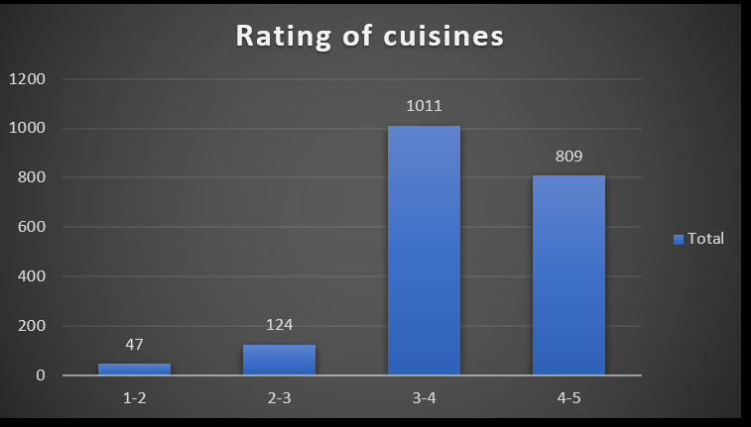

1. What is the distribution of the number of restaurants of different price ranges in all the countries?

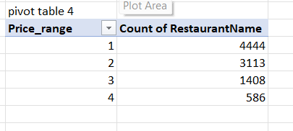

1. Explain your approach in brief for suggesting countries/cities in order to open new restaurants, if the objective and subjective questions would have been given to assist you. **[you have to give bullet pointers in order to answer this question]**

**Ans :-** The approach that I have used for doing the analysis using the dashboard that I have created includes the following steps that are mention below.

* Research competition levels in different countries.
* Analyze customer ratings and feedback.
* Consider economic factors like food expenditure.
* Visualize data for clearer insights.
* Prioritize countries with lower competition and positive customer feedback.