CSEE5590-0005

IoT/ Robot Programming

(2018 Fall)

*Lab Assignment 1*

**Smart IOT Monitoring Station**

Submitted On:

19 September, 2018

Submitted By:

Name: Farid Uddin Ahmed

Class ID: 01

Name: Mihir Manoj Pitale

Class ID: 09

Name: Zarin Tasnim Sandhie

Class ID: 10

Name: Kenton William Hanifl

Class ID: 12



LIST OF THE DOCUMENTATIONS

1. Authors
2. Objective
3. Introduction
4. MATERIALS REQUIRED
5. SOFTWARE AND HARDWARE IMPLEMENTATION
6. METHODS
7. Evaluation
8. Contribution
9. Conclusion
10. Links

AUTHORS

This is the report containing the documentations of the Assignment #1. The contributors of the assinments are: Farid Uddin Ahmed (Class ID: 01), Mihir Manoj Pitale (Class ID: 09), Zarin Tasnim Sandhie (Class ID: 10) and Kenton William Hanifl (Class ID: 12)

OBJECTIVE

To build a Smart IOT system that will contain a Weather station and Pulse beat monitoring and will have the capability of sending the data to a IoT visualization platform.

INTRODUCTION

The previous three weeks of IoT/Robot Programming class contained use of Arduino with LED, LCD and different types of sensors like Pulse, temperature, UV, Light etc. sensor. The assignment #1 is a combination of all the previous three ICPs. The assignment can be subdivide into the following sections:

* Integrate a Pulse, Barometer, Dust, Light, Temperature and UV sensor with an Arduino Board.
* All the sensors have to be connected with two LEDs which would turn on at different times depending on a particular threshold value for the sensors.
* There have to be two switches to turn on and off the whole circuit.
* The data have to be send into an LCD monitor sequentially.
* To receive the data through a WIFI module and send it to a visualization platform and visualize the outputs simultaneously.

MATERIALS REQUIRED

* Arduino Uno Board
* WIFI module (ESP8266)
* Visualization Software (ThingSpeak)
* Pulse Sensor
* Barometer Sensor
* Dust Sensor
* Light Sensor
* Temperature Sensor
* UV Sensor
* Breadboard
* LCD
* LED
* Mobile with internet connection
* Connectors
* Resistors
* Switch

SOFTWARE AND HARDWARE IMPLEMENTATION

For the implementation of the assignment, we used the Arduino Uno board and the software used here is Arduino IDE.

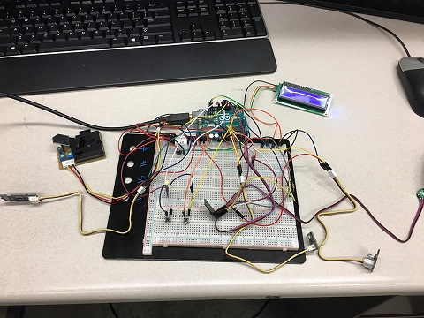

Figure 1: Circuit Connection for Smart IOT Monitoring Station

METHODS

* All the required libraries required for LCD, WIFI module and ThingSpeak are imported.
* The configuration for the WiFi module is done.
* Initialization of the pre-declared variables for different sensors is done.
* The function “void setup ()” sets up all the input data pins for sensors and LCD monitor and sets up WiFi module.
* Each sensor requires a function to take data from the sensor and send the values to the LCD monitor and also to the WiFi module.
* Threshold value is declared in the code for each sensor. If any value from the sensor goes above the threshold level, it displays a warning sign in the LCD and the sign stays there for ten seconds.
* One green and one red LEDs are associated with each sensors. Whenever there is a warning sign in the LCD, the red LED blinks. Otherwise, the green LED blinks.
* “void sendData” sends the data value from each of the sensors to the WiFi module and prints the data to respective field of the ThingSpeak visualizer.
* Three Interrupts were introduced. One for pulse sensor and other two is for on-off switch.
* “connectWiFi()” is used for connecting the WiFi module with the mobile network.
* The main loop calls all the functions for data sensing sequentially depending on the on-off switch interrupt.

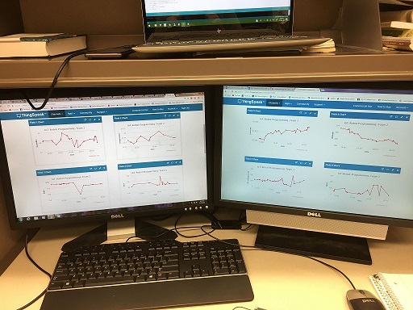

Figure 2: Visualization of Sensor Data in ThingSpeak Platform

EVALUATION

* All the sensors, LED, LCD and WiFi modules worked properly according to requirement.
* We faced some problems during the selection of hosting platforms and collected a list of issues that we encountered while working with each platform.
* The platforms which we have tried are: Thingsboard, Adafruit, IFTTT, Thinger.io, Ubidots, Cloudino, thethings.io, Dweet and Blynk.
* The problems faced with the platforms are explained in the Wiki page on the GitHub account. The link of the GitHub is given at the end of the report.

CONTRIBUTION

**Circuit Connection:**

Farid Uddin Ahmed, Mihir Manoj Pitale, Zarin Tasnim Sandhie, Kenton William Hanifl

**Coding:**

Kenton William Hanifl, Farid Uddin Ahmed

**Feature (On/Off):**

Mihir Manoj Pitale

**Feature (On/Off):**

Zarin Tasnim Sandhie

**WiFi Module:**

Farid Uddin Ahmed, Zarin Tasnim Sandhie

**ThingSpeak:**

Kenton William Hanifl, Farid Uddin Ahmed

**Exploring Platform Options:**

Farid Uddin Ahmed, Mihir Manoj Pitale, Zarin Tasnim Sandhie, Kenton William Hanifl

**Documentation:**

Kenton William Hanifl, Zarin Tasnim Sandhie

CONCLUSION

This assignment is a combination of all the ICPs done during the first three weeks. During this assignment, we were able to build the weather station along with pulse sensor. And we were able to visualize the data through the LCD monitor as well as ThingSpeak visualization.

LINKS

GitHub Link:

<https://github.com/farid7666/CS5690-IoT-Robot/tree/master/Assignment>

GitHub Wiki Link:

<https://github.com/farid7666/CS5690-IoT-Robot/wiki/Lab-1>

Video link:

<https://www.youtube.com/watch?v=uTjkYM3YsTU&feature=youtu.be>