CSEE5590-0005

IoT/ Robot Programming

(2018 Fall)

*Lab Assignment 2*

**An End to End system for visualizing sensor data on node red platform**

Submitted On:

05 October, 2018

Submitted By:

Name: Farid Uddin Ahmed

Class ID: 01

Name: Mihir Manoj Pitale

Class ID: 09

Name: Zarin Tasnim Sandhie

Class ID: 10

Name: Kenton William Hanifl

Class ID: 12



LIST OF THE DOCUMENTATIONS

1. AUTHORS
2. OBJECTIVE
3. INTRODUCTION
4. MATERIALS REQUIRED
5. PLATFORM USED
6. CIRCUIT CONNECTION
7. NODE RED FLOW
8. METHODOLOGY
9. THRESHOLD FOR UPDATING TO TWITTER
10. TEAM CONTRIBUTION
11. CONCLUSION
12. LINKS

AUTHORS

This is the report containing the documentations of the Assignment #2. The contributors of the assinments are: Farid Uddin Ahmed (Class ID: 01), Mihir Manoj Pitale (Class ID: 09), Zarin Tasnim Sandhie (Class ID: 10) and Kenton William Hanifl (Class ID: 12)

OBJECTIVE

Connect any of the sensor (Light, pressure, temperature etc.) with node red and visualize the data on the dashboard. And post to social net apps.

INTRODUCTION

In the past three weeks of IoT/Robot Programming class, we learned the use of node-red, connecting node-red with any kind of social app like twitter, gmail etc. and integrating node-red with Arduino. The assignment #2 is a combination of all the previous three ICPs. The assignment can be subdivide into the following sections:

* Integrate a Barometer, Dust, Light and Temperature sensor with an Arduino Board.
* Fetch the data of the sensors from the Arduino Board using node-red platform.
* Show the data into node-red dashboard.
* Also post the data into Twitter account.
* Maintain a threshold portion for the sensor. If the data exceeds the threshold value, it will post a warning in the twitter account.

MATERIALS REQUIRED

* Light Sensor
* Barometer
* Dust Sensor
* Temperature Sensor
* Breadboard
* Arduino Uno Board
* Connectors

PLATFORM USED

* Node-red

CIRCUIT CONNECTON

The circuit is connected as per figure:

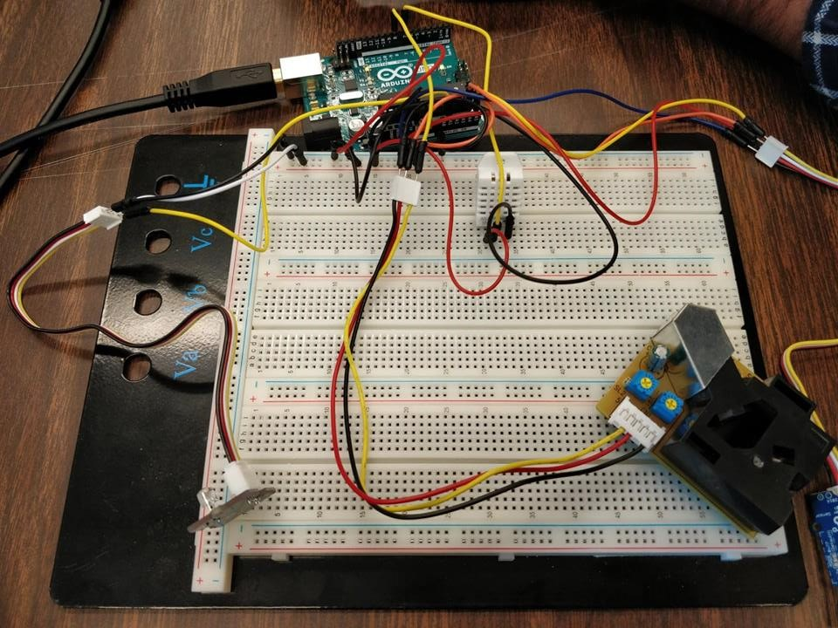

NODE-RED FLOW

The flow is made in node-red. The flow consists of two separate branches, one for dashboard visualization and another is for twitter visualization:

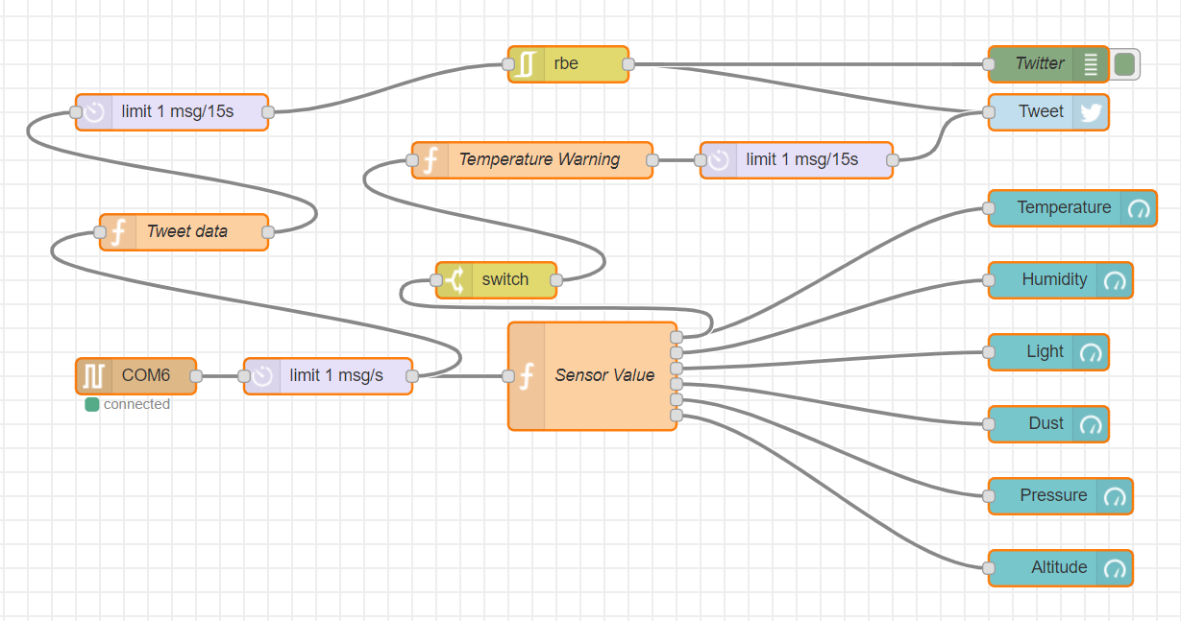

METHODOLOGY

* At first, the flow is created according to the picture given above.
* Instead of using Arduino output node in the flow, we used "COM" port which acts as serial port and convenient to use.
* The "COM6" port is used to take the input from Arduino Board.
* Code is uploaded in the Arduino board to take all the sensor values and send them in side a string.
* Limiting Function is created to limit 1 message per second.

**Dashboard Visualization:**

* For dashboard visualization, a function named "Sensor Value" is created.
* The function has 6 outputs.
* Inside the function, code is written which take the value of all the sensors which comes as a sting and splits them on the basis of spaces.
* Then it gives six separate sensor values in an array.
* Then the elements of the array is returned as the "msg".
* Six separate gauge type of dashboard is used for visualization of six different types of sensor data. All the required libraries required for LCD, WIFI module and ThingSpeak are imported.

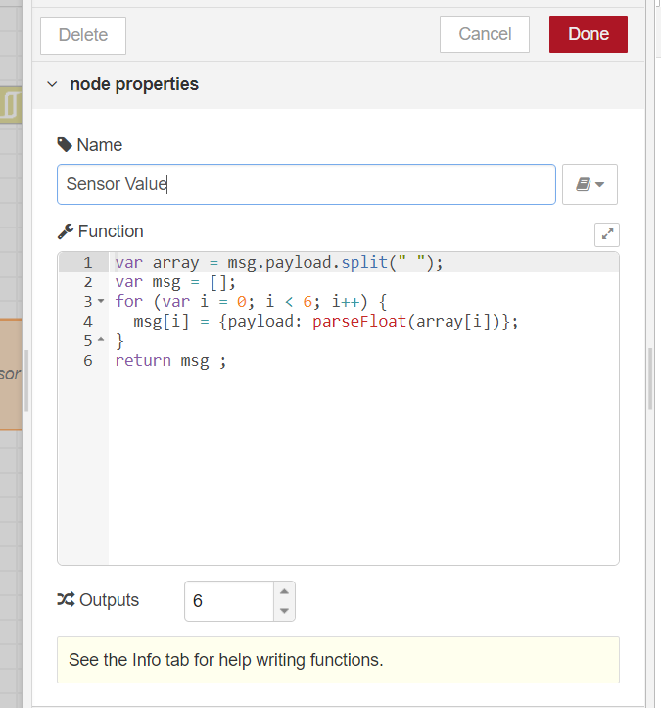

**Twitter Visualization**

* For the twitter visualization, a function called "Tweet data" is created in which the input string containing all the sensor data is split in respect to the spaces. And all the values are taken is an array.
* Tag and unit for all the sensor data are added accordingly.
* Inside a for loop, all the information are matched.
* Then a limiting function is used to limit 1 data per 15 second.
* Then an "rbe" function is used to block the twitter output if the sensor data matches the previous one.
* After that, a twitter node is used in which all the information for the twitter account is given.
* For the threshold part, it takes the temperature value from the Sensor value function and checks if it crosses the threshold.
* If the threshold is reached, a warning sign is posted in the Twitter account. The configuration for the WiFi module is done.

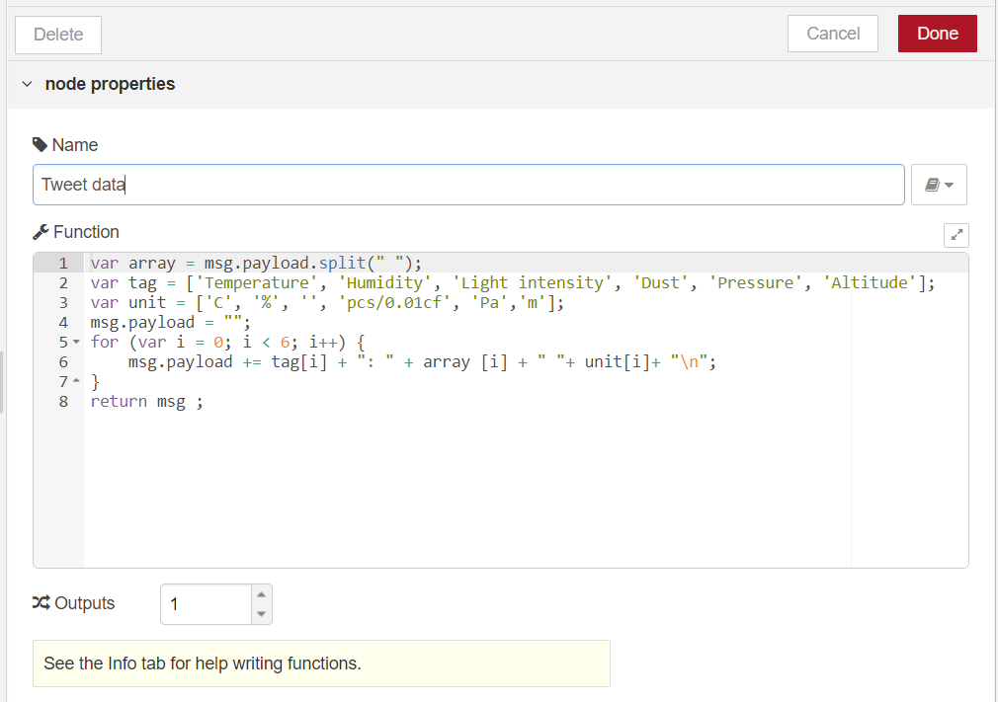

THRESHOLD FOR UPDATING TO TWITTER

If the temperature goes above 20'C, it will post a warning in the twitter. It will not give the warning if the temperature is same as the previous one. It will post the warning only once for a same temperature.

OUTPUT

**Dashboard Visualization:**

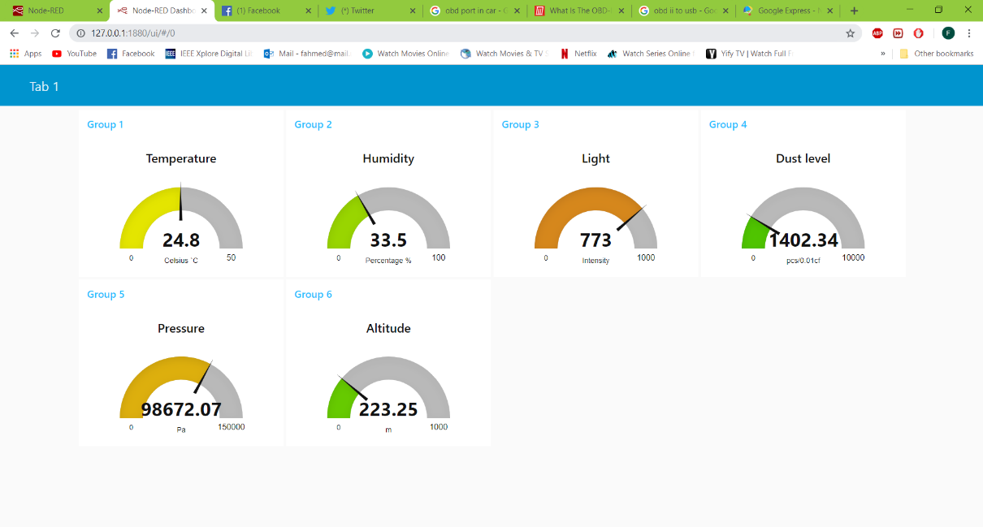

**Twitter Visualization:**

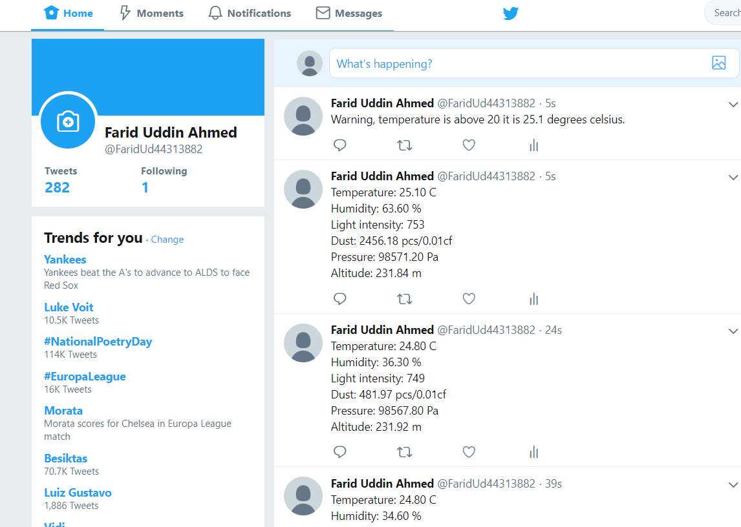

TEAM CONTRIBUTION

**Circuit Connection:**

Farid Uddin Ahmed, Zarin Tasnim Sandhie, Kenton William Hanifl, Mihir Manoj Pitale

**Coding:**

Kenton William Hanifl, Farid Uddin Ahmed, Zarin Tasnim Sandhie

**Visualization:**

Farid Uddin Ahmed, Kenton William Hanifl

**Documentation:**

Zarin Tasnim Sandhie, Kenton William Hanifl, Manoj Pitale

Farid Uddin Ahmed, Mihir Manoj Pitale, Zarin Tasnim Sandhie, Kenton William Hanifl

CONCLUSION

This assignment is a combination of all the ICPs done during the previous three weeks. During this assignment, we were able to create a flow to take all the sensor data from the Arduino board. The visualization was done using node-red dashboard visualization and twitter also. Threshold was set for the temperature sensor.

LINKS

GitHub Link:

https://github.com/farid7666/CS5690-IoT-Robot/tree/master/Assignment_2

GitHub Wiki Link:

https://github.com/farid7666/CS5690-IoT-Robot/wiki/Lab-%232

Video link:

<https://www.youtube.com/watch?v=U96bU_tPtAE&feature=youtu.be>

Code Link:

<https://github.com/farid7666/CS5690-IoT-Robot/tree/master/Assignment_2/Codes>

Flow Link:

<https://github.com/farid7666/CS5690-IoT-Robot/blob/master/Assignment_2/Assignment_flow_2.txt>