|  |  |
| --- | --- |
| **NAME :** | SANDHIYA V |
| **DEPARTMENT :** | INDUSTRIAL BIOTECHNOLOGY |
| **COLLEGE :** | GOVERNMENT COLLEGE OF TECHNOLOGY |
| **NAAN MUDHALVAN COURSE:** | DIGITAL MARKETING |
| **NAAN MUDHALVAN ID :** | FEFF54A6FD7A6EAB80745960F715C1B3 |

ASSIGNMENT ON DIGITAL MARKETING

1. Create a blog or website using blogspot and wordpress.Customize the theme design and post new article with 500 Words.

<https://myhealthydietin2.wordpress.com/>

2.Create a new facebook business page and post one social media poster for your brand.

<https://www.facebook.com/61552839393287/posts/122099144624094646/?mibextid=rS40aB7S9Ucbxw6v>

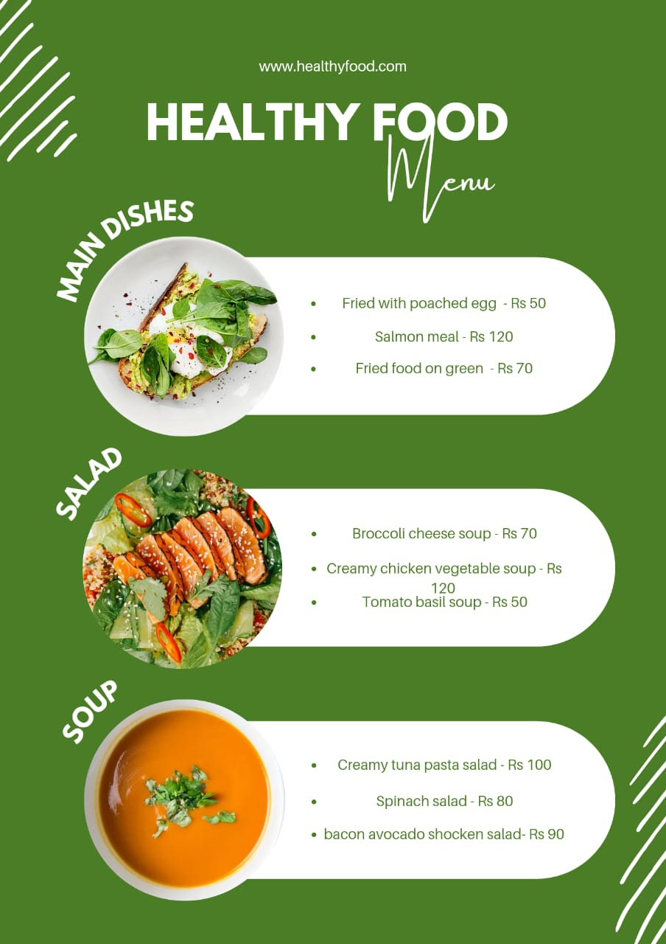

1. Create and design a social media advertisement poster using canva.

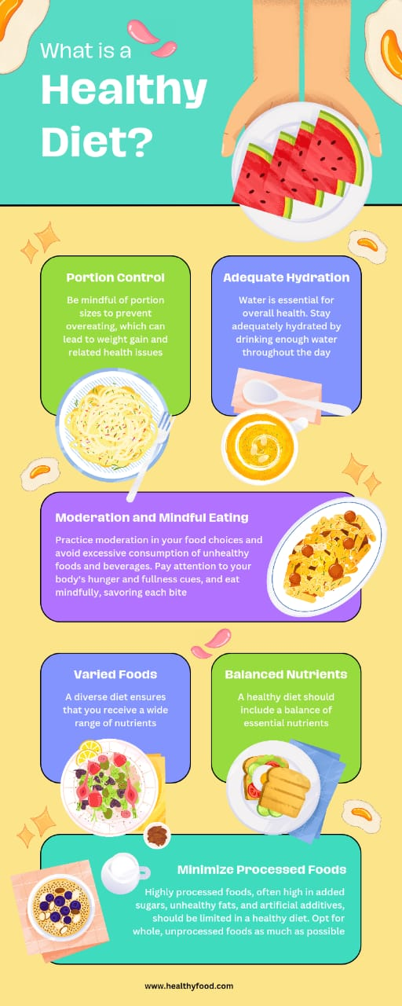

1. Create email newsletter design using Mailchimp or canva tool.

