**NETFLIX**

**Objective:**

The objective of this project is to showcase my ability to independently create a meaningful and visually engaging Tableau dashboard. This project will test my skills in data preparation, analysis, visualization, and presentation, allowing me to demonstrate my proficiency with Tableau’s core features.

**Data Source:**

I choose my topic in the field of entertainment. After that, I have generated my dataset using MOCKAROO, having 1000 rows containing Show ID, Type, Title, Director, Cast, Ratings, Release Year, Duration, Country, Date Added, Listed In, Description. After generated, I downloaded in the excel format. Then, loaded it in the Tableau.

**Calculated Fields:**

I used the calculated field for categories the ratings using if elseif else.

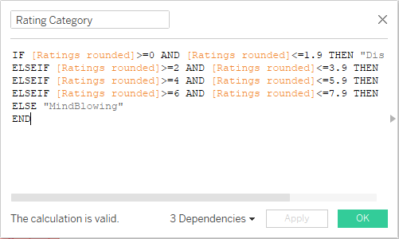

**Dashboard:**

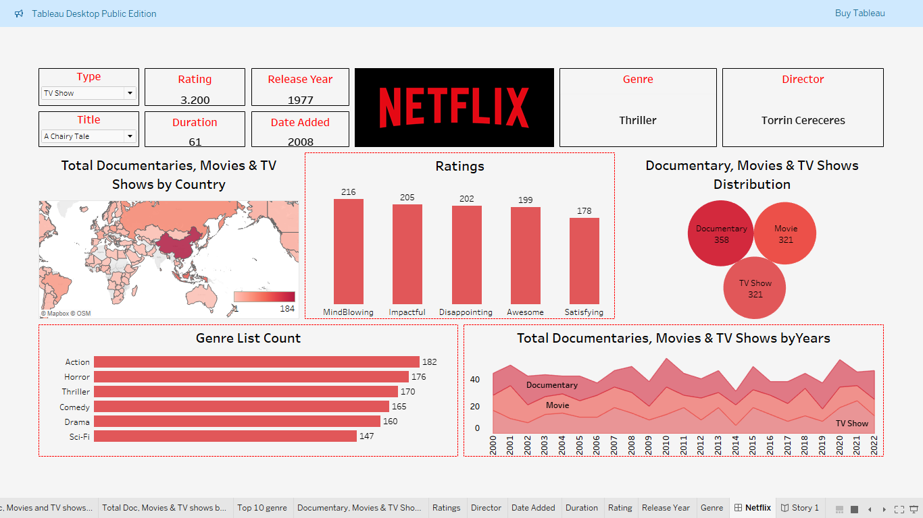

**Insights and Conclusion:**