**Credit Card Fraud Detection**

**Phase 1**

**Problem Definition:**

**The problem is to develop a machine learning-based system for real-time credit card fraud detection. The goal is to create a solution that can accurately identify fraudulent transactions while minimizing false positives. This project involves data preprocessing, feature engineering, model selection, training, and evaluation to create a robust fraud detection system.**

**Design Thinking:**

**1.Data Source:**

A "data source" in the context of credit card fraud detection refers to the origin or provider of the data used for training, testing, and validating fraud detection models. It is the place or entity from which you obtain the dataset containing information about credit card transactions, including both legitimate and fraudulent activities. A data source typically includes:

**A)Data Provider**: This is the organization, institution, or entity that collects, maintains, and shares the dataset. Data providers can include financial institutions, research organizations, government agencies, or third-party data providers.

**B)Data Description**: A data source should provide a detailed description of the dataset, including the type of information it contains. For credit card fraud detection, this would include features such as transaction amounts, timestamps, merchant information, card details, and, most importantly, labels or indicators of fraud/non-fraud for each transaction.

**C)Data Privacy and Security**: Information regarding how the data source handles data privacy and security is essential. It should adhere to regulations and best practices for protecting sensitive customer information, often through anonymization or data masking techniques.

**D)Data Accessibility**: The data source should specify how you can access the dataset. This may include downloading the dataset from a website, obtaining it through a data-sharing agreement, or accessing it through an API.

**E)Data Usage Policies**: The data source may have terms and conditions regarding the permissible uses of the dataset. Ensure you comply with these policies, which may include restrictions on data sharing, redistribution, or commercial use.

**F)Data Updates**: It's important to know if the dataset is regularly updated. In fraud detection, staying up-to-date with the latest transaction data is crucial for maintaining the accuracy of models.

**G)Data Quality and Integrity**: Information about data quality, including potential issues like missing values or outliers, should be documented. High-quality data is essential for building effective fraud detection models.

**H)Data Format**: The data source should specify the format in which the data is provided (e.g., CSV, JSON, SQL database). Understanding the data format is essential for data preprocessing.

**I)Documentation:** Comprehensive documentation, including data dictionaries or metadata, is helpful for understanding the meaning and structure of each column in the dataset.

**J)Data Licensing**: If applicable, the data source may provide information on the licensing terms associated with the dataset. Some datasets have open licenses that allow broader usage, while others may have more restrictive licenses.

Obtaining data from a trustworthy and reputable source is critical in credit card fraud detection, as it impacts the reliability and ethics of your analysis. Additionally, it's important to handle sensitive financial data with care and ensure compliance with relevant data protection regulations, such as GDPR or HIPAA, depending on your jurisdiction and the nature of the data.

**Dataset Link:**[**https://www.kaggle.com/datasets/mlg-ulb/creditcardfraud**](https://www.kaggle.com/datasets/mlg-ulb/creditcardfraud)

The dataset contains transactions made by credit cards..

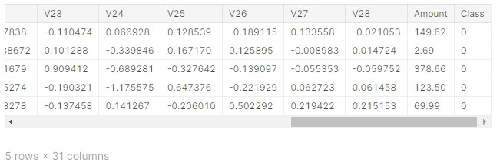

**2**.**Data Preprocessing**:

Clean and preprocess the data, handle missing values, and normalize features. Data preprocessing is a crucial step in credit card fraud detection as it helps prepare the raw transaction data for analysis and model training. Here are the key data preprocessing steps involved in credit card fraud detection:

**A)Data Loading:**Load the raw transaction data from your data source into your chosen data analysis tool or programming environment (e.g., Python with pandas).

**B)Data Exploration:**Perform initial data exploration to understand the dataset's structure, features, and data types.Check for missing values in the dataset and decide how to handle them (e.g., imputation or removal).Examine summary statistics to gain insights into transaction amounts, timestamps, and other relevant features.

**C)Data Cleaning:**Remove or handle duplicate records if they exist in the dataset.Address missing values by imputing them with appropriate values, such as the mean, median, or using advanced imputation methods like K-nearest neighbors or regression imputation.Correct any data format issues, such as inconsistent date/time formats.

**PYTHON PROGRAM:**

import matplotlib.pyplot as plt

import seaborn as sns

from matplotlib import gridspec

from sklearn.model_selection import train_test_split

from sklearn.ensemble import RandomForestClassifier

from sklearn.metrics import (classification_report, accuracy_score,

precision_score, recall_score,

f1_score, matthews_corrcoef,

confusion_matrix)

credit = pd.read_csv('/kaggle/input/creditcardfraud/creditcard.csv')

credit.head()

credit.shape

credit.describe().T

fraud = credit[credit['Class'] == 1]

valid = credit[credit['Class'] == 0]

fraction = len(fraud)/float(len(valid))

print(fraction)

print("Fraud Cases: {}".format(len(credit[credit['Class'] == 1])))

print("Valid Cases: {}".format(len(credit[credit['Class'] == 0])))

print("Amount of details for the Fraudulent Transaction")

fraud.Amount.describe()

print("Amount of details for Normal Transaction")

valid.Amount.describe()

corrmat = credit.corr()

fig = plt.figure(figsize=(12, 9))

sns.heatmap(corrmat, vmax=.8, square=True)

plt.show()

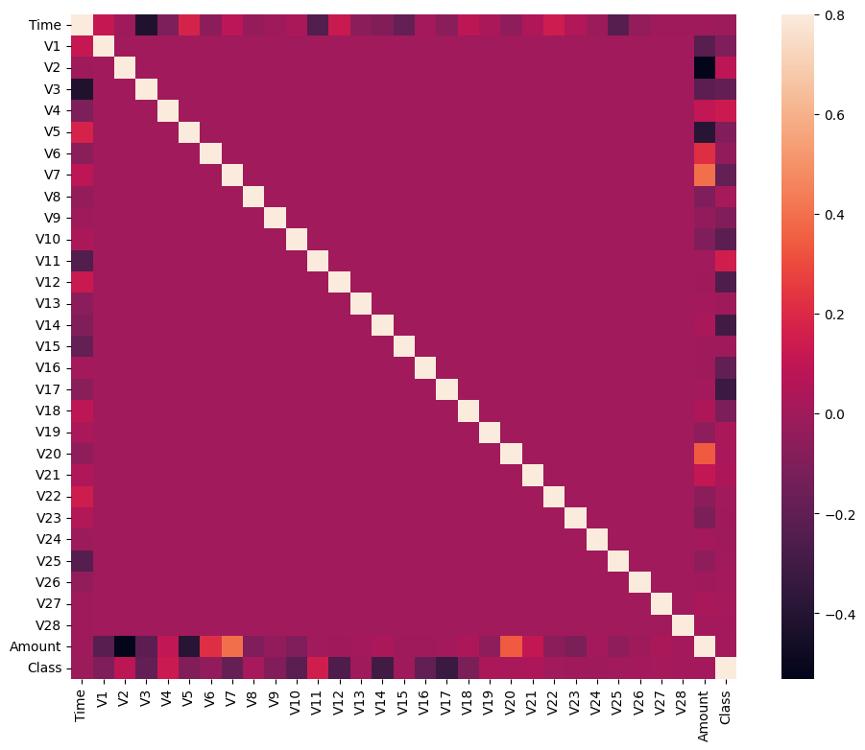

**3.Feature Engineering:**

Feature engineering is a critical step in credit card fraud detection that involves creating new features or transforming existing ones to improve the performance of machine learning models in identifying fraudulent transactions. Here are some feature engineering techniques commonly used in credit card fraud detection

**A)Time-Based Features:**Transaction Timestamp: Extract information such as the hour of the day, day of the week, or month from transaction timestamps. Fraudulent activities may exhibit temporal patterns.Time Since Last Transaction: Calculate the time elapsed since the cardholder's last transaction. Unusual gaps in transaction times could be indicative of fraud.

**B)Aggregated Statistics:**Transaction Amount Aggregates: Compute statistics like the mean, median, maximum, minimum, or standard deviation of transaction amounts for each cardholder or merchant. This helps identify abnormal spending patterns.

**C)Transaction Frequency:** Calculate the average time between transactions for each cardholder. Unusually high or low transaction frequencies may be indicative of fraud.

**D)Rolling Window Aggregates:** Create rolling window statistics, such as the sum of transaction amounts over the last N days, to capture short-term spending behavior.

**E)Merchant-Based Features:**Merchant Category: Categorize merchants into specific categories (e.g., retail, online, entertainment) and use these categories as features.

**F)Merchant Popularity:** Calculate the frequency of transactions with each merchant and flag less common merchants as potential anomalies.

**G)Cardholder-Based Features:**Cardholder Transaction History: Analyze each cardholder's historical transaction behavior, such as their spending patterns, average transaction amounts, and transaction frequency.Cardholder's Geographical Location: If available, use the cardholder's location data to detect unusual transaction locations.

**H)Transaction Velocity**:Velocity Filters: Calculate metrics like the number of transactions in a given time window and set thresholds to detect high-velocity transactions that may indicate fraud.

**I)Velocity Clusters:** Group transactions by cardholder and merchant and analyze patterns of multiple transactions within a short time frame.

**J)Cardholder Behavior Change:**Calculate metrics that capture changes in a cardholder's behavior over time. Sudden deviations from historical behavior may indicate fraud.

**H)Outlier Detection:**Use outlier detection techniques to identify unusual transactions based on statistical methods (e.g., Z-scores, Isolation Forests) or clustering algorithms.

Consider using anomaly scores as features in your model.

**I)Transaction Sequences:**Analyze sequences of transactions over time to identify patterns that are indicative of fraud. Sequence-based models like recurrent neural networks (RNNs) can be useful for this purpose.

**J)Encoding Categorical Variables**:Encode categorical features like cardholder ID, merchant ID, or merchant category using techniques like one-hot encoding or label encoding.

**K)Feature Scaling:**Ensure that all numerical features are on the same scale by applying scaling techniques like Min-Max scaling or standardization (z-score normalization).

**L)Derived Features:**Create composite features that combine relevant information. For example, a "transaction amount to average transaction amount ratio" could be informative.

Feature engineering is often an iterative process, and domain knowledge plays a crucial role in selecting and creating meaningful features. Experiment with different feature combinations and transformations to improve the performance of your credit card fraud detection model.

**4. Model Selection:**

Selecting the right model for credit card fraud detection is a crucial step in building an effective fraud detection system. The choice of model depends on various factors, including the characteristics of the dataset, the type of features engineered, and the trade-offs between different model properties. Here are some common models and considerations for selecting them in credit card fraud detection:

**A)Logistic Regression:**Use Case: Logistic regression is a simple and interpretable model suitable for binary classification tasks like fraud detection.

Pros: Interpretable, fast training and prediction, handles imbalanced datasets well with proper class weights.

Cons: Limited ability to capture complex relationships in data.

B)(Decision Trees and Random Forests:Use Case: Decision trees and random forests can capture non-linear relationships and interactions between features.

Pros: Can handle both numerical and categorical features, interpretable (for individual trees), and robust to outliers.

Cons: Random forests can be prone to overfitting if not tuned properly.

**C)Gradient Boosting Models (e.g., XGBoost, LightGBM, CatBoost):**Use Case: Gradient boosting models are powerful ensemble methods for improving classification accuracy.

Pros: High predictive accuracy, can handle complex relationships, and often robust to overfitting with proper regularization.

Cons: More complex than simpler models, may require hyperparameter tuning.

**D)Support Vector Machines (SVM):**Use Case: SVMs are effective when dealing with high-dimensional data and can handle non-linear relationships with the kernel trick.

Pros: Effective at capturing complex decision boundaries, good for handling imbalanced datasets.

Cons: Less interpretable, training time can be longer for large datasets.

**E)Neural Networks:**Use Case: Deep learning models like feedforward neural networks or convolutional neural networks (CNNs) can capture intricate patterns in data.

Pros: High capacity for feature learning, adaptability to various data types, and can handle large and complex datasets.

Cons: Requires a large amount of data and computational resources, can be challenging to interpret, and may overfit if not carefully regularized.

**F)Anomaly Detection Algorithms:**Use Case: Algorithms like Isolation Forest, One-Class SVM, or Autoencoders are specifically designed for anomaly detection tasks.

Pros: Tailored for fraud detection, effective at identifying rare events, and can be interpretable depending on the algorithm.

Cons: May not perform as well on non-anomalous data, may require specialized tuning.

**G)Ensemble Models:**Use Case: Combining multiple models (e.g., stacking or bagging) can often improve overall performance and robustness.

Pros: Improved accuracy, reduced overfitting, and better handling of class imbalance.

Cons: Increased complexity, may require more computational resources.

**H)Hybrid Approaches:**Consider using a combination of models, including rule-based systems and machine learning models, to leverage domain knowledge and statistical techniques for better fraud detection.

When selecting a model, it's essential to consider factors like the dataset size, class imbalance, interpretability, computational resources, and the trade-offs between false positives and false negatives. Additionally, hyperparameter tuning and model evaluation using appropriate metrics (e.g., precision, recall, F1-score, AUC-ROC) are essential to ensure the chosen model meets your fraud detection objectives.

Iterative experimentation and testing different models are often necessary to find the best-performing model for your specific credit card fraud detection problem.

**5. Model Training:**

Model training in credit card fraud detection involves using historical transaction data to teach a machine learning model to distinguish between legitimate and fraudulent transactions. Here's a step-by-step guide on how to train a model for this task:

**A)Data Preprocessing:**Begin by preprocessing your dataset as discussed earlier, which includes tasks like data cleaning, feature engineering, handling class imbalance, and data splitting.

**B)Select Evaluation Metrics:**Decide on the evaluation metrics you will use to assess the model's performance. Common metrics for fraud detection include precision, recall, F1-score, accuracy, and the area under the ROC curve (AUC-ROC).

**C)Data Splitting:**Split your preprocessed dataset into three subsets: a training set, a validation set, and a testing set. The training set is used for model training, the validation set for hyperparameter tuning, and the testing set for final model evaluation.

**D)Model Selection:**Choose an appropriate machine learning model based on your dataset characteristics and objectives. This could be logistic regression, decision trees, random forests, gradient boosting, support vector machines, neural networks, or an ensemble of multiple models.

**E)Hyperparameter Tuning:**If applicable, perform hyperparameter tuning using the validation set to optimize the model's performance. This involves adjusting model-specific parameters to find the best configuration.

**F)Model Training:**Train the selected model on the training dataset using the optimal hyperparameters. The model learns to distinguish between fraudulent and non-fraudulent transactions based on the features you've engineered.

**G)Model Evaluation:**Evaluate the model's performance on the validation set using the chosen evaluation metrics. Adjust hyperparameters as needed to improve the model's performance.

**H)Final Model Training:**Once satisfied with the model's performance on the validation set, train the final model on both the training and validation datasets to maximize the amount of data the model learns from.

**I)Model Testing:**Assess the final model's performance on the testing set, which contains unseen data. This step provides an unbiased estimate of how well the model will perform on new, real-world data.

**J)Threshold Selection:**Choose an appropriate decision threshold for classification. Depending on the trade-off between false positives and false negatives, you may adjust the threshold to meet specific fraud detection objectives.

**K)Monitoring and Maintenance:**Implement a system for continuous model monitoring and maintenance. As fraud patterns change over time, regularly retrain the model with new data to ensure its effectiveness.

**L)Deployment:**Once the model performs well on the testing set, deploy it into your production environment for real-time or batch processing of transactions. Ensure that deployment complies with all regulatory and security requirements.

**M)Feedback Loop:**Establish a feedback loop to continually improve the model. Monitor model performance in production, collect feedback on its predictions, and use this information to make model updates and refinements.

**N)Documentation and Reporting:**Maintain detailed documentation of the model's training process, hyperparameters, evaluation results, and any updates. This documentation is important for compliance and auditing purposes.

**O)Security and Privacy:**Implement robust security measures to protect both the model and the sensitive customer data used in fraud detection. Ensure that data privacy regulations are strictly adhered to.

Credit card fraud detection models may need periodic retraining and adjustment to stay effective, as fraudsters constantly adapt their tactics. Therefore, it's crucial to establish a well-defined process for model maintenance and improvement over time.

**PYTHON PROGRAM:**

X = credit.drop(['Class'], axis=1 )

Y = credit['Class']

print(X.shape)

print(Y.shape)

X_credit = X.values

X_train, X_test, y_train, y_test = train_test_split(X, Y, test_size=0.2, random_state=42)

# Build RandomForestClassifier

rfc = RandomForestClassifier()

rfc.fit(X_train, y_train)

y_pred = rfc.predict(X_test)

**6.Evaluation:**

Evaluating the performance of a credit card fraud detection model is a critical step to ensure that it effectively identifies fraudulent transactions while minimizing false alarms (false positives). Several evaluation metrics and techniques can be used to assess the model's performance. Here are some key aspects to consider when evaluating the model's performance in credit card fraud detection:

**A)Confusion Matrix:**A confusion matrix is a table that summarizes the model's predictions compared to the actual outcomes. It consists of four elements:

True Positives (TP): Legitimate transactions correctly classified as legitimate.

True Negatives (TN): Fraudulent transactions correctly classified as fraudulent.

False Positives (FP): Legitimate transactions incorrectly classified as fraudulent (Type I error).

False Negatives (FN): Fraudulent transactions incorrectly classified as legitimate (Type II error).

The confusion matrix is the foundation for calculating various evaluation metrics.

**B)Precision:**Precision measures the model's ability to correctly identify fraudulent transactions among all transactions it labels as fraudulent. It is calculated as TP / (TP + FP).

A higher precision indicates fewer false positives, which is important for reducing the number of legitimate transactions mistakenly flagged as fraud.

Recall (Sensitivity or True Positive Rate):

Recall measures the model's ability to correctly identify all actual fraudulent transactions. It is calculated as TP / (TP + FN).

A higher recall indicates that the model is better at catching fraudulent transactions, reducing false negatives.

**C)F1-Score:**The F1-score is the harmonic mean of precision and recall. It balances precision and recall, providing a single metric to assess overall model performance. It is calculated as 2 * (Precision * Recall) / (Precision + Recall).

The F1-score is particularly useful when dealing with imbalanced datasets, as it accounts for both false positives and false negatives.

**D)Accuracy:**Accuracy measures the proportion of correctly classified transactions (both legitimate and fraudulent) out of the total transactions. It is calculated as (TP + TN) / (TP + TN + FP + FN).

While accuracy is an important metric, it may not be suitable for imbalanced datasets, as high accuracy can be achieved by simply classifying all transactions as legitimate.

**E)Receiver Operating Characteristic (ROC) Curve and Area Under the Curve (AUC-ROC):**The ROC curve plots the trade-off between true positive rate (TPR or recall) and false positive rate (FPR) for different decision thresholds.

AUC-ROC quantifies the overall performance of the model. A higher AUC-ROC indicates better discrimination between legitimate and fraudulent transactions.

**F)Precision-Recall Curve and Area Under the Curve (AUC-PR):**The precision-recall curve illustrates the trade-off between precision and recall for different decision thresholds.

AUC-PR quantifies the model's performance in terms of precision and recall, focusing on the positive class (fraudulent transactions).

**G)Specificity and True Negative Rate (TNR):**Specificity measures the model's ability to correctly identify legitimate transactions as legitimate. It is calculated as TN / (TN + FP).

**H)False Positive Rate (FPR):**FPR measures the proportion of legitimate transactions incorrectly classified as fraudulent. It is calculated as 1 - Specificity.

**I)Cost-Based Metrics:**Consider cost-sensitive evaluation metrics that account for the financial impact of false positives and false negatives, as well as the operational costs of investigating alerts.

**J)Threshold Selection:**Choose an appropriate decision threshold that balances precision and recall based on the specific needs and objectives of the fraud detection system. Adjusting the threshold can help tailor the model's behavior.

**K)Cross-Validation:**Perform cross-validation, such as k-fold cross-validation, to assess the model's robustness and generalization performance. Cross-validation helps mitigate overfitting and provides more reliable performance estimates.

**L)Model Interpretability:**Consider the interpretability of the model, especially when explaining its predictions to stakeholders or regulatory authorities.

**M)Monitoring and Feedback:**Continuously monitor the model's performance in a production environment and gather feedback from fraud analysts and investigators to make necessary adjustments and improvements.

Evaluating the model's performance in credit card fraud detection is an ongoing process, as fraud patterns evolve over time. It's important to regularly re-evaluate and update the model to maintain its effectiveness. Additionally, it's essential to document the evaluation results for compliance and reporting purposes.

**PYTHON PROGRAM:**

n_outliers = len(fraud)

n_errors = (y_pred != y_test).sum()

print("The model used is RandomForestClassifier")

acc = accuracy_score(y_test, y_pred)

print(f"The accuracy is {acc}")

prec = precision_score(y_test, y_pred)

print(f"The precision score is {prec}")

rec = recall_score(y_test, y_pred)

print(f"The recall score is {rec}")

f1 = f1_score(y_test, y_pred)

print(f"The f1 score is {f1}")

MCC = matthews_corrcoef(y_test, y_pred)

print(f"The Matthews correlation coeficient is {MCC}")

LABELS = ['Normal', 'Fraud']

conf_matrix = confusion_matrix(y_test, y_pred)

plt.figure(figsize=(12,12))

sns.heatmap(conf_matrix, xticklabels = LABELS, yticklabels = LABELS, annot=True, fmt='d')

plt.title('Confusion Matrix')

plt.ylabel('True class')

plt.xlabel('Predicted class')

plt.show()

