

ISWE406P - AGILE DEVELOPMENT PROCESS AND DEVEOPS

LAB FAT EXAM

NAME : SANDHIYA U
REGNO : 23MIS0357 Slot : L3 +L4
Expense Tracking System

Simple Java Application (in local machine)

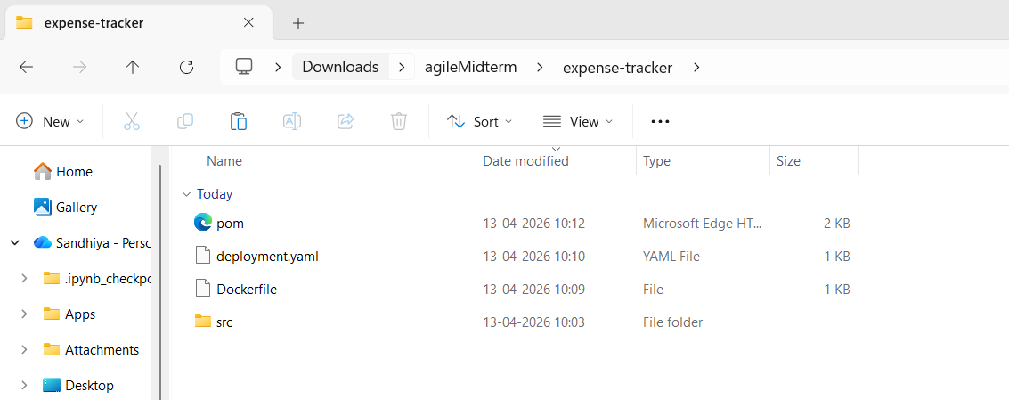
Java Files

- ExpenseManager.Java
package com.expense;
import java.util.*;
class Expense {
String category;
double amount;

Expense(String category, double amount) {
this.category = category;
this.amount = amount;
}
}
public class ExpenseManager {

private List<Expense> expenses = new ArrayList<>();

public void addExpense(String category, double amount) {
expenses.add(new Expense(category, amount));
}

public double getTotalExpense() {
double total = 0;
for (Expense e : expenses) {
total += e.amount;
}
return total;
}

public double getExpenseByCategory(String category) {
double total = 0;
for (Expense e : expenses) {
if (e.category.equalsIgnoreCase(category)) {
total += e.amount;
}
}
return total;
}
public void clearExpenses() {
expenses.clear();
}
public static void main(String[] args) {
ExpenseManager manager = new ExpenseManager();
manager.addExpense("Food", 200);
manager.addExpense("Travel", 300);

System.out.println("Total Expense: " + manager.getTotalExpense());
}
}

ExpenseManagerTest.java

package com.expense;

import org.junit.jupiter.api.Test;
import static org.junit.jupiter.api.Assertions.*;

public class ExpenseManagerTest {

@Test
void testTotalExpense() {
ExpenseManager manager = new ExpenseManager();
manager.addExpense("Food", 200);
manager.addExpense("Travel", 300);

assertEquals(500, manager.getTotalExpense());
}

@Test
void testCategoryExpense() {
ExpenseManager manager = new ExpenseManager();
manager.addExpense("Food", 200);
manager.addExpense("Food", 100);

assertEquals(300, manager.getExpenseByCategory("Food"));
}

@Test
void testClearExpenses() {
ExpenseManager manager = new ExpenseManager();
manager.addExpense("Food", 200);
manager.clearExpenses();

assertEquals(0, manager.getTotalExpense());
}
}

Maven File - pom.xml

<project xmlns="http://maven.apache.org/POM/4.0.0"
xmlns:xsi="http://www.w3.org/2001/XMLSchema-instance"
xsi:schemaLocation="http://maven.apache.org/POM/4.0.0
http://maven.apache.org/xsd/maven-4.0.0.xsd">

<modelVersion>4.0.0</modelVersion>

<groupId>com.expense</groupId>
<artifactId>expense-tracker</artifactId>
<version>1.0</version>
<packaging>jar</packaging>

<properties>
<maven.compiler.source>17</maven.compiler.source>
<maven.compiler.target>17</maven.compiler.target>
<junit.version>5.10.1</junit.version>
</properties>

<dependencies>
<dependency>
<groupId>org.junit.jupiter</groupId>
<artifactId>junit-jupiter</artifactId>
<version>${junit.version}</version>
<scope>test</scope>
</dependency>
</dependencies>

<build>
<plugins>

<plugin>
<groupId>org.apache.maven.plugins</groupId>
<artifactId>maven-compiler-plugin</artifactId>
<version>3.11.0</version>
</plugin>

<plugin>
<groupId>org.apache.maven.plugins</groupId>
<artifactId>maven-surefire-plugin</artifactId>
<version>3.2.5</version>
<configuration>
<useModulePath>false</useModulePath>
</configuration>
</plugin>

<plugin>
<groupId>org.apache.maven.plugins</groupId>
<artifactId>maven-jar-plugin</artifactId>
<version>3.4.1</version>
<configuration>
<archive>
<manifest>
<mainClass>com.cart.Cart</mainClass>
</manifest>
</archive>
</configuration>
</plugin>

</plugins>
</build>
</project>

Kubernetes Deployment File deployment.yaml

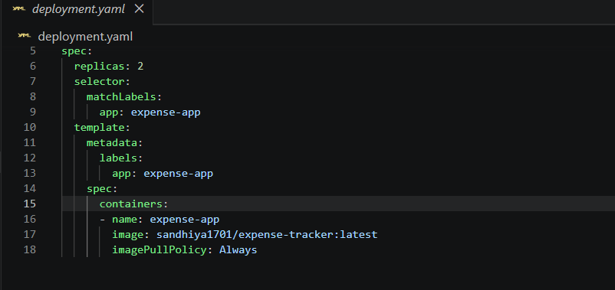
Dockerfile

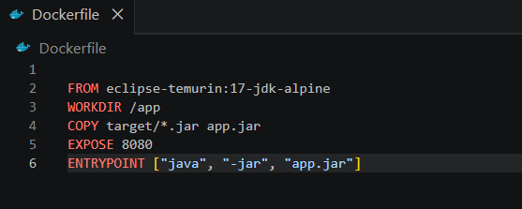

Build Locally using Maven (Test)
Inside project folder:
mvn clean test

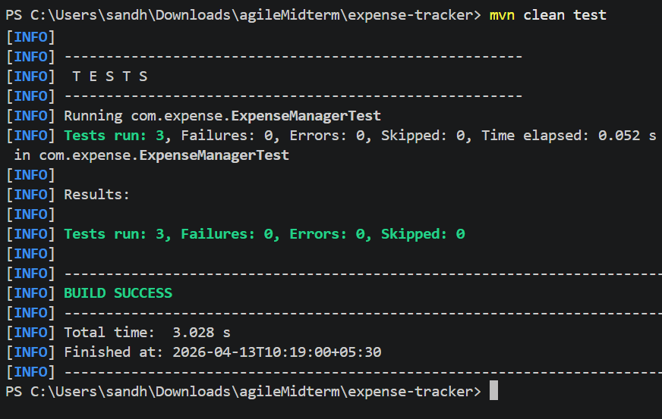
mvn clean package

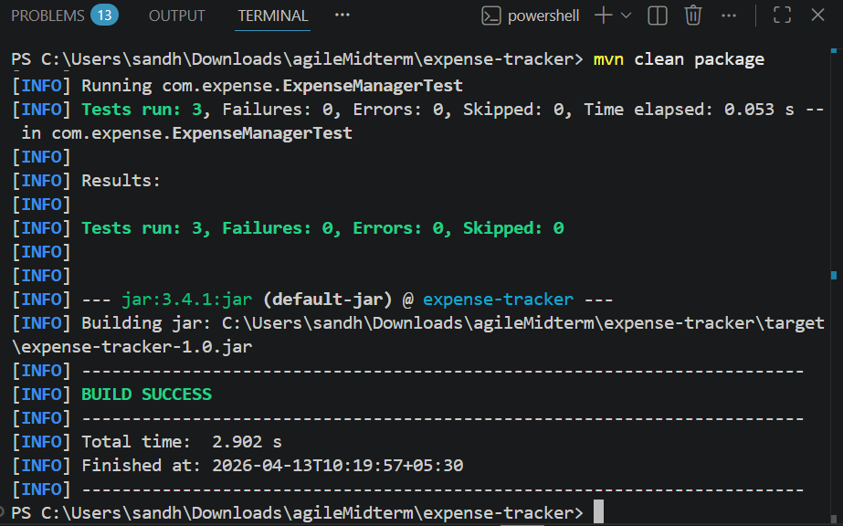

It generates target file

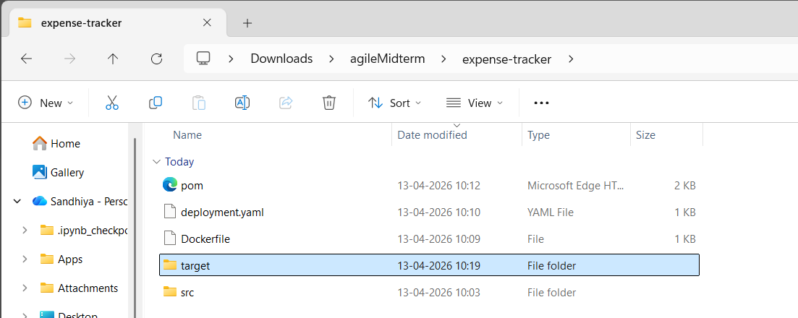

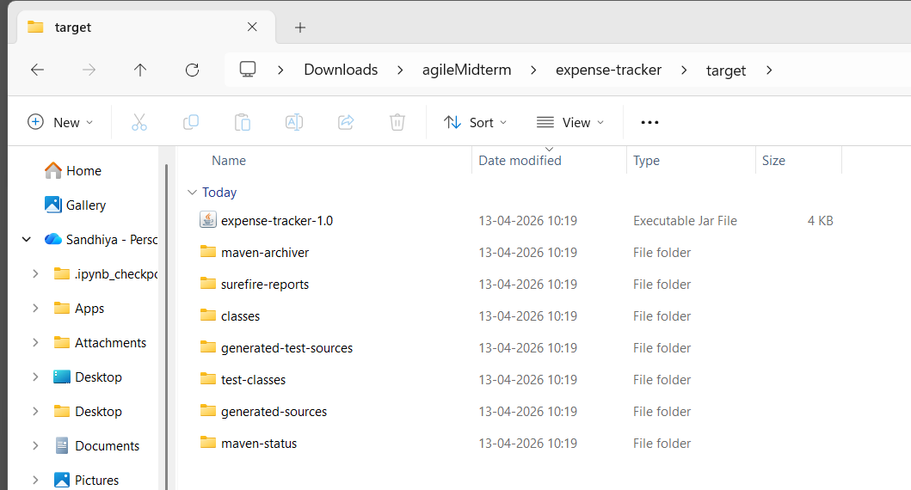

Push Code to GitHub

git init
git add .
git commit -m "first commit"
git branch -M main
git remote add origin https://github.com/SandhiyaUmapathi/expense-tracker.git
git push -u origin main

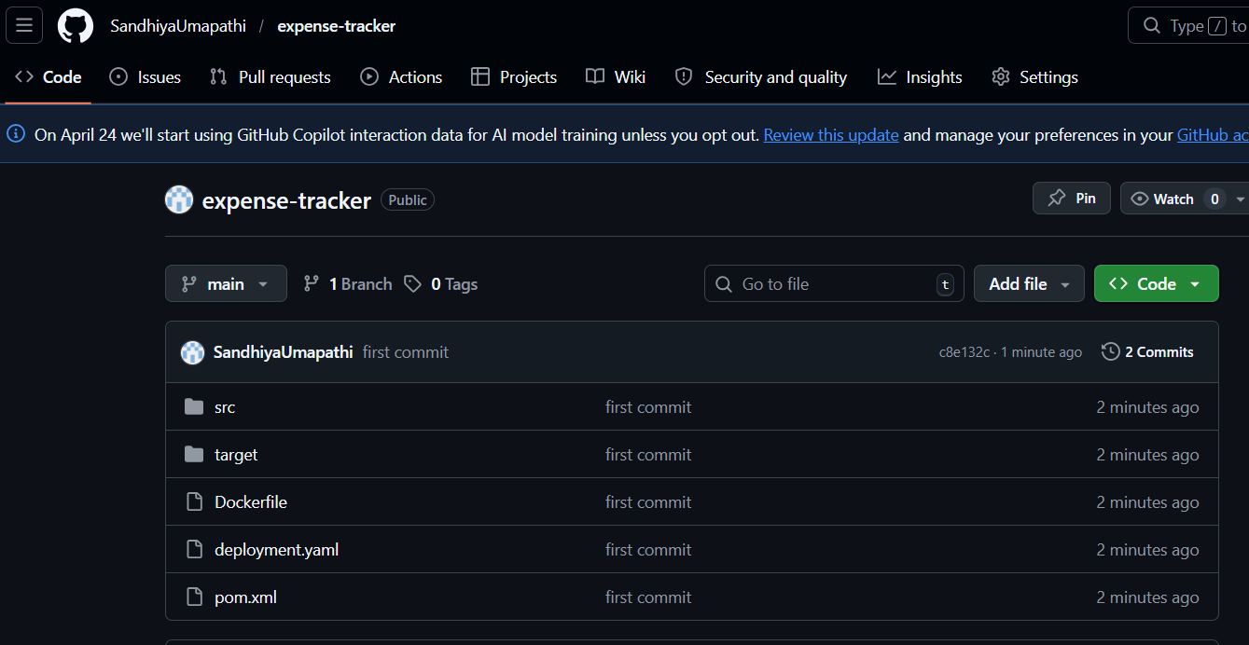

Jenkins Pipeline Job

pipeline {
agent any

tools {
jdk 'JDK17'
maven 'Maven3'
}

environment {
DOCKER_IMAGE = "sandhiya1701/expense-tracker"
IMAGE_TAG = "${BUILD_NUMBER}"
}

stages {

stage('Clean Workspace') {
steps {
deleteDir()
}
}

stage('Clone Repository') {
steps {
git branch: 'main',
url: 'https://github.com/SandhiyaUmapathi/expense-tracker.git'
}
}

stage('Build & Run Tests') {
steps {
bat 'mvn clean test'
}
post {
always {
junit 'target/surefire-reports/*.xml'
}
}
}

stage('Package Application') {
steps {
bat 'mvn clean package -DskipTests'
}
}

stage('Check Docker') {
steps {
bat 'docker info'
}
}

stage('Build Docker Image') {
steps {
bat '''
docker build -t %DOCKER_IMAGE%:latest .
docker build -t %DOCKER_IMAGE%:%IMAGE_TAG% .
'''
}
}

stage('Push to DockerHub') {
steps {
withCredentials([usernamePassword(
credentialsId: 'dockerhub-creds',
usernameVariable: 'DOCKER_USER',
passwordVariable: 'DOCKER_PASS'
)]) {
bat '''
docker logout

echo Logging in as %DOCKER_USER%

docker login -u %DOCKER_USER% -p %DOCKER_PASS%

IF %ERRORLEVEL% NEQ 0 (
echo Docker login failed
exit /b 1
)

docker push %DOCKER_IMAGE%:latest
docker push %DOCKER_IMAGE%:%IMAGE_TAG%
'''
}
}
}

stage('Deploy to Kubernetes') {
steps {
bat '''
echo Setting KUBECONFIG...
set KUBECONFIG=C:\\Users\\sandh\\.kube\\config

echo Checking cluster...
kubectl get nodes

echo Deploying application...
kubectl apply -f deployment.yaml --validate=false
'''
}
}
}

post {
success {
echo 'Expense Tracker App deployed successfully!'
}
failure {
echo 'Pipeline failed. Check logs.'
}
}
}
Pipeline Overview

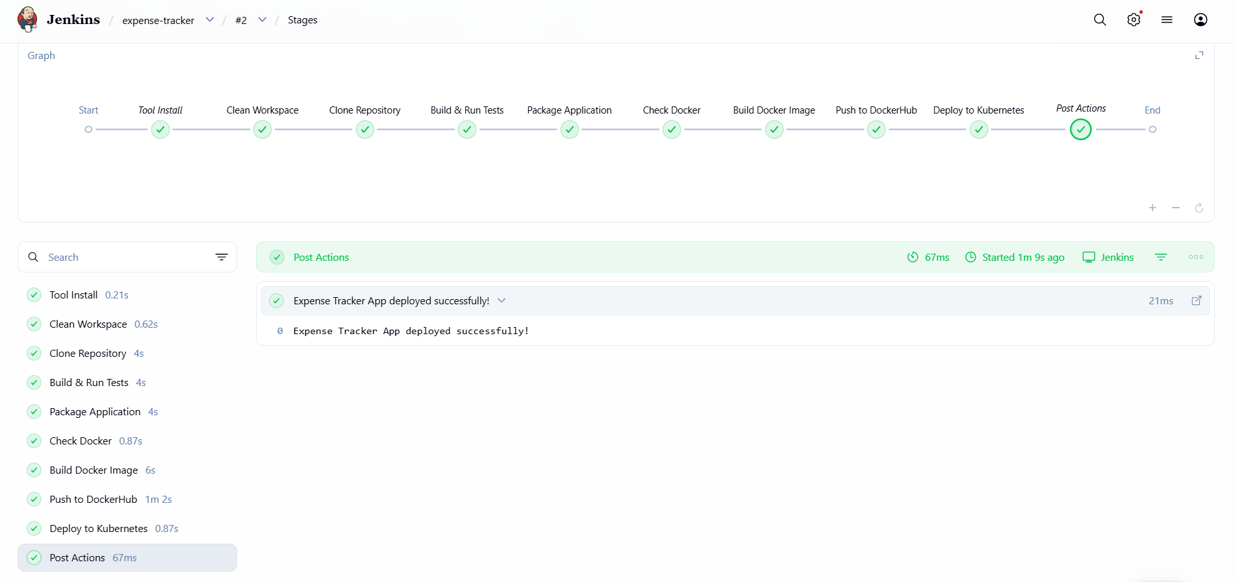

Console Output

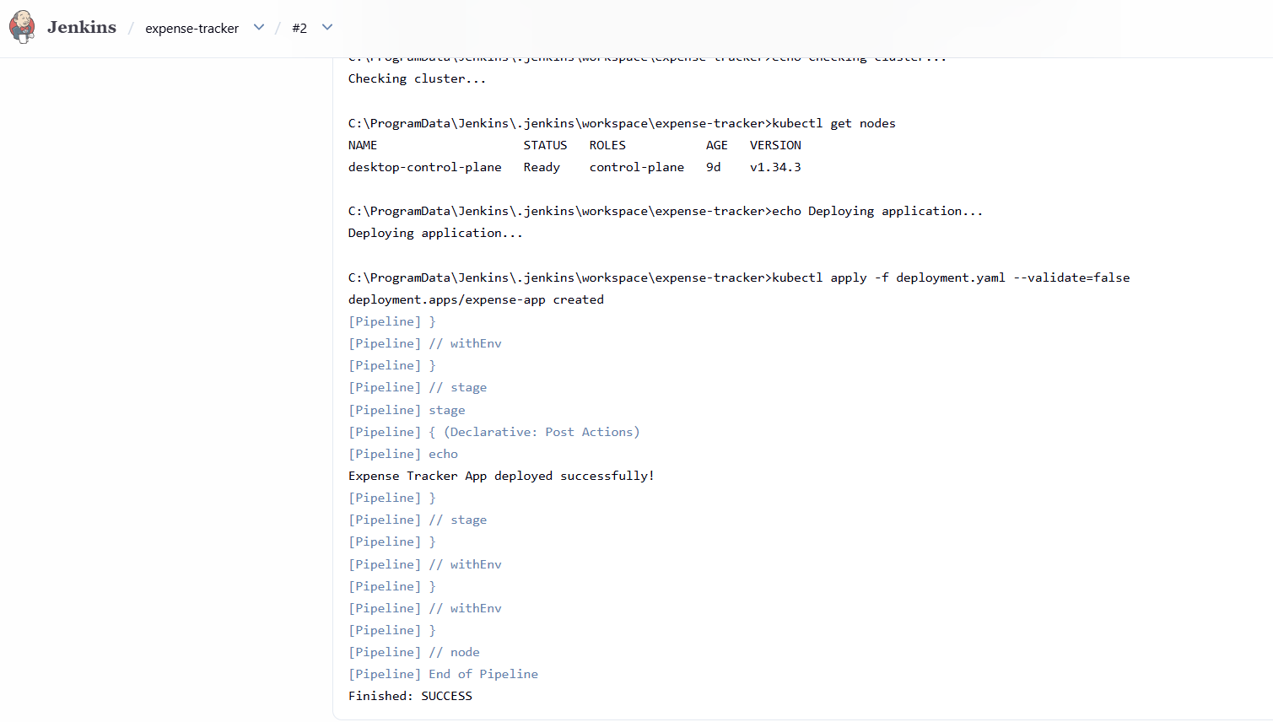

Docker Image

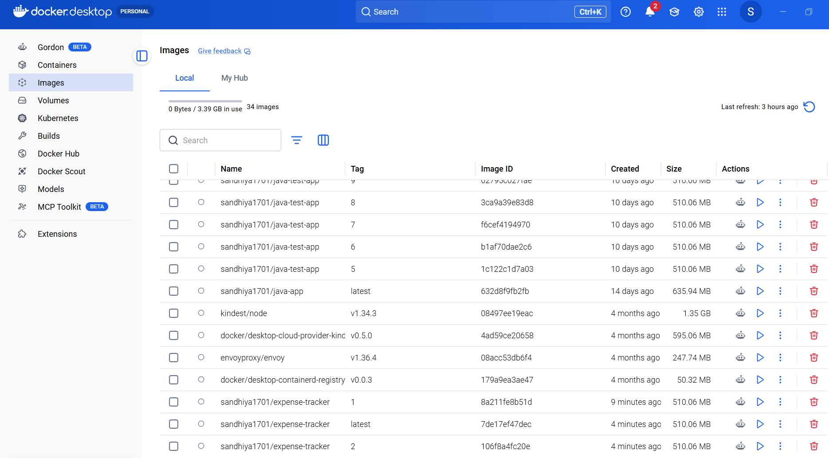

Kubernetes

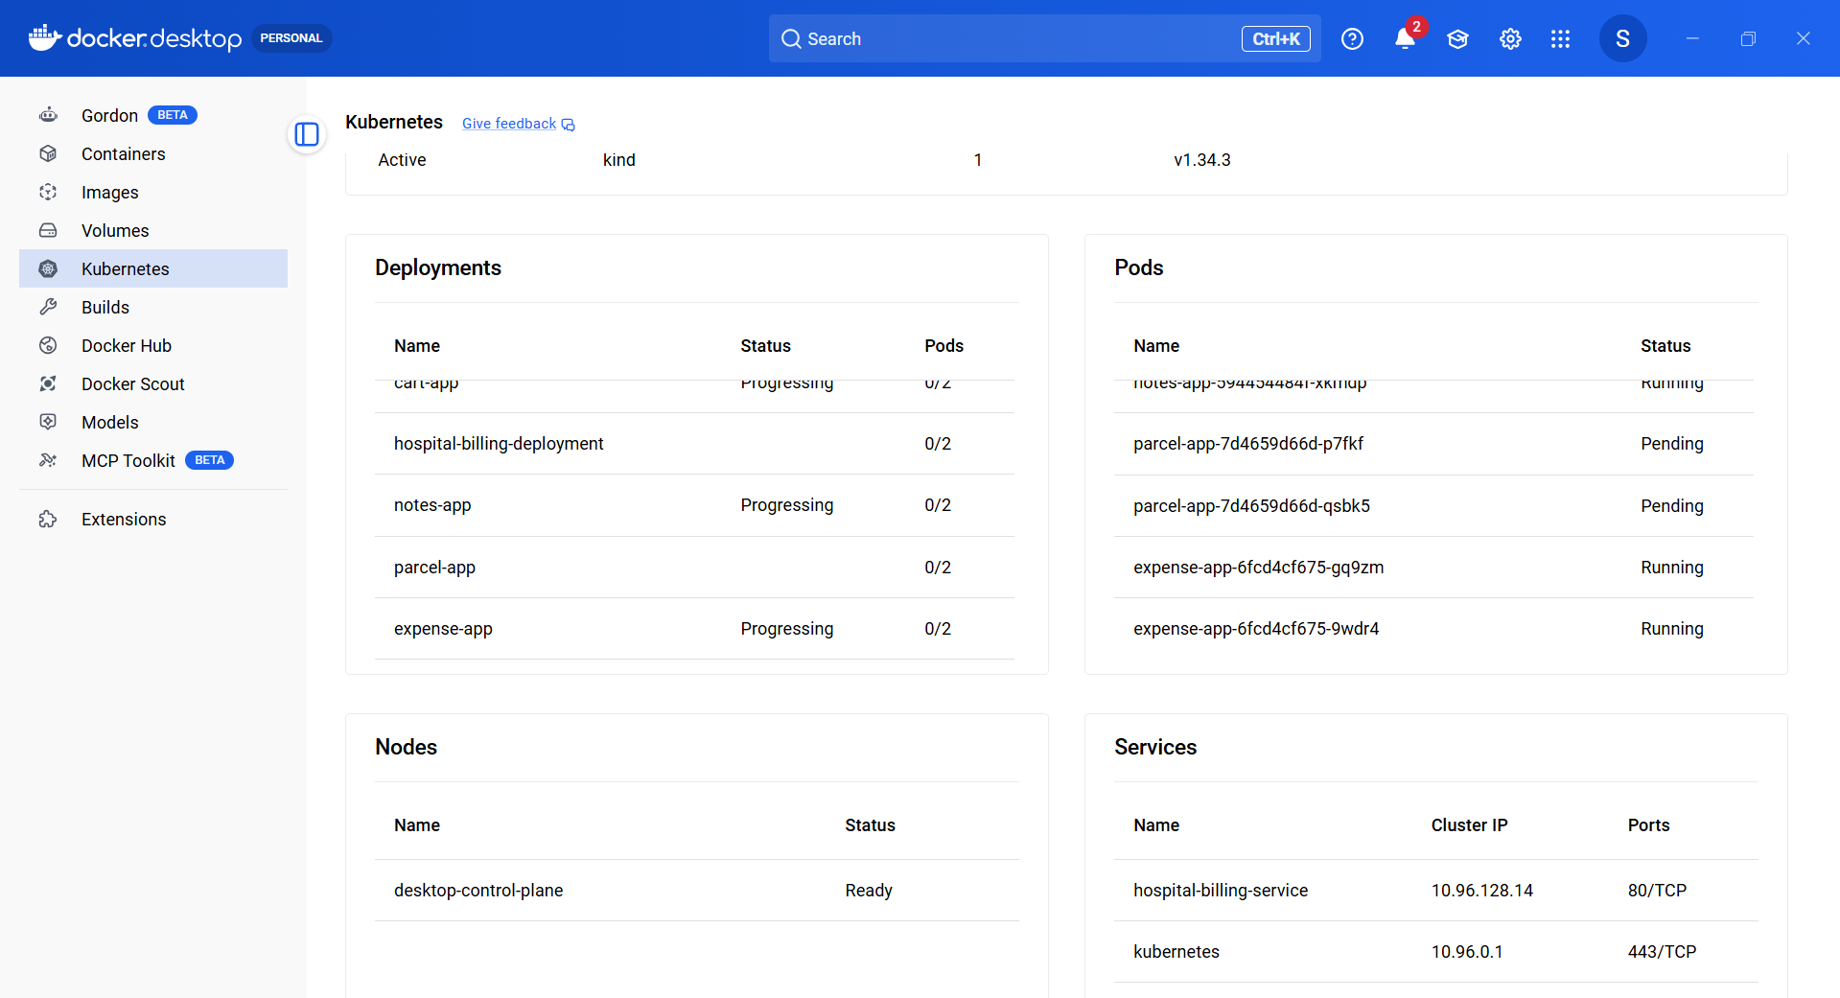

kubectl get svc

