*SOFTWARE REQUIREMENT SPECIFICATIONS*

***Author: Sandhiya.S***

***Date :28/11/2024***

**TABLE OF CONTENTS:**

1. Objective and Scope.............................................................................3
2. Project End Users................................................................................ 3
3. System Features....................................................................................3

3.1 Functional Requirements ...............................................................3

3.1.1 Login to the System.................................................................3

3.1.2 User management....................................................................3

3.1.3 Ambulance dispatch............................................................... .3

3.1.4 Real-time tracking...................................................................3

3.1.5 Emergency call handling..........................................................3

3.1.6 Booking management...............................................................4

3.1.7 Payment management...............................................................4

3.2 Non-Functional Requirements........................................................4

3.2.1 Performance............................................................................4

3.2.2Scalability................................................................................4

3.2.3 Availability..............................................................................4

3.2.4 Security....................................................................................4

3.2.5 Reliability...............................................................................4

3.2.6 Usability.................................................................................4

3.2.7 Maintainability.......................................................................5

3.2.8 Interoperability.......................................................................5

3.2.9 Compliance............................................................................ 5

3.3.0 Disaster recovery....................................................................5

4. UML Diagrams

4.1 Use Case Diagram .........................................................................6

4.2 Class Diagram ..............................................................................7

4.3 Sequence Diagram .......................................................................8

4.4 Flow Chart ...................................................................................9

4.5 ER Diagram .................................................................................10

**AMBULANCE BOOKING SYSTEM**

**OBJECTIVE AND SCOPE:**

The objective of an ambulance booking system is to provide an efficient and reliable way for users to request and schedule ambulance services. This system aims to automate the booking process, reduce response time, and improve overall customer satisfaction.

This system can be used by individuals, hospitals, and emergency response organizations. It can also be integrated with other emergency management systems to improve overall coordination and response times.

**PROJECT END USERS:**

The user will be able to register themselves in the application. The user details will be monitor by the admin. Users can interact with the ambulance booking system through a user-friendly interface, such as a website or mobile application, to request and schedule ambulance services. The system enables these end-users to track the status of their request and receive updates on the ambulance's estimated arrival time.

**SYSTEM FEATURES:**

**Functional requirements:**

**Login to the system:**

This functionality would allow user to register for ambulance booking application using their social media accounts or phone numbers. After logging into the ambulance booking application, user can book an ambulance with a couple of clicks at any point in time.

**User management:** to manage the user information, including patients, family members, and medical staff.

**Ambulance dispatch:** to dispatch ambulances to patients quickly and efficiently.

**Real-time tracking:** to track the location of ambulances and ensure they reach patients in a timely manner.

**Emergency call handling:** to receive and respond to emergency calls from patients and family members.

**Booking management:** to manage and schedule ambulance bookings for patients.

**Payment management:** to handle payment transactions for ambulance services.

**Reporting and data analytics:** to provide insights and reports on ambulance usage and service delivery.

**Communication:** to provide real-time communication between patients, medical staff, and ambulance crews.

**Integration with healthcare systems:** to integrate with existing healthcare systems for seamless patient care.

**Non-functional requirements:**

**Performance:** to ensure the system is responsive and can handle high volumes of requests and transactions.

**Scalability:** to allow for the system to grow and adapt to changing demands.

**Availability:** to ensure the system is available 24/7 with minimal downtime.

**Security:** to protect sensitive patient information and ensure the confidentiality and privacy of user data.

**Reliability:** to ensure the system is reliable and consistently performs as expected.

**Usability:** to ensure the system is easy to use and understand for patients, family members, and medical staff.

**Maintainability:** to make it easy to maintain and update the system as needed.

**Interoperability:** to ensure the system can easily integrate with other systems and technology.

**Compliance:** to comply with relevant industry standards and regulations.

**Disaster recovery:** to have a plan in place for disaster recovery to ensure the system can quickly be restored in case of an outage.

**USE CASE DIGRAM:**

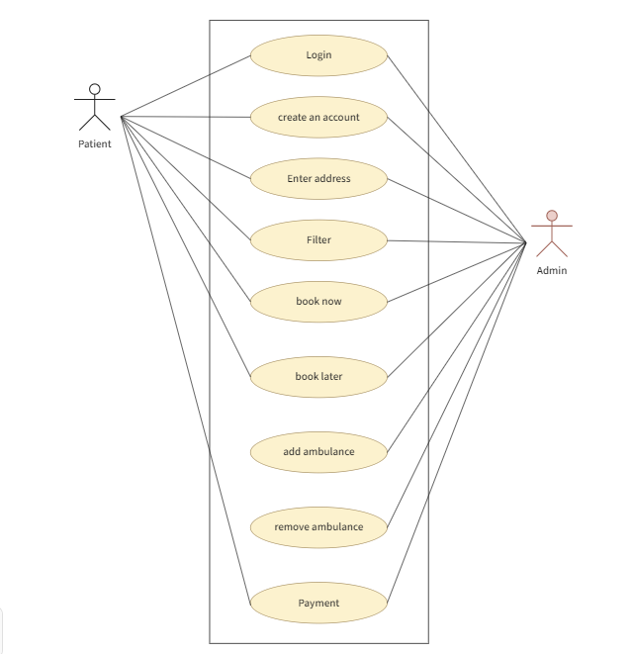

**CLASS DIAGRAM:**

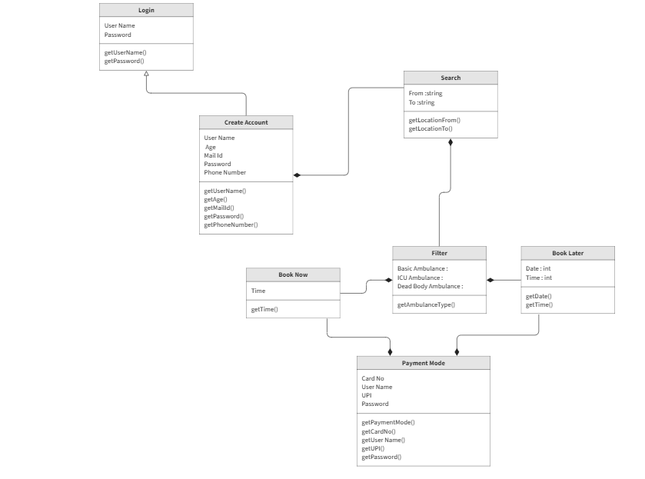

**SEQUENCE DIAGRAM:**

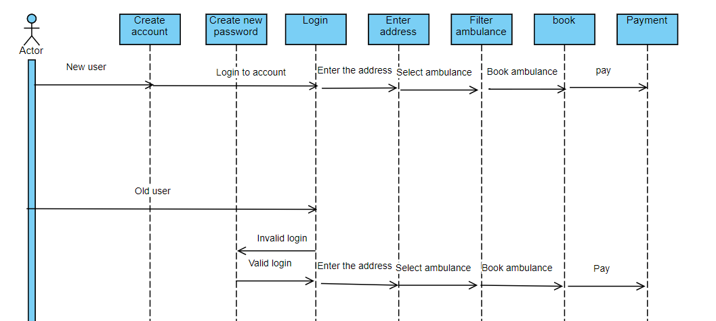

**FLOWCHART:** 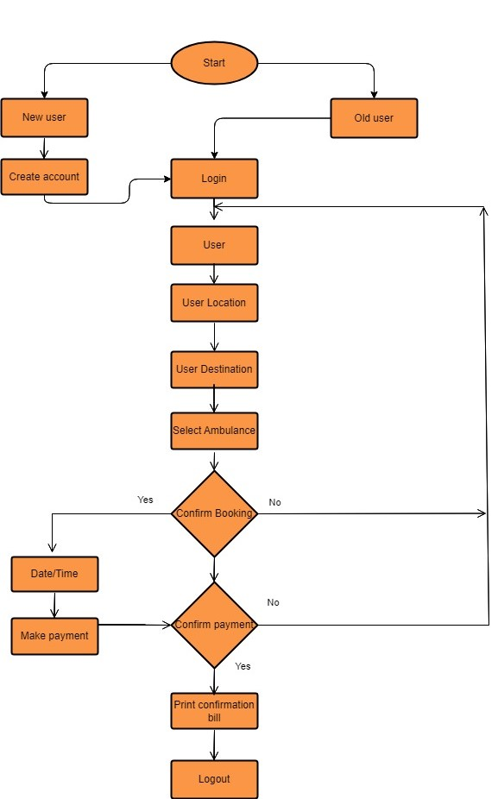

**ER DIAGRAM:**

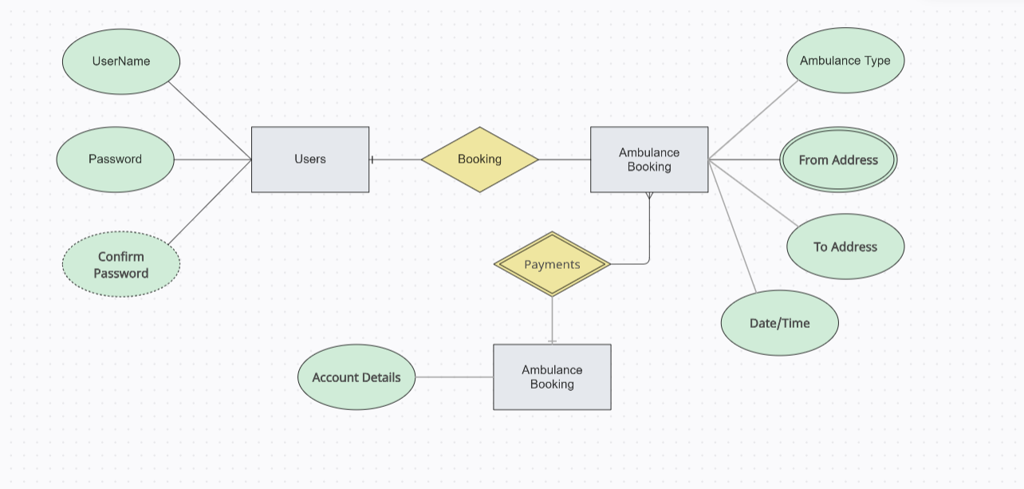

**CONCLUSION:**

The ambulance booking system is a valuable tool for streamlining the process of calling for emergency medical transportation. By providing a centralized platform for booking and dispatching ambulances, it can help improve response times, reduce wait times for patients, and increase overall efficiency in the delivery of emergency medical services. With the ability to quickly access patient information, track ambulance locations, and communicate with healthcare providers, the ambulance booking system is an essential component of any modern emergency medical services system.