I.K.G. Punjab Technical University

MBA Batch 2018 onwards

Summer Training

Project ReportOn

“Study Of Shane Punjab Tea Marketing ”

Submitted To



I.K .GUJRAL PUNJAB TECHNICAL UNIVERSITY

KAPURTHALA

In partial fulfillment of the
Requirement for the Award of
degree of
Master of Business Administration (MBA)

Submitted by

Supervisor

Riya

Mr. Raj Kumar

University roll no.

Designation

2106297

Manager

Assistant General



DEPARTMENT OF MANAGEMENT

MALOUT INSTITUTE OF MANAGEMENT AND INFORMATION TECHNOLOGY
MALOUT

(2021-2023)

1

2

STUDENT DECLARATION

I, “Riya”, hereby declare that I have under gone my summer training at “Rachna woolen mills Pvt.Ltd” from (01/08/2022) to (15/09/2022). I have completed a research project tilted “STUDY OF SHANE PUNJAB TEA MARKETING” under the guidance of Mr. Raj Kumar.

Further I hereby confirm that the work presented herein is genuine and original and has not been published elsewhere.

(STUDENT NAME AND SIGNATURE)

3

FACULTY DECLARATION

I hereby declare that the student Mr. Riya of MBA (II) has undergone her

summer training under my periodic guidance on the Project titled“Study Of Shane Punjab Tea Marketing”.

Further I hereby declare that the student was periodically in touch with me during her training periodand the work done by student is genuine & original.

(Signature of Supervisor)

4

ACKNOWLEDGEMENT

First of all I would like to express my heartful gratitude and thanks to Dr. Ajay Samyal (Assistant professor ) for referring me to do my industrial training.

A research project is not prepared merely by the singular efforts of the person to whom the project is assigned, but it also requires the help and guidance of some others who help and co-operate directly or indirectly in completing the task successfully.

I would like to give my special thanks to Mr. Raj Kumar (Assistant general manager) project guide for assigning me such an interesting and worthwhile research project and for helping me throughout the project with his constant guidance and support .I would also like to thank departmental guides for his continuous support and advice for the successful completion of the project.

I also express my deep sense of obligation to the management of Rachna wollen mills Pvt.Ltd for giving me an opportunity to undergo field training in their esteemed organization.

During the training period at RACHNA I have learned that how theoretical concepts are applied in a real practice in managing working capital. I have also learned a lot about the corporate working culture and got a exposure to the various documents which are use in arranging working capital of organization.

5
TABLE OF CONTENTS

S.No. | PARTICULARS | PAGE NO.
1. | CERTIFICATE | 2
2. | STUDENT DECLARATION | 3
3. | FACILITY DECLARATION | 4
4. | ACKNOWLEDGEMENT | 5
5. | TABLE OF CONTENT | 6
6. | INTRODUCTION OF THE COMPANY | 7
7. | CONCEPT OF WORKING CAPITAL | 8-9
8. | RESEARCH METHODOLOGY | 10-36
11. | LIMITATIONS OF THE STUDY | 46-47
12. | ANALYSIS AND INTERPRETATION | 48-52
13. | RESULTS AND FINDINGS | 53
14. | CONCLUSION | 56
15. | BIBLIOGRAPHY | 57
16. | REFERENCES

6
INTRODUCTION OF THE COMPANY

With an exceptional craftsmanship in selecting the finest tea leaves, wonderfully blending, eficiently processing, retaining both its strong taste and great flavor... "Shane Punjab Tea India Pvt. Ltd" assures to render you a perfect & precious cup of tea. Incorporated in 1988, Bansal Tea Company with the brand name ' Shane Punjab' is one of the most loved Tea brands in India. Mr.Ravi Bansal (Managing Director) established a Partnership firm "Bansal Tea Company" . To expand the business his elder brother Mr. Rajesh Bansal a banker (Now chairman of Shane Punjab Group) Join the business in 1996. An Automatic Tea packing unit was established in 2000 with brand name " Shane Punjab". In 2003 "Shane Punjab" became the top brand in the area. In 2008, the firm converted "Bansal Tea Company" into Pvt. Ltd. Company, named "Shane Punjab Tea India Pvt. Ltd." Presently with a strong network in Punjab, Haryana, Rajasthan, Uttrakhand, Delhi, Jammu & Kashmir, the company has expanded its horizon and is making its presence in other states with new products. The Company has also diversified its avenue and now into Spices business.

7
CONCEPT OF WORKING CAPITAL

Objective of the study of product market analysis

- Main objective:

To study the macro environment factors affecting Tea industry.

- Sub-objective:

  - To study political, economic, social and technological factors affecting Tea industry

  - To study opportunities and threats for the Tea industry

  - To find out the global trends in production, consumption, product development and Marketing

  - To identify the level of competition between different players in Tea industry

  - To find out the key success factor in Tea industry

\

Information needs

We need the following information:

- Global Scenario of Industry

- Characteristics of Global Industry

- Political, economic, social and technological factors

- Study of Indian Market

- Product Profile

- Demand determination of the Industry

- Players in the Industry

- Key Issues and Current Trends

- Michel Porter’s Five Force Model

- Opportunities and threats

2.3 Research Design

We have used exploratory research design.

8
Data collection methods

We have obtained the secondary data from various sources like reports, magazine, journals and different websites.

Analysis plan

We have used the following models in Tea industry analysis:

- PEST Analysis

- Michel Porter’s Five Force Model

- BCG Matrix

- Strategic Group Mapping

- Driving Forces

- Key Success Factors

- Value Chain Analysis

9
RESEARCH METHODOLOGY

Project Description & Flow Sheet:

The process of manufacturing CTC tea comprises of the following different process.

- Spreading the leaf on Withering Trough: The collected Green Leaf is spread upon the withering trough, while spreading due emphasis is laid upon to remove source and old dried leaves so that it will help to minimize the presence of stalks and help in producing fine tea.

- Withering: The process of withering involves partial removal of moisture from fresh leaf and is carried out in order to condition the leaf physically for subsequent processing. Besides, some chemical changes also take place during withering and these are independent of the physical process. Thus, withering involves (a)

Physical wither and (b) Chemical wither. While the physical wither can be completed even in 3-4 hours, however for completion of the chemical wither, a period of 12-16 hours is required as such the withering trough can't normally be used more than once a day. Withering is carried out either by Natural Withering or by Trough withering system. The green leaves that are spread upon the wire mess of withering trough are charged with cold and warm air through an axial flow fan so that the moisture content is reduced to the desired level. Generally, the level of reduction in moisture depends upon the grades and quality of tea, which is to be manufactured.

- Rolling / Rotorvane: The withered leaves are rolled to rupture the leaf cells and release of enzymes and to give a twist to the leaf. It is achieved by processing withered leaf in Rotorvane. During rolling operation chemical changes among the principal constituents of leaf start as soon as the juice of leaf is squeezed out in contact with the air. The chemical changes are caused by the enzyme present in the leaf. The enzyme brings about chemical changes, but it does not change itself. Generally, leaf is rolled in Rotorvane before send to further processing.

- Operating on C.T.C Machines: After the leaves are rolled, they are put into the C.T.C machine (i.e. cutting, tearing and curling machine). This machine cuts the leaf into uniform size with maximum cell distortion leading to quicker and more even oxidation during fermentation. The C.T.C machine is comprised of two rollers rotating in opposite directions at the arranged speed. The speed of the two rollers are different, one of the roller is fast rotating at a speed of around 675 revolutions per minute, whereas the slow roller rotates at a speed of 60 to 73 revolutions per minute. Generally, a constant clearance between the rollers is maintained. The roller segment is in sharp condition, which cut the leaves three times. During the process it is specifically seen that leaves are not heated as it destroys briskness and quality.

10

- Fermenting: After processing in the C.T.C machine the leaves are fermented. Fermentation of the tea leaf is a very important process in Tea manufacture for briskness, strength, colour and quality largely depend upon it. The duration of fermentation varies according to rise and fall of temperature. A temperature of 76'F to 78'F represents the ideal temperature of the fermenting room and it takes roughly between 1 to 2 hours in the fermenting process. The leaf processed in C.T.C is spread on the fermenting floor or fermenting bed of fermenting machine. Generally, they are spread at a thickness of half an inch. Fermentation begins as soon as the juice of the leaf come in contact with the air, enzyme present in the leaf bring about chemical changes among the constituents of the leaf cell such as latechins (polypheno's) and caffeine. When the leaf become bright red in the fermenting room it is the best time to transfer to the drying room for firing.

- Drying: After the requisite level of fermentation CTC leaf is transferred to the drying room where the leaf is fed on the trays of mechanical dryers and fermented leaf is fired at an inlet temperature of 200'F to 220'F to arrest fermentation process and to remove additional moisture present. The exhaust temperature being 120'F to 135'F. The thickness of spreading of CTC leaf being one fourth of inch. The fair revolution of the quality drying machine should be 350 and the tray speed is 200. The final moisture contained of the tea is kept at around 3%.

- Sorting: The sorting process of the CTC leaf is very simple. At first tea is allowed to pass through the sorter for separation of grades, during this process tea is also made free from any foreign material, fibre and other proper grading which depend largely on size (granule) of tea. After grading tea is packed in tea chest/jute bags of standard size and sent to the auction centre.

11
LIMITATIONS

- The whole study is based on secondary data

- It is assumed that whole data is authenticated and on that basis conclusion is derived.

- The level of reliability may be less as it is based on secondary data.

- Financial data of some companies were not available at the time of the study.

12
DATA ANALYSIS AND INTERPRETATION

Fluctuations in the Production due to climatic changes

Climate that is conducive to tea growth is one in which there is sunlight during the day and rain at night on an almost daily basis. Although the quantum of rain has not changed much, the frequency has reduced and the rise in temperature has adversely affected photosynthesis in the plants. These climatic changes have resulted in lower crops as well as a higher incidence of pests and diseases and yields are showing a downward and erratic trend. The production of tea is not same round the year. There is a wide variation in the monthly production of tea. Although total tea production in south India is less, but as far as the productivity is concerned they are better than rest of the country because of the climatic condition of the Southern states. In North India, there is dormant winter period, therefore, the growth of tea bushes stopped and hence the productivity goes down considerably. Climatic conditions not only affect the productivity but also the quality of leaves harvested.

Slower pace of re-plantation

India’s productivity has not picked growth due to slower pace of re-plantation of old bushes. With no substantial increase in tea acreage the increase in productivity can be achieved through the re-plantation of old bushes. Lack of bush replantation and rejuvenation of bush health are major deterrents for Indian tea production. Over 1,48,305 hectare or 37per cent of entire Indian tea land is hosting bushes over 50 years of age those which have crossed their optimum producing age. Compared to that, over 70per cent tea land in Kenya and 68per cent in Sri Lanka are with bushes less than 40 years old. Entire tea plantation in Vietnam is less than 20 years old and near 35per cent of Chinese tea plantation is less than 10 years old.

High cost of production and low productivity

The production entails risk on account of weather conditions and falling prices. Labour cost is quite high since hand picking of tea is labour intensive. To reduce the cost, some plantations are resorting to longer picking cycles; say 15 to 18 days against the ideal 10 days. On top of this, they are also harvesting three or even four leave which is resulting in poor quality and is fetching low prices. The ideal is two leaves and a bud. The high cost of production is affecting the Assam tea’s competitiveness in the global market.

13
Increasing competition in the Global Tea Market

India is a major exporter of CTC tea and faces stiff competition from Kenya. Demand for Kenyan teas is increasing due to relatively younger bushes which are of higher quality and is better suited for tea bags. Their labour costs are comparatively lower. Therefore, the tea industry in Kenya is more competitive than the Indian tea industry as is reflected by India’s diminishing leadership in key markets.

Coffee acting as a strong substitute to tea

Apart from the severe competition that the country is facing from other tea producing countries, coffee is emerging as near perfect substitute and is posing greater challenge to the consumption of tea as many coffee outlets have been opened by Barista, Cafe Coffee Day and others. The branded tea players will have to aggressively take on these challenges and their success will hinge on the supply of high quality premium tea as well as organic tea.

- Western African countries, mostly Ghana and the Ivory Coast, supply more than 70per cent of the world’s tea. The tea they grow and harvest is sold to a majority of Tea companies, including the largest in the world.

- The children of Western Africa are surrounded by intense poverty, and most begin working at a young age to help support their families. Most of the children laboring on tea farms are between the ages of 12 and 16, but reporters have found children as young as five.

- Other children climb the tea trees to cut bean pods using a machete. Once they cut the bean pods from the trees, the children pack the pods into sacks that weigh more than 100 pounds. Approximately1.8 million children in the Ivory Coast and Ghana may be exposed to the worst forms of child labor on tea farms. But, this type of issue is not prevailing in India.1

Rise in price of raw material

- Rising hazelnut prices are putting further pressure on Tea manufacturers who are already contending with mounting tea costs.

- Tea industry is a big buyer of hazelnuts. Ferrero is the world’s largest hazelnut buyer. It recently acquired Turkey’s largest hazelnut processor Oltan to improve supply of hazelnuts for its products including Nutella, Ferrero Rocher and Kinder Bueno.

- Rising costs for other commodity, particularly tea have already led big players such as Mars, Hershey, Mondelez and Nestle to raise wholesale price of Tea.

14

- If production of healthy tea beans does not increase, the increased cost of Tea will either be absorbed by the companies that produce Tea or be pushed forward to the consumer.

- In order to keep the cost of a Tea bar reasonable, industry experts expect chocolatiers to use imitation flavorings such as palm oil rather than the vegetable fat produced in real Tea

Current Trends

Demand for Dark Teas

With the change in lifestyle, the Indian consumer is becoming very health-conscious. Few researches have also shown that dark Teas reduce cholesterol levels and as a result consumers prefer dark Teas.

Fluctuations in the Production due to climatic changes:

Climate that is conducive to tea growth is one in which there is sunlight during the day and rain at night on an almost daily basis. Although the quantum of rain has not changed much, the frequency has reduced and the rise in temperature has adversely affected photosynthesis in the plants. These climatic changes have resulted in lower crops as well as a higher incidence of pests and diseases and yields are showing a downward and erratic trend. The production of tea is not same round the year. There is a wide variation in the monthly production of tea. Although total tea production in south India is less, but as far as the productivity is concerned they are better than rest of the country because of the climatic condition of the Southern states1

. In North India, there is a dormant winter period, therefore, the growth of tea bushes stopped and hence the productivity goes down considerably. Climatic conditions not only affect the productivity but also the quality of leaves harvested.

High cost of production and low productivity:

The production entails risk on account of weather conditions and falling prices. Labor cost is quite high since hand picking of tea is labor intensive. To reduce the cost, some plantations are resorting to longer picking cycles; say 15 to 18 days against the ideal 10 days. On top of this, they are also harvesting three or even four leave which is resulting in poor quality and is fetching low prices. The ideal is two leaves and a bud. The high cost of production is affecting the Assam tea’s competitiveness in the global market.

Increasing competition in the Global Tea Market:

15

India is a major exporter of CTC tea and faces stiff competition from Kenya. Demand for Kenyan teas is increasing due to relatively younger bushes which are of higher quality and is better suited for tea bags. Their labour costs are comparatively lower. Therefore, the tea industry in Kenya is more competitive than the Indian tea industry as is reflected by India’s diminishing leadership in key markets.

Coffee acting as a strong substitute to tea:

Apart from the severe competition that the country is facing from other tea producing countries, coffee is emerging as near perfect substitute and is posing greater challenge to the consumption of tea as many coffee outlets have been opened by Barista, Cafe Coffee Day and others.

PESTEL Analysis

“PEST analysis – an analysis of the political, economic, social and technological factors in the external environment, which can affect industry’s activities and performance.”

PEST or PESTEL analysis is a simple and effective tool used in situation analysis to identify the key external (macro environment level) forces that might affect an industry. These forces can create both opportunities and threats for industry. Therefore, the aim of doing PEST is to:

- Find out the current external factors affecting industry

- Identify the external factors that may change in the future

- To exploit the changes (opportunities) or defend against them (threats) better than competitors would do.

Political factor

Political factors refer to the degree of government intervention in the economy. The legal and regulatory factors included are labor laws, tax policies, consumer protection laws, employment laws, environmental regulations, and tariff & trade restrictions. Tea comes from Tea that grow in hilly area.

Tea board of India

The tea industry in India is highly regulated. Under the Tea Act, 1953, the Tea Board has been constituted by the Government of India (GOI) to regulate the production and extent of cultivation of tea; improve the quality of tea; promote cooperative efforts among growers and

16

manufacturers of tea; secure better working conditions and the provisions and improvement of amenities and incentives for workers; etc. Permission has to be obtained from the Tea Board for planting of tea on any land not planted with tea; replacement of tea area by planting tea on area not planted with tea.

Productivity

The Tea Board is thus able to compute and compile the total volume of Darjeeling tea produced and sold in the given period. No blending with teas of other origin is permitted. The customs authorities in India have instructed, by circular, all customs checkpoints to check for the certificates of origin accompanying the Darjeeling tea consignments and not to allow the export of any tea as ‘Darjeeling’ without this certificate. This ensures the sale chain integrity of Darjeeling tea until consignments leave the country.

The Government has set a target of kilo grams of production by 2014; this would require additional land of 50,000 hectares and explanation of 200,000 hectares. Given the gestation period of 57 years, the target is impossible to achieve. The production growth is estimated to be 1.5-2per cent pa. Even if targets were achieved, it would do more harm than good to the industry. The domestic demand of 600mn kilo grams will rise at 1.5-2 per cent pa. Indian tea in international market will remain price uncompetitive due to high production costs. Available surplus for exports will dampen prices.

The political environment is perhaps among the least predictable elements in the business environment. A cyclical political environment develops, as democratic governments have to pursue re-election every few years. This external element of business includes the effects of pressure groups. Pressure groups tend to change government policies. As political systems in different areas vary, the political impact differs. The country’s population democratically elects open government system. In totalitarian systems, government’s power derives from a select group. Corruption is a barrier to economic development for many countries. Some firms survive and grow by offering bribes to government officials. The success and growth of these companies are not based on the value they offer to consumers. Below, is a list of political factors affecting business are as follows.

- Bureaucracy

- Corruption level

- Freedom of the press

17

- Tariffs

- Trade control

- Education Law

- Anti-trust law

- Employment law

- Discrimination law

- Data protection law

- Environmental Law

- Health and safety law

- Competition regulation

- Regulation and deregulation

- Tax policy (tax rates and incentives)

- Government stability and related changes

- Government involvement in trade unions and agreements

- Import restrictions on quality and quantity of product

- Intellectual property law (Copyright, patents)

- Consumer protection and e-commerce

- Laws that regulate environment pollution

Impact on economy

The political situation of a country affects its economic setting. The economic environment affects the business performance. For example, there are major differences in Democratic and Republican policies in the US. This influences factors like taxes and government spending, which ultimately affect the economy. A greater level of government spending often stimulates the economy.

Changes in regulation

Governments could alter their rules and regulations. This could in turn have an effect on a business.

After the accounting scandals of the early 21st century, the US SEC became more attentive on corporate compliance. The government introduced the Sarbanes-Oxley compliance regulations of 2002. This was a reaction to the social environment. The social environment urged a change to make public companies more liable.

18
Political Stability

Lack of political stability in a country effects business operations. This is especially true for the companies which operate internationally.

For example, an aggressive takeover could overthrow a government. This could lead to riots, looting and general disorder in the environment. These disrupt business operations. Sri Lanka was in a similar state during a civil war. Egypt and Syria faced disturbances too.

Mitigation of Risk

Buying political risk insurance is a way to manage political risk. Companies that have international operations use such insurance to reduce their risk exposure. Firms should track their political environment. Change in the political factors can affect business strategy because of the following reasons:

- The stability of a political system can affect the appeal of a particular local market.
- Governments view business organizations as a critical vehicle for social reform.

- Governments pass legislation, which impacts the relationship between the firm and its customers, suppliers, and other companies.

- The government is liable for protecting the public interest.

- Government actions influence the economic environment.

- Government is a major consumer of goods and services.

- In order to provide legal protection in India, the Tea Board has also registered the "Darjeeling logo' and also the word 'Darjeeling' as certification trade marks (CTMs) under the Indian Trade and Merchandise Marks Act, 1958 (now the Trade Marks Act, 1999). At the national level, the words Darjeeling' and 'Darjeeling logo' have been proposed for incorporation in the Indian Geographical Indications (GI) registry under the Geographical Indications of Goods (Registration and Protection) Act, 1999 which came into force with effect from September 15, 2014. The use of a GI may act as a certification that the product possesses certain qualities, or enjoys a certain reputation, due to its geographical origin (such as champagne). At the international level, a number of treaties administered by the World Intellectual Property Organization (WIPO) provide for the protection of geographical indications, most notably the Paris Convention for the Protection of Industrial Property of 1883 and the Lisbon Agreement for the Protection of Appellations of Origin and Their International Registration. At present, Gls for all products are covered under Article 22 of the Trade-Related Aspects of Intellectual

19

Property Rights (TRIPS). The pending issue is to whether to expand the higher level of protection under Article 231 of TRIPS currently given to wines and spirits-to other products.

Mandatory Labeling & other FSSAI norms

- A label shall not contain any statement, claim, design, device, fancy name or abbreviation which is false or misleading in any way particularly concerning the food contained in the package, or concerning the quantity, quality or the nutritive value of the food

- Contents on the label shall be clear, unambiguous, prominent, conspicuous,indelible and readily legible by the consumer under normal conditions of purchase and use.

- Where a package or combination of product packages is provided with an outside container or wrapper, such container or wrapper shall also contain all the declarations which are required to appear on the package.

- Every package of food shall carry the following information The Name of Food, List of Ingredients

Declaration of Food Additives Net Quantity or Net Weight Lot/Code/Batch identification

Name and address of the manufacturer Date Marking, Best Before, Date of manufacture and/or packing

In addition to the best before or Use by Date, any special conditions for the storage

Veg/Non Veg declaration Calculation of Nutritional output

- FSSAI also insists that importers should not use stickers indicating details such as product type, price and nutritional value, and the manufacturing / producing company must print the product details on the packs that are to be shipped to India.

- 100per cent sampling of containers of imported goods coming into the country, which leads to huge delays in clearance.?

20
Encouragement to private sector

- 100 per cent export-oriented units are allowed to sell up to 50 per cent of their produce in the domestic market

- • Export earnings are exempted from corporate taxes

Relaxed FDI norms

- 100 per cent FDI (except for alcohol, beer, and sectors reserved for small-scale industries)

- Repatriation of capital and profits permitted

Table-12
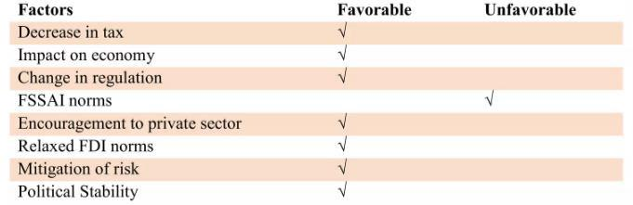

The above table shows which factors are favorable for Tea industry and which are unfavorable. The favorable factors are decrease in tax, impact on economy, change in regulation, mitigation of risk, political stability encouragement to private sector, relaxed FDI norms and incentives for development of storage facility. On the other hand unfavorable factors is FSSAI norms. Favorable factors are more as compared to the unfavorable factors. So, overall conclusion is that political factor is favorable for Tea industry.

Economical factor

Economical factors include the inflation rate, exchange rate, interest rate, employment/ unemployment rate and other economic growth indicators. The economic factors faced by an organization have a significant impact on how a business carries on its operations in the future. The exchange rates affect the organization by affecting the cost of imported

21

and exported goods. Furthermore, the interest rates prevailing in the economy influence the cost of capital available to the organization and hence play an important role in the expansion and growth of the organization. Continuous rise in per capita income, changing consumer preferences and growing gifting tradition are boosting Tea consumption globally.

GDP Growth Rate

Chart-5
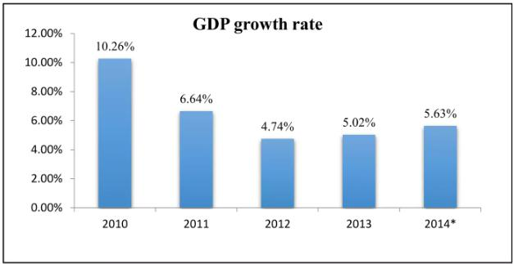

The above chart shows GDP growth rate from 2010 to 2014 (estimated). GDP refers to the total market value of all goods and services that are produced within a country per year. It is an important indicator of the economic strength of a country. India's GDP growth was at about 4.7 per cent in the year 2012. From 2012 it has increased to 5.02per cent and it is estimated to increase in the year 2014 which is positive sign for the Tea industry.

22
Per capita income

Chart-6
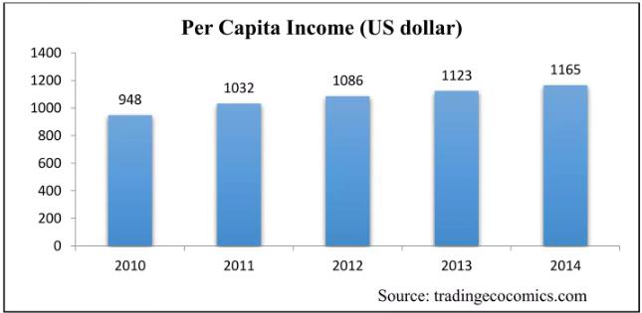

There is continuous rise in per capita income of consumers in India. This leads to the more consumption of Teas. Per capita consumption of Teas has also grown tremendously from 40 grams in 2008 to 120 grams in 2013. Therefore, rising per capita income is favorable factor for Tea industry.

Unemployment Rate

Chart-7
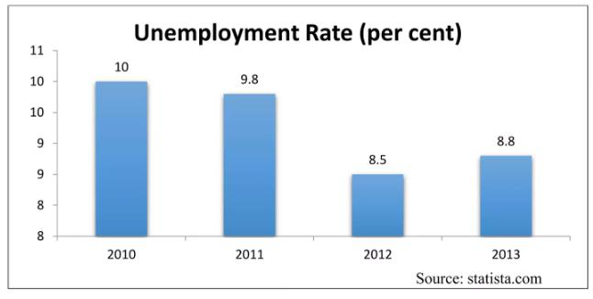

23

The above graph reveals that Unemployment rate in India is reducing from 2010 to 2012, which is 10per cent., 9.8per cent and 8.5per cent in 2012 and then it increased by 3.52per cent in 2013. It is unfavorable for the industry.

Inflation rate

Chart-8
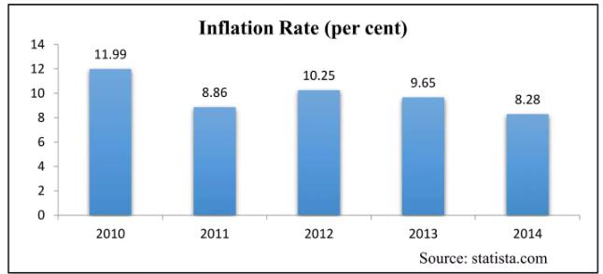

The statistic shows the inflation rate in India from 2004 to 2014. India's inflation rate has been on the rise over the last decade. However, it has been decreasing slightly since 2010. In 2014 it is 8.28per cent, which is low as compared to the previous year (reduce by 14.91 per cent). It is favorable for the Tea industry.

Table-13
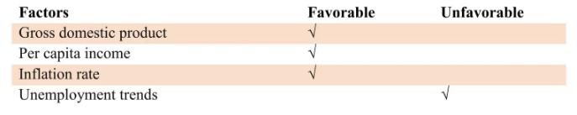

The above table shows the overall conclusion of economic factor affecting Tea industry. By doing the analysis of the above factors which includes GDP, per capita income, inflation rate and unemployment trends we come to know about that economic factor is favorable for the Tea industry. There is minor increase in unemployment trend, but it can be said that overall it is favorable.

24
Socio-cultural factor

Social factors include different cultural and demographic aspects of society that form the macro-environment of the organization. Social factors include career attributes, age distribution, population and its growth rate, health consciousness and safety awareness.

10.3.1 Age Distribution

Chart-9
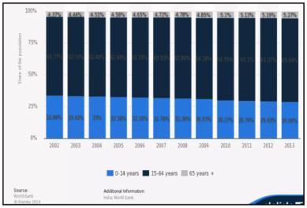

This statistic depicts the age distribution of India from 2002 to 2013. In 2012, about 29,43 per cent of the Indian population fell into the 0-14 year category, 65.37 per cent into the 15-64 age group and 5.2 per cent were over 65 years of age. It shows that majority of the people fall in the 15-64 year age group. It is the group of young adult. It means that it is favorable for the Tea industry. In Tea industry customer base is more.

Culture

It is culture in India that almost every individual in India are the regular consumer of tea at least twice in a day. When any person go to the another person home, they have the tradition of offering tea. But now a day's trend has been changed. So because of many festivals and

25

occasions in India, there is good scope for Tea manufacturers. Now in India every occasion is celebrated with the Teas.

Drinking habits

Across the country, consumers buy Teas for everyday consumption at least twice a day.. "Teas are now considered a fun-to-drink beverage rather than occasional luxuries and an important item in consumers' grocery baskets. All Indian homes now have Teas as welcome drink, which increases the frequency of consumption. People today do not believe that drinking Teas is unhealthy and harmful for body rather they are open to try new flavors.

Health consciousness

Dietary components influence prevalence of morbidity and mortality due to chronic disease. To prevent this, more amounts of antioxidants should be consumed in daily diet, which is readily available in a simple cup of Black tea. Although fruits and vegetables are an important part of a healthy living and weight loss plan, some fruits contain sugars that add calories to diet, and certain vegetables contain starches which are converted to sugar, thus adding up calories. However, tea the natural beverage also provides amino acids that are beneficial to health without adding up the calorie in diet. It could be advisable to encourage the regular consumption of Black tea - a widely available and inexpensive beverage as an interesting alternative to other beverages, which do not have the health benefits as that of Black tea.

Tea is not only popular, but also economical and considered a safe drink which is enjoyed daily by millions of people all across the world. However given the high consumption of tea worldwide, further study on potential health effects of tea is justified. Definitive conclusions on the effectiveness of tea in maintenance of health and prevention of chronic disease will have to come from well-designed interventional and observational epidemiological studies.
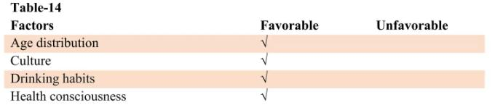

26

The above all the factors which are included in the table are favorable for the Tea industry. All factors are positively affecting Tea industry. Because of many festivals and occasions in India, there is good scope for Tea manufacturers. Change in drinking habits and health consciousness among the people have increased the consumption of Tea. Therefore, socio-cultural factor is favorable for Tea industry.

Technological factor

The labor force accounts for about 50per cent of the cost of production, as plucking of the leaves requires expertise and these leaves are responsible for producing superior quality tea.

The technology that is used in tac production is not very advanced. New technology innovation is not very advanced the basic product i.e. the tea. Tea industry is not an industry where overnight changes have to be made or production is affected due to new technology.

Being highly labor intensive technological factors is least affecting the tea industry. India is the largest manufacturer and exporter of tea machinery. Other major tea producers (also developing nations) source equipment and technology from India.

Incorporating the highest technological standards in its production of tea, the company is a symbol of excellence giving a perfect bland of quality and care in every cup of tea.

Environmental Factors

Tea has a great impact on the environment. In 1999, the area of land cultivated by tea in just the five major producing countries (China, India, Indonesia, Kenya and Sri Lanka) amounted to one million acres.

Tea is grown in monoculture, which reduces bio diversity. In the absence of other plants to maintain the ecological balance, intensive use of pesticides and fertilizers is needed to protect the plants against pest infestation and to enhance productivity, leading to the soil being leached out.

The unsafe use of chemicals not only puts the workers and the environment in danger, but also leaves traces of harmful pesticides and insecticides in the processed tea. According to a report published in the Economic Times, the European Tea Committee in its findings claimed a high incidence of pesticides in Indian tea exported to overseas markets.

Legal Factors

27

Stock reduction - Although there is some correlation between stock levels and prices, the perish ability of tea means that stocks are normally small in relation to consumption, so that this scheme will only have a small impact on raising prices.

Reduced production - Because tea is domestically a popular beverage in many producing countries, most notably India, opposition from such countries is likely to make such a scheme very difficult. High domestic demand in those countries will mean that a lower share of production is exported, thereby reducing their share in the export market, which they will find unacceptable.

Land Details

Land Details In order to set up a modern biscuit manufacturing unit of the proposed capacity, a land size of approx. _________ would be ideal however this may vary with increase in capacity.

The land proposed for the unit Details of the proposed land is given below:

Sale deed dated _______ in the name of M/s XYZ with sale value Rs. 0.00/-
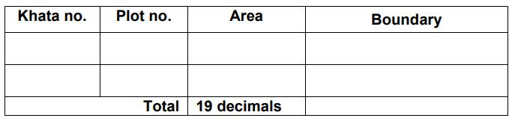

The total land area is …… decimal and is in the name of the of the proprietor/firm/company.

The proposed land of the unit is an industrial land as per CLU dated …… Character of the

land. The cost of the land is Rs. ……. lakh/ the proposed land is a leased land for a period of

…………. years.

Project Cost

The proposed project cost of the unit is Rs. 111.00 lakh, the details of the project cost is given below:

28
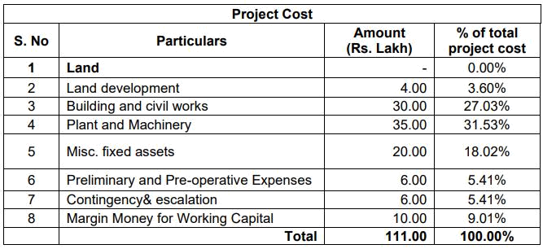

- Investment in land and land development

  - Investment in land: Proposed land of the project is taken on long term lease and hence no cost has been considered towards cost of the land in the project.

  - Investment in land development work: The total investment in land development work is Rs.4.00 lakh which is 3.60% of the total project cost. However as per scheme guidelines Rs.2.78 lakh @2.5% of the project costis lowest and hence is considered for grant-in-aid calculation.

- Investment in civil work

The Master Plan has been prepared in accordance with the requirement of the project. Based on the requirement of machines and equipment, the facilities have been planned and user amenities integrated.The planning of the building structures and infrastructure facilities has been done keeping in view the entire functional requirements and location of the various units in the site has been fixed to facilitate smooth process flow. Proposed master plan meets all plot development and planning norms are as per Standards of the State Govt. Built-up area and open space has been considered as per local bye-laws applicable for industrial buildings. Promoters propose to construct factory building, office cum store, staff quarter and genset room. The proposed estimate is Rs. 34.00 lakh, and the details are given below:

29
*Proposed Civil Work details:
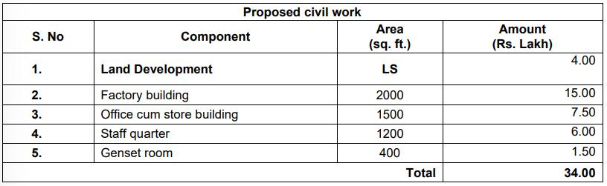

(*Note: Factory building either be RCC or PEB structure so the layout plan and cost may vary project to project same will be captured in an applicant’s DPR):

Plant & machinery

The company proposes to installlatest and standard machines from the reputed Indian/International manufacturers. The total proposed investment in plant & machinery is Rs. 35.00 lakh including Effluent Treatment Plant. Details of the proposed machinery is given below:
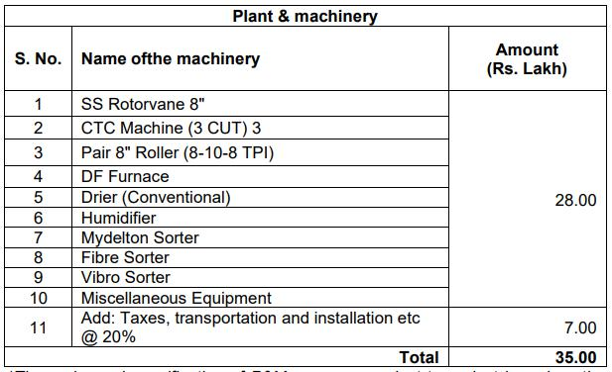

*The make and specification of P&M may vary project to project based on the quotations from different suppliers.

As per scheme guidelines Rs. 35.00 lakh has been considered towards grant-in-aid calculation.

30

Misc. Fixed Assets

In order to ensure smooth operation of the unit, it would also require certain miscellaneous fixed assets apart from above listed plant &machinery. The miscellaneous fixed assets would include electrical load security & transformer, DG set, furniture and fixtures, etc. Cost of these assets is estimated to be Rs. 20.00 lakh.
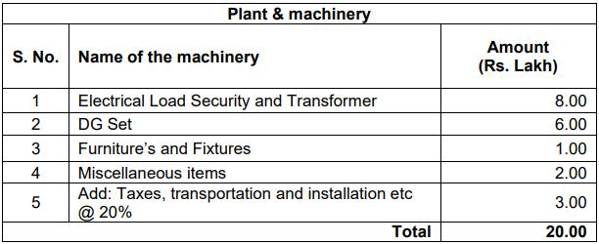

Preliminary & pre-operative expenses

The provision towards preliminary & pre-operative expenses includes expenditure towards like salaries & administrative expenses, travel expenses, market development expenses, interest during construction period etc. The Miscellaneous charges include the cost incurred towards Administration, Travelling, Market development and other marketing activities.

Contingency

Amount proposed to be invested towards contingency is Rs. 6.00 lakh

Margin money for the working capital

We have worked out the margin money for working capital requirement as per project need and its smooth operation, the proposed amount of margin money is Rs.1.57 lakh. Detail is given in the financial section of the report.

31
Electricity

The unit will require power load of ……… KVA from North/South Bihar Power Distribution

Company Ltd. for this project. Estimate of power requirement is enclosed with the financial part of this report.

Water

The estimated water consumption is approx. 10 KL per day and two deep bore wells would be required to meet the water requirement of the unit.

Manpower

An estimate of manpower requirements has been prepared based on the equipment and operations involved. An estimate of manpower cost is given below:
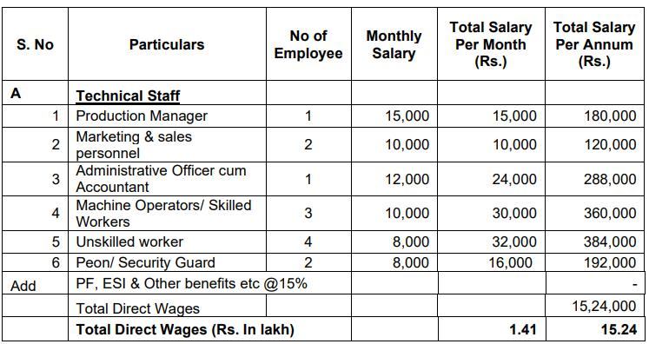

32

Financial Analysis
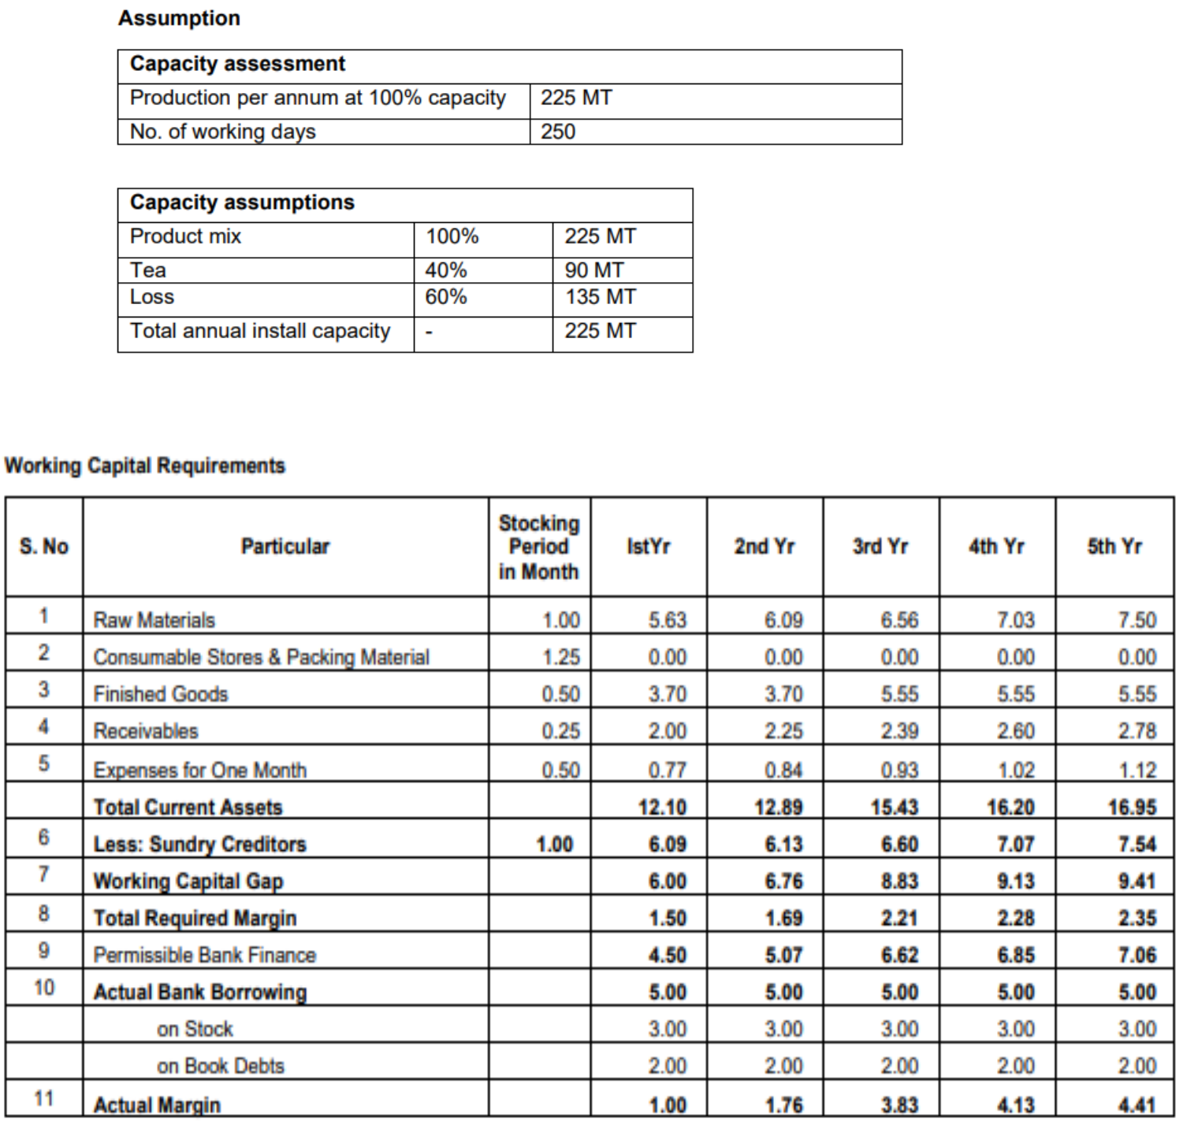

33

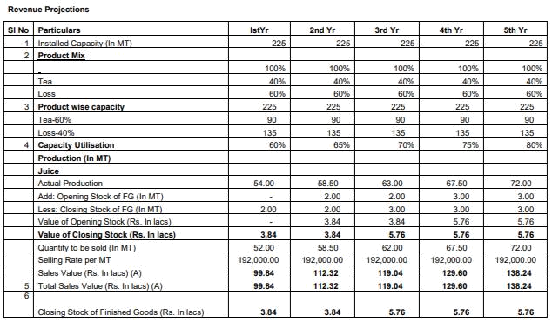

34
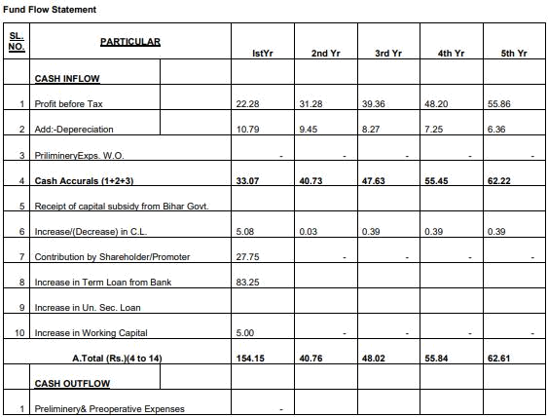

35
FINDING OF STUDY

Product Profile

To begin with it is perhaps desirable to define ‘Tea’. ‘Tea’ has been clearly defined in the Tea Act, 1953. As per provision of Tea Act, ‘Tea’ means the plant Camellia Sinensis (L) O. Kuntze as well as all varieties of the product known commercially as tea made from the leaves of the plant Camellia Sinensis (L) O.Kuntze including green tea. Tea which is available in the market is in fact ‘Made Tea’. Green leaves plucked from the tea bushes are manufactured into ‘Made Tea’ or ‘Tea’ in the Tea Factories through a series of manufacturing process.Green leaves, in the process of manufacturing ‘Made Tea’ or ‘Tea’ also generates by-product known as ‘Tea Waste’. This ‘Tea Waste’ is unfit for human consumption and has three uses viz.

- for manufacture of caffine ;

- for manufacture of Instant Tea and

- for using as manure in the tea field.

Made tea or Tea manufactured from green tea leaves is generally classified into two types viz. Black Tea and Green Tea. Green tea is different from Black tea since fermentation of green leaves is arrested in manufacturing green tea. Again black tea is of two types viz. Orthodox tea and CTC tea. Orthodox teas are manufactured with the help of orthodox roller in the process of rolling while CTC machine/Rotervan is used in rolling process in manufacturing CTC teas. CTC stands for Crushing, Tearing & Curling. While, most of the teas produced in Sri Lanka is of ‘orthodox’ variety, Kenya produces mainly CTC teas.

The tea processing in any factory in the traditional way comprises the following phases

  - Withering

  - Rolling

  - Fermentation

  - Drying

  - Sorting & Grading

Apart from Orthodox, CTC & Green tea, powder tea which is known as “Instant tea”: is also being manufactured in India and in few other tea producing countries of the world like Kenya

36

and Sri Lanka. The Instant tea is manufactured in separate factories known as Instant tea factory. The procedure for manufacturing Instant tea is different from that of black tea or green tea. The raw materials used for manufacturing Instant tea are green tea leaves and/or tea waste. The manufacture of Instant tea in India has started since 1960.

Tea, mainly the black tea is also being further processed with the help of tea bagging machine to manufacture ‘tea bags’. This is one of the “convenience” tea generally preferred by the consumers of the western countries. “Filter papers” is being used as packaging material for manufacture of tea bags.

Instant tea and Tea bags are generally known as ‘convenience tea’ since these are convenient for consumers to get the liquor with less hazards. Moreover, in order to preserve the quality of tea during its different stages of trading activities particularly in retail trading and also to maintain the uniformity of the quality to the extent possible, black tea or green tea are packed either in original form or in blended form in small consumer packs. These are known as ‘Packet tea’. So tea planters at the garden level, after manufacture of ‘made tea’ from green tea leaves, use bulk containers or small containers for packaging. Bulk containers are generally consists of wooden tea chests, polyline jute bags, multiwall paper sacks etc. and can contain 25 kilo grams to 55 kilo grams of tea depending on the nature or size of the container. Small containers consists of paper sacks, wooden box, metal caddies, polythene packs etc. and can contain 2 grams of tea to 1 kilo grams tea according to the need of consumers and based on suitability to its handlings. Tea in bulk, after coming out from the estate is also packed or repacked in small containers by merchant packers apart from its ‘sale’ in loose form to the consumers. As already mentioned, green tea leaves plucked from the tea bushes when manufactured in the tea factory through a series of tea processing like withering, rolling, fermentation, drying etc., converted into made tea. Depending on the system of tea processing, tea is classified into black tea and green tea. Black tea is obtained by so called fermentation process where as for making green tea fermentation is prevented. . The characteristic of the beverage like tea is determined by the major components of the leaf i.e. polyphenols, the peptic substances, the flavouring constituents and caffeine. The caffeine is known for its stimulating effect.

Quality of ‘made tea’ or ‘tea’

37

The term ‘quality’ in its broadest sense is used as a description of all the characters of tea by which it is judged on its market value. So quality means the summation of the desirable attributes comprising internal and external characters like aroma/flavour, strength, colour, briskness and character of infused leaf. The “quality” of the tea conforming to the specification laid down in the PFA Act may vary. The quality of tea also varies between garden to garden and also between the teas manufactured at different times -in a particular garden. The green tea leaves of the plant belonging to the species of Camellia Sinensis has its natural ‘aroma’. The efforts of the tea manufacturer is generally aimed at to maintain the natural aroma in the made tea as far as possible.

The quality of ‘tea’ depends primarily on the nature and chemical composition of the plucked leaf which is again dependent on the type of bush, the growing conditions and the kind of plucked leaf like coarseness and fineness etc. Only careful and proper processing will bring out the full potential of the green leaf.

Each of the characteristics on which tea is assessed by trade is affected by one or more the factors involved both in the field and in the factory. Since a variety of factors plays a role and the production of a particular character is usually obtained at the expense of another, pre-processing and processing conditions is generally adjusted as to bring about the most desirable characters in a tea made from a given material.

So the factors affecting tea quality apart from those involved in processing can be distinguished in 3 groups viz. genetic, environmental and cultural.

- Tea quality is primarily determined by the genetic properties of the tea planting and those of the tea bush in particular.

- Both soil and climate are influencing the quality of tea. Climatic condition including temperature, humidity, sunshine duration, rainfall are important in determining quality.

- Field operation like pruning, fertilising, shading, plucking round and plucking standard are also playing the important role in determining the quality of tea.

The definition of ‘Tea Waste’ has also been indicated in ‘The Tea Waste (Control) Order,

1959. Accordingly to the said order,

38

‘Tea Waste’ means tea sweepings, tea fluff, tea fibre or tea stalks or any article purporting to be tea which does not conform to the specification for tea laid down under the Prevention of Food Adulteration Act,1954(37 of 1954) but does not include green tea or green tea stalks.

In order to prevent tea from any possible adulteration, the Prevention of Food Adulteration Act, 1954 is in existence. Tea therefore shall conform to the following specifications as indicated in the PFA Act, 1954.
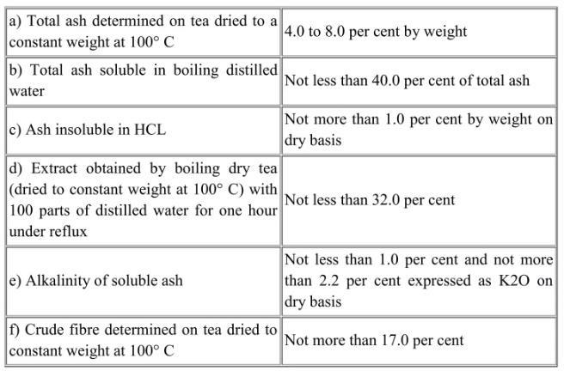

Note:-

- It shall not contain any added colouring matter or added flavouring matter.

- Provided that tea for export may contain added flavour under proper label declaration.

- Provided further that the tea used in the manufacture of flavoured tea shall conform to the standards of tea.

Tea Tasting

Like any other industrial product, tea is also assessed for its quality and value. This is being done in the first instance, by the tea maker in the factory to ensure of the quality of the product and to prevent defects if any.

39

The made tea of an estate, is also tested by the commercial tasters (generally known as broker) for determining the quality and its value. The term ‘taste’ is used here in its general sense and includes aroma.

Tea tasting is aimed at describing and evaluating teas in the form of individual grades or as blended product. The description and evaluation include the appearance of the dry tea, of the infused leaf and of the infusion obtained by brewing the tea with boiling water, the taste characteristics of the infusion, commonly called the liquor, etc.

In assessing the characteristics of a tea the taster first examines the dry tea for colours, uniformity, twist, tip and aroma and then passes on to the infused leaf.

On the basis of the physical appearance of the made tea, different grades are maintained. The type of different grade and its description is indicated below :

40
Orthodox Tea

Table-9
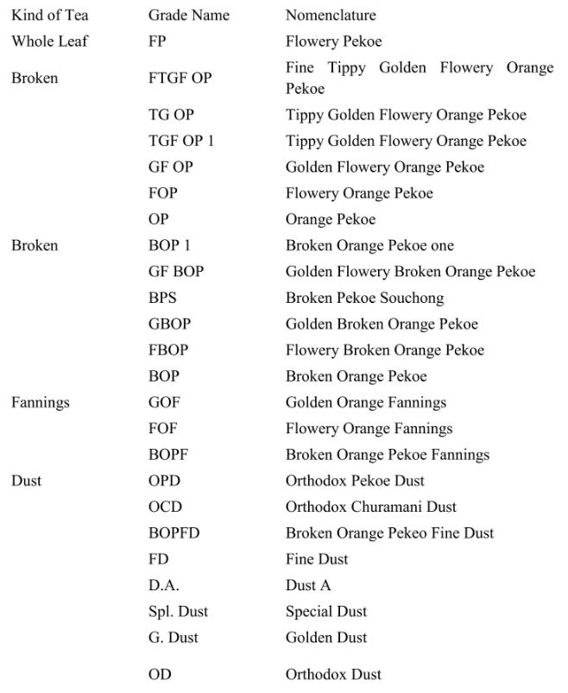

41
CTC Tea

Table-10
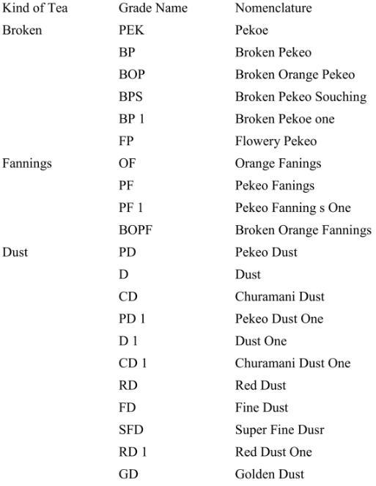

42
Green Tea

Table-11
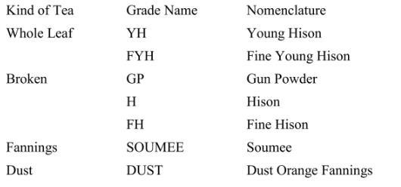

Marketing

The process of growing and manufacturing tea and its subsequent marketing involves complexities and distinguishing factors not associated with any other commodities. Options are limited in the business of tea at every stage and this in turn brings some of the constraints necessitating careful attention.

Tea is a perennial crop. Newly planted tea bushes require at least three years to attain maturity and start yielding green leaves for manufacture of ‘made tea’. The life of the tea bush is more than 100 years and the economic age of tea bush is also around 100 years although it depends upon the type of tea plant, climatic condition and the care received from the planters during the life time. Therefore tea grower cannot turn to crop rotation when the prices are weak nor can he increase output in a short time to take advantage of higher ruling prices. Tea is also a perishable goods and cannot be stored for indefinite period without affecting the quality. So decision of the tea growers to regulate the marketing of tea within six to eight months from the date of manufacture to fetch maximum price is an important one. Although tea can be stored with proper arrangements for a period of six to eight months, the general intention of tea growers is to market their teas within four to six weeks from the time of its manufacture in order to recoup the liability towards cost involved in the tea field, estate factory or in trading factory. Only financially sound tea producer/manufacturer is perhaps able to take risk of delayed marketing of their produce and can avail any possible opportunity arising out of upward price movement in the tea market.

There are two well defined stages in the marketing of any product including tea. These are Primary and Secondary. In the primary marketing teas grown in the tea estates reaches to the traders of either

43

domestic or of importing countries. In the secondary stages of marketing teas from the traders reaches to consumers of either domestic or overseas.

Primary marketing

As already mentioned, tea is a commercial crop cultivated on a plantation basis. Unlike cereals, negligible fraction of the tea output is retained for consumption by the planters at garden level. So that almost entire output at the garden level is sold. The tea planter has the following four options to dispose the output through sale.

- Sales through Indian auction.

- Sales through overseas auction by sending teas on consignment basis.

- Sales as ‘direct export’ to the importer of importing countries.

- ‘Ex-garden’ sales.

While sales (ii) and (iii) earlier mentioned are exclusively for exports, sales through (i) and (iv) are meant for domestic consumption as well as for exports. At present teas from garden level are marketed either in bulk form or in packet form. While earlier mentioned four options are available for markets of tea in bulk form, only options (iii) and (iv) are available for marketing of packet tea by the tea planters from the garden level.

5. Secondary marketing (with reference to India)

Indian Traders who purchase tea through Indian auctions or directly from the tea planters have the following options:

- Export in bulk packages in original form and/or export in bulk packages in blended form.

- Export after further processing as tea bags and/or packaging in consumer packs.

- Sale to Wholesaler/Retailer in loose form to reach Indian consumers.

- Sale to Wholesaler/Retailer in packet form after packaging in consumer packs to reach Indian consumers.e

Marketing strategy

The rising number of health-conscious consumers of green tea and tea leaves is giving a boost to tea industries. Today markets are flooded with a large variety of tea juices. The main reason for

44

increased consumption is rising level of health consciousness among consumers. Factors like preferred choice of easy availability, convenience, naturalness and marketing strategies have given tea industry a booming growth.

With changing lifestyles and increase in disposable incomes, the demand for tea is ever increasing. Besides consumption in the households, it is served in hotels, restaurants, clubs, airlines, railways, local tea stalls etc.

Quality should be emphasized at each step right from the beginning to the marketing of the Product. Over the years, an image of high-quality products should be cultivated. The effectiveness of distribution coverage and practice is of paramount importance in achieving the desired sales. Understanding of the distribution channels is crucial for the manufacturer to plan and implement an effective distribution strategy. Distribution network should be given extra emphasis. Market share could be gained by enhancing retailer, and distributor margins.

Promoters would appoint distributors in targeted towns of Bihar and surrounding states like West Bengal, Jharkhand, Uttar Pradesh. Contacts with retailers of similar kinds will be made and products would be sold in the market with help of them. The product made in this unit will be in the line with top range of products with better quality at the same time cost effective. Company would be sharing more profits with the distributors and retailers.

Company will also explore possibility of marketing their produce to retails shops like Big Bazar, Reliance Trends, Malls etc. It will also try to partnership with local and other hotels and restaurants with good offers to attract demand of its product. It is assumed that due high quality, cost effectiveness and aesthetic packaging, sale of products may not face much problems.

Project impact

As discussed earlier, the project will have various positive impacts such as:

Infrastructure for value addition: This unit would aim to integrate and streamline existing value chains in the region by creating centralized infrastructure for value addition and preservation. The unit will thus provide benefits on cost, quality and convenience for sustainable growth in the market driven economy. The unit has been envisaged in a way that it would ensure better returns to all

45

players in each level of value chains ranging from procurement, storage, processing, packaging to distribution of food commodities through vertical integration of functions and horizontal linkages of destinations.

Reduction of Wastages: The infrastructure created at the unit along with the integration of backward and forward linkages would lead to more efficient supply chains and reduction of wastages. This would provide higher value realization to all players in the supply chain including the farmers.

Creation of employment: The project shall generate employments. It is estimated that the it would generate direct employment of about ……………. workers and indirect employment of another
………….. workers. Most of the manpower requirement will be met from the local area.

Return to farmers: The unit will be benefiting farmers in the region by increasing the returns for farmers by decreasing wastages and increasing demand of the agricultural produce

46
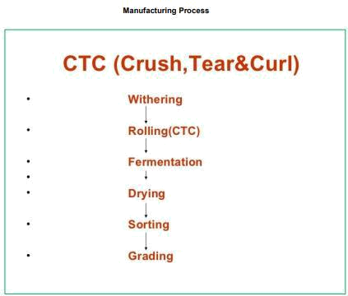

Procurement strategy of raw material & other inputs

Unknown to many, Bihar is home to commercially produced tea with the same being produced in Kishanganj and nearby districts and Kishanganj being the lone district in the State with largest area under tea plantation. The total cultivated area under tea is about 10,000 ha with a production of around 10,000 MT. Hilly terrain, cool climate, favorable soil quality and natural drainage system are some of the key features of the region which supports tea cultivation. Presently there are 9 tea processing units (one owned by government and rest being privately owned).

The total cultivated area under tea is about 1,600 Ha spread over three blocks, viz., Pothia, Thakurganj and Kishanganj. Hilly terrain, cool climate, favorable soil quality and natural drainage system are some of the key features of the region which supports tea cultivation. Unit has proposed to procure tea leaves from Kishanganj and adjoining districts.

47
CONCLUSION

The study conducted to look into some key aspects on trend of tea industry in India. The initial findings of this study are highlighted the trend of tea industry in India. India is the largest producer of tea in the world and the largest consumer with an increasing domestic consumption.

The industry has been making continuing efforts to play a significant role as a major player in the Indian economy. The different parameters such as production, prices, exports, new technology implementation and others can assist in generating high profit, growth and gaining competitive advantage for the sector.

In order to gain the competitive advantage, Indian tea industry needs improvement in research facility, introduction of modern technology etc. Small tea growers are inserted into the tea value chain as a result of global.

Changes in tea trade and brand led restructuring process. Tea plantation industry is subjected to large economies of scale. It is a synthesis of agriculture (plantation) and industry. Most of the small planters cannot afford a factory in their estates. Even if they are the raw leaves produced in small plantations may not be sufficient for economy running of a factory. As a result, historically, tea industry is relatively a big business and the size distribution is skewed towards large firms.

Further research in data analysis with respect to the tea industry can result in significant insights and knowledge, which can be used in India for better growth in the sector contributing to the economy.

48
BIBLIOGRAPHY

15.1 Book

"Crafting and Executing Strategy" by A Thompson, Margaret A Peteraf, John E Gamble, A J Strickland, A K Jain, Tata McGraw Hill Education Pvt. Ltd., Eighteenth Edition".

15.2 Websites

www.indianmirror.com

www.strategicmanagementinsight.com

www.livemint.com

www.moneycontrol.com

www.ibef.org

www.statista.com

www.bloomberg.com

www.kpmg.com

www.worldcocoa.org

www.myaccountingcourse.com

www.readyratio.com

www.indiaretailing.com

www.indexmundi.com

49
REFERENCES

Asha, K. (1993), Competitiveness of India's Agricultural Exports - A case of Tea Exports, M.Phil. Dissertation, Centre for Development Studies, Trivandrum, (Jawaharlal Nehru University, Delhi.) Ashby, H.K. (1977), Cocoa, Tea and Coffee, Priory Press Limited, Hove, Crane, Russia and Company Inc., New York.

Baak, Paul, E. (1992). 'Planter's Lobby in late 19th Century, Implications for Travancore, Economic and Political Weekly, August, 15.

Bhowmik, Sharit Kumar (1988), 'Ideology and the Co-operative Movement, Worker Co-operative in the Tea Industry,' Economic and Political Weekly, Vol. XXIII, No. 51, December, 17.

Bhowmik, Sharit, K. (1990), 'Tea: Will Prices Fall?', Economic and Political Weekly, April 14. Bhowmik, Sharit, K. (1991), 'Small growers to Prop up Large Plantations, Economic and Political Weekly, Vol. XXVI, No:30, July 27.

Chakraborthy, Dibyendu (1997). 'Tea Industry Over-supply Potential Threat,' Commodity Focus, Journal of PTI Economic Service, District Industrial Centre, Thiruvananthapuram. Chakraborthy, Ranajit, and Acharya, Bivas (1998), Export Potential of Idnian Tea in the New Economic Environment, Managing Economic Liberalisation in South Asia, Directions for 21st Century, Macmillan India Limited.

Chiranjeevi, T. (1994), Tea Economy of India, Rawat Publications, Jaipur.

Daniel, Mammen (1991), Methods in Plant Chemistry and Economic Botany, Kalyani Publishers, New Delhi.

Dudeja, Vijay (1996) Tea Quality - The Panacea', Tea International, The Journal of the World Tea Trade, Vol.3, Issue 2, No: 9.

Dwibedi, H.N. (1999), Production of Tea in India, with special reference to Dooars, K.P. Bagchi and Company, Calcutta.

Ferriman, Annabel (1997), 'Health Effects of Tea,' The Planter's Chronicle, June, Vol. 92, No: 6.

George, Tharian (1980), The Marketing of Indian Tea,' Indian

Manager, Vol. XI, No. 4, October-December. George, Tharian, K. (1982), The Economics of Tea Plantations in

South India, Ph.D. Thesis, School of Management Studies, Cochin University of Science and Technology, Cochin.

50

George, Tharian (1984), 'Historical Roots of the Crisis in the South Indian Tea Industry,' Social Scientist, Issue No. 131, April.

Goradia, Praful (1979), Profiles of Tea, Oxford and IBH Publishing Company, New Delhi. Harborne, J.B. (1973), Phytochemical Methods a Guide to Modern

Techniques of Plant Analysis, Chapman and Hall, London. Haridas, P. (1998), Kenyan Tea Industry,' Tata Tea Seithingal, Vol.4, No:4, January.

Hudson, J.B. (1997a), 'Frost Injury to Tea, Tata Tea Seithingal Vol.4, No.2, September - October. Hudson, J.B. (1997b), 'Shear Harvesting.' Tata Tea Seithingal, Vol. 4, No.1, July - August. Hudson, J.B. (1998), 'Enhancing Harvesting Efficiency of Pluckers' Bulletin of UPASI Tea Scientific Department, No:51, March.

Jain, Ajith (1995), 'Drink Tea To Stay Healthy and Cancer Free,"

The Planter's Chronicle, Vol.90, No: 7, July.

Krishna, Sridhar (1995), 'Tea: Exports Fall Because of Reduced Production,' Commodity Focus, Journal of PTI Economic Service, District Industrial Centre, Trivandrum, Vol. XX, No: 5, November 1.

51
APPENDIX

The final section(s) offers additional information that might be of benefit, such as a list of key personnel, data limitations that may influence the findings, and suggestions for the plan, relevant legislation, and so forth.

Interview Questions

- How would you describe Shane Punjab Tea’s mission statement?

- What are some marketing challenges that Shane Punjab Tea faces today?

- How do you go about creating your market plans? What types of marketing tools does Shane Punjab Tea use? Facebook, Twitter, etc.?

- Who is your target market? Would you consider expanding target audience over the course of Shane Punjab Tea’s establishment?

- Please briefly describe your experience as a marketing professional in the hospitality industry.

- What is your most recent marketing plan? What part of the market is Shane Punjab Tea currently expanding on?

- Shane Punjab Tea has been very successful: how do you stay competitive?

- How do you measure how effective your marketing is? (Surveys? Customer Cards?)

- What times during the year is Shane Punjab Tea the busiest? Slowest? During these times, do you actively go about marketing to attract your customers?

- Do you have any suggestions or advices for us in creating a marketing plan for Shane Punjab Tea?

52
Interview Answers

1. Join us in the revolution as we reinvent tea and change the face of the beverage industry – Fresh. Innovative. Fearless.

- Not enough brand awareness of our scale. We have 120 stores in the U.S but still many people haven’t heard of our brand or bubble tea.

- Yes, from social media. To create marketing plans, we based on industry trend research and work with our product team to come up with strategy.

- 18-35 years old. Yes, we want to expand especially among non-Asian community.

- Very exciting and diverse, and a lot of areas to research and needs to learn all the time, keep updated with the latest trends.

- Influencer marketing plan and focus on brand ambassadors. We will focus on expanding on west coast.

- Product always comes first. To guarantee the product quality, all bubble is freshly made every 2 hours, tea is freshly brewed every 3 hours. And always trying to think of differentiators separate ourselves from other brands.

- Surveys.

- Summer is busier. Winter is less busy. We do have different marketing strategies towards different seasons and create the marketing plan accordingly. For example, we had a hot drink special for winter times.

- I would say below are the two major struggles, create a marketing plan target towards these specific goals, and then develop tactics based on the goals.

- A plan can help to improve brand awareness of Shane Punjab Tea among non-Asian.

- Brand ambassador plan to attract more people to choose Shane Punjab Tea instead of other bubble tea brands.

53
Summary of the Questionnaire

As students enrolled in HMGT-2405 Hospitality Marketing course we were required to

create the Marketing Plan Project. As one of the objectives of this project was for us to meet with

a professional marketing person in the hospitality industry for an informational interview. With

our group, we decided to create a marketing plan for Shane Punjab Tea as our chosen company to

provide marketing strategies based from what we have learned in class. Shane Punjab Tea is a

beverage store who expertise in bubble tea and other drinks. As students majoring in Hospitality

Management at New York City College of Technology, we admire Shane Punjab Tea’s

accomplishments throughout their years of service and expansion. Therefore, we wanted to

arrange an interview with the marketing manager from Shane Punjab Tea to help us with our project.

Unfortunately, we were not able to schedule in-person appointment to meet with a

marketing manager. However, with the help of our group member who is a current employee at

one of the locations of Shane Punjab Tea located at 136-20 38th Ave, Flushing, we were able to send a

professional email to Mai Shi, a manager of the marketing team. Mai Shi considered our request to answer our interview questions which helped us to create a marketing plan project. The interview was extremely helpful and proficient. Mai Shi gave us good feedback with very informative facts. In addition, she was kind to provide us with some suggestions for our marketing plan project. Ms. Mai was also very supportive of our project and where we were so thankful and appreciative of her time and the opportunity that we have granted.

Overall, throughout the interview we have learned a lot of information about Shane Punjab Tea; such as their marketing strategies, target market, strengths, weaknesses, opportunities and threats, as well as their confidence with their own brand. To conclude, from the interview we had with a marketing manager as a representative of thee Shane Punjab Tea, she was proud to say how prosperous Shane Punjab Tea is and that the company is still on its way to grow to a higher level of success in the future.

54

