Project Report
On
CONTACT BOOK
For the Degree of
BACHELOR OF COMPUTER APPLICATIONS

SUBMITTED To :-
Mrs. Ranjeet kaur
SUBMITTED BY :-
Sunny (University Roll no. 1820302)
Neelam (University Roll no. 1919805)
Malout Institute of Management and Information Technology,Malout

DECLARATION

I hereby declare that this project report is based on my original work except for citations and quotations which have been duly acknowledged. I also declare that it has not been previously and concurrently submitted for any other degree or award at UTAR or other institutions.

Signature :

Name : Sunny , Neelam
Date :_________________________

ACKNOWLEDGEMENTS

I would like to thank everyone who has contributed to the successful completion of this project. First, I would like to express my utmost gratitude to my research supervisor, _______________ who in spite of being extraordinarily busy with her/his duties, took time to give invaluable advice and guidance throughout the development of the research.

In addition, I would also like to express my deepest appreciation to my loving parents and family members for their constant support and encouragement.

Last but not the least, I am grateful for the unselfish cooperation and assistance that my friends had given me to complete this task

INDEX

CHAPTER 1
INTRODUCTION 7
• Abstract of the Project Contact Management System 7
• Objective of Project on Contact Management System 9
• Scope of the project Contact Management System 9

CHAPTER 2
Software Requirement Speciﬁcation 7
• Feasibility Study 7
• Economical Feasibility 9
• Operational Feasibility 9

CHAPTER 3
System Design 7
• System Design 7
• Primary Design phase 9
• Secondary design phase 9
• User Interface Design 10

CHAPTER 4
Requirement speciﬁcations 7
• Software Requirement 9
• Hardware Requirements 9

CHAPTER 5
Installation Phase 7
• Screenshots 9
• Conclusion of the Project Contact Management System 9

CHAPTER 6
Future Scope of the Project 7
• Limitation of Project on Contact Management System 9
• References and Bibliography 9

Chapter 1

Introduction of the Project Contact Management System

The "Contact Management System" has been developed to override the problems prevailing in the practicing manual system. This software is supported to eliminate and in some cases reduce the hardships faced by this existing system. Moreover this system is designed for the particular need of the company to carry out operations in a smooth and effective manner.
The application is reduced as much as possible to avoid errors while entering the data. It also provides an error message while entering invalid data. No formal knowledge is needed for the user to use this system. Thus by this all it proves it is user-friendly. Contact Management System , as described above, can lead to error free, secure, reliable and fast management systems. It can assist the user to concentrate on their other activities rather than concentrating on the record keeping. Thus it will help organizations in better utilization of resources.
Every organization, whether big or small, has challenges to overcome and manage the information of Credential, Contact, Profile, Mobile, Emails. Every Contact Management System has different Contact needs, therefore we design exclusive employee management systems that are adapted to your managerial requirements. This is designed to assist in strategic

planning, and will help you ensure that your organization is equipped with the right level of information and details for your future goals. Also, for those busy executives who are always on the go, our systems come with remote access features, which will allow you to manage your workforce anytime, at all times. These systems will ultimately allow you to better manage resources.

Abstract of the Project Contact Management System
The purpose of Contact Management System is to automate the existing manual system by the help of computerized equipment and full-fledged computer software, fulfilling their requirements, so that their valuable data/information can be stored for a longer period with easy accessing and manipulation of the same. The required software and hardware are easily available and easy to work with.

Objective of Project on Contact Management System

The main objective of the Project on Contact Management System is to manage the details of Contact, Credential, Telephone, Profile, Emails. It manages all the information about Contact, Mobile, Emails, Contact. The project is totally built at the administrative end and thus only the administrator is guaranteed access. The purpose of the project is to build an application program to reduce the manual work for managing the Contact, Credential, Mobile, Telephone. It tracks all the details about the Telephone, Profile, Emails

Scope of the project Contact Management System

It may help collect perfect management in detail. In a very short time, the collection will be obvious, simple and sensible. It will help a person to know the management of the past year perfectly and vividly. It also helps in current work relative to the Contact Management System. It will also reduce the cost of collecting the management & collection procedure will go on smoothly.
Our project aims at Business process automation, i.e. we have tried to computerize various processes of Contact Management System.
- In the computer system the person has to fill the various forms & number of copies of the forms can be easily generated at a time.
- In a computer system, it is not necessary to create the manifest but we can directly print it, which saves our time.
- To assist the staff in capturing the effort spent on their respective working areas.
- To utilize resources in an efficient manner by increasing their productivity through automation.
- The system generates types of information that can be used for various purposes.
- It satisfy the user requirement
- Be easy to understand by the user and operator
- Be easy to operate
- Have a good user interface
- Be expandable
- Delivered on schedule within the budget.

Reports of Contact Management System:

• It generates the report on Contact, Credential, Mobile
• Provide filter reports on Telephone, Profile, Emails
• You can easily export PDF for the Contact, Mobile, Profile
• Application also provides excel export for Credential, Telephone, Emails
• You can also export the report into csv format for Contact, Credential, Emails

Modules of Contact Management System:

• Contact Management Module: Used for managing the Contact details.
• Emails Module : Used for managing the details of Emails
• Mobile Module : Used for managing the details of Mobile
• Credential Management Module: Used for managing the information and details of the Credential.
• Telephone Module : Used for managing the Telephone details
• Profile Module : Used for managing the Profile information
• Login Module: Used for managing the login details
• Users Module : Used for managing the users of the system

Software Requirement Specification

The Software Requirements Specification is produced at the culmination of the analysis task. The function and performance allocated to software as part of system engineering are refined by establishing a complete information description, a detailed functional and behavioral description, an indication of performance requirements and design constraints, appropriate validation criteria, and other data pertinent to requirements.

Feasibility Study:
After doing the project Contact Management System, study and analyze all the existing or required functionalities of the system, the next task is to do the feasibility study for the project. All projects are feasible - given unlimited resources and infinite time.
Feasibility study includes consideration of all the possible ways to provide a solution to the given problem. The proposed solution should satisfy all the user requirements and should be flexible enough so that future changes can be easily done based on the future upcoming requirements.
- Economical Feasibility
This is a very important aspect to be considered while developing a project. We decided on the technology based on the minimum possible cost factor.
- All hardware and software cost has to be borne by the organization.
- Overall we have estimated that the benefits the organization is going to receive from the proposed system will surely overcome the initial costs and the later on running cost for the system.

- Technical Feasibility
This included the study of function, performance and constraints that may affect the ability to achieve an acceptable system. For this feasibility study, we studied complete functionality to be provided in the system, as described in the System Requirement Specification (SRS), and checked if everything was possible using different types of frontend and backend platforms.

- Operational Feasibility
No doubt the proposed system is fully GUI based and is very user friendly and all inputs to be taken are all self-explanatory even to a layman. Besides, proper training has been conducted to let the users know the essence of the system so that they feel comfortable with the new system. As far as our study is concerned the clients are comfortable and happy as the system has cut down their loads and doing.

System Design of Contact Management System

In this phase, a logical system is built which fulfills the given requirements. Design phase of software development deals with transforming the client's requirements into a logically working system. Normally, design is performed in the following in the following two steps:
- Primary Design Phase:
In this phase, the system is designed at block level. The blocks are created on the basis of analysis done in the problem identification phase. Different blocks are created for different functions; emphasis is put on minimizing the information flow between blocks. Thus, all activities which require more interaction are kept in one block.
- Secondary Design Phase:
In the secondary phase the detailed design of every block is performed.

The general tasks involved in the design process are the following:

- Design various blocks for overall system processes.
- Design smaller, compact and workable modules in each block.
- Design various database structures.
- Specify details of programs to achieve desired functionality.

- Design the form of inputs, and outputs of the system.
- Perform documentation of the design.
- System reviews.

User Interface Design

User Interface Design is concerned with the dialogue between a user and the computer. It is concerned with everything from starting the system or logging into the system to the eventual presentation of desired inputs and outputs. The overall flow of screens and messages is called a dialogue.
The following steps are various guidelines for User Interface Design:

- The system user should always be aware of what to do next.

- The screen should be formatted so that various types of information, instructions and messages always appear in the same general display area.
- Messages, instructions or information should be displayed long enough to allow the system user to read them.
- Use display attributes sparingly.

- Default values for fields and answers to be entered by the user should be specified.
- A user should not be allowed to proceed without correcting an error.

- The system user should never get an operating system message or fatal error.

Preliminary Product Description:

The first step in the system development life cycle is the preliminary investigation to determine the feasibility of the system. The purpose of the preliminary investigation is to evaluate project requests. It is not a design study nor does it include the collection of details to describe the business system in all respects. Rather, it is the collecting of information that helps committee members to evaluate the merits of the project request and make an informed judgment about the feasibility of the proposed project.

Project Category

Relational Database Management System (RDBMS) : This is an RDBMS based project which is currently using MySQL for all the transaction statements. MySQL is an opensource RDBMS System.

Brief Introduction about RDBSM :

A relational database management system (RDBMS) is a database management system (DBMS) that is based on the relational model as invented by E. F. Codd, of IBM's San Jose Research Laboratory. Many popular databases currently in use are based on the relational database model.

RDBMSs have become a predominant choice for the storage of information in new databases used for financial records, manufacturing and logistical information, personnel data, and much more since the 1980s. Relational databases have often replaced legacy hierarchical databases and network databases because they are easier to understand and use. However, relational databases have been challenged by object databases, which were introduced in an attempt to address the object-relational

Implementation Methodology:
Model View Controller or MVC as it is popularly called, is a software design pattern for developing web applications. A Model View Controller pattern is made up of the following three parts:
- Model - The lowest level of the pattern which is responsible for maintaining data.
- View - This is responsible for displaying all or a portion of the data to the user.
- Controller - Software Code that controls the interactions between the Model and View.
MVC is popular as it isolates the application logic from the user interface layer and supports separation of concerns. Here the Controller receives all requests for the application and then works with the Model to prepare any data needed by the View. The View then uses the data prepared by the Controller to generate a final presentable response. The MVC abstraction can be graphically represented as follows.

MVC (Model View Controller Flow) Diagram

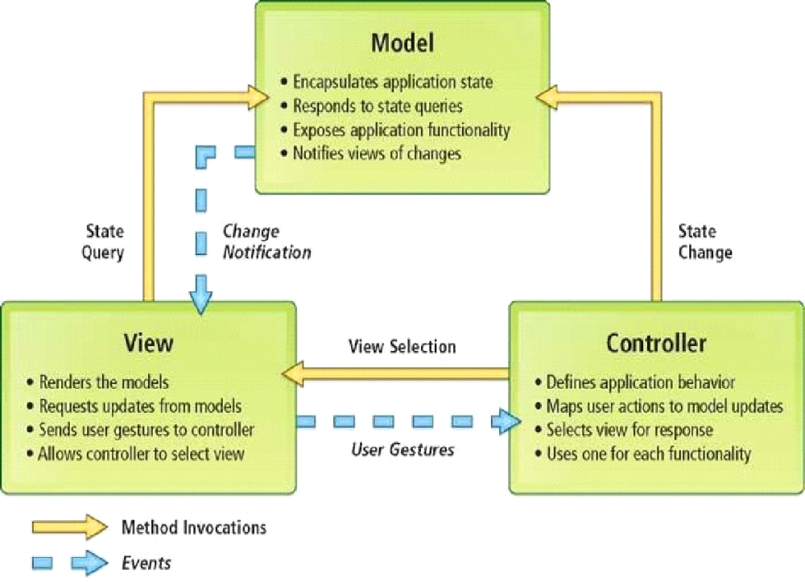
DATA FLOW DIAGRAMS

Project Planning:

Software project plan can be viewed as the following:

- Within the organization: How the project is to be implemented? What are various constraints (time, cost, staff)? What is market strategy?
- With respect to the customer: Weekly or timely meetings with the customer with presentation on status reports. Customers feedback is also taken and further modification and developments are done.

Project milestones and deliverables are also presented to the customer.
Project Scheduling:

An elementary Gantt chart or Timeline chart for the development plan is given below. The plan explains the tasks versus the time (in weeks) they will take to complete.

 | January |  |  |  | February |  |  |  | March
Requirement Gathering
Analysis
Design
Coding
Testing
Implement
 | W1 | W2 | W3 | W4 | W1 | W2 | W3 | W4 | W1 | W2 | W3 | W4

Wi‘s are weeks of the months, for i =1, 2, 3, 4

Requirement specifications:

Software Requirements:

Name of component Specification

Language Java 2 Runtime Environment
Database MySQL Server

Browser Any of Mozilla, Opera, Chrome etc
Web Server Tomcat 7

Scripting Language Enable JSP (Java Server Pages)
Software Development Kit Java JDK 1.7 or Above
Database JDBC Driver MySQL Jconnector

Hardware Requirements:

Name of component Specification

RAM 128 MB
Hard disk 20 GB

Monitor 15” color monitor

Project Profile

There has been continuous effort to develop tools, which can ease the process of software development. But, with the evolving trend of different programming paradigms today’s software developers are really

challenged to deal with the changing technology. Among other issues, software re-engineering is being regarded as an important process in the software development industry. One of the major tasks here is to understand software systems that are already developed and to transform them to a different software environment. Generally, this requires a lot of manual effort in going through a program that might have been developed by another programmer. This project makes a novel attempt to address the issued of program analysis and generation of diagrams, which can depict the structure of a program in a better way. Today, UML is being considered as an industrial standard for software engineering design process. It essential provides several diagramming tools that can express different aspects/ characteristics of program such as
Use cases: Elicit requirement from users in meaningful chunks. Construction planning is built around delivering some use cases n each interaction basis for system testing.
Class diagrams: shows static structure of concepts, types and class. Concepts how users think about the world; type shows interfaces of software components; classes shows implementation of software components.
Interaction diagrams: shows how several objects collaborate in single use case.

Package diagram: show group of classes and dependencies among them.

State diagram: show how single object behaves across many use cases.

Activity diagram: shows behavior with control structure. Can show many objects over many uses, many object in single use case, or implementations methods encourage parallel behavior, etc.

The end-product of this project is a comprehensive tool that can parse any vb.net program and extract most of the object oriented features inherent in the program such as polymorphism, inheritance, encapsulation and abstraction.

Installation Phase

In this phase the new Computerized system is installed, the conversion to new procedures is fully implemented, and the potential of the new system is explored.

System Installation

The process of starting the actual use of a system and training user personnel in its operation.

Review Phase

This phase evaluates the successes and failures during a systems development project, and to measure the results of a new Computerized Transystem in terms of benefits and savings projected at the start of the project.

Development Recap

A review of a project immediately after completion to find successes and potential problems in future work.

Post-Implementation Review

A review, conducted after a new system has been in operation for some time, to evaluate actual system performance against original expectations and projections for cost-benefit improvements. Also identifies maintenance projects to enhance or improve the system.

Screenshots of the
Project Contact
Management System

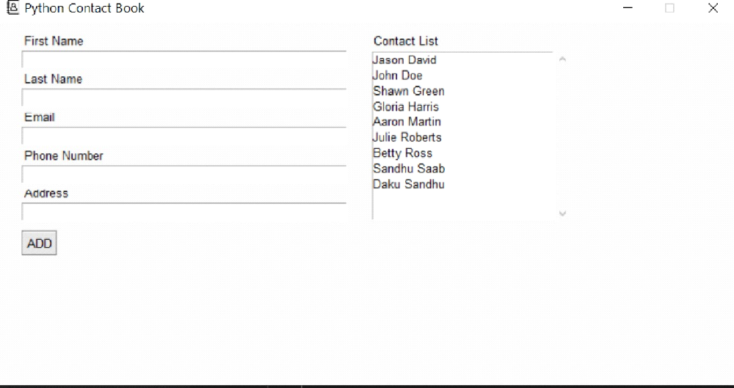

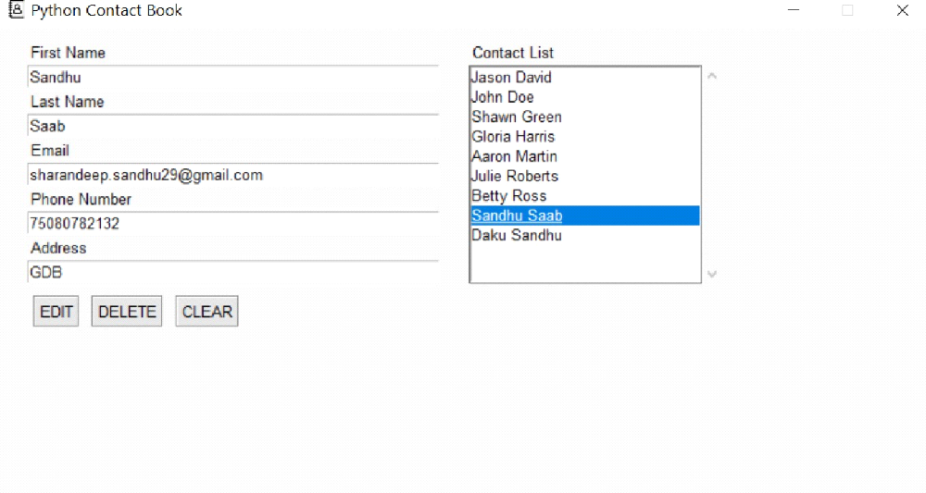

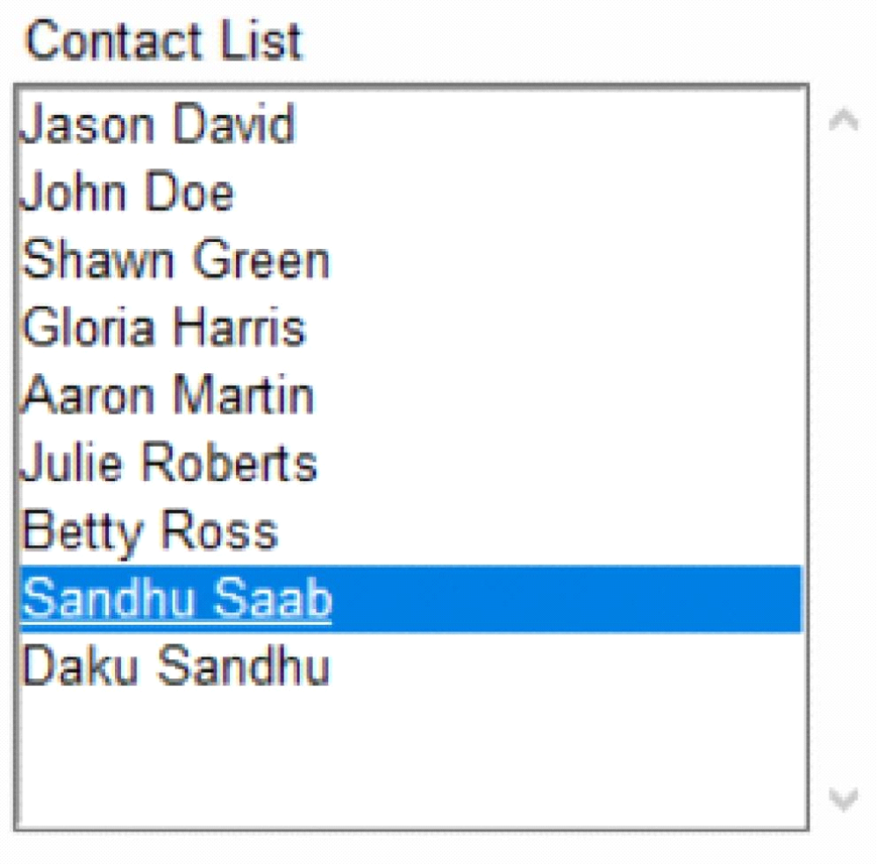

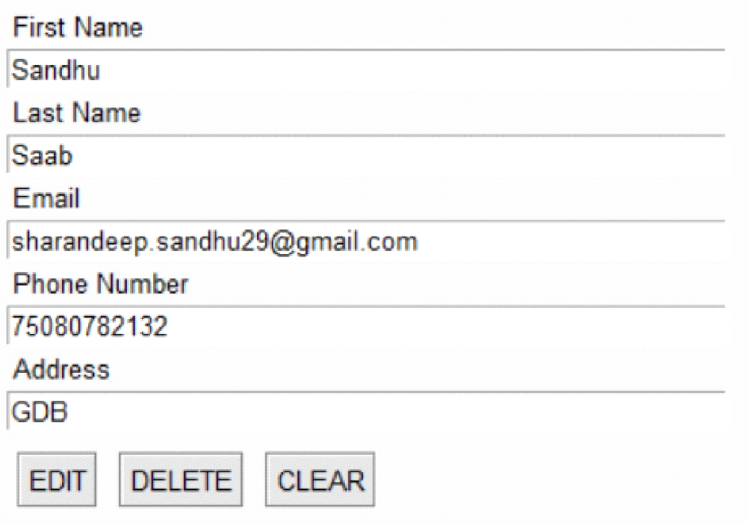

Conclusion of the Project Contact Management System:

Our project is only a humble venture to satisfy the needs to manage their project work. Several user friendly coding have also adopted. This package shall prove to be a powerful package in satisfying all the requirements of the school. The objective of software planning is to provide

a frame work that enables the manger to make reasonable estimates made within a limited time frame at the beginning of the software project and should be updated regularly as the project progresses.
At the end it is concluded that we have made effort on following points…

- A description of the background and context of the project and its relation to work already done in the area.
- Made statement of the aims and objectives of the project.
- The description of Purpose, Scope, and applicability.
- We define the problem on which we are working in the project.
- We describe the requirement Specifications of the system and the actions that can be done on these things.
- We understand the problem domain and produce a model of the system, which describes operations that can be performed on the system.
- We included features and operations in detail, including screen layouts.
- We designed user interface and security issues related to system.
- Finally the system is implemented and tested according to test cases.

Future Scope of the Project:

In a nutshell, it can be summarized that the future scope of the project circles around maintaining information regarding:

- We can add printer in future.
- We can give more advance software for Contact Management System including more facilities
- We will host the platform on online servers to make it accessible worldwide
- Integrate multiple load balancers to distribute the loads of the system
- Create the master and slave database structure to reduce the overload of the database queries

- Implement the backup mechanism for taking backup of codebase and database on regular basis on different servers

The above mentioned points are the enhancements which can be done to increase the applicability and usage of this project. Here we can maintain the records of Contact and Credential. Also, as it can be seen that now-a-days the players are versatile, i.e. so there is a scope for introducing a method to maintain the Contact Management System. Enhancements can be done to maintain all the Contact, Credential, Telephone, Profile, Emails.

We have left all the options open so that if there is any other future requirement in the system by the user for the enhancement of the system then it is possible to implement them.In the last we would like to thanks all the persons involved in the development of the system directly or indirectly. We hope that the project will serve its purpose for which it is develop there by underlining success of process.

Limitation of Project on Contact Management System

Although I have put my best efforts to make the software flexible, easy to operate but limitations cannot be ruled out even by me. Though the software presents a broad range of options to its users some intricate options could not be covered into it; partly because of logistic and partly due to lack of sophistication. Paucity of time was also major constraint, thus it was not possible to make the software foolproof and dynamic. Lack of time also compelled me to ignore some part such as storing old result of the candidate etc.

Considerable efforts have made the software easy to operate even for the people not related to the field of computers but it is acknowledged that a layman may find it a bit problematic at the first instance. The user is provided help at each step for his convenience in working with the software.
List of limitations which is available in the Contact Management System:

- Excel export has not been developed for Contact, Credential due to some criticality.
- The transactions are executed in off-line mode, hence on-line data for Telephone, Profile capture and modification is not possible.
- Off-line reports of Contact, Emails, Telephone cannot be generated due to batch mode execution.

References and Bibliography:
- Google for problem solving
- http://www.javaworld.com/javaworld/jw-01-1998/jw-01-Credentialreview.html
- Database Programming with JDBC and Java by O'Reilly
- Head First Java 2nd Edition
- http://www.jdbc-tutorial.com/
- Java and Software Design Concepts by Apress
- https://www.tutorialspoint.com/java/
- http://www.javatpoint.com/java-tutorial
- https://docs.oracle.com/javase/tutorial/
- http://www.wampserver.com/en/
- http://www.JSP.net/
- http://www.tutorialspoint.com/mysql/
- httpd.apache.org/docs/2.0/misc/tutorials.html

