Term Project-Music Player
Group Name - F
1.On the first page,User will login into the app by entering the username and password as shown below:
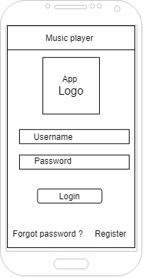

2.On the bottom of the page there will be an option for the" Forgot Password" by clicking on which user will go to a new screen where he can reset his password as shown below:
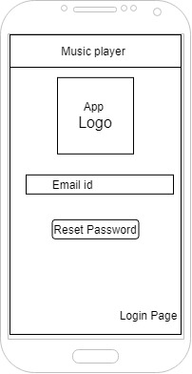
3.Also there is an option at the bottom of the Login Page to register a new user clicking on which will lead to a register screen as shown below:
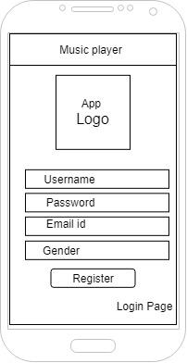
4.There will be four text boxes for entering value for Username, Password,Email id and Gender.
5.On clicking the Register button , all the entered values are stored into the database.
6.As well as , there is an option below to take the user back to Login Page.
7.When the user is logged in into the app the following screen will be opened:
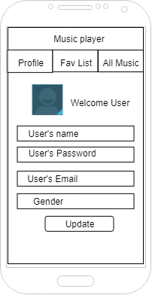
It has Three tabs named as Profile, Fav List and All Music.
8.It has text views showing User's name , password ,email and gender which are only enabled to change when the user click on "Update" button.
9.This page will also show the image of the user.
10.On clicking first tab, the user will go to a new page showing all the information about the user.
11.The second tab is about the "Favourite list" clicking on which leads the user to the following screen:
This page has description about each song that how many times it has been played as well as liked alongwith the photo of the singer.

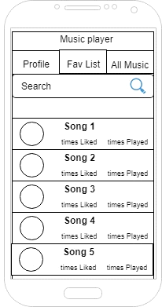
This screen contains a search bar to search the songs and clicking on the song will play that song and gets the user to the following screen:
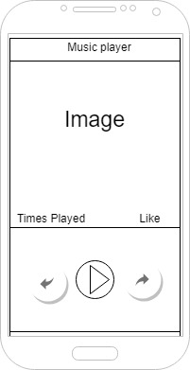
12.This screen has the option to play and pause the song as well as to the right side of play button there is button to go to the next song whereas on the left side of the play button there is option to go to the previous songs.
Also,this screen will show the picture of the singer and below that there is option to like that song as well as information about number of times the song has been played.

13.The third tab is "All music" which takes to the following screen:
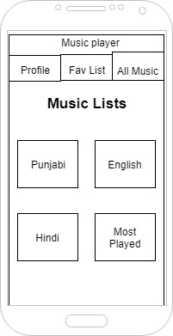

It has different sections for different type of music-Punjabi,Hindi,English,Most played and liked.
14.Here clicking on a song will add it to your favourite list.

