**Name: Babalpreet**

**ID: 3157654**

**Title: Bar and Hotel Management**

**Task 1 - Identify the problem**

**Call Discussion with Client: Balraj**

**Information of the Client:**  Balraj, my client is a hotelier and ows bars too. He is facing difficulties in maintaining the record of his hotels and bars manually, that was the reason he called me and asked me to help him to build a software so that he can maintain his day to day records or activities in the software and can deal with work easily and efficiently.

**Primary objective of the project:** The main objective of the project is to simplify the task of Balraj. As he owns hotels, he has got huge records and to handle and maintain/check all those records manually is becoming impossible for him. And even for streamlining the process and for the growth of the hotels and bars, software is needed; so that Balraj can maintain the records and have access to the records whenever or anywhere he needs.

**Task 2 - Define and document requirements**

Scope of Work

Features: I am going to create software of on Bar and Hotel Management. Which will be fully automated and balraj can maintain and store the data for future. He can see all the customers and Items through this application online. This application would be fully secure. Data will be saved in the future efficiently. And no unauthorized person can make changes in it. So Application would be very effective and efficience.

***Functional Requirements: Demanded requirements by end user:-***

1. Firstly we will make dashboard page which will enhance the beauty of the software.
2. *He wants wines module in the software. Where he can add update the record of the wines. In this page end user can add different sizes of peg quantities as well as its wine name. This would be the master page.*
3. *We are going to add Food Categories page which would be also master page where end user can add update view and delete the different different categories of the food like Non-veg, Veg, South Indian etc.*
4. *In Food items module the end user can add different-2 food items available in the hotel. In this page we will use Food Categories Name as a drop down list so end user will have to firstly select the food category then he can add the food item like Butter Chicken, Paneer Tikks etc.*
5. *After these pages we will make the food Rate lists page where we can add different-2 rates of different-2 food items based its plate size.*
6. *Now we will make table order page where we will add orders of that tables where customer is giving the orders and its date also.*
7. *In Billing page we can add the bills based on table no and its order.*
8. *Next page we will make Feedback page when customer gives the feedback then end user can also add the feedback of the food.*
9. *He wants login and logout facility in the software.*

***Non-functional requirements:***

1. System should be secure. So balraj’s employee can’t do any fraud with the system.
2. System should be portable. So our system would be portable which will run on different-2 platforms like on mobile’s operating system or windows etc.
3. Performance of system should be good. Our system’s performance will be very good. It works very efficiently without any bug.
4. System should be flexible. Our system should be very flexible whenever balraj needs any changes in the system he can make these changes from us or any developers also.
5. Our system would be very reliable so that in complex modules like billing etc system would not create any failure.

**Time:** It will take minimum 18 days to complete. We will create the project based on SDLC Model. We are defining the full milestone as under below:

# Milestones

|  |  |  |  |
| --- | --- | --- | --- |
| **Id** | **Description** | **Completing days** | |
| **Plan** | **Actual** |
|
| 1 | Project study | 2 | 2 |
| 2 | Requirements analysis & definition | 4 | 4 |
| 3 | Development | 8 | 8 |
| 4 | Module testing | 01 | 01 |
| 5 | Integration | 01 | 01 |
| 6 | Testing | 01 | 01 |
| 7 | Project presentation | 01 | 01 |

Cost: We will charge $1000 in partly. All payments which we will cost as under below:

| **Project component** | **Price** |
| --- | --- |
| **Hosting (first year)** | $300 |
| **Graphics** | $100 |
| **Web Pages**  **And code** | $300 |
| **Trainings** | $200 |
| **Go Live** | $100 |
| **Total** | $1000 |

**The 4 essential steps of the Risk Management Process are:**

1. **Identify the risk:** Analyzing risk is hard. There is never enough information you can gather. Of course, a lot of that data is complex, but most industries have best practices, which can help you with your analysis.
2. **Assess the risk:** Not all risks are created equally. You need to evaluate the risk to know what resources you’re going to assemble towards resolving it when and if it occurs.
3. **Treat the risk:** All your hard work identifying and evaluating risk is for naught if you don’t assign someone to oversee the risk. In fact, this is something that you should do when listing the risks.
4. **Monitor and Report on the risk:** You can’t just set forces against a risk without tracking the progress of that initiative. That’s where the monitoring comes in. Whoever owns the risk will be responsible for tracking its progress towards resolution.

**Project management:-** Project management is the application of processes, methods, skills, knowledge and experience to achieve specific project objectives according to the project acceptance criteria within agreed parameters. Project management has final deliverables that are constrained to a finite timescale and budget. We are going to use SDLC Pattern for creating the project. We will write the completed task history in client forms.

**Gantt Chart :** A Gantt chart is another visual project management technique, but this one has even more applications for a project manager.

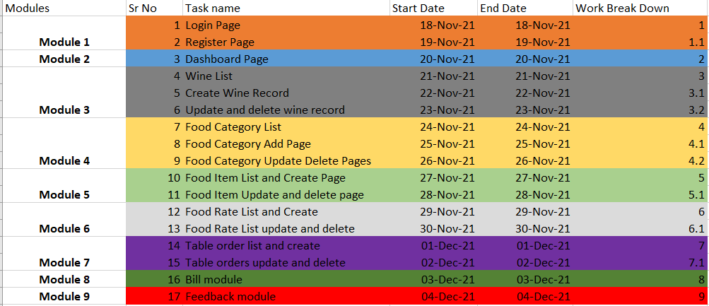

**Gantt Chart Link:** [**GanttChart.xlsx**](GanttChart.xlsx)

**Task 3 - Design mockups**

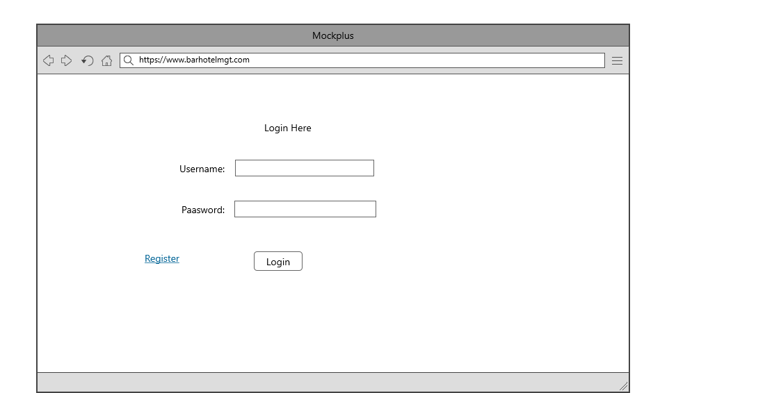

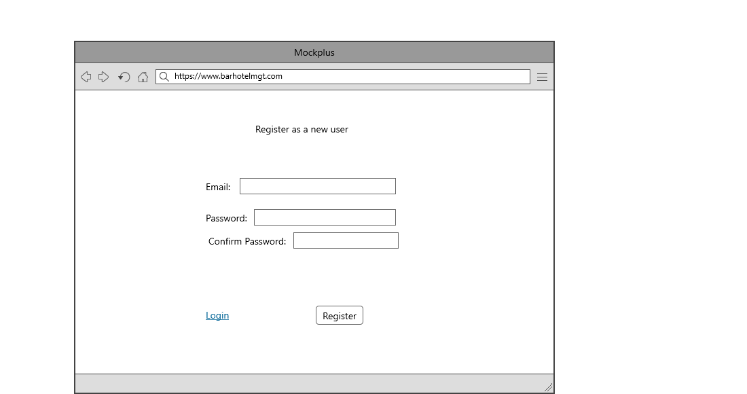

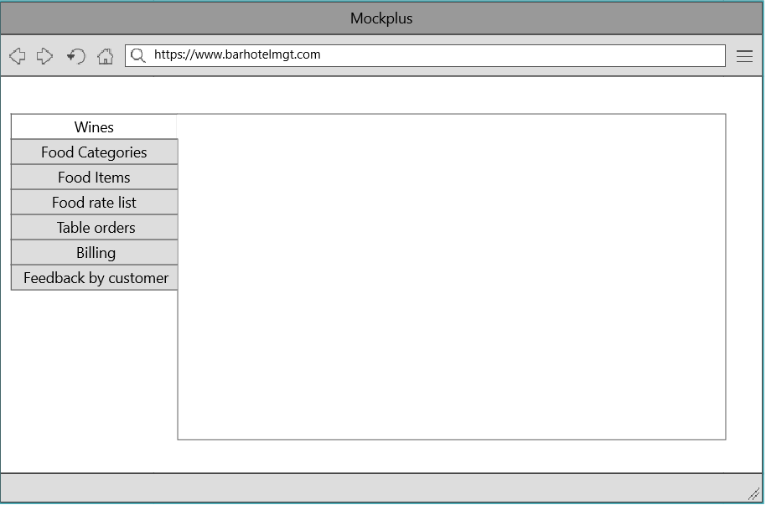

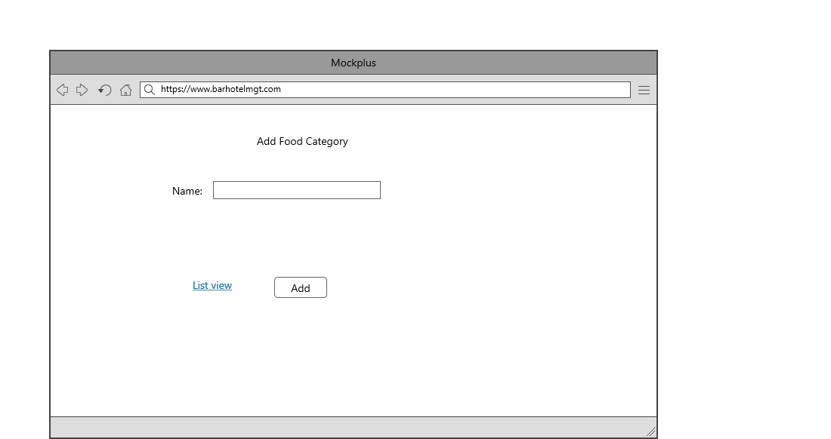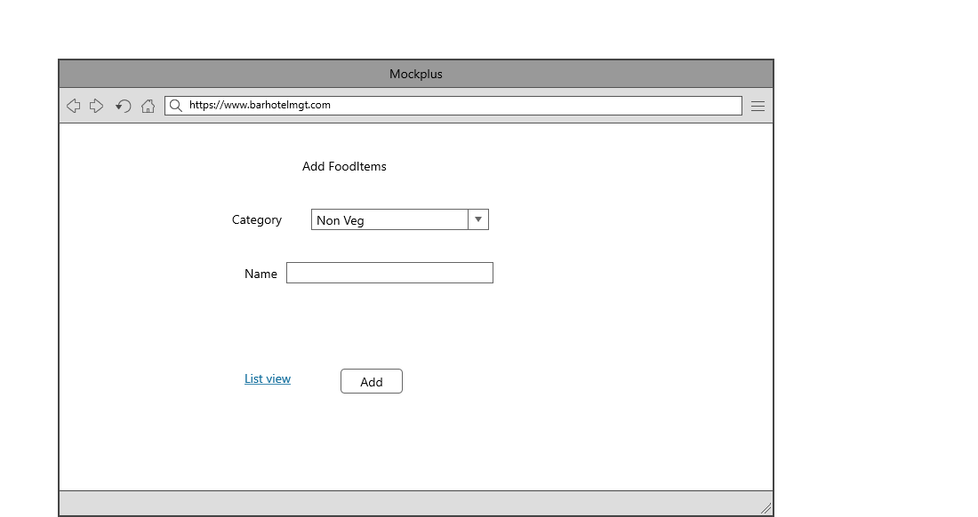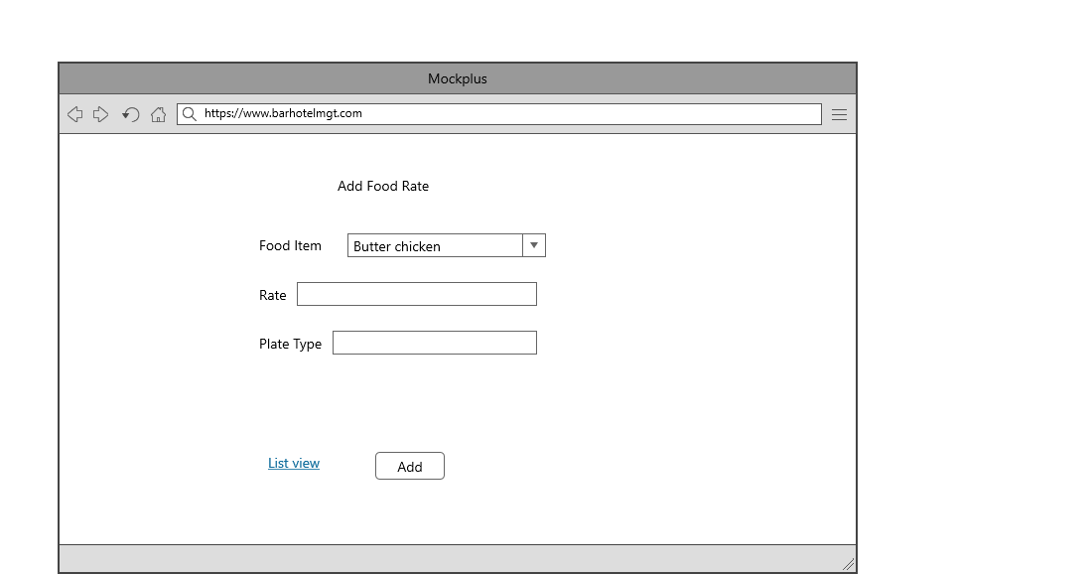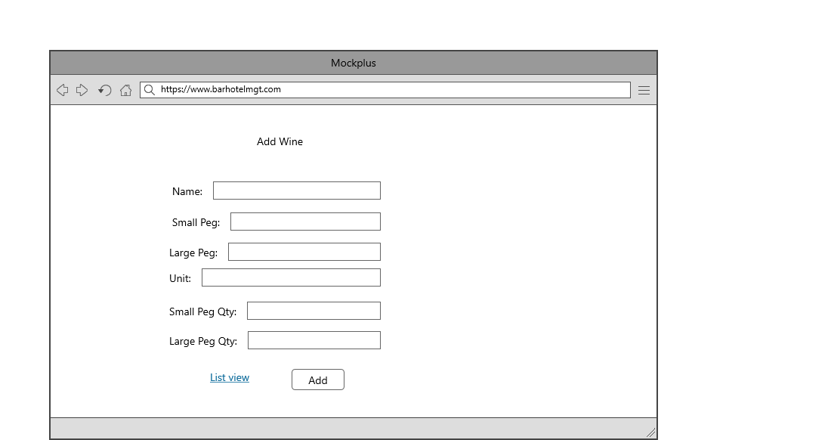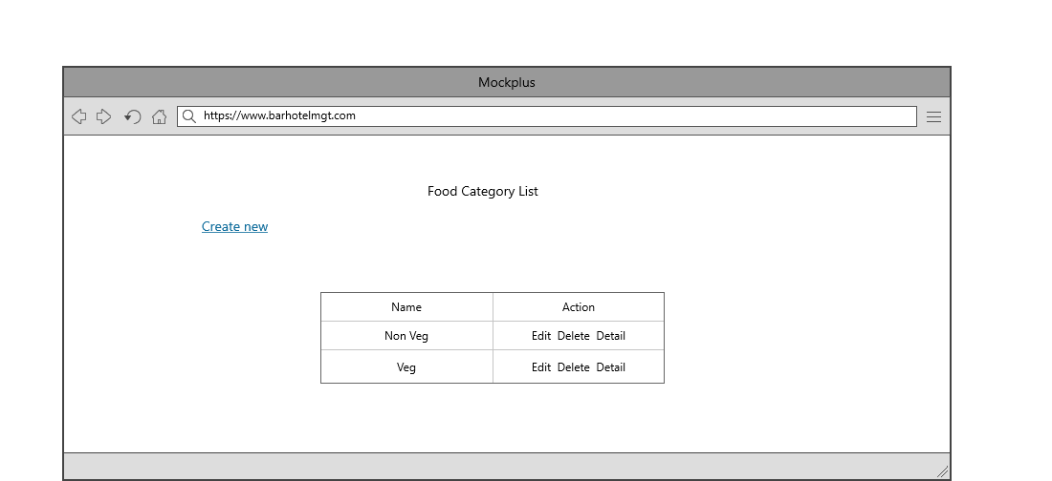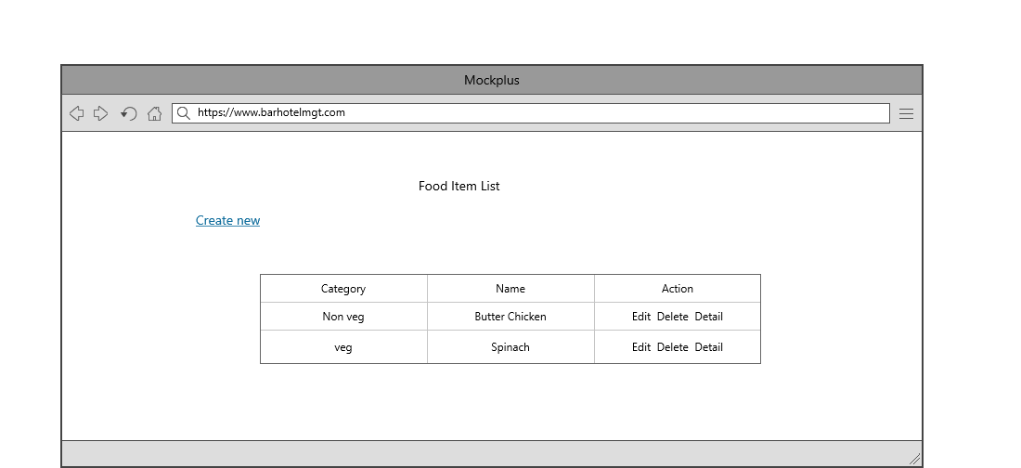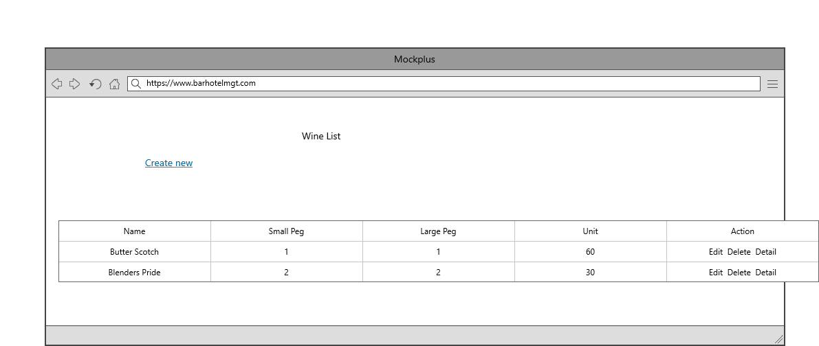

|  |  |  |
| --- | --- | --- |
| **Colour Schemes** | | |
| **Module** | **Colour code** | **Colour** |
| Login form | #343a40, #fff | Light black and white |
| Top Bar | #343a40, #fff | Light black and white |
| Side menu bar | #343a40, #fff,#fffff80 | Light black, white,shaded white |
| Body content | #fff, #212529 | White and black |

## Task 5- usability testing

|  |  |  |  |  |  |
| --- | --- | --- | --- | --- | --- |
| **User #** | **Login form** | **Food Category form** | **Food Items Module** | **Pass / Fail / Not executed / Suspended** | **Reviews** |
| Balraj | Login form is impressive. We pass this module. | Food category module is build as expected. This module is also pass. | Food items module’ functionality is also perfect. So I pass it. | Pass | All modules are ok |
| Babal | might be more attractive. But I pass it | This page’s functionality is as expected. I pass it. | Food items page is working as expected. I pass it | Pass | Login form should be more attractive |
| Kanwar | Login form is looking good. So I pass it | This page should more attractive. But I pass it. | This page functionality is good. So I pass it. | Pass | all modules are as expected |

**Task 6 - Meet with your client**

Client Meeting:

|  |
| --- |
| Meeting Details |
| * Date and time: 25-Oct-2021 * Location: Newzealand |
| Attendees: Babal and Balraj |
| Agenda: Discussion of Software of Bar & Hotel System |
| Discussion (Important Points): He wants neat and clean software which will work effectively |
| My To Dos (Actions): Firstly I have to make the mockups of the application. Then Starting the application after the next meeting. |
| Questions requiring Follow- Up: Discussion of the mock ups |
| Comments: Balraj is good person and he described regarding software very wisely. |
| Next meeting  Date and Time: 1- Nov-2021 1:00 Pm  Location: Newzealand  Agenda: Showing the mock ups to the client and discussion about further development. |

**Client Review Form:-**

**Appendix 3**

**Client Review Form**

My developer’s name: Babal

This form is intended to let you review the communication skills of your developer for this assignment. Your review will partly count towards their final mark. Do not take into account technical skills.

# Grading scale

You must grade your developer for each item listed in the tables below. 1 being the lowest, 5 the highest.

|  |  |  |  |  |
| --- | --- | --- | --- | --- |
| **1** | **2** | **3** | **4** | **5** |
| Strongly disagree | Disagree | Ok | Agree | Strongly agree |

# Review your developer

|  |  |  |
| --- | --- | --- |
| **Item** | **Grade** | **Comment** |
| Communicated clearly and effectively | 5 |  |
| Kept you informed of the progress | 4 |  |
| Met timelines | 3 |  |
| Responded promptly to problems | 2 |  |
| Met overall project objectives | 5 |  |
| Was open to new ideas and suggestions | 3 |  |
| Was easy to work with | 3 |  |

Comments

Provide any extra comments on your developer’s communication skills and professionalism.

Babal is good person and he has good knowledge of coding.

## Signed by Client

|  |  |
| --- | --- |
| **Signature: Balraj** | **Date: 14-nov-2021** |
| **Name:Balraj** | **Title:Bar & Hotel System** |
| **Contact details (email/Tel):** | |

**Task 8 - Software development life cycle stages**

**Planning :-** Before we even begin with the planning stage, the best tip we can give you is to take time and acquire proper understanding of app development life cycle. It helps to define the problem and scope of any existing systems, as well as determine the objectives for their new systems.

**Requirement :-** During this phase, all the relevant information is collected from the customer to develop a product as per their expectation. Any ambiguities must be resolved in this phase only. Business analyst and Project Manager set up a meeting with the customer to gather all the information like what the customer wants to build, who will be the end-user, what is the purpose of the product.

**Software Design and prototyping :-**

In this phase, the requirement gathered in the SRS document is used as an input and software architecture that is used for implementing system development is derived.

Screen shots

Login Page

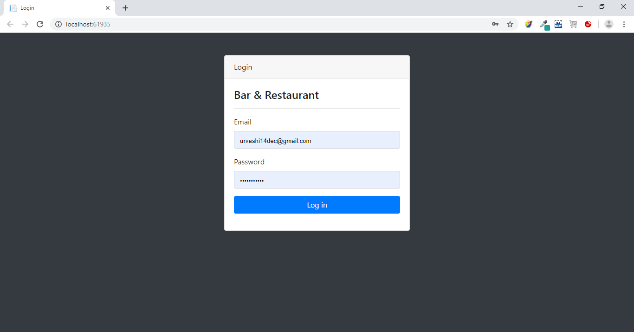

Dashboard Landing Page

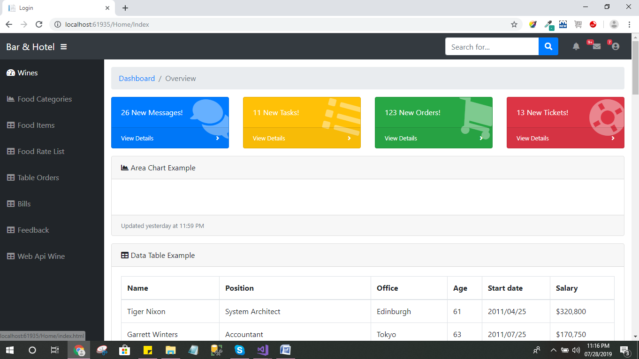

Wine List

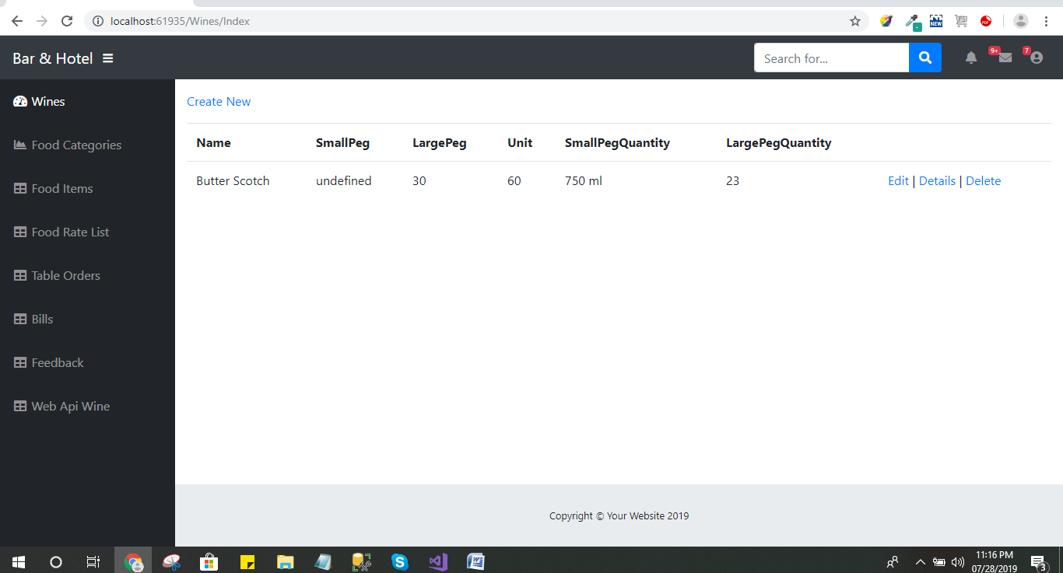

Create Wine Record

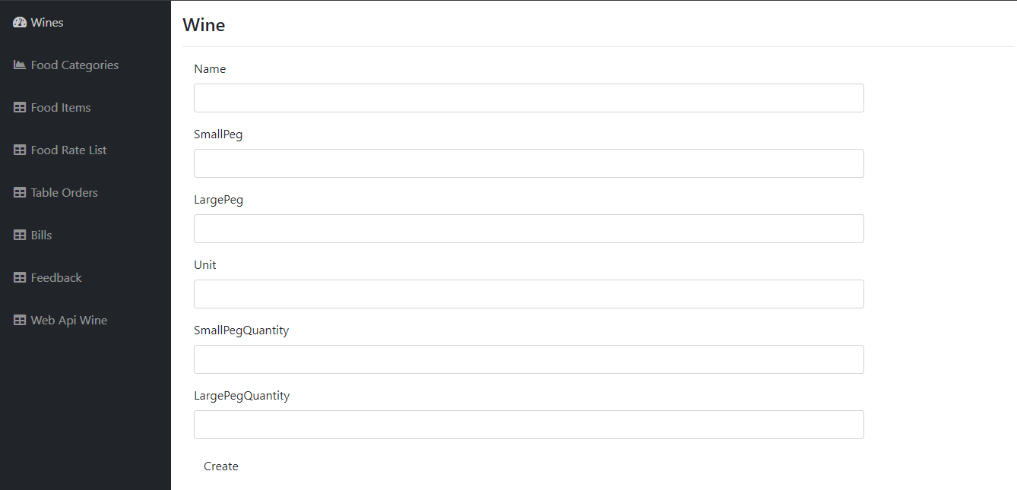

Food Category List

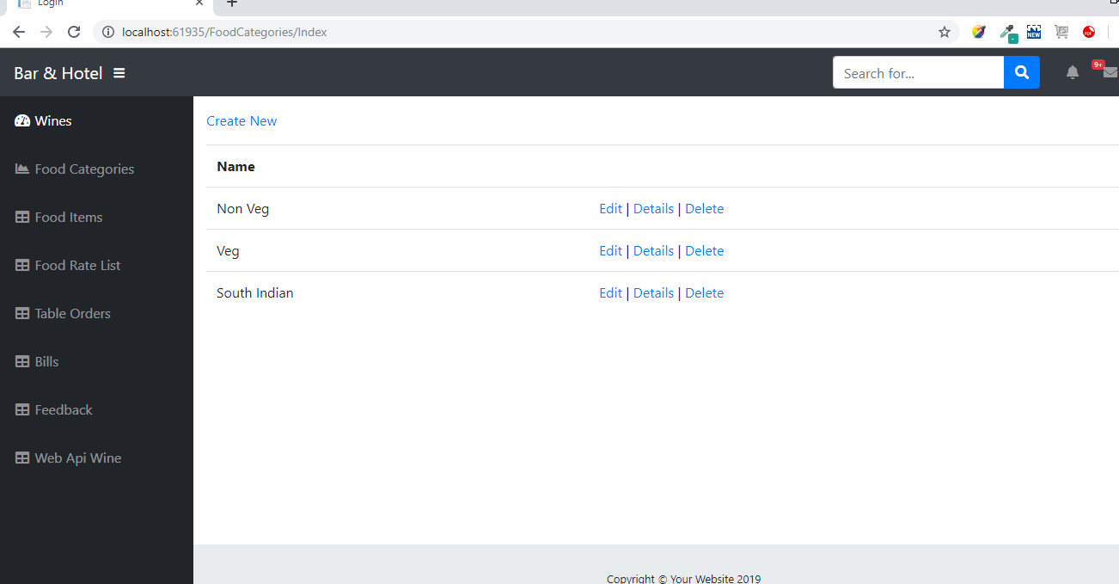

Create Food Category

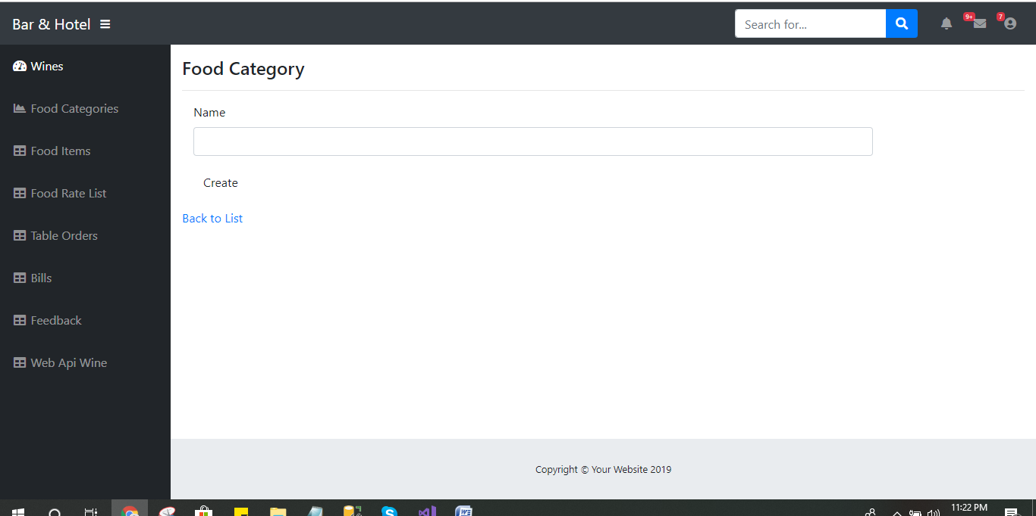

Food Item List

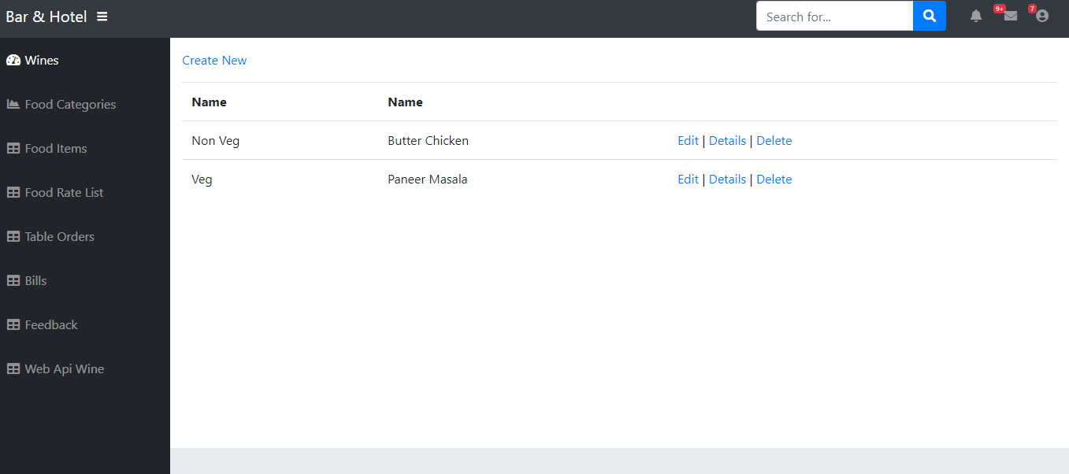

Create Food Item

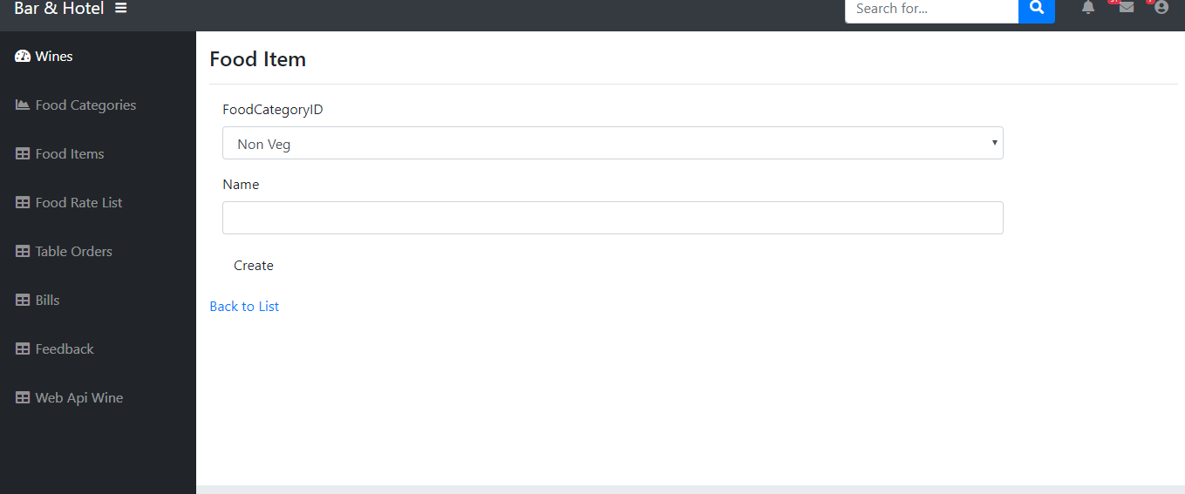

Food Rate List

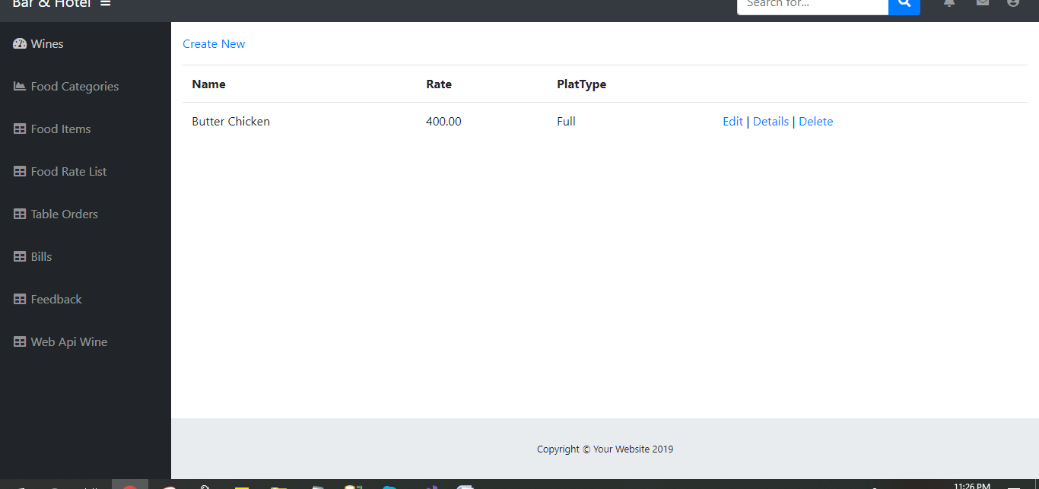

Add New Food Rate

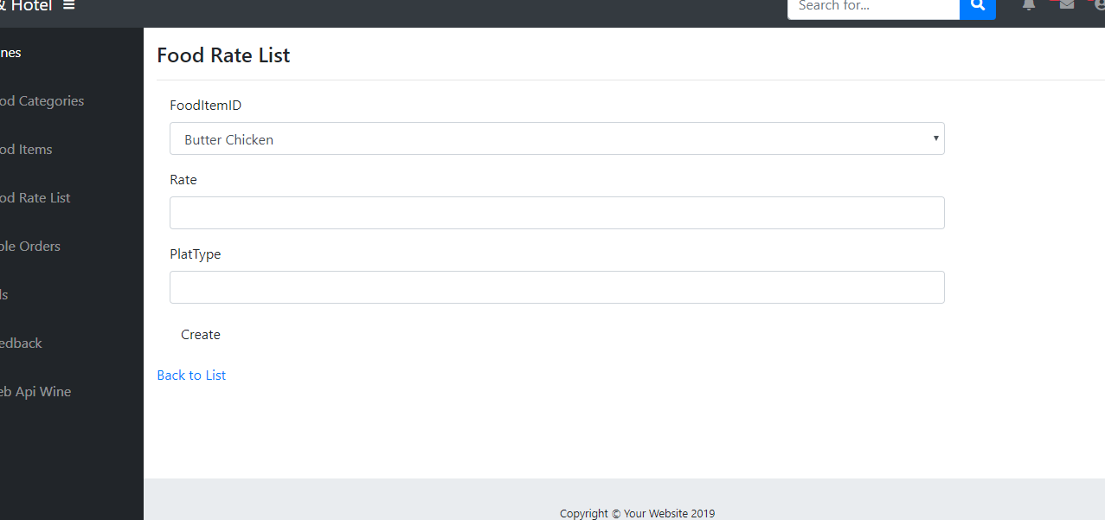

Table Order List

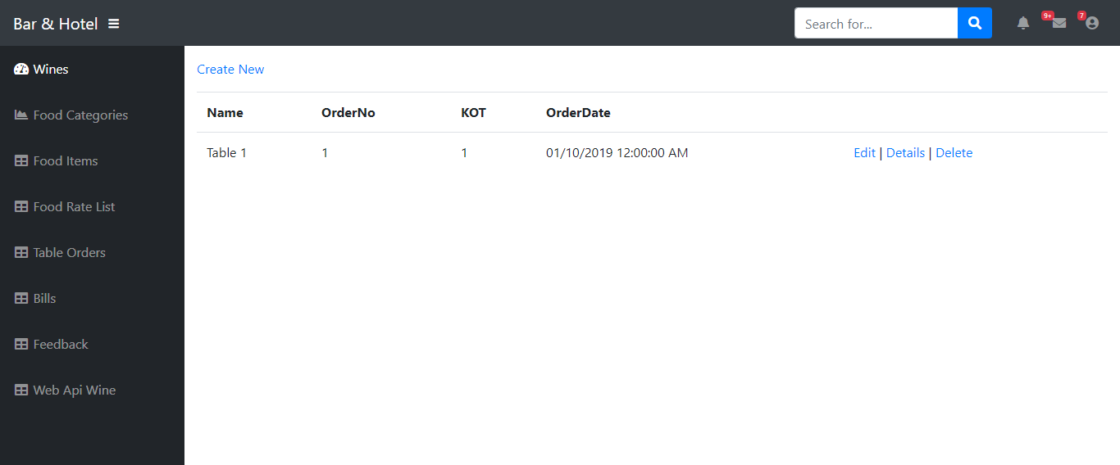

Save Table Order

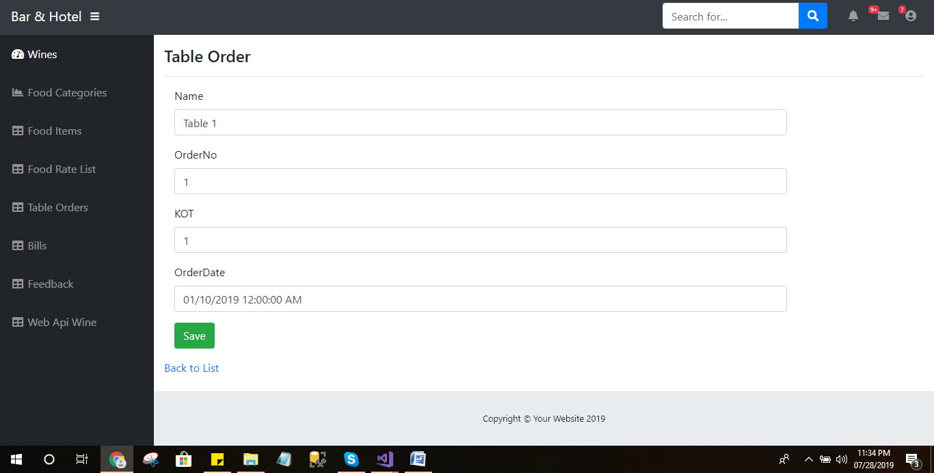

Details of Table Order

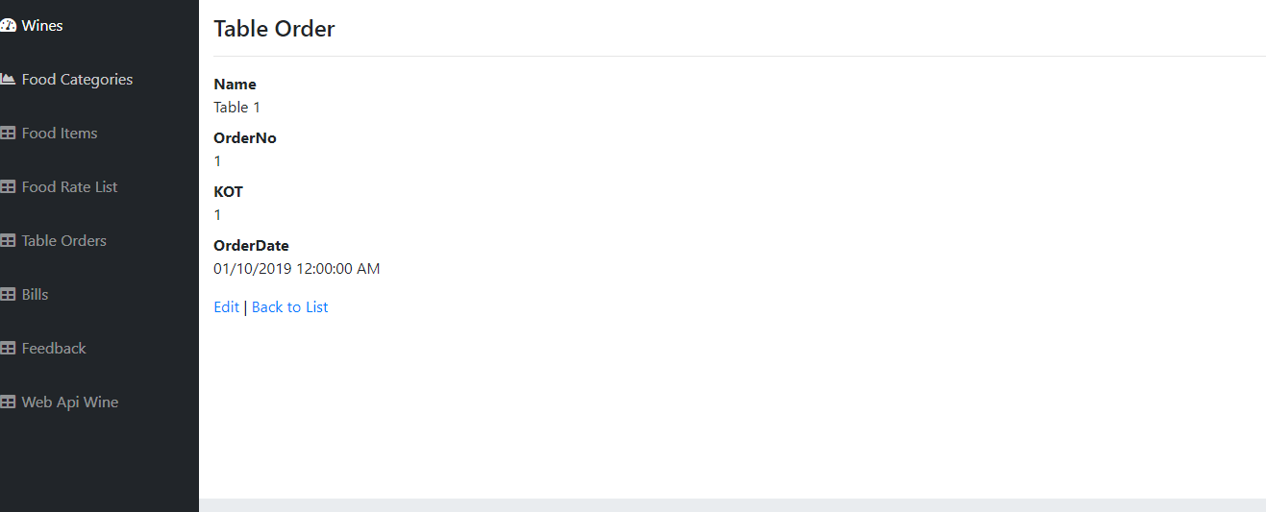

Delete Table Order

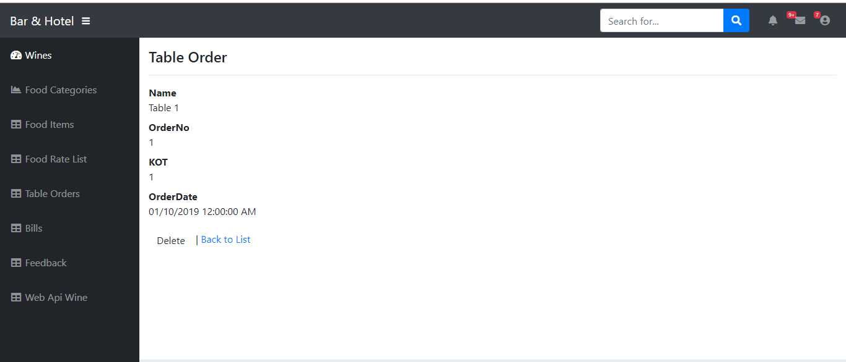

Bill List

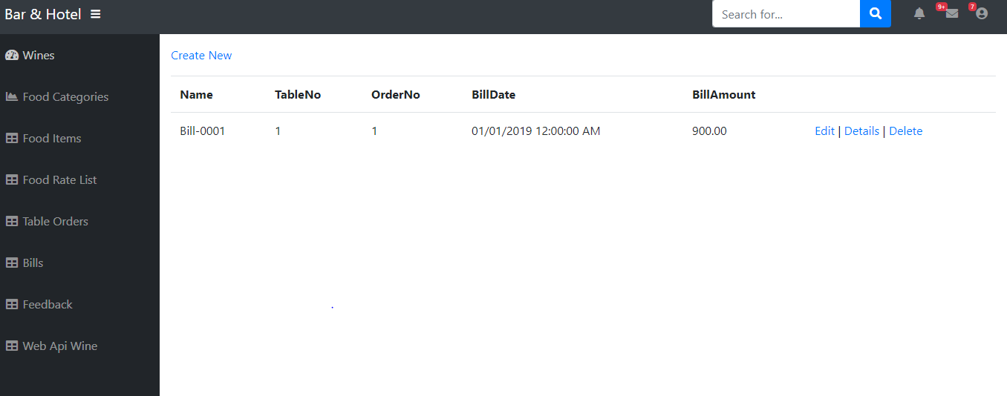

Create Bill

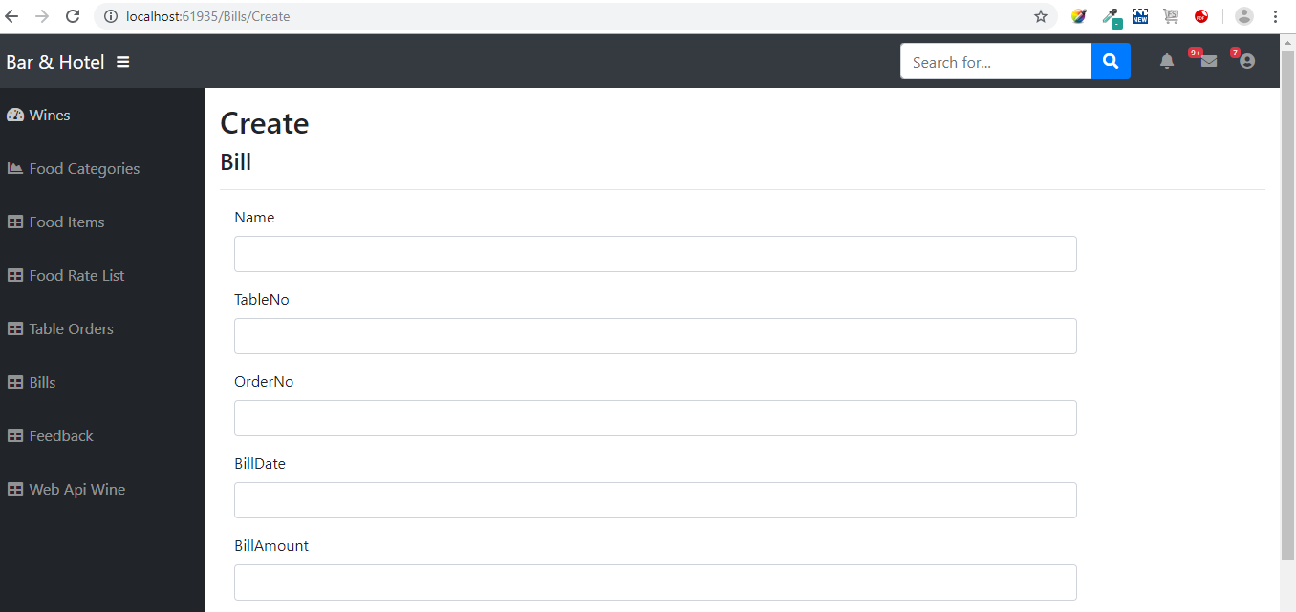

Create Bill

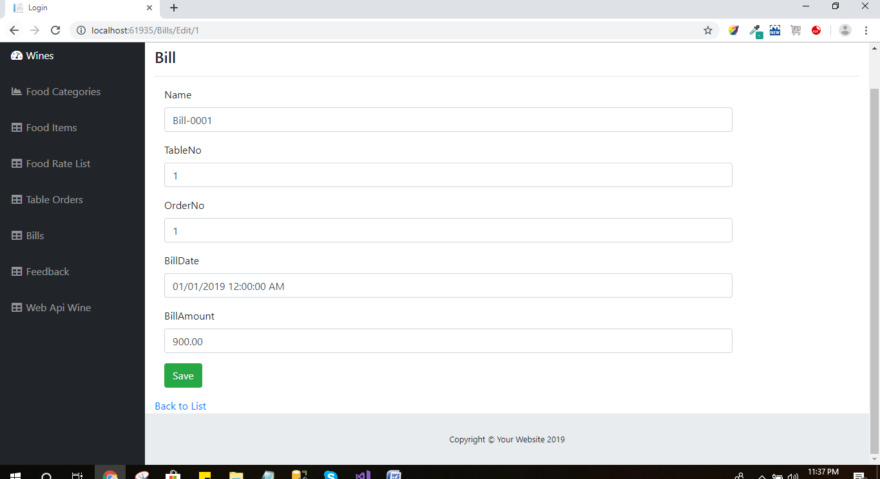

Bill Detail

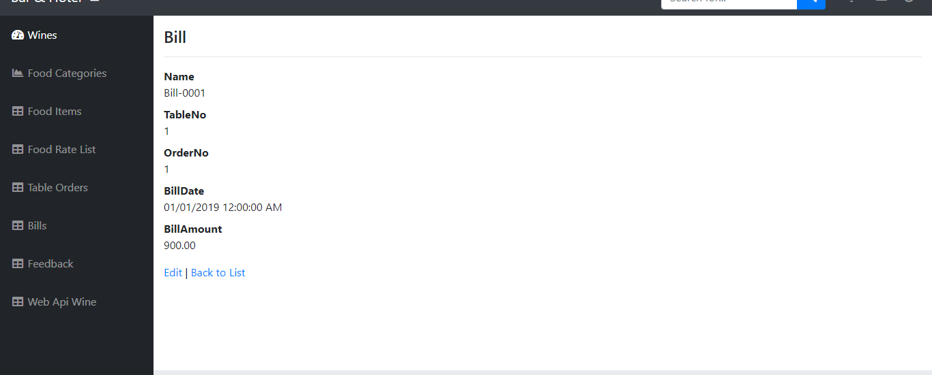

Delete Bill

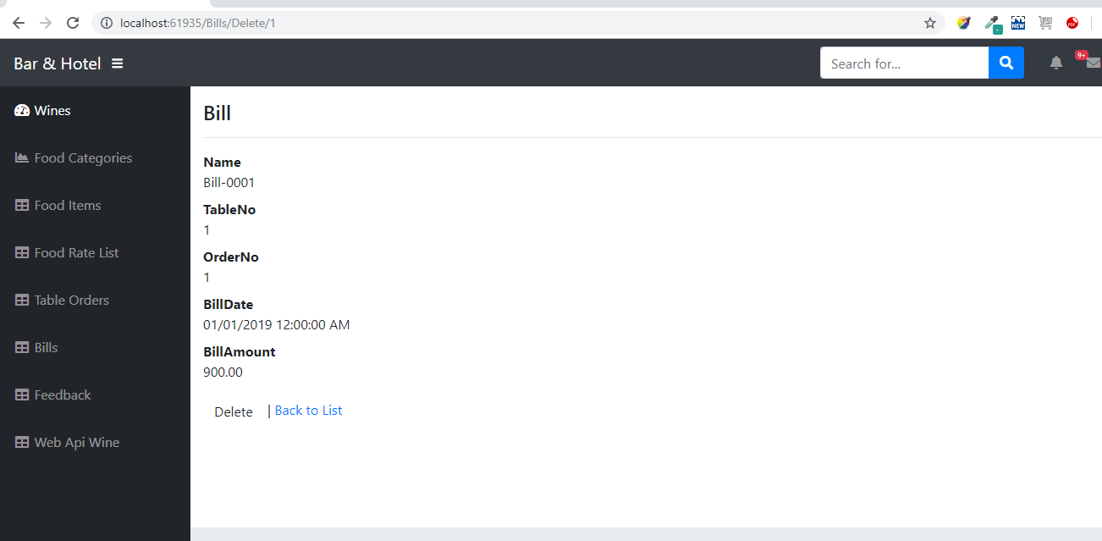

Feedback List

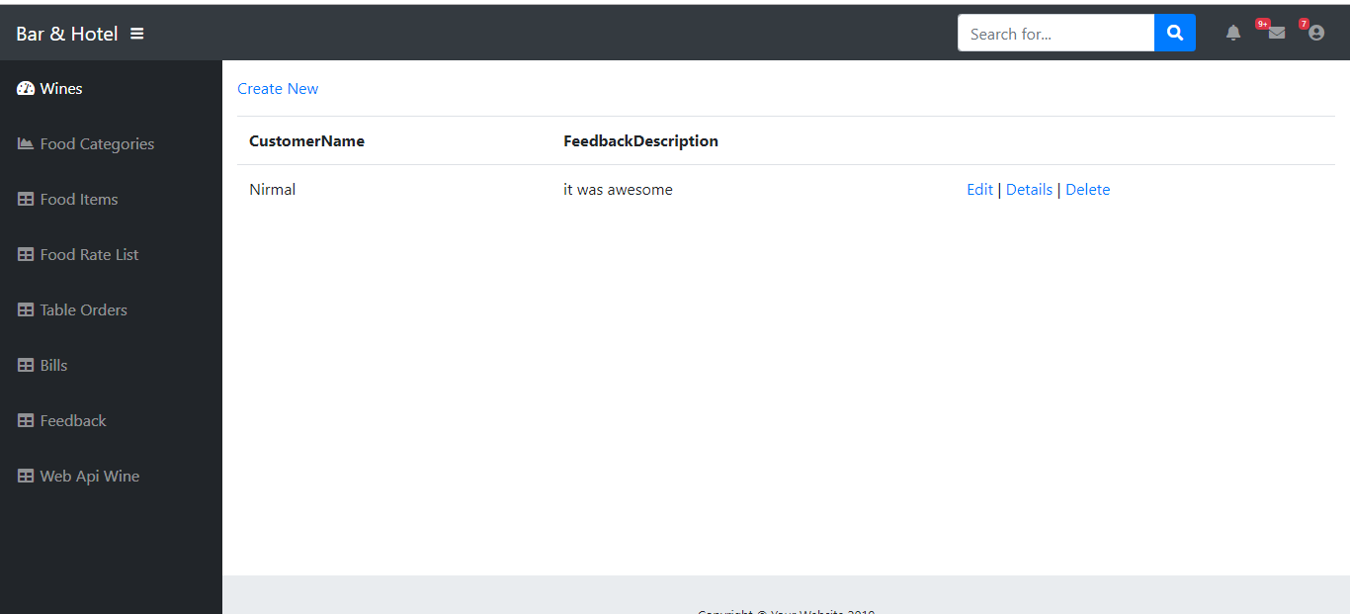

Customer Feedback Creation

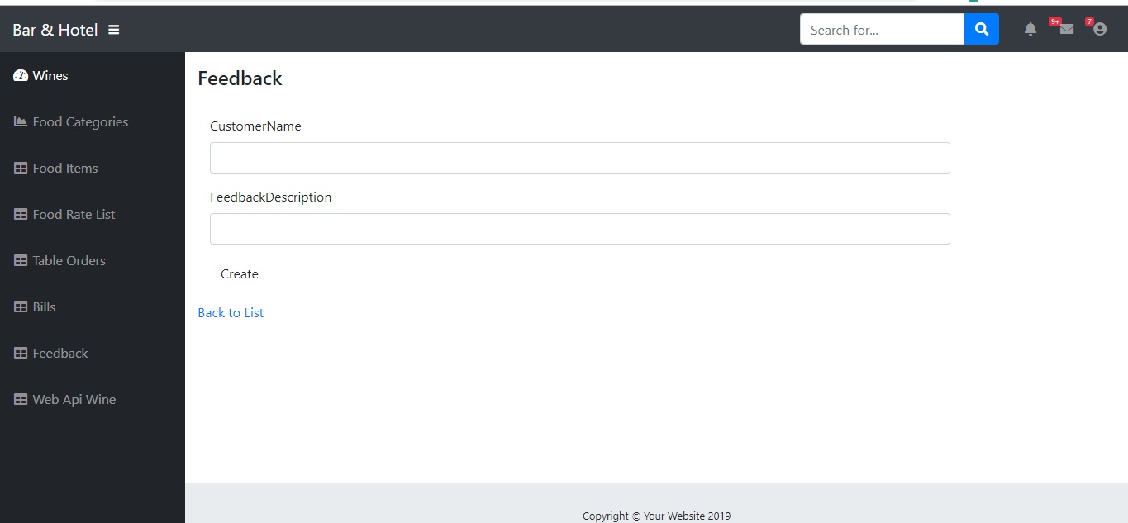

Show details of Customer Feedback

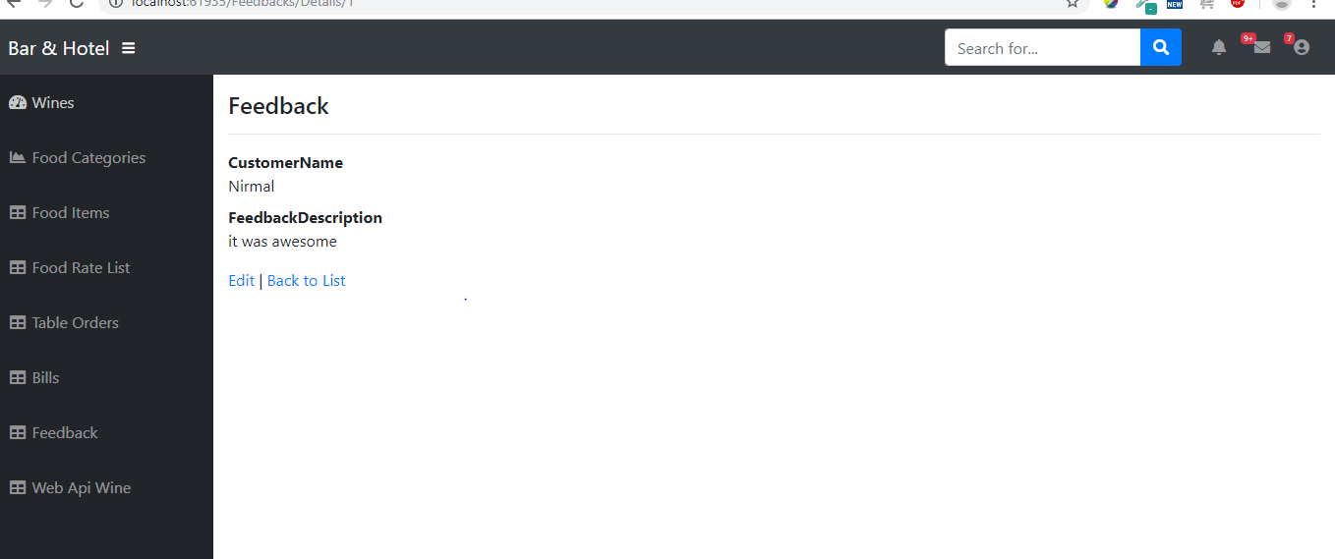

Delete Feedback

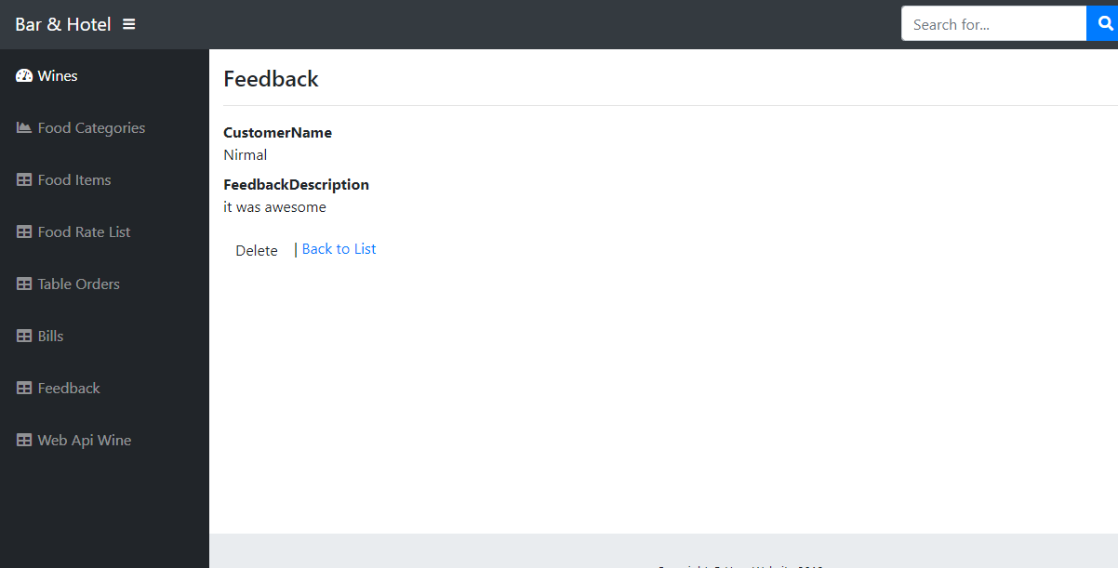

Web Api of Wine (Insert Update Delete Read Operations)

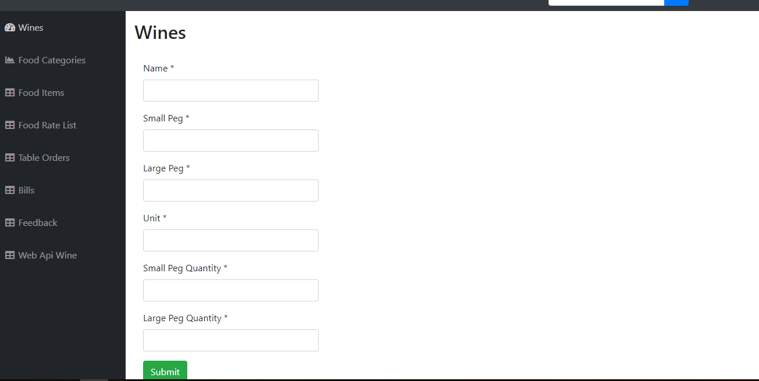

Wine List with Web APi

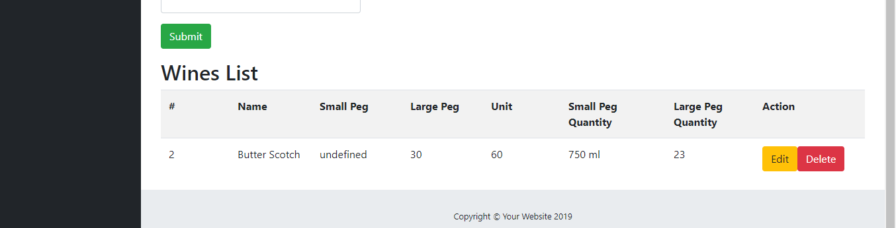

**CONTROLLERS**

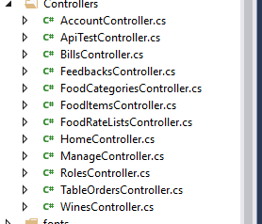

**MODELS**

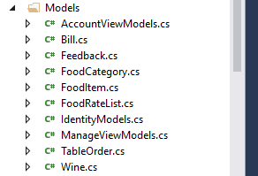

WEB API CONTROLLER

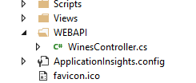

**SOFTWARE DEVELOPMENT AND CODING**

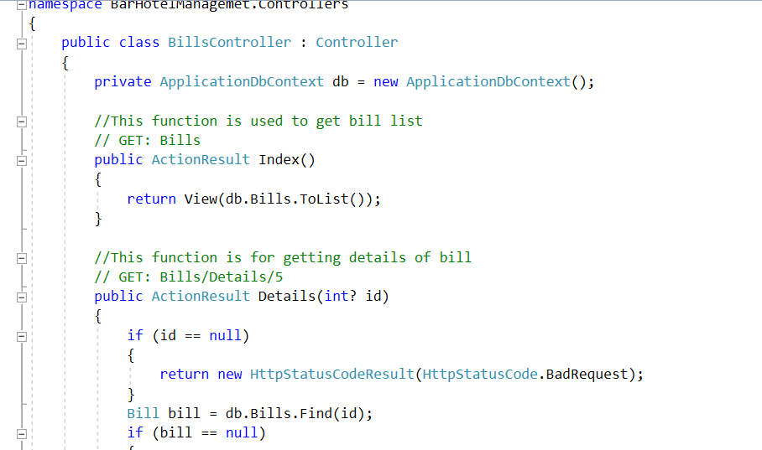

**Testing:-** Testing starts once the coding is complete and the modules are released for testing. In this phase, the developed software is tested thoroughly and any defects found are assigned to developers to get them fixed.

**Task 9- Project management**

**Major Successes:-** The major success of this project is add identity in the project. with the help of identity I have created the identity tables for login and logout. I have created tables after thinking the client requirement. so these are also the best part of my success to create full project on myself. after taking the requirements from the client to divide the project into modules. it is also best part which i have learnt. So I am very thankful to my teachers who have given this kind of project because i have learnt so many things from this project and got many successes.

**Weaknesses:-** The major weaknesses in this project when i was creating table structure of the project. So on that time i had to think about the tables of this project how it will be efficient for the project. So that process has taken to much time for thinking. In this process I have spent 4 5 days. after that i was able to deciding the project structure. When I was thinking about the design so it was also difficult for me to finalise the design its also time taken process. when we create the design then its also tough section to satisfy the client with the design. we have to make our client satisfy with the design otherwise he can find many mistakes in this part. So its also very time taken process in the project.

**Lesson learned:-** In this project i have learned so many lessons. like how to implement our logics in the code and how to make the full project with the client requirements. So main part of client interaction is the best part. So in future I can easily manage to interact with client and easily work with software company. I have also learnt identity part in the mvc project. because I have used identity for making the login logout forms. which makes code very easy. I have learnt how to use foreign key in the project and how to bind it in another form with drop down list or and tool from html. Basically the main part of this project I have created full project on myself. through this process i have learnt so many things which will be very helpful in the future.