**PROJECT**

TRAFFIC MANAGEMENT SYSTEM

TEAM NAME:

Project-212981-Team-1

**Traffic Management System**

# **Problem Statement**

The traffic management system is a comprehensive solution designed to tackle the challenges of congestion, improve traffic flow, and enhance overall transportation efficiency. In order to develop and implement such a system, a thorough understanding and analysis of the problem are necessary.

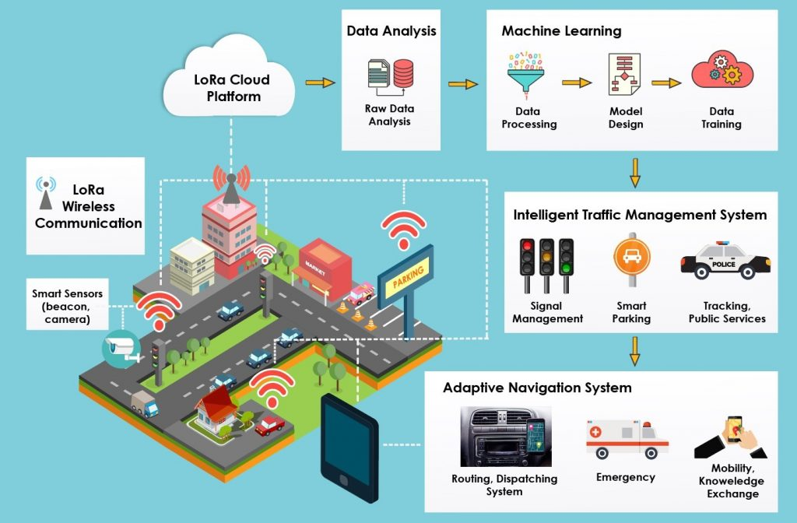

## **Design Thinking**

* **Empathize:** This phase involves putting yourself in the shoes of traffic users, authorities, and stakeholders to understand their needs, frustrations, and aspirations. By gathering data through surveys, interviews, and observations, you can develop a deeper understanding of the issues at hand.
* **Define**: Once you have empathized with the various stakeholders, it is crucial to define the problem statement clearly and concisely. This step involves identifying the specific pain points, bottlenecks, and inefficiencies in the existing traffic management system. It also includes setting measurable goals and objectives for the proposed solution.
* **Ideate:** In the ideation phase, you generate a wide range of ideas to address the identified problem. Stakeholders, traffic experts, and technology specialists come together to brainstorm potential solutions. This creative process encourages out-of-the-box thinking and fosters innovation.
* **Prototype:** After ideation, select the most promising ideas and develop prototypes or mock-ups to visually represent the proposed solution. These prototypes serve as tangible examples that showcase the functionality, features, and potential benefits of the system. Prototyping allows for early validation and feedback from stakeholders, which helps refine the concept before moving forward.
* **Test:** Testing is a critical phase where the prototypes are evaluated, refined, and validated. It involves rigorous real-world simulations, controlled experiments, and pilot projects to assess the effectiveness, feasibility, and practicality of the proposed traffic management system. Testing helps identify any shortcomings, challenges, or unintended consequences, enabling further improvements and adjustments to be made.

# **Conclusion**

By following this user-centred design approach, the traffic management system can be developed iteratively, ensuring that it achieves its intended goals and meets the needs of all stakeholders. It is an ongoing process that requires continuous evaluation and optimization to cope with the changing dynamics and complexities of transportation systems.