- System-wide Gross NPA ratio by year
SELECT
Year,
Financial_Year,
ROUND(SUM(Gross_NPA_Cr) / SUM(Gross_Advances_Cr) * 100, 2) AS system_wide_npa_ratio_pct
FROM bank_npa_analytics.bank_npa
GROUP BY Year, Financial_Year
ORDER BY Year;
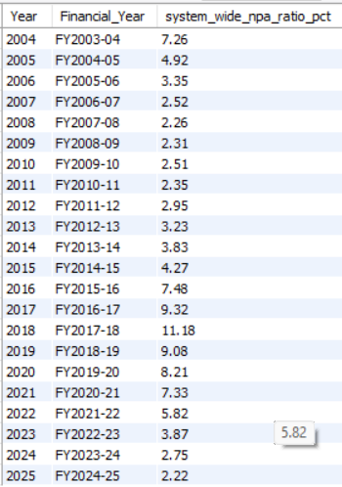
Q2 — Average Gross NPA ratio by bank_group, by year (CTE)
SELECT Year, Financial_Year, bank_group,
AVG(Gross_NPA_Ratio_Pct) AS avg_ratio_simple,
SUM(Gross_NPA_Cr) / SUM(Gross_Advances_Cr) * 100 AS weighted_ratio
FROM bank_npa_analytics.bank_npa
WHERE bank_group IN ('PUBLIC SECTOR BANKS', 'PRIVATE SECTOR BANKS')
GROUP BY Year, Financial_Year, bank_group
ORDER BY Year, bank_group;
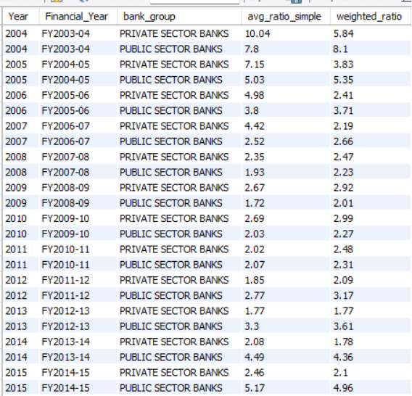
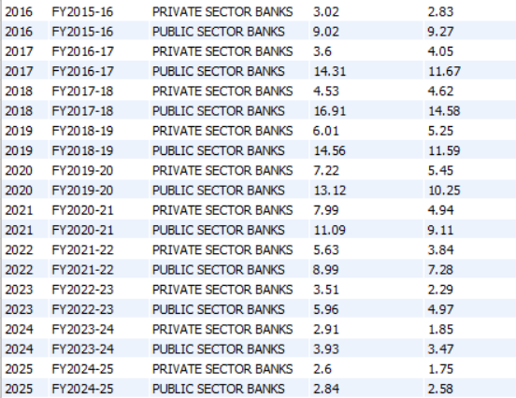

Q3 — Which individual banks have the highest Gross NPA ratio in the most recent year
USE bank_npa_analytics;
SELECT
bank_name,
bank_group,
Gross_NPA_Ratio_Pct,
RANK() OVER (ORDER BY Gross_NPA_Ratio_Pct DESC) AS npa_rank
FROM bank_npa
WHERE Year = (SELECT MAX(Year) FROM bank_npa)
AND bank_group IN ('PUBLIC SECTOR BANKS', 'PRIVATE SECTOR BANKS')
ORDER BY npa_rank
LIMIT 10;
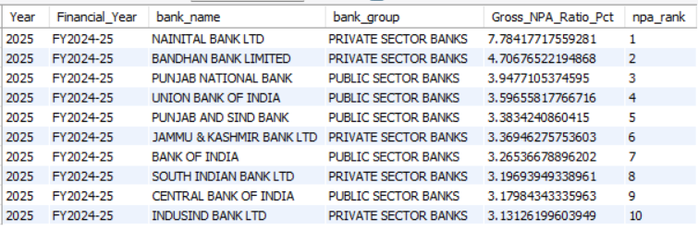

Q4 — Year-over-year change in Gross NPA ratio per bank, using LAG()
WITH yoy AS (
SELECT
bank_name,
bank_group,
Year,
Gross_NPA_Ratio_Pct,
LAG(Gross_NPA_Ratio_Pct) OVER (PARTITION BY bank_name ORDER BY Year) AS prev_year_ratio,
Gross_NPA_Ratio_Pct - LAG(Gross_NPA_Ratio_Pct) OVER (PARTITION BY bank_name ORDER BY Year) AS ratio_change_pp
FROM bank_npa
WHERE bank_group IN ('PUBLIC SECTOR BANKS', 'PRIVATE SECTOR BANKS')
)
SELECT bank_name, bank_group, Year, Gross_NPA_Ratio_Pct, ROUND(ratio_change_pp, 2) AS ratio_change_pp
FROM yoy
WHERE Year >= (SELECT MAX(Year) FROM bank_npa) - 2
AND ratio_change_pp IS NOT NULL
ORDER BY ratio_change_pp DESC
LIMIT 10;
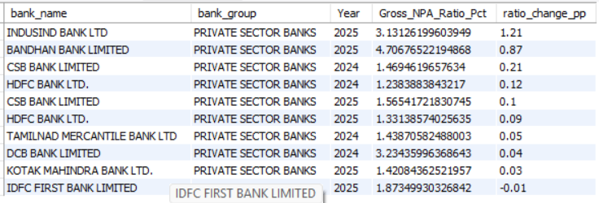

Q5 — % of total system-wide Gross NPA concentrated in the top 3 banks, most recent year
WITH ranked AS (
SELECT
bank_name,
Gross_NPA_Cr,
RANK() OVER (ORDER BY Gross_NPA_Cr DESC) AS npa_rank
FROM bank_npa
WHERE Year = (SELECT MAX(Year) FROM bank_npa)
AND bank_group IN ('PUBLIC SECTOR BANKS', 'PRIVATE SECTOR BANKS')
)
SELECT
ROUND(SUM(CASE WHEN npa_rank <= 3 THEN Gross_NPA_Cr ELSE 0 END) / SUM(Gross_NPA_Cr) * 100, 2) AS top3_concentration_pct
FROM ranked;
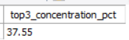

-- Q6 — NTILE(4) risk quartile per year, worst quartile banks in the latest year
WITH quartiles AS (
SELECT
Year,
bank_name,
bank_group,
Gross_NPA_Ratio_Pct,
NTILE(4) OVER (PARTITION BY Year ORDER BY Gross_NPA_Ratio_Pct DESC) AS risk_quartile
FROM bank_npa
WHERE bank_group IN ('PUBLIC SECTOR BANKS', 'PRIVATE SECTOR BANKS')
)
SELECT bank_name, bank_group, Gross_NPA_Ratio_Pct, risk_quartile
FROM quartiles
WHERE Year = (SELECT MAX(Year) FROM bank_npa)
AND risk_quartile = 1
ORDER BY Gross_NPA_Ratio_Pct DESC;
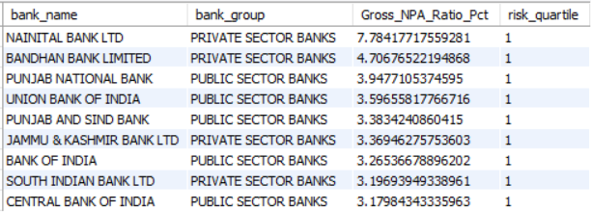

Q7 — PSU-Private gap trend, year by year,
WITH group_ratio AS ( SELECT Year,
bank_group,
SUM(Gross_NPA_Cr) / SUM(Gross_Advances_Cr) * 100 AS weighted_ratio
FROM bank_npa
WHERE bank_group IN ('PUBLIC SECTOR BANKS', 'PRIVATE SECTOR BANKS')
GROUP BY Year, bank_group
),
pivoted AS ( SELECT Year, MAX(CASE WHEN bank_group = 'PUBLIC SECTOR BANKS' THEN weighted_ratio END) AS psu_ratio,
MAX(CASE WHEN bank_group = 'PRIVATE SECTOR BANKS' THEN weighted_ratio END) AS private_ratio
FROM group_ratio
GROUP BY Year
)
SELECT
Year,
ROUND(psu_ratio, 2) AS psu_ratio,
ROUND(private_ratio, 2) AS private_ratio,
ROUND(psu_ratio - private_ratio, 2) AS psu_private_gap_pp
FROM pivoted
ORDER BY Year;
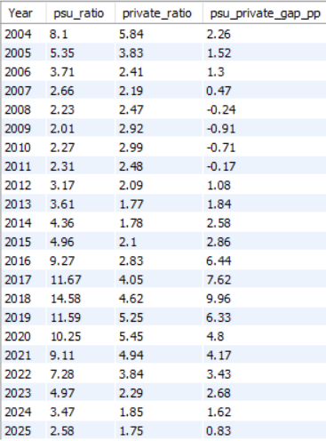

8. Structurally weak banks: worst-3 in ≥5 of the last 10 years
WITH ranked AS (
SELECT
Year,
bank_name,
bank_group,
RANK() OVER (PARTITION BY Year ORDER BY Gross_NPA_Ratio_Pct DESC) AS yearly_rank
FROM bank_npa
WHERE bank_group IN ('PUBLIC SECTOR BANKS', 'PRIVATE SECTOR BANKS')
AND Year >= (SELECT MAX(Year) FROM bank_npa) - 9
),
worst3_counts AS (
SELECT
bank_name,
COUNT(*) AS years_in_worst3
FROM ranked
WHERE yearly_rank <= 3
GROUP BY bank_name
)
SELECT bank_name, years_in_worst3
FROM worst3_counts
WHERE years_in_worst3 >= 5
ORDER BY years_in_worst3 DESC;
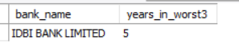

10. Merger impact: pre- vs post-merger combined-entity comparison (Discontinuation approach note)
SELECT
bank_name,
MIN(Year) AS first_year_observed,
MAX(Year) AS last_year_observed,
COUNT(*) AS years_observed
FROM bank_npa
WHERE bank_group = 'PUBLIC SECTOR BANKS'
AND bank_name IN (
'ORIENTAL BANK OF COMMERCE', 'UNITED BANK OF INDIA', 'SYNDICATE BANK',
'ALLAHABAD BANK', 'ANDHRA BANK', 'CORPORATION BANK', 'DENA BANK', 'VIJAYA BANK'
)
GROUP BY bank_name
ORDER BY last_year_observed DESC;
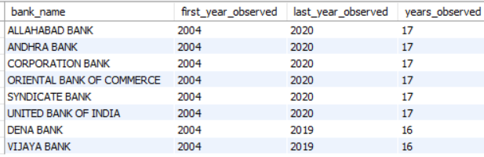

9. Average Gross Advances (loan-book size): top-NPA-quartile vs bottom-NPA-quartile banks
WITH quartiles AS (
SELECT
Year,
bank_name,
bank_group,
Gross_NPA_Ratio_Pct,
Gross_Advances_Cr,
NTILE(4) OVER (PARTITION BY Year ORDER BY Gross_NPA_Ratio_Pct DESC) AS risk_quartile
FROM bank_npa
WHERE bank_group IN ('PUBLIC SECTOR BANKS', 'PRIVATE SECTOR BANKS')
AND Year = (SELECT MAX(Year) FROM bank_npa)
)
SELECT
CASE WHEN risk_quartile = 1 THEN 'Top (worst ratio) quartile'
WHEN risk_quartile = 4 THEN 'Bottom (best ratio) quartile'
ELSE 'Middle' END AS quartile_label,
ROUND(AVG(Gross_Advances_Cr), 0) AS avg_advances_cr,
COUNT(*) AS n_banks
FROM quartiles
WHERE risk_quartile IN (1, 4)
GROUP BY quartile_label;
Top (worst ratio) quartile 387949 9
Bottom (best ratio) quartile 737011 8
11. Risk-tier CTE: % of total system-wide Gross Advances in the highest-risk tier, by year
WITH quartiles AS (
SELECT
Year,
bank_name,
Gross_Advances_Cr,
NTILE(4) OVER (PARTITION BY Year ORDER BY Gross_NPA_Ratio_Pct DESC) AS risk_quartile
FROM bank_npa
WHERE bank_group IN ('PUBLIC SECTOR BANKS', 'PRIVATE SECTOR BANKS')
)
SELECT
Year,
ROUND(SUM(CASE WHEN risk_quartile = 1 THEN Gross_Advances_Cr ELSE 0 END) / SUM(Gross_Advances_Cr) * 100, 2) AS pct_advances_in_highest_risk_tier
FROM quartiles
GROUP BY Year
ORDER BY Year;
2004 14.1
2005 13.24
2006 10.05
2007 8.05
2008 44.06
2009 36.97
2010 33.05
2011 38.22
2012 38.75
2013 41.59
2014 41.48
2015 23.16
2016 37.08
2017 15.08
2018 20.31
2019 21.17
2020 20.03
2021 22.22
2022 22.73
2023 21.04
2024 24.23
2025 18.82

12. each bank's percentage-point gap from that year's system-wide benchmark, ranked
WITH yearly_benchmark AS (
SELECT Year, AVG(Gross_NPA_Ratio_Pct) AS benchmark_ratio
FROM bank_npa
WHERE bank_group IN ('PUBLIC SECTOR BANKS', 'PRIVATE SECTOR BANKS')
GROUP BY Year
)
SELECT
b.bank_name,
b.bank_group,
b.Year,
b.Gross_NPA_Ratio_Pct,
ROUND(yb.benchmark_ratio, 2) AS year_benchmark,
ROUND(b.Gross_NPA_Ratio_Pct - yb.benchmark_ratio, 2) AS gap_from_benchmark_pp,
RANK() OVER (ORDER BY (b.Gross_NPA_Ratio_Pct - yb.benchmark_ratio) DESC) AS gap_rank
FROM bank_npa b
JOIN yearly_benchmark yb ON b.Year = yb.Year
WHERE b.Year = (SELECT MAX(Year) FROM bank_npa)
AND b.bank_group IN ('PUBLIC SECTOR BANKS', 'PRIVATE SECTOR BANKS')
ORDER BY gap_rank
LIMIT 10;
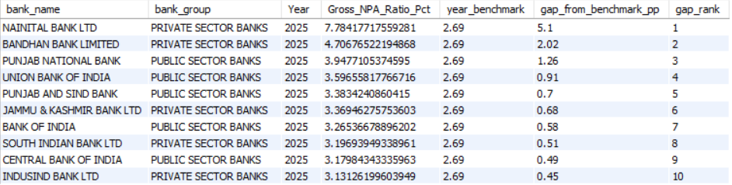

-- Q13 — Historical peak vs. current: how many pp has the system-wide ratio improved
WITH system_yearly AS (
SELECT
Year,
SUM(Gross_NPA_Cr) / SUM(Gross_Advances_Cr) * 100 AS system_ratio
FROM bank_npa
GROUP BY Year
)
SELECT
(SELECT Year FROM system_yearly ORDER BY system_ratio DESC LIMIT 1) AS peak_year,
(SELECT ROUND(system_ratio, 2) FROM system_yearly ORDER BY system_ratio DESC LIMIT 1) AS peak_ratio,
(SELECT Year FROM system_yearly ORDER BY Year DESC LIMIT 1) AS latest_year,
(SELECT ROUND(system_ratio, 2) FROM system_yearly ORDER BY Year DESC LIMIT 1) AS latest_ratio,
(SELECT ROUND(system_ratio, 2) FROM system_yearly ORDER BY system_ratio DESC LIMIT 1)
- (SELECT ROUND(system_ratio, 2) FROM system_yearly ORDER BY Year DESC LIMIT 1) AS improvement_pp;
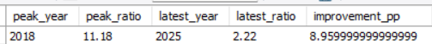

Q14 — Which bank_group is most volatile (highest YoY std dev of ratio) across the full window
WITH yoy AS (
SELECT
bank_name,
bank_group,
Year,
Gross_NPA_Ratio_Pct - LAG(Gross_NPA_Ratio_Pct) OVER (PARTITION BY bank_name ORDER BY Year) AS ratio_change_pp
FROM bank_npa
WHERE bank_group IN ('PUBLIC SECTOR BANKS', 'PRIVATE SECTOR BANKS')
)
SELECT
bank_group,
ROUND(STDDEV(ratio_change_pp), 2) AS yoy_volatility_pp,
COUNT(*) AS n_observations
FROM yoy
WHERE ratio_change_pp IS NOT NULL
GROUP BY bank_group
ORDER BY yoy_volatility_pp DESC;
PUBLIC SECTOR BANKS 2.88 466
PRIVATE SECTOR BANKS 2.38 442

15. SELECT
bank_group,
CASE
WHEN Gross_Advances_Cr < 50000 THEN 'Small (<₹50k Cr)'
WHEN Gross_Advances_Cr BETWEEN 50000 AND 300000 THEN 'Mid (₹50k-3L Cr)'
ELSE 'Large (>₹3L Cr)'
END AS size_bucket,
ROUND(AVG(Gross_NPA_Ratio_Pct), 2) AS avg_ratio,
COUNT(*) AS n_bank_years
FROM bank_npa
WHERE bank_group IN ('PUBLIC SECTOR BANKS', 'PRIVATE SECTOR BANKS')
AND Year = (SELECT MAX(Year) FROM bank_npa)
GROUP BY bank_group, size_bucket
ORDER BY bank_group, avg_ratio DESC;
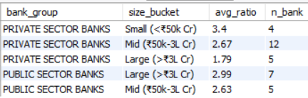

-- Q16 — All four bank groups compared, most recent year (Executive Overview "other groups" context)
SELECT
bank_group,
COUNT(*) AS n_banks,
ROUND(SUM(Gross_NPA_Cr) / SUM(Gross_Advances_Cr) * 100, 2) AS weighted_ratio,
ROUND(SUM(Gross_NPA_Cr), 0) AS total_gross_npa_cr,
ROUND(SUM(Gross_Advances_Cr), 0) AS total_advances_cr
FROM bank_npa
WHERE Year = (SELECT MAX(Year) FROM bank_npa)
GROUP BY bank_group
ORDER BY weighted_ratio DESC;
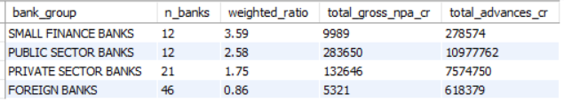

-- Q17 — Number of distinct banks per group, per year (merger/consolidation visual — SQL version of your Python bank-count table)
SELECT
Year,
bank_group,
COUNT(DISTINCT bank_name) AS n_banks
FROM bank_npa
WHERE bank_group IN ('PUBLIC SECTOR BANKS', 'PRIVATE SECTOR BANKS')
GROUP BY Year, bank_group
ORDER BY Year, bank_group;
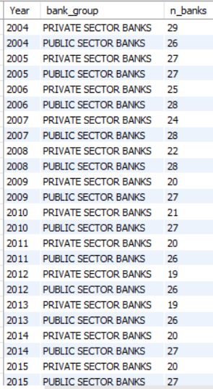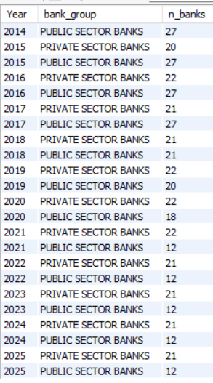

- Q18 — Best-performing banks (lowest ratio), most recent year — the mirror of Q3
SELECT
bank_name,
bank_group,
Gross_NPA_Ratio_Pct,
RANK() OVER (ORDER BY Gross_NPA_Ratio_Pct ASC) AS best_rank
FROM bank_npa
WHERE Year = (SELECT MAX(Year) FROM bank_npa)
AND bank_group IN ('PUBLIC SECTOR BANKS', 'PRIVATE SECTOR BANKS')
ORDER BY best_rank
LIMIT 10;
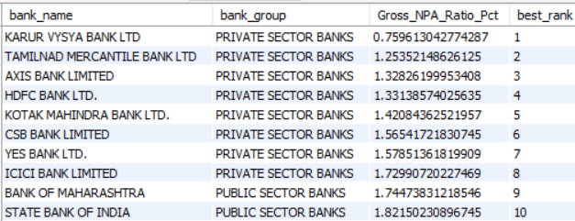
-- Q19 — IDBI Bank's full year-by-year trajectory with its group label (documents the reclassification decision directly in SQL)
SELECT
Year,
Financial_Year,
bank_group,
Gross_NPA_Ratio_Pct,
Gross_Advances_Cr
FROM bank_npa
WHERE bank_name = 'IDBI BANK LIMITED'
ORDER BY Year;
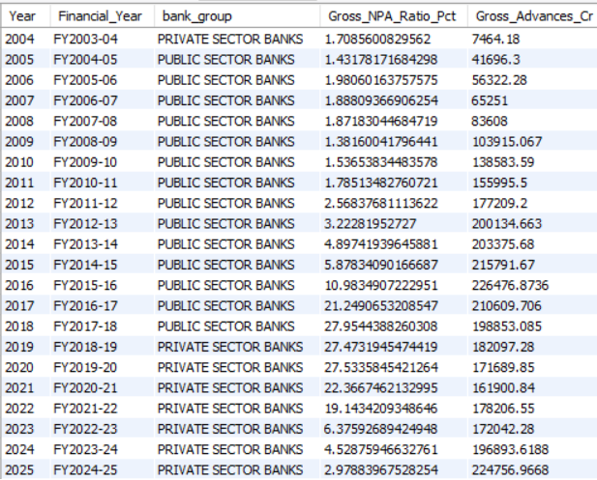

-- Q20 — Broader "structurally weak" threshold: worst-3 in ≥3 of last 10 years (wider list than Q8's strict ≥5, useful for a fuller watchlist)
WITH ranked AS (
SELECT
Year, bank_name, bank_group,
RANK() OVER (PARTITION BY Year ORDER BY Gross_NPA_Ratio_Pct DESC) AS yearly_rank
FROM bank_npa
WHERE bank_group IN ('PUBLIC SECTOR BANKS', 'PRIVATE SECTOR BANKS')
AND Year >= (SELECT MAX(Year) FROM bank_npa) - 9
)
SELECT bank_name, bank_group, COUNT(*) AS years_in_worst3
FROM ranked
WHERE yearly_rank <= 3
GROUP BY bank_name, bank_group
HAVING COUNT(*) >= 3
ORDER BY years_in_worst3 DESC;
INDIAN OVERSEAS BANK | PUBLIC SECTOR BANKS | 4
IDBI BANK LIMITED | PRIVATE SECTOR BANKS | 4
CENTRAL BANK OF INDIA | PUBLIC SECTOR BANKS | 4
UCO BANK | PUBLIC SECTOR BANKS | 3
NAINITAL BANK LTD | PRIVATE SECTOR BANKS | 3
PUNJAB NATIONAL BANK | PUBLIC SECTOR BANKS | 3

- Q21 — System-wide absolute Gross NPA growth vs Advances growth, full period (CAGR-style, non-ratio view for Executive Overview)
WITH endpoints AS (
SELECT
(SELECT SUM(Gross_NPA_Cr) FROM bank_npa WHERE Year = (SELECT MIN(Year) FROM bank_npa)) AS npa_start,
(SELECT SUM(Gross_NPA_Cr) FROM bank_npa WHERE Year = (SELECT MAX(Year) FROM bank_npa)) AS npa_end,
(SELECT SUM(Gross_Advances_Cr) FROM bank_npa WHERE Year = (SELECT MIN(Year) FROM bank_npa)) AS adv_start,
(SELECT SUM(Gross_Advances_Cr) FROM bank_npa WHERE Year = (SELECT MAX(Year) FROM bank_npa)) AS adv_end
)
SELECT
ROUND(npa_start, 0) AS npa_2004, ROUND(npa_end, 0) AS npa_2025,
ROUND((POWER(npa_end / npa_start, 1.0/21) - 1) * 100, 2) AS npa_cagr_pct,
ROUND(adv_start, 0) AS advances_2004, ROUND(adv_end, 0) AS advances_2025,
ROUND((POWER(adv_end / adv_start, 1.0/21) - 1) * 100, 2) AS advances_cagr_pct
FROM endpoints;
51557 | 431607 | 10.65 | 710262 | 19449465 | 17.07

-- Q22 — Banks that entered PSU group post-merger but weren't present pre-2020 (sanity check — should return zero rows, confirming no "new" PSU banks appeared, only consolidation)
SELECT DISTINCT bank_name
FROM bank_npa
WHERE bank_group = 'PUBLIC SECTOR BANKS'
AND Year >= 2021
AND bank_name NOT IN (
SELECT DISTINCT bank_name FROM bank_npa
WHERE bank_group = 'PUBLIC SECTOR BANKS' AND Year <= 2020
);
has returned :0

Q23 — Correlation proxy in SQL: banks with the largest 3-year ratio improvement vs their loan-book growth (supports Q4's "improved most" question, but ranked over 3 years not 1)
WITH endpoints AS (
SELECT
bank_name, bank_group,
MAX(CASE WHEN Year = (SELECT MAX(Year) FROM bank_npa) THEN Gross_NPA_Ratio_Pct END) AS ratio_latest,
MAX(CASE WHEN Year = (SELECT MAX(Year) FROM bank_npa) - 2 THEN Gross_NPA_Ratio_Pct END) AS ratio_3yr_ago,
MAX(CASE WHEN Year = (SELECT MAX(Year) FROM bank_npa) THEN Gross_Advances_Cr END) AS advances_latest,
MAX(CASE WHEN Year = (SELECT MAX(Year) FROM bank_npa) - 2 THEN Gross_Advances_Cr END) AS advances_3yr_ago
FROM bank_npa
WHERE bank_group IN ('PUBLIC SECTOR BANKS', 'PRIVATE SECTOR BANKS')
GROUP BY bank_name, bank_group
)
SELECT
bank_name, bank_group,
ROUND(ratio_latest - ratio_3yr_ago, 2) AS ratio_change_3yr_pp,
ROUND((advances_latest / advances_3yr_ago - 1) * 100, 1) AS advances_growth_3yr_pct
FROM endpoints
WHERE ratio_3yr_ago IS NOT NULL AND advances_3yr_ago IS NOT NULL
ORDER BY ratio_change_3yr_pp ASC
LIMIT 10;
INDIAN OVERSEAS BANK | PUBLIC SECTOR BANKS | -5.31 | 32.3
CENTRAL BANK OF INDIA | PUBLIC SECTOR BANKS | -5.26 | 33.2
PUNJAB NATIONAL BANK | PUBLIC SECTOR BANKS | -4.79 | 26.2
BANK OF INDIA | PUBLIC SECTOR BANKS | -4.04 | 29.1
UNION BANK OF INDIA | PUBLIC SECTOR BANKS | -3.93 | 21.4
PUNJAB AND SIND BANK | PUBLIC SECTOR BANKS | -3.59 | 23
IDBI BANK LIMITED | PRIVATE SECTOR BANKS | -3.4 | 30.6
INDIAN BANK | PUBLIC SECTOR BANKS | -2.86 | 24.2
JAMMU & KASHMIR BANK LTD | PRIVATE SECTOR BANKS | -2.67 | 24.2
CANARA BANK | PUBLIC SECTOR BANKS | -2.41 | 24.4

-- Q24 — Data-limitation documentation query: confirm SBI standalone figures are unavailable pre-2018 (supports your report's stated limitation)
SELECT Year, bank_name
FROM bank_npa
WHERE bank_name LIKE '%STATE BANK OF INDIA%'
ORDER BY Year;
2005 | STATE BANK OF INDIA
2006 | STATE BANK OF INDIA
2007 | STATE BANK OF INDIA
2008 | STATE BANK OF INDIA
2009 | STATE BANK OF INDIA
2010 | STATE BANK OF INDIA
2011 | STATE BANK OF INDIA
2012 | STATE BANK OF INDIA
2013 | STATE BANK OF INDIA
2014 | STATE BANK OF INDIA
2015 | STATE BANK OF INDIA
2016 | STATE BANK OF INDIA
2017 | STATE BANK OF INDIA
2018 | STATE BANK OF INDIA
2019 | STATE BANK OF INDIA
2020 | STATE BANK OF INDIA
2021 | STATE BANK OF INDIA
2022 | STATE BANK OF INDIA
2023 | STATE BANK OF INDIA
2024 | STATE BANK OF INDIA
2025 | STATE BANK OF INDIA

