Indian Bank NPA & Asset-Quality Analytics
Financial Data Analysis Internship — Consolidated Report, Weeks 1–6
Dataset: RBI Gross NPA, Gross Advances & Gross NPA Ratio, Scheduled Commercial Banks (FY2003-04 – FY2024-25)
Note to evaluator: This single report consolidates all six weekly deliverables — data understanding and EDA (Week 1), financial forecasting (Week 2), risk analysis (Week 3), hypothesis testing (Week 4), data visualization (Week 5), and the final summary (Week 6) — into one document, organized by clearly labeled sections below. The same file is submitted against each week's task; each week's description field points to the relevant section.

Week 1 — Understanding Financial Data

Objective & Dataset
This week's task was to source a public financial dataset, understand its structure, clean it, and perform exploratory data analysis. I chose a 22-year, bank-level panel published by the Reserve Bank of India, covering Gross Non-Performing Assets (NPA), Gross Advances, and the Gross NPA Ratio for every Scheduled Commercial Bank in India, from financial year 2003-04 through 2024-25, accessed via RBI's Database on Indian Economy through the Dataful platform (dataset #17801). This is genuinely used banking-sector data — the same kind of panel RBI supervisors, credit-rating agencies, and equity-research analysts work with — rather than a toy dataset, which meant the cleaning and analysis had to hold up to real scrutiny.

Data Acquisition & Initial Structure
The raw file arrived as a single Excel sheet with 2,020 rows across 6 columns, but it was not analysis-ready. I first loaded it with no header assumption at all, to see the true layout, and searched the sheet for marker text (“Public Sector Banks”, “Gross NPAs”, “Year”) to locate the real header row, which turned out to sit at row index 6, beneath a title, a currency note, and blank rows. The sheet also embeds RBI's own subtotal rows — for example, a row literally labeled “PUBLIC SECTOR BANKS” — mixed into the same column as individual bank names, and a further 22 grand-total rows labeled “ALL SCHEDULED COMMERCIAL BANKS” representing the entire system rather than any one bank.

Data Cleaning
Cleaning required several deliberate steps: forward-filling the Year column (populated only once per year-block), back-filling each bank's group label from its trailing subtotal row, and converting RBI's dash symbol (its convention for nil/negligible) into a proper missing value rather than leaving it as unparseable text. After separating out subtotal and grand-total rows, I was left with 1,928 clean bank-level rows. A missing-value audit showed Foreign Banks missing data in about 39.6% of rows (genuine — many have only a token wholesale presence in India), versus under 1% missing for Private banks and zero missing for Public Sector banks — this is what justified restricting the core statistical comparison later in the project to just PSU and Private banks.
During this process I discovered and fixed a real bug: RBI reports Public Sector Banks under two different label conventions depending on the year — as two separate blocks (“Nationalised Banks” and “State Bank of India and its Associates”) for 2004–2017, and as one unified “Public Sector Banks” row from 2018 onward. My first cleaning pass only recognized the newer label, which silently misclassified fourteen years of PSU banks as Private. I caught this because a diagnostic check showed State Bank of India — which has never been anything but a Public Sector Bank — appearing under more than one group label. After fixing the label map to recognize both conventions, I validated the fix by reconciling summed bank-level figures against RBI's own reported group subtotals for every year and group: the maximum discrepancy was 2.9 × 10⁻¹¹ — floating-point rounding, effectively zero. The final validated dataset holds 1,900 bank-level rows with zero missing group labels.

Exploratory Data Analysis — Key Findings
The system-wide Gross NPA ratio started at 7.26% in FY2003-04, fell to a low of about 2.26% by FY2007-08, spiked to an all-time 22-year peak of 11.18% in FY2017-18 (the RBI Asset Quality Review and infrastructure-stress cycle), and has declined every year since to 2.22% in FY2024-25 — the lowest point in the entire series. The distribution of bank-level ratios is right-skewed (corrected overall skewness 2.49; Public Sector 1.54; Private Sector 3.89), meaning a small number of severely stressed bank-years pull the average upward in both groups. A weak negative correlation (r ≈ -0.26) was found between loan-book growth and change in NPA ratio, and system-wide NPA grew at a compound annual rate of 10.65% versus 17.07% for advances — indicating part of the ratio's decline is a denominator (dilution) effect, not purely a fall in absolute bad loans. Top-3-bank NPA concentration has ranged between 24.6% and 45.9% across the 22 years with no sustained trend, sitting at 37.5% in the latest year.

Week 2 — Creating Financial Forecasts

Objective & Indicator Chosen
This week's task was to build a simple forecast model for a financial indicator from the Week 1 dataset. I chose to forecast the system-wide Gross NPA Ratio for FY2026–FY2028, since it is the single indicator this entire project is built around, and because it shows a clear, strong, recent trend (a steep post-2018 decline) that is genuinely forecastable rather than noisy.

Model Design & Justification
With only 22 annual observations, and a series that visibly contains a full boom-bust-recovery cycle rather than a stable trend, I deliberately avoided a complex model such as ARIMA, which would overfit on this little data and produce an unstable, uninterpretable forecast. I first tried the simplest reasonable approach — an ordinary linear regression fit on the eight most recent years (FY2018–FY2025, the post-peak recovery regime, rather than the full 22-year series, since the full series mixes the crisis build-up and the recovery into one misleading average slope). That linear model fit the recent data very well (R² = 0.985), but extrapolating it forward produces a negative ratio by FY2027-28 — which is impossible, since a ratio is bounded at zero. That failure was itself an important, reportable finding: a linear trend is the wrong functional form for a bounded quantity in continuous decline.
I therefore switched to a log-linear (constant percentage decline) model, fitting a straight line to the logarithm of the ratio rather than the ratio itself. This form is naturally bounded above zero — it can approach zero but never cross it — and fits the same eight-year window with R² = 0.959, implying the ratio has been shrinking at a roughly constant 21% relative rate per year.

Forecast Results
Year | Log-linear forecast (used) | Naive linear (rejected)
FY2026 | 1.91% | 0.47%
FY2027 | 1.51% | -0.82% (invalid)
FY2028 | 1.19% | -2.12% (invalid)

Analysis & Limitations
The forecast implies continued, decelerating improvement in system-wide asset quality through FY2028, absent a new shock. I want to be direct about the limitations of this model, since a forecast is only useful if its assumptions are stated plainly: it is a trend-extrapolation model, not a structural or causal one — it has no way to anticipate a future stress event (a new AQR-style cycle, a macro shock, or a change in RBI provisioning norms), and it is fit on only eight data points, so the confidence in the FY2028 figure specifically is meaningfully lower than in the FY2026 figure. I would treat this forecast as a reasonable base case for the near term, not a long-range structural prediction.

Week 3 — Risk Analysis

Risk Identification
I identified four distinct risk dimensions in the data: the ratio level and trend per bank (is a bank's asset quality currently bad, and is it getting better or worse); concentration risk (how much of system-wide NPA sits in a handful of large banks); structural weakness (which banks are persistently, not just occasionally, among the worst performers); and absolute exposure (a bank's loan-book size, since a large bank with a moderate ratio can represent more real rupee-value risk than a small bank with a worse ratio).

Impact Assessment
Only one bank met a strict rule of “ratio above its group average AND not improved over the last 3 years”: IndusInd Bank, a Private Sector bank whose ratio rose to 3.13% in FY2024-25, up 1.15 percentage points over three years, and which had stayed below the Private-sector average every year from FY2020-21 through FY2023-24 before crossing above it for the first time in five years — a timing that lines up with IndusInd's real, publicly reported 2025 derivatives-accounting disclosure. Separately, ranking every bank's ratio within each of the last ten years and counting how often each landed in the worst three showed only IDBI Bank Limited meeting a strict “5 of the last 10 years” threshold; a broader “3 of the last 10 years” threshold adds Indian Overseas Bank, Central Bank of India, Punjab National Bank, UCO Bank, and Nainital Bank.
For concentration and absolute exposure, I built a Probability × Impact matrix (Chart 7 in the Week 5 section), plotting each bank's Gross NPA Ratio (probability of continued stress) against its Gross Advances (impact if stressed). Because the sector-wide ratio is currently at a 22-year low, a matrix built on fixed historical thresholds returned almost no banks in the “high probability” tier — itself a genuine finding of sector health, not an analytical failure — so I recalibrated the probability tiers to be relative to the current year's peer distribution, which produced a usable, non-empty watch list.

Mitigation Strategies
- Enhanced supervisory review triggers for any bank whose Gross NPA ratio exceeds a defined threshold relative to its peer group in the current year, rather than a fixed historical threshold that becomes stale as the sector's overall health improves.
- Continued differentiated capital and provisioning requirements for structurally weak banks (IDBI Bank, and on a broader basis Indian Overseas Bank and Central Bank of India), since persistence across multiple years is a stronger risk signal than any single bad year.
- Closer monitoring specifically for banks whose ratio trend reverses upward after a period of improvement — exactly the pattern IndusInd Bank showed in FY2024-25 — since a reversal after sustained improvement is a leading indicator worth flagging before it shows up as a multi-year trend.
- Recognition that concentration risk (Top-3 banks holding 25-46% of system NPA) is structurally persistent and tied to bank size rather than worsening asset quality, so mitigation should focus on those banks' absolute capital buffers rather than treating the concentration itself as a deteriorating trend.

Week 4 — Hypothesis Testing

Hypothesis
H₀ (null): There is no significant difference in mean Gross NPA ratio between Public Sector Banks and Private Sector Banks. H₁ (alternative): A significant difference exists.

Statistical Test & Justification
Before selecting a test, I checked the normality assumption formally using the Shapiro-Wilk test on both groups, which returned p < 0.0001 for both — formally rejecting normality, consistent with the right-skewed distributions found in Week 1. Because of this, I used the Mann-Whitney U test, a non-parametric test that does not assume normally distributed data, rather than a t-test. Rather than testing a single year, I ran the test across every year from FY2015-16 through FY2024-25, since a single year's result could be a statistical fluke of that year's specific events, while testing across a decade reveals whether the underlying pattern itself is changing.

Results
Year | p-value | Significant (α = 0.05)?
FY2015-16 | 0.00000049 | Yes
FY2017-18 (peak gap) | 0.00000015 | Yes
FY2020-21 | 0.01106 | Yes
FY2022-23 | 0.00373 | Yes
FY2023-24 | 0.02597 | Yes
FY2024-25 | 0.13934 | No — first time in the decade

Interpretation
The PSU–Private difference was statistically significant in every single year from FY2015-16 through FY2023-24, in most years overwhelmingly so. In FY2024-25, for the first time in the observed decade, the p-value crosses above the conventional 0.05 threshold, meaning the difference between the two groups' asset quality can no longer be called statistically significant. Interpreted together with the shrinking raw gap (9.96 percentage points at the FY2017-18 peak, down to 0.83 percentage points in FY2024-25), this is read as evidence that post-2020 PSU consolidation and years of recapitalization have measurably, not just cosmetically, closed the historical asset-quality gap. A limitation worth stating directly: only about 12 Public Sector banks remain after the 2020 mergers, compared to around 21 Private Sector banks, so the Public Sector sample size is genuinely small — this is exactly why the test was run across multiple years rather than trusted from a single snapshot.

Week 5 — Data Visualization
This section presents the seven core visualizations built for this project, each chosen to answer a specific business question rather than as decoration. All charts use the validated, corrected dataset described in Week 1.

Figure 1 — Gross NPA Ratio Trend, 2004–2025
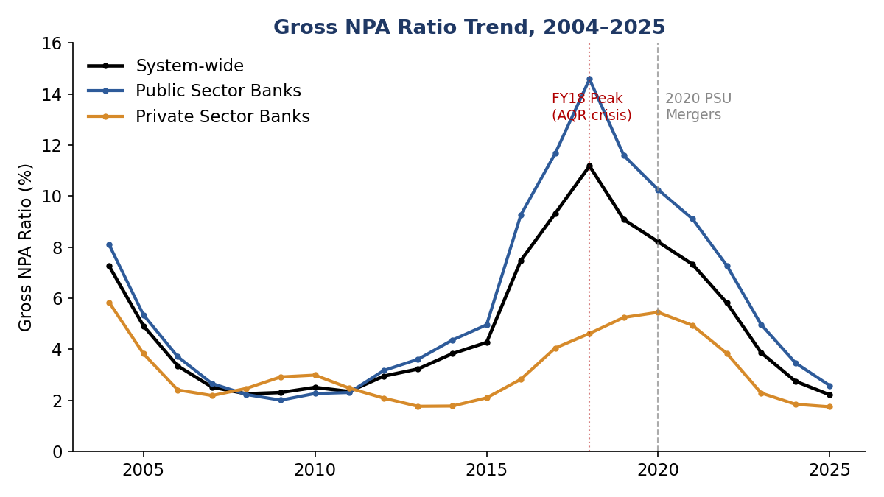
System-wide, Public Sector, and Private Sector Gross NPA ratios plotted together, with the FY2017-18 crisis peak and the 2020 merger event marked.
This is the project's anchor chart. It shows Public Sector Banks tracking closely with the system-wide line but always running higher, especially through the 2016–2020 stress period, while Private Sector Banks show a smaller, shorter-lived bump over the same period. Both lines converge sharply toward the right edge of the chart, visually setting up the central finding developed further in Figure 2.

Figure 2 — PSU–Private Asset-Quality Gap
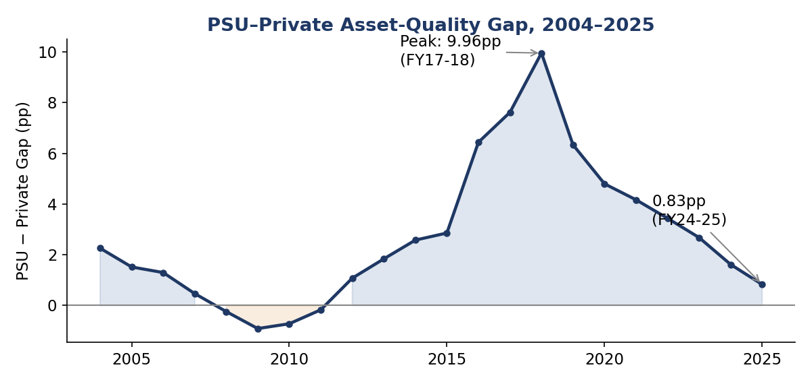
The gap (PSU ratio minus Private ratio) isolated as its own series, with the FY2017-18 peak and FY2024-25 latest value annotated.
Isolating the gap itself, rather than the two ratios separately, makes the shape of the story unmistakable: a brief period (2008–2011) where Private banks were actually worse, then a sharp widening to a peak of nearly 10 percentage points by FY2017-18, followed by a steady, uninterrupted narrowing down to under 1 percentage point today.

Figure 3 — Distribution Skewness by Group
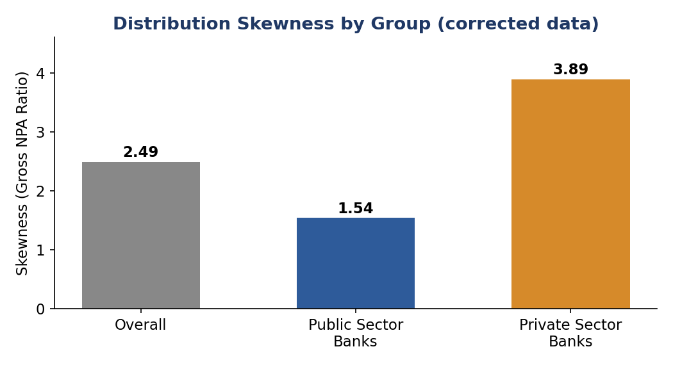
Skewness of the Gross NPA ratio distribution, overall and by bank group, computed on the corrected dataset.
Both groups are right-skewed — confirmed statistically by the Shapiro-Wilk test in Week 4 — but Private Sector Banks are far more skewed than Public Sector Banks, reflecting that most Private banks are healthy with a small number of severe outliers (such as Yes Bank during its 2019-2020 crisis), while Public Sector Banks are more uniformly stressed as a group.

Figure 4 — NPA Concentration in Top-3 Banks
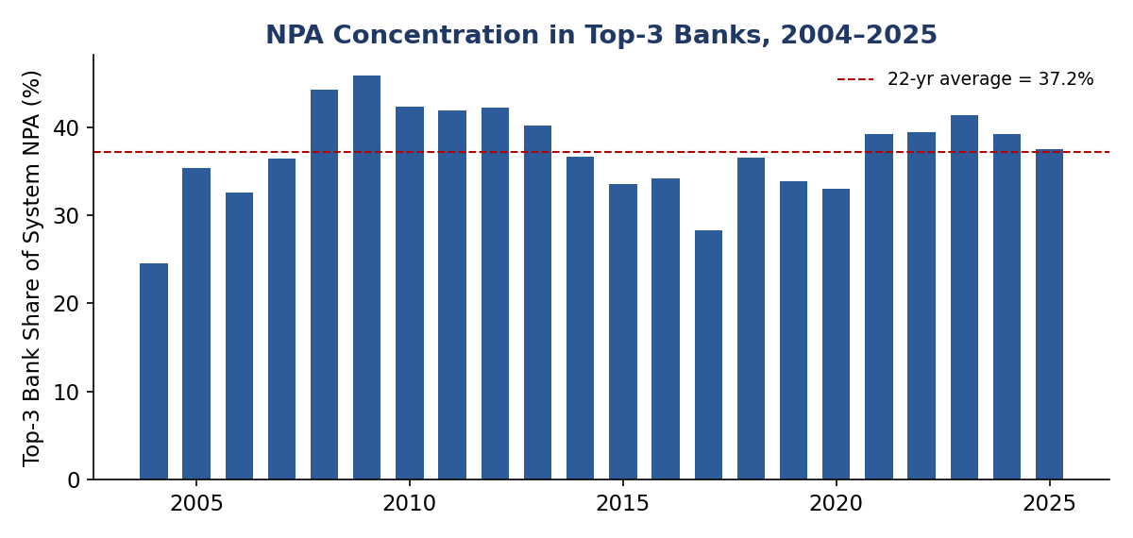
Share of total system-wide Gross NPA held by the three largest banks (by absolute NPA), each year, with the 22-year average shown.
Concentration fluctuates between roughly a quarter and just under half of total system NPA, with no sustained upward or downward trend — this supports the Week 3 finding that concentration is a structural feature of the sector (driven by a few banks' sheer size) rather than a worsening or improving risk trend.

Figure 5 — Statistical Significance Over Time
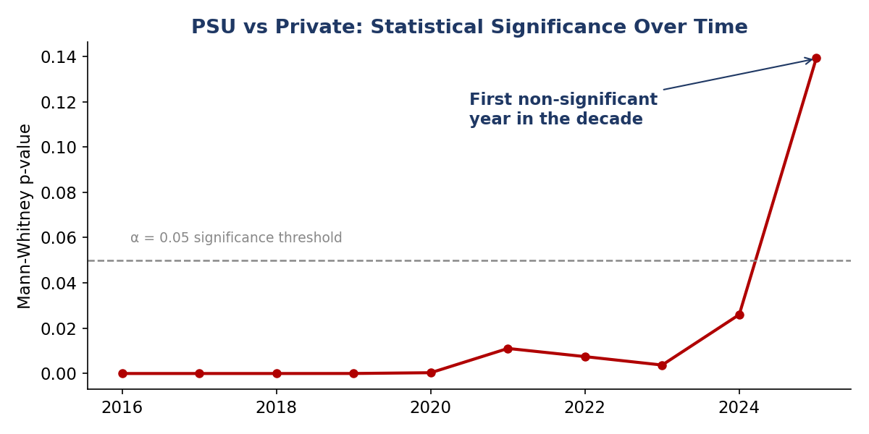
Mann-Whitney U test p-value by year, with the α = 0.05 significance threshold marked. This is the chart-form of the Week 4 results table.
The p-value stays far below the significance threshold for almost the entire decade, then rises sharply in the final three years and crosses above the threshold in FY2024-25 — visually, this is the clearest single piece of evidence in the whole project that the PSU-Private gap has genuinely closed, not just narrowed.

Figure 6 — NPA Ratio Forecast, FY2026–FY2028
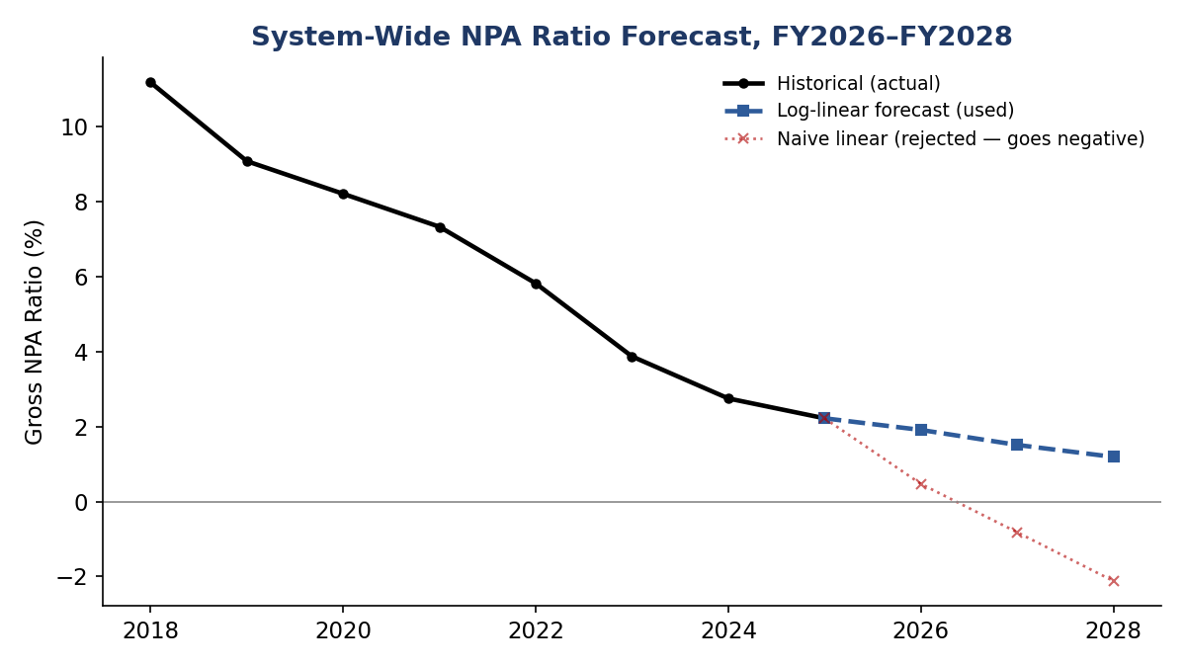
Historical ratio (2018–2025) with the Week 2 log-linear forecast, alongside the rejected naive linear model shown for comparison.
This chart makes the Week 2 model-selection decision visible: the naive linear model (dotted red) crosses below zero by FY2027, which is impossible for a ratio, while the log-linear model (dashed blue) continues the recent decline in a bounded, decelerating way.

Figure 7 — Probability × Impact Risk Matrix
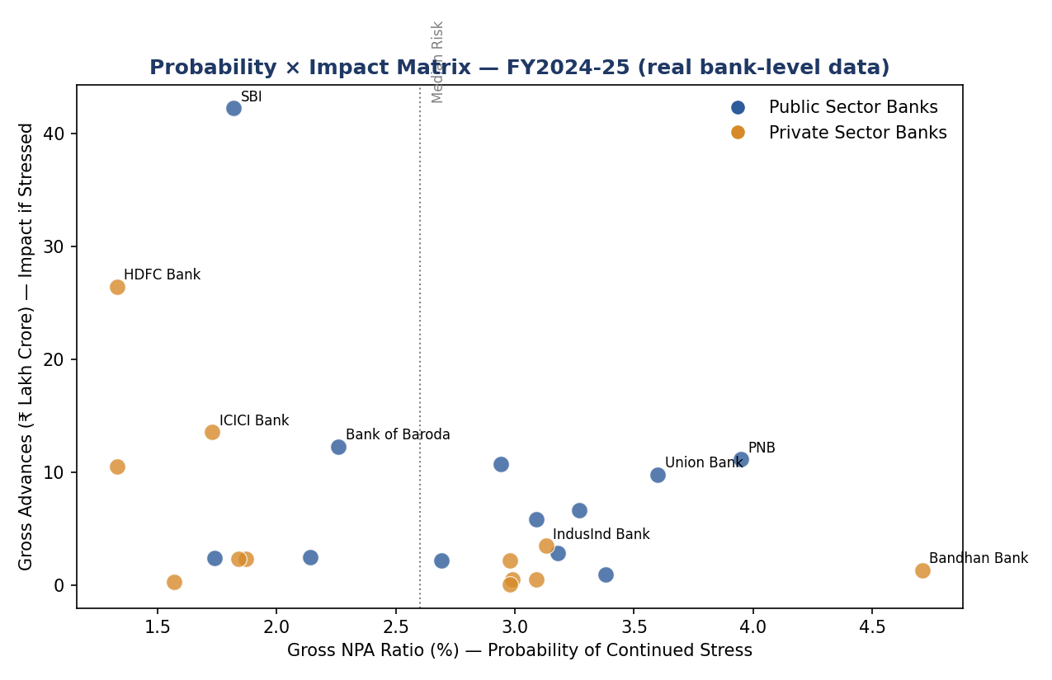
Each bank's FY2024-25 Gross NPA Ratio (x-axis) against its Gross Advances (y-axis), using real bank-level figures from the cleaned dataset.
This chart makes the Week 3 risk analysis concrete: State Bank of India sits at low probability but by far the highest impact, given its sheer size; Punjab National Bank and Union Bank sit in the more dangerous upper-middle region, combining an elevated ratio with very large absolute exposure; and Bandhan Bank has the single highest ratio in the dataset but low absolute impact, since it is a comparatively small bank.

Week 6 — Final Summary, Insights & Recommendations

Summary of Findings
Across all five prior weeks, this project traced a single, coherent story using RBI's own 22-year bank-level data: India's banking sector asset quality went through a severe stress cycle peaking in FY2017-18, driven disproportionately by Public Sector Banks, and has since recovered to its healthiest point in the entire observed series. The recovery is not just visible on a trend chart — it is statistically confirmed: the historically significant gap between PSU and Private bank asset quality became statistically insignificant for the first time in FY2024-25, a finding that survived a real, non-trivial data-cleaning correction (the group-mislabeling bug documented in Week 1), which is itself a meaningful proof of the finding's robustness rather than an artifact of dirty data.

Key Insights
- The PSU-Private asset-quality gap has closed both in raw size (9.96pp → 0.83pp) and in statistical significance (p=0.139 in FY25), suggesting post-2020 consolidation and recapitalization have had a real, measurable effect, not just a cosmetic one.
- Part of the system-wide ratio improvement is a denominator effect — advances grew faster (17.07% CAGR) than NPA declined (10.65% CAGR) — so the improvement, while real, should not be read as entirely reflecting better credit underwriting alone.
- Concentration risk (top-3 banks) is structurally persistent, tied to bank size, and has not meaningfully worsened or improved over 22 years.
- A small number of banks — IDBI Bank on a structural, multi-year basis, and IndusInd Bank on a current-trend basis — warrant continued individual monitoring even as the sector overall has strengthened.
- A simple, correctly-specified log-linear model forecasts continued gradual improvement in the system-wide ratio through FY2028, absent a new shock.

Recommendations for Future Analysis
- Incorporate Net NPA, Provisioning Coverage Ratio, and Capital Adequacy Ratio to build a fuller CAMELS-style view of bank health, since Gross NPA alone cannot distinguish genuine credit recovery from aggressive write-offs moving bad loans off the books.
- Join in RBI/data.gov.in's separate bank-wise NPA Recovery dataset to add a recovery-effectiveness dimension — which banks are recovering the most relative to their Gross NPA, and through which channel (SARFAESI, DRT, Lok Adalat, IBC).
- Extend the forecasting work with a proper prediction interval (e.g. bootstrapped residuals) rather than a single point forecast, and revisit the model once one or two more years of data are available to confirm the log-linear assumption continues to hold.
- Build a simple early-warning classification model (e.g. logistic regression) using multi-year ratio trend and loan-book growth rate as features, to flag banks at risk of future asset-quality deterioration before it appears in a single year's numbers.

Limitations, Stated Directly
- Foreign Banks and Small Finance Banks were excluded from the core statistical comparison due to substantial genuine missing data (~40% for Foreign Banks), not because their data is uninteresting.
- The 2020 PSU mergers were handled with a discontinuation approach (pre-merger entities treated as ended) rather than full historical reconstruction, to keep the project scope manageable; this is stated explicitly rather than left implicit.
- IDBI Bank's group label changes across years reflect RBI's own real 2019 reclassification of the bank from Public to Private Sector, and was retained as-is rather than forced into one category.
- The forecast model in Week 2 is a trend-extrapolation model and cannot anticipate a future macro or regulatory shock; it should be treated as a base case, not a guaranteed outcome.
- The Public Sector sample size (~12 banks post-merger) is small, a limitation acknowledged directly in the Week 4 hypothesis-testing section rather than glossed over.

