R Notebook

1 - Calling ISLR library and printing the summary of Carseats dataset

library(ISLR)  
s<-Carseats#assigning the Carseats dataset to a variable  
print(summary(s))

## Sales CompPrice Income Advertising   
## Min. : 0.000 Min. : 77 Min. : 21.00 Min. : 0.000   
## 1st Qu.: 5.390 1st Qu.:115 1st Qu.: 42.75 1st Qu.: 0.000   
## Median : 7.490 Median :125 Median : 69.00 Median : 5.000   
## Mean : 7.496 Mean :125 Mean : 68.66 Mean : 6.635   
## 3rd Qu.: 9.320 3rd Qu.:135 3rd Qu.: 91.00 3rd Qu.:12.000   
## Max. :16.270 Max. :175 Max. :120.00 Max. :29.000   
## Population Price ShelveLoc Age Education   
## Min. : 10.0 Min. : 24.0 Bad : 96 Min. :25.00 Min. :10.0   
## 1st Qu.:139.0 1st Qu.:100.0 Good : 85 1st Qu.:39.75 1st Qu.:12.0   
## Median :272.0 Median :117.0 Medium:219 Median :54.50 Median :14.0   
## Mean :264.8 Mean :115.8 Mean :53.32 Mean :13.9   
## 3rd Qu.:398.5 3rd Qu.:131.0 3rd Qu.:66.00 3rd Qu.:16.0   
## Max. :509.0 Max. :191.0 Max. :80.00 Max. :18.0   
## Urban US   
## No :118 No :142   
## Yes:282 Yes:258   
##   
##   
##   
##

2 - Printing the number of rows in the dataset

print(paste("Number of rows in the dataset are:",nrow(s)))

## [1] "Number of rows in the dataset are: 400"

print(paste("Maximum value of Advertising is:", max(s$Advertising)))#calculating the maximum value of the Advertising column

## [1] "Maximum value of Advertising is: 29"

3 - Calculating Interquartile Range (IQR)

print(paste("The Inter Quartile Range of Price is:", IQR(s$Price)))

## [1] "The Inter Quartile Range of Price is: 31"

4 - Plotting Price vs Sales

library(tidyverse)

## ── Attaching packages ─────────────────────────────────────── tidyverse 1.3.2 ──  
## ✔ ggplot2 3.3.6 ✔ purrr 0.3.4   
## ✔ tibble 3.1.8 ✔ dplyr 1.0.10  
## ✔ tidyr 1.2.1 ✔ stringr 1.4.1   
## ✔ readr 2.1.3 ✔ forcats 0.5.2   
## ── Conflicts ────────────────────────────────────────── tidyverse_conflicts() ──  
## ✖ dplyr::filter() masks stats::filter()  
## ✖ dplyr::lag() masks stats::lag()

library(car)

## Loading required package: carData  
##   
## Attaching package: 'car'  
##   
## The following object is masked from 'package:dplyr':  
##   
## recode  
##   
## The following object is masked from 'package:purrr':  
##   
## some

scatterplot(Price ~ Sales, data=s)

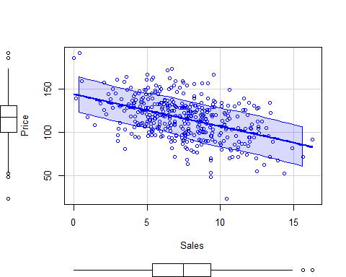

cor(s$Price,s$Sales,method='pearson')#calculating the correaltion between Price and Sales

## [1] -0.4449507

Here, from the plot we notice that, as the Price of the Carseats are increasing the sales are decreasing.  
From the above we calculated the correlation of Price and Sales of the Carseats. We notice that the correlation between the two is a negative linear correlation.