CSS BOX MODEL

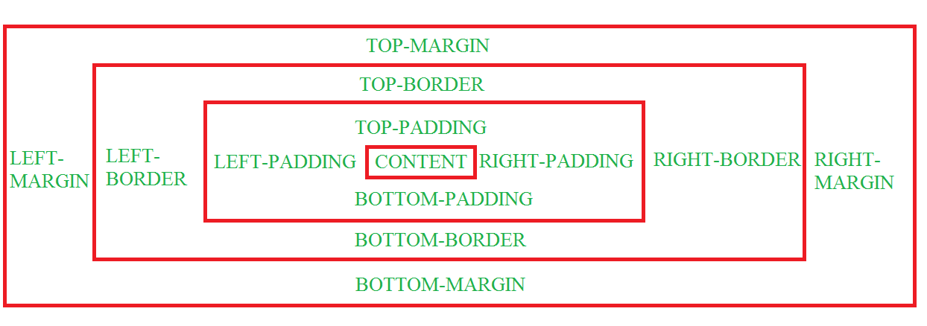

🡪The spaces which we have around content is called as padding.

🡪Padding properties:-

a)Padding-top:px,cm,mm;

b) Padding-bottom:px,cm,mm;

c) Padding-left:px,cm,mm;

d)Padding-right:px,cm,mm;

🡪Border properties:-

a)border-width:px;

b)border-style:px;

c)border-color:px;

🡪Margin properties are same like padding properties

a)margin-top:px,cm,mm;

b) margin-bottom:px,cm,mm;

c) margin-left:px,cm,mm;

d)margin-right:px,cm,mm;

🡪Shortcut properties:-

Border:3px solid black;

Padding:40px;//For all sides

Padding:5px 10px;//first value for top and bottom

//second value for left and right.

Margin: 5px 10px;//first value for top and bottom

//second value for left and right.

OUTLINE:-

🡪Outline is same as the border, which indicates outside of the border.

a)outline-width:px;

b)outline-style:px;

c)outline-color:px;

shortcut:- outline:3px solid color;

