**PYTHON: ASSIGNMENT 02(Advanced Questions)**

**PROBLEM STATEMENT 1:**

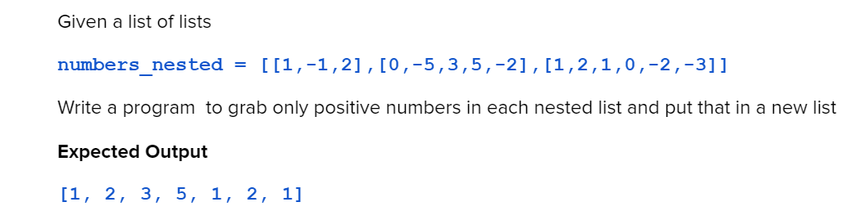

**CODE:**

**nested_list=[[1,-1,2],[0,-5,3,5,-2],[1,2,1,0,-2,-3]]**

**print("The given nested list is:",nested_list)**

**num=[]**

**for num1 in nested_list:**

**for pos_num in num1:**

**if pos_num>0:**

**num.append(pos_num)**

**print("Positive numbers from the given nested list is:",num)**

**EXECUTION:**

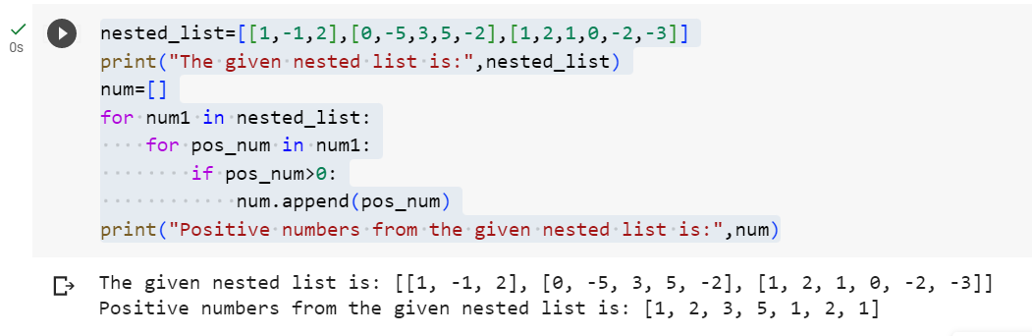

**OUTPUT:**



**PROBLEM STATEMENT 2:**

**CODE:**

nested_list=[[1,2,3], [4,5,6,3], [-1,-2,-10,5,8]]

print("The given nested list is:",nested_list)

average=[]

sum_average=[]

for x in nested_list:

    print("The inner list is",x)

    avg_list=sum(x)/len(x)

    print("average of inner list is",avg_list)

    average.append(avg_list)

print("The average values of each inner list is ",average)

sum_average=sum(average)

print("The sum of average of each inner list is",sum_average)

**EXECUTION:**

**OUTPUT:**

**----------------------------------------------END OF FILE---------------------------------------------**