SNOWFLAKE

ASSIGNMENT 2

Upload sample data from snowflake to S3 through external stage.

--STEPS TO ULOAD DATA FROM SNOWFLAKE TABLE TO AWS S3 BUCKET

Execution query in SNOWFLAKE:

--craete warehouse

create warehouse customer;

--create database

create database customer;

--use the database created

use customer;

--change the role to accountadmin

USE ROLE ACCOUNTADMIN;

--create a table and load the data from snowflake_sample_data

CREATE OR REPLACE TRANSIENT TABLE cust_data

AS

SELECT * FROM

"SNOWFLAKE_SAMPLE_DATA"."TPCDS_SF100TCL"."CUSTOMER";

SELECT * FROM cust_data limit 10;

--CREATE FIEL FORMAT

create or replace file format csv_unload

type = csv field_delimiter = ',' skip_header = 1 null_if = ('NULL', 'null') empty_field_as_null = true compression = gzip;

--CREATE STORAGE INTEGRATION(CREATE ROLE THROUGH IAM WITH S3 ALL ACCESS AND COPY ARM FROM ROLE)

create or replace storage integration s3_cav

type = external_stage

storage_provider = s3

enabled = true

storage_aws_role_arn = 'arn:aws:iam::891377129521:role/csv_unload'

storage_allowed_locations = ('s3://csv11072024/sandhyas/');

--describe the integration created(copy the 5,6 arn and id in trust relations in roles created)

desc integration s3_cav;

--CREATE EXTERNAL STAGE

create or replace stage customer.public.csv_ext_stage

storage_integration = s3_cav

url = 's3://csv11072024/sandhyas/'

file_format = customer.public.csv_unload;

--copy the data from external stage to S3 bucket

COPY INTO @customer.PUBLIC.csv_ext_stage/sandhyas/

from

customer.PUBLIC.cust_data;

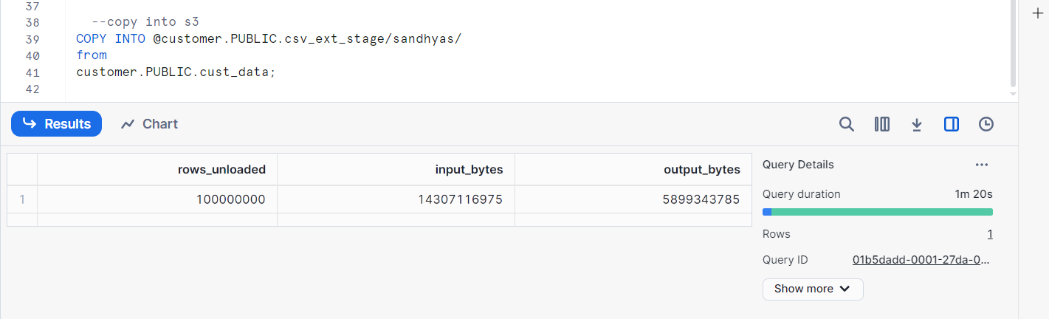

Csv files in S3 bucket in GZ format:

3. QUERY DATA IN S3 FROM SNOWFLAKE. Now data got uploaded to s3. We have 100 Million records uploaded and data size is 4.5 GB. Uploaded files will be csv compressed files.

SELECT $1 C_CUSTOMER_SK,

$2 C_CUSTOMER_ID ,

$3 C_CURRENT_CDEMO_SK ,

$4 C_CURRENT_HDEMO_SK ,

$5 C_CURRENT_ADDR_SK,

$6 C_FIRST_SHIPTO_DATE_SK ,

$7 C_FIRST_SALES_DATE_SK ,

$8 C_SALUTATION ,

$9 C_FIRST_NAME ,

$10 C_LAST_NAME,

$11 C_PREFERRED_CUST_FLAG ,

$12 C_BIRTH_DAY ,

$13 C_BIRTH_MONTH ,

$14 C_BIRTH_YEAR,

$16 C_LOGIN ,

$17 C_EMAIL_ADDRESS ,

$18 C_LAST_REVIEW_DATE

FROM @customer.PUBLIC.csv_ext_stage/sandhyas/

(file_format => customer.public.csv_unload);

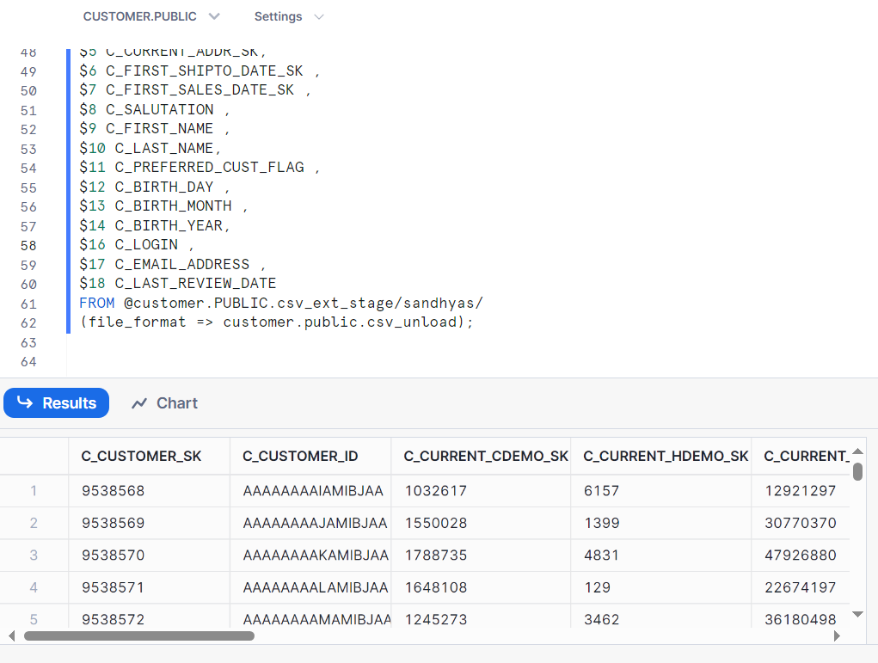

--Filter data directly from s3

SELECT $1 C_CUSTOMER_SK,

$2 C_CUSTOMER_ID ,

$3 C_CURRENT_CDEMO_SK ,

$4 C_CURRENT_HDEMO_SK ,

$5 C_CURRENT_ADDR_SK,

$6 C_FIRST_SHIPTO_DATE_SK,

$7 C_FIRST_SALES_DATE_SK ,

$8 C_SALUTATION ,

$9 C_FIRST_NAME ,

$10 C_LAST_NAME,

$11 C_PREFERRED_CUST_FLAG ,

$12 C_BIRTH_DAY ,

$13 C_BIRTH_MONTH ,

$14 C_BIRTH_YEAR,

$16 C_LOGIN ,

$17 C_EMAIL_ADDRESS ,

$18 C_LAST_REVIEW_DATE

FROM @customer.PUBLIC.csv_ext_stage/sandhyas/

(file_format => customer.public.csv_unload)

WHERE C_CUSTOMER_SK ='64596949'

**--Execute group by**

SELECT $9 C_FIRST_NAME,$10 C_LAST_NAME,COUNT(*)

FROM @customer.PUBLIC.csv_ext_stage/sandhyas/

(file_format => customer.public.csv_unload)

GROUP BY $9,$10;

4.CREATE VIEW OVER S3 DATA

CREATE OR REPLACE VIEW CUSTOMER_DATA

AS

SELECT $1 C_CUSTOMER_SK,

$2 C_CUSTOMER_ID ,

$3 C_CURRENT_CDEMO_SK ,

$4 C_CURRENT_HDEMO_SK ,

$5 C_CURRENT_ADDR_SK,

$6 C_FIRST_SHIPTO_DATE_SK ,

$7 C_FIRST_SALES_DATE_SK ,

$8 C_SALUTATION ,

$9 C_FIRST_NAME ,

$10 C_LAST_NAME,

$11 C_PREFERRED_CUST_FLAG ,

$12 C_BIRTH_DAY ,

$13 C_BIRTH_MONTH ,

$14 C_BIRTH_YEAR,

$16 C_LOGIN ,

$17 C_EMAIL_ADDRESS ,

$18 C_LAST_REVIEW_DATE

FROM @customer.PUBLIC.csv_ext_stage/sandhyas/

(file_format => customer.public.csv_unload);

--Query data directly on view

SELECT * FROM CUSTOMER_DATA;

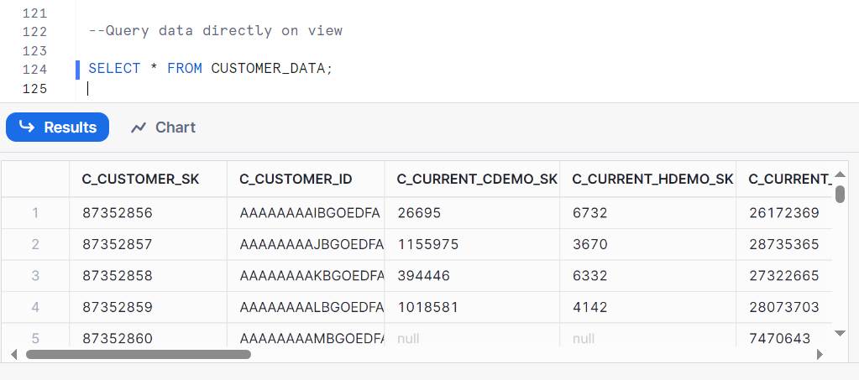

**Now we can directly query data from s3 through view. What is the disadvantage of using this approach? Can you see partitions being scanned in the backend??**

Yes, we can query data from S3 directly through views in Snowflake using external stages.

Disadvantages of this approach is mentioned below:

* **Performance**: Queries through views may have slower performance when we query directly from Snowflake internal storage. This is because data retrieval involves fetching from external storage over the network, we will face performance issues.
* **Cost**: Depending on the Amazon S3, Azure & frequency of data access, there might be extra costs along with data.
* **Data Consistency**: External data may change with out snowflake control, which leads to inconsistencies if we do not managed carefully.

**We can not see any partitions created in the backend for views**. Screenshot attached below:

--Join this with the view we created earlier,

SELECT B.*

FROM CUSTOMER_SNOWFLAKE_TABLE B

LEFT OUTER JOIN

customer_data A

ON

A.C_CUSTOMER_SK = B.C_CUSTOMER_SK;

Now we successfully joined data in s3 with snowflake table. It may look simple but this approach has lot of potential. Can you mention few below:

Joining data in S3 with Snowflake tables has a wide range of benefits related to **scalability** where S3 bucket can store vast amounts of data, **cost efficiency** in which storing data in S3 is typically cheaper than storing it in Snowflake's internal storage, **data integration** where we can integrate different verieties of data like structured, semi-structured also unstructured data. **performance optimization** through intelligent query planning and execution. **data governance** and **security and privacy**.

How many partitions got scanned from snowflake table: **scanned partitions are 356 and total partition is 1**, when checked through query profile:

5. UNLOAD DATA BACK TO S3 This approach leverages micro partitions in snowflake for lookup table still giving us the freedom to query data which we have stored in s3. Once we are done looking up we can copy data back to s3 with new derived lookup column.

COPY INTO @customer.PUBLIC.csv_ext_stage/sandhyas_join_data/

from(

SELECT B.*

FROM CUSTOMER_SNOWFLAKE_TABLE B

LEFT OUTER JOIN

customer_data A

ON

A.C_CUSTOMER_SK = B.C_CUSTOMER_SK);

In S3 Bucket:

6. ADVANTAGES AND DISADVANTAGES

**Advantages:**

* Joining data in S3 with Snowflake tables has a wide range of benefits related to scalability where S3 bucket can store vast amounts of data.
* cost efficiency in which storing data in S3 is typically cheaper than storing it in Snowflake's internal storage.
* data integration where we can integrate different varieties of data like structured, semi-structured also unstructured data.
* performance optimization through intelligent query planning and execution.
* data governance and security and privacy.

**Disadvantages:**

* **Performance**: Queries through views may have slower performance when we query directly from Snowflake internal storage. This is because data retrieval involves fetching from external storage over the network, we will face performance issues.
* **Cost**: Depending on the Amazon S3, Azure & frequency of data access, there might be extra costs along with data.
* **Data Consistency**: External data may change with out snowflake control, which leads to inconsistencies if we do not managed carefully.

///////////////////////////////////////////THANK YOU//////////////////////////////////////////////////////////

From,

Sandhya Shankar