08. What are FPS conversations
Audience: [LOB: Fraud Support]
- Overview
- What are FPS Conversations?
- Goal of FPS Conversations
- Who handles FPS Conversations?
- Key FPS Conversation topics
- Process flow chart
- Pre-Conversation checklists
- Things to avoid during an FPS Conversation

Overview
This article explains what Fraud Penalty System (FPS) Conversations are and why they happen after a property receives a fraud warning or penalty. It outlines the main topics covered during these interactions and the objectives of the conversation.

What are FPS Conversations?
Fraud Penalty System (FPS) is a subcategory within Fraud Support that specifically handles conversations with owners when their listings are affected by a fraud penalty or have received a Warning or Fraud Letter from Tripadvisor.
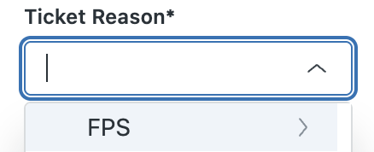

Goal of FPS Conversations
- Educate the owner about our fraud policies
- Address all concerns from the user (Owner)
- Encourage compliance with our guidelines to prevent future fraudulent activity

Who handles FPS Conversations?
- Fraud Support Tier 1 agents
- Fraud Support Tier 2 agents
- The Investigations Team

Key FPS Conversation topics
Scenario | Description
A WL or a FL that the property received | The owner received a Fraud Letter or Warning Letter and is seeking additional information
A ranking drop resulting from fraudulent activity | The owner is asking about a ranking decrease caused by fraudulent activity
Missing guest reviews | The owner asks why some reviews were removed due to fraud
Traveler's Choice Award removal | The owner is told the award was taken away or not given due to fraud

Process flow chart
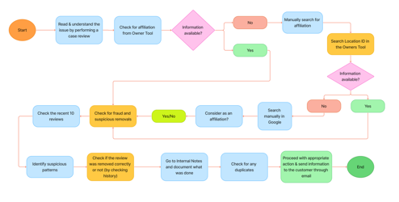

Pre-Conversation checklists
- Confirm Affiliation - Verify the individual is an official representative.
- Confirm which property - Identify the correct property they are discussing about.
- Violation type - Understand the specific policy violation. (Eg: Boosting, Vandalism).
- Check for previous mitigation - Review Zendesk history and Guidelines compliance form (GCF) status for prior actions.

Things to avoid during an FPS Conversation
- Using Jargons during conversations.
- Sharing sensitive information with unauthorized individuals.
- Advising repeated steps to the owners.
- Respond to owners using professional & neutral language that acknowledge their inquiry without disclosing detailed internal investigation methods or decision-making criteria.

