08a. What to check before replying to an Owner in FPS Conversation
Audience: [LOB: Fraud Support]
- Overview
- Standard checks before responding to an owner
- Scope and official verification criteria - Affiliation
- Agent Responsibilities and Affiliation Checks
- How to handle affiliated unregistered/unverified owners?
- How to handle end-users with no clear affiliation?
- How to determine the correct property?
- How to identify the applicable violation?
- Peripheral Actions

Overview
This article explains the mandatory checks to complete before responding to an owner. It helps you verify the required information, understand the request, and take the appropriate action before sending a response.

Standard checks before responding to an owner
- Check for affiliation whether the person you are talking to is a representative of the business.
- Check if there are any dupe tickets to merge. For more information refer to: Instructions on how to merge
- Check the property information and identify the violation type.
4.Check for any peripheral actions that need to be accomplished.

Scope and official verification criteria - Affiliation
We can only communicate with official representatives of a business and users. When communicating with Owners, it is essential to verify their affiliation with the specific property in question, as we handle highly sensitive and confidential information.
Verification Criteria | Description
Verified Owners | - Business representatives who are officially registered and verified as owners within the Owner Tool.  - Individuals can hold various roles such as Owner, General Manager, Consultant, or Accounting.  Note: Agents should not use the Member Tool or Location Center for confirmation of this.
Official Domain Correspondence | Individuals communicating from the property's official domain (e.g., joe@marriott.com). Send the registration (short) macro when talking to this type of owner.
Receipt of Correspondence | Non-registered owners forward an official letter or template they received from us (such as Warning Letters, Boosting Letters, or voter templates), unless they say it was sent to them by mistake.
Online Research Correlation | Individuals linked to the property through online research, such as checking the property's website contact section or social media profiles.
Important note: Please do not rely on email addresses found on the Tripadvisor live listing page, as these can be added by anyone.

Agent Responsibilities and Affiliation Checks
Agent Responsibilities | Affiliation Checks
Primary Responsibility | Agents must confirm genuine affiliation before starting a conversation, even if confirmed by another team.
Chain Listings | - When a requester uses a chain domain (e.g., @hilton.com) for a sub-brand (e.g., Waldorf Astoria), affiliation cannot be assumed.  - Agents should verify by checking on the property’s official website or checking we have other registered/verified owners using the same domain on the OT.
Child/Parent Listings | Agents can assume main attraction owners also own child attractions.

How to handle affiliated unregistered/unverified owners?
If affiliation is confirmed via the methods above but the user is not registered/verified, focus on the specific inquiry (review disputes or FPS concerns). Requesting registration should be secondary.
Instead of the full "Owner is Not Yet Registered" macro, you can send the “How to register” (short) macro or the Not Yet verified (short) macro. If the case is being sent to CS, there is no need to request registration.

How to handle end-users with no clear affiliation?
Scenarios | Action
Unlinked & Unregistered Owner | Request they register or contact us from a registered email using the "Owner is Not Yet Registered" macro.
Unverified but registered Owner | Guide them to complete verification using the "Not yet verified" macro before replying to inquiries.
Repeated Contact | If they cannot be traced, inform them that no information can be provided until the registration/verification process is complete.

How to determine the correct property?
- Check the Owner’s email address in the Owner Tool.
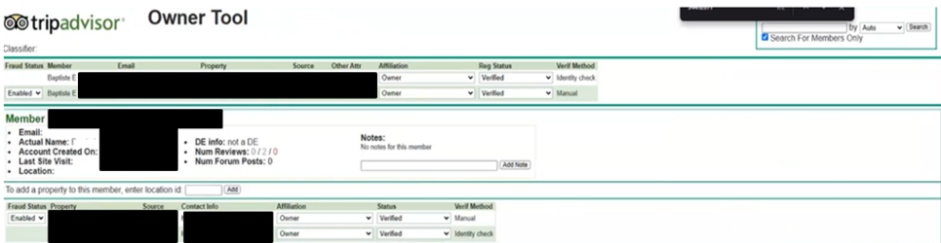
- Search for their email address in the URD tool to see if they've written any recent owner responses. You can also search for "voter email" to see if they reported reviews for any particular property.
- If the Owner has forwarded the letter, you can find the Property ID at the bottom of the document. If the letter is unavailable, check the support ticket for the property name and search for it on the Tripadvisor live site to identify the Property ID.
- If a search doesn't yield results, try a Google search with the name of the property or with the property ID.
- Review the property's ticket history in Zendesk to determine whether they have contacted support previously and to identify any duplicate tickets.
Verifying the correct property leads to:
- Investigate the right listing.
- Review the correct history.
- Avoid making decisions based on the wrong property, which could result in an incorrect response or action.

How to identify the applicable violation?
- Check the fraud history in the Location Center for the most recent fraud letter sent.
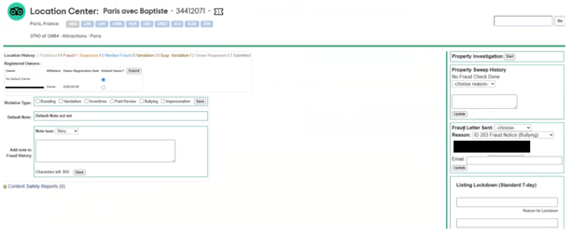
- Check their correspondence history in Zendesk by following the steps below.
a). Open the relevant Zendesk ticket.
b). Search for the Property ID or property name using the search bar.
c.) Open User History.
d). Review previous correspondence and check for duplicate tickets.
You can also verify the property's fraud history using either the Fraud Support Location Summary App or a manual check in the Location Center. Both methods are valid.
To review the penalty details:
- Check the red expiration box for the penalty reason. To find matching removals, sort the fraud history by "queue"; the removal date will match the penalty date.
- In the Location Center, check the list of published and removed reviews displayed at the top of the page.
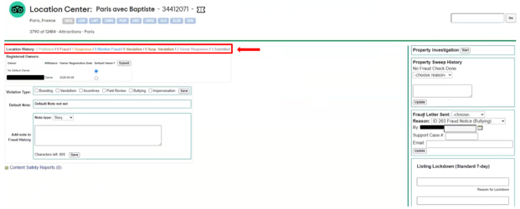
- If no letter was sent automatically after a removal, send one manually and set the ticket to "On-Hold" to discuss the next day.
When reviewing a property's fraud history, check fraudulent removals first, as fraud letters and penalty notices may be delayed.
If the penalty box doesn’t appear within a couple of days of the fraud removal, please escalate the case to Tier 2 so we can investigate if a bug is causing the issue.
In the case of parent/child listings, the penalty box will only appear within the Location Center of the parent listing. Agents must still initiate an FPS (Fraud Penalty System) conversation, even if their investigation reveals that the penalty was actually applied to a child listing.

Peripheral Actions
What are Peripheral Actions?
Peripheral actions refer to additional sets of actions taken during a case review to address issues identified outside the scope of the original request. These actions must be documented in the internal notes and are generally not shared with the requester unless they are relevant to the response.
Important: Peripheral actions are not predefined and will vary depending on the circumstances of each case.
Sample case scenario
Scenario | Case action | Peripheral action
If a user submits suspicious or fraudulent reviews. | Investigate the review and remove it under Fraud removals | - Check for additional reviews submitted by the user which are in the queue.  - If the reviews are found to be suspicious or fraudulent, remove them under peripheral action.
If the user submits a duplicate review | Investigate and remove only the duplicate review under duplicate | - Check for additional reviews submitted by the user which are in the queue.  - If there are further duplicate reviews, remove them under Peripheral actions.
Note: Add a comment in the internal note: pf of review 123456789 - Review ID (No other words need to be added)

