11 Guideline Compliance Form (GCF) Overview & How to handle FPS
Audience: [LOB: Fraud Support]
- Overview
- What is auto-mitigation?
- Why are we offering auto-mitigation?
- Who is eligible for auto-mitigation?
- What does the auto-mitigation process look like for owners?
- What happens when an owner applies for auto-mitigation?
- How to handle auto-mitigation in Fraud Support?
- GCF troubleshooting
- Macros
- Process maps

Overview
This article explains how auto-mitigation works, when to direct owners to the Guideline Compliance Form (GCF), and how to handle these cases in Fraud Support. It also covers eligibility checks, troubleshooting steps, and the macros used throughout the process.

What is auto-mitigation?
Auto-mitigation is an automated process that follows the same mitigation steps previously handled by agents. It is triggered when an owner receives a Fraud Letter (FL) for:
- Confirmed Boosting, Vandalism, or Paid Reviews
- Confirmed Incentives or Bullying
For these specific fraud types, the system automatically handles the evaluation and mitigation decision-making, ensuring a faster and more consistent response for the owner.
The Guideline Compliance Form (GCF)
Owners are being directed to a new form on the live site called the "Guideline Compliance Form" (GCF).
- Purpose: Owners use this form to answer questions about their violations and apply for mitigation directly.
- Decision Criteria: Mitigation is automatically granted or denied based on the property’s fraud history.

Why are we offering auto-mitigation?
The shift to an automated "Guideline Compliance Form" (GCF) was implemented for two primary reasons:
1. Increased efficiency for Agents
Category | Description
Focus on complex and high-impact cases | Automating routine inquiries allows agents to dedicate more time to complex cases that require human intervention.
Self-service for first-time offenders | First-time violators can now resolve their penalties through a self-service mechanism and receive automatic mitigation without agent involvement.
2. Standardization and risk reduction
Category | Description
Consistency | The manual process often led owners to believe that individual agents could personally "adjust" rankings, creating a perception of inconsistency or bias.
System transparency | Using a formal site form shows owners that there is an established, objective process for penalty relief.
Empowerment | This semi-private resolution process gives owners a clear, direct path to resolve their issues, helping reduce owner anxiety.

Who is eligible for auto-mitigation?
The system automatically grants a Full (100%) mitigation, which entirely removes a property's penalty, provided the following criteria are met:
Criteria | Description
Low fraud volume | The listing has fewer than two fraud removals within the last 365 days.
Single source violation | The listing has more than one fraud removal, but all removals originated from the same Member ID within the last 365 days.
Suspicious activity threshold | 29% or less of the property's remaining reviews from the past year were removed as "suspicious."
⚠️Important: This information is for your awareness only; agents are not required to verify these criteria manually and they must not share these with any owner.

What does the auto-mitigation process look like for owners?
Once owners complete the Guideline Compliance Form, they receive the following confirmation: "Compliance form submitted. Please allow up to two business days for a response” (most happen sooner).
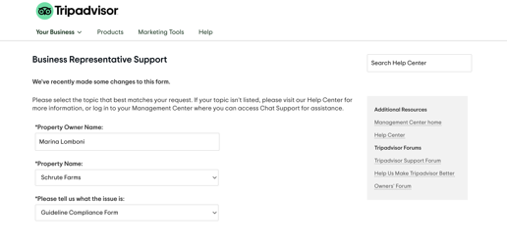

What happens when an owner applies for auto-mitigation?
Once the form is submitted, the auto-mitigation system analyzes the listing and automatically generates a Zendesk ticket called Guideline Compliance Appeal: (name of the property) containing all the information provided by the owner.
Scenario: Auto-Mitigation is GRANTED
If the property meets the eligibility requirements, the penalty is removed.
- Owner Notification: The owner receives an automated email confirming relief.
“Subject: Tripadvisor Penalty Relief Granted
Thank you for completing Tripadvisor's Guideline Compliance form and for your diligence in addressing this matter.
Given that you have taken steps to ensure that your business and marketing partners know our guidelines, we have removed the penalty associated with this activity from your listing. Please allow up to seven days for the change to be made to our site.
You must ensure that your team remains aware of our guidelines, as any further violations may result in quick and steep penalties being implemented, with no opportunity for mitigation.
We wish you the best of luck with your venture.
Tripadvisor's Trust & Safety Team”
- On Zendesk: This is how the Zendesk ticket looks when mitigation is granted.
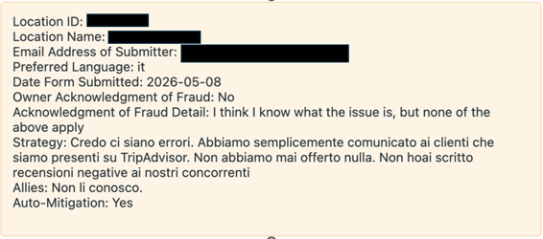
- Internal Tracking: A record of the granted mitigation is automatically added to the "Location Notes" section in the Location Center.
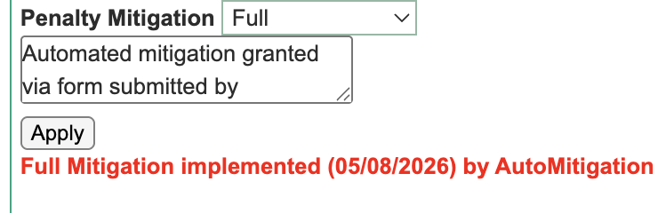
Scenario: Auto-Mitigation is NOT GRANTED
If the property does not meet the eligibility criteria:
Condition | Details
No automated response | Owners do not receive an automated notification.
Agent involvement | These cases typically require manual review or remain as they are, depending on existing workflows.
On Zendesk | This is how the Zendesk ticket looks when mitigation is not granted.
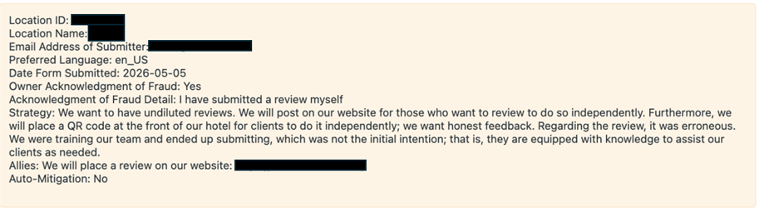

How to handle auto-mitigation in Fraud Support?
Step 1: Check Auto-Mitigation Status
Before engaging with the owner, check the Location Center to see if the property has already applied for auto-mitigation during the past year.
Scenario A: The property HAS applied for auto-mitigation
Action | Description
If GRANTED | You will see a "Full - 100%" mitigation stamp in the Location Center. Process the ticket according to standard instructions.
If DENIED | There is no stamp for denials. To confirm a denial, you must search Zendesk:  - Search by Location ID and sort by the most recent date.  - Look for a closed ticket with the subject: "Guideline Compliance Appeal."  - If found, the property failed auto-mitigation.
Important: Do not discuss the reasons why auto-mitigation was granted or denied with the owner. Refer to the 11c Penalty Mitigation page for manual handling, which should remain a rare exception.
Scenario B: The property HAS NOT yet applied
If an owner asks about their ranking, missing reviews, or admits to fraud and the property has a penalty your default action is to direct them to the Guideline Compliance Form (GCF) while answering their specific questions, unless the violation type requires a different handling process (Example: coached or coerced reviews, which should be escalated to Investigations).
Exceptions (Do NOT send to GCF if):
Exceptions | Description
OSM/ORM scenarios | Handle these misdirected reviews in FS as usual.
Active badges | Listings with an active badge are ineligible for automation; handled manually by escalating to Investigators.
Recent use | The property already used auto-mitigation within the last 12 months.
Bullying and incentives | If the violation is strictly bullying or incentives with no removals, there is no penalty to mitigate.
Step 2: Verification and action
Verification | Action
Confirm penalty | Ensure the property has a confirmed fraud removal within the last 365 days.
Send the GCF | If eligible, provide the GCF link alongside relevant macros (e.g., Ranking drop from fraud).
Repeat offenders | If they re-offended after receiving auto-mitigation within the last year, handle the ticket manually without mentioning the GCF.

GCF troubleshooting
If the owner reports technical issues with the GCF, follow these step
Troubleshooting step | Description
Verify login | Ensure they are logged into the Management Centre using the registered email address for that specific property.
Tag failure | If the form still doesn't work, continue the FPS discussion and add a comment using the "GCF Failure" macro to tag the ticket.
Escalate | If the form fails and the violations are severe (e.g., vandalism, paid reviews, or bullying), escalate the ticket to Investigators for potential manual mitigation.

Macros
⚠️Important: This information is for your awareness only; agents are not required to verify these criteria manually and they must not share these with any owner.
Owner::CI::Mitigation::Send to GCF macro:
GCF macro template
Hello {{ticket.requester.first_name}},
Thank you for contacting Tripadvisor. We understand that violations of our guidelines may be unintentional, or may have occurred without your knowledge. We are happy to work with properties who wish to remedy the situation. Tripadvisor now offers a self-service form that allows businesses to make an appeal to have ranking penalties removed or reduced.
Here is what you can do now:
- Speak with your staff, family, and vendors (especially those that may interact with your Tripadvisor listing, like social media managers). Ask about their activity on Tripadvisor and ensure that they are aware of our guidelines.
- Review your own activity on Tripadvisor; and
- Complete the Guideline Compliance Form which can be found by selecting it from the dropdown on this page <https://www.tripadvisor.com/OwnerSupport >. The greater detail you provide, the better the chance we can completely clear your penalty. If you control multiple listings on Tripadvisor, please make sure you have the correct business selected in the dropdown form on that page.
The majority of owners who complete our "Guideline Compliance Form" receive confirmation of being penalty-free within 24 hours, ensuring that they are still eligible for Tripadvisor recognition awards like "Best of the Best."
Best regards,
{{ticket.assignee.signature}}
Tripadvisor Content Integrity

Process maps
