11a GCF: Mitigation Granted Tickets
Audience: [LOB: Fraud Support]
- Overview
- GCF mitigation granted - standard procedure
- Exceptional cases on when to send a manual response

Overview
This article explains the process for handling Guideline Compliance Form (GCF) submissions in Zendesk when mitigation is granted, including situations that require a manual response.

GCF mitigation granted - standard procedure
- Every Guideline Compliance Form (GCF) submitted by an owner automatically creates a Zendesk ticket.
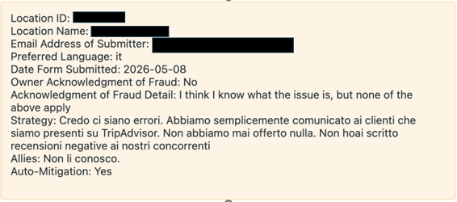
- If the property meets the eligibility requirements, penalty mitigation is granted.
Note: For more details on the eligibility requirements, refer to the article Guideline Compliance Form (GCF) Overview & How to handle FPS
- When penalty mitigation is granted, the owner receives the following automated email notification:
Subject: Tripadvisor Penalty Relief Granted
Thank you for completing Tripadvisor's Guideline Compliance form and for your diligence in addressing this matter.
Given that you have taken steps to ensure that your business and marketing partners are aware of our guidelines, we have removed the penalty associated with this activity from your listing. Please allow up to seven days for the change to be made to our site.
It is important that you ensure that your team remains aware of our guidelines, as any further violations may result in quick and steep penalties being implemented, with no opportunity for mitigation.
We wish you the best of luck with your venture.
Tripadvisor's Trust & Safety Team
- In most cases, the automated approval or mitigation email provides the owner with all the information they need.
- While most GCF tickets are automated, manual intervention is still required if an owner leaves specific comments in their submission. For more details refer to the Exceptional Cases: When to Send a Manual Response section.
- If no further action is required:
- Add an internal note explaining why a response isn't needed.
- Set the ticket to Solved.

Exceptional cases on when to send a manual response
Use the opening statements below to provide context for your response.
Case type | Manual response steps
- Admission of Violations (Other than Boosting)  Example:  When an owner admits to Incentives, Staff Incentives, or Review Gating (cherry-picking). | - Use the opening statement:  "Thank you for submitting the form to appeal your recent penalty. I’m glad to see we were able to remove the penalty against your business. I’m writing because of this comment you included in your form submission: [Insert Quote]"  - After inserting the statement, use the specific Macro section that explains the relevant policy violation and draft the response.
- Questions or Requests for Assistance  Example:  When the owner asks a specific question or needs help. | - Use the opening statement:  "Thank you for submitting the form to appeal your recent penalty. I’m glad to see we were able to remove the penalty against your business. I’m writing because you left a comment asking about..."  - After inserting the statement, continue to draft the response based on the owner’s request.
- Claims of Vandalism or Blackmail  Example:  If an owner claims they were targeted by a third party. You must request evidence. | - Use the opening statement:  "Thank you for submitting the form to appeal your recent penalty. I’m glad to see we were able to remove the penalty against your business. I’m writing because you mentioned that your business experienced..."  - After inserting the statement, use the appropriate Vandalism/Blackmail Macro to request specific details and evidence and draft the response.
Important:
Mitigating vandalism penalty - When auto-mitigation is granted for vandalism, the penalty in the “Penalties” section of the Location Center must be manually cleared by the agent.

